**WEB APPLICATION DEVELOPMENT LAB (WAD LAB)**

**1604-21-737-097**

**ASSIGNMENT – 6**

**PROGRM-1**

**AIM:** Write and test a HTML page which includes Angular JS framework to implement arithmetic operations like addition, subtraction, multiplication and division, using controllers.

**CODE:**

<!DOCTYPE html>

<html>

<head>

<title>Q1</title>

<script type="text/javascript" src="D:\it2164\angular.min.js"></script>

</head>

<body>

<div ng-app="myApp" ng-controller="arthCtrl">

Enter The First Number:<input type="text" ng-model="val1"><br><br><br>

Enter Second Number:<input type="text" ng-model="val2"><br><br><br>

<br>

Result:{{val3}}<br>

<button ng-click="add()">Addition</button>

<button ng-click="mul()">Multiplication</button>

<button ng-click="sub()">Subtraction</button>

<button ng-click="div()">Division</button>

</div>

<script type="text/javascript">

var app=angular.module('myApp',[]);

app.controller('arthCtrl',function($scope)

{

$scope.val1=0;

$scope.val2=0;

$scope.val3=0;

$scope.add=function(){

$scope.val3=Number($scope.val1)+Number($scope.val2);

};

$scope.sub=function(){

$scope.val3=Number($scope.val1)-Number($scope.val2);

}

$scope.mul=function(){

$scope.val3=$scope.val1*$scope.val2;

};

$scope.div=function(){

$scope.val3=$scope.val1/$scope.val2;

};

});

</script>

</body>

</html>

**OUTPUT:**

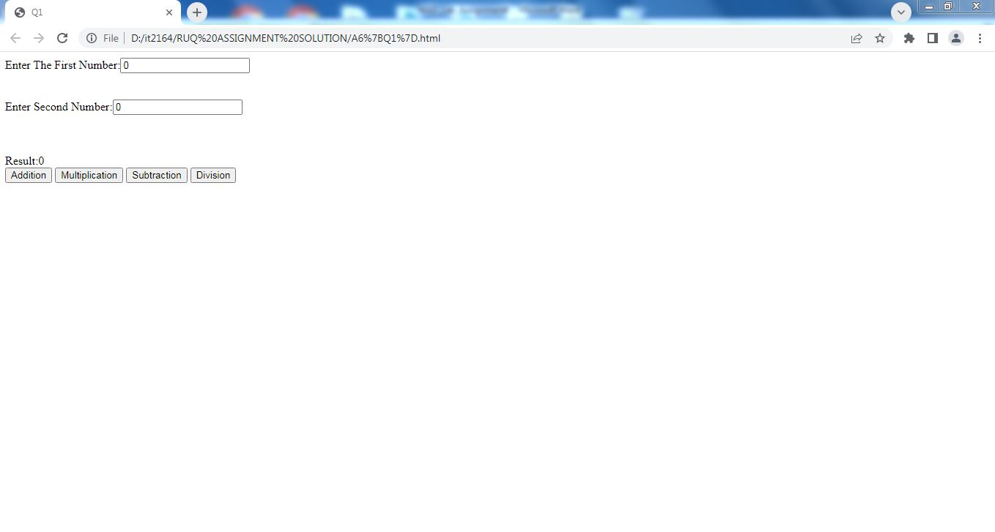

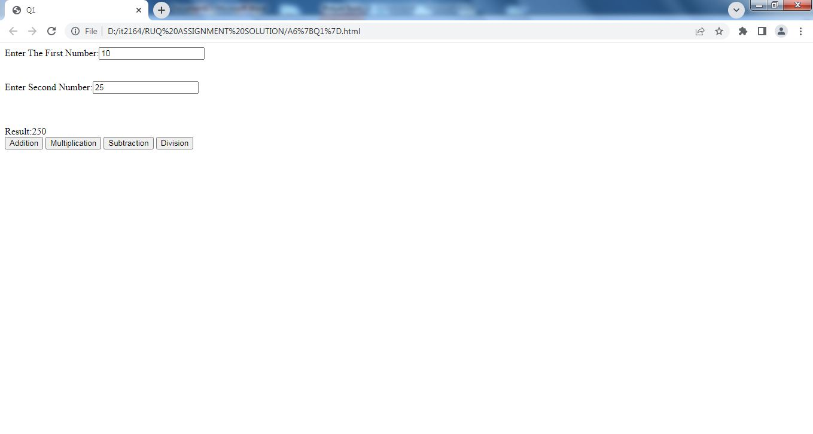

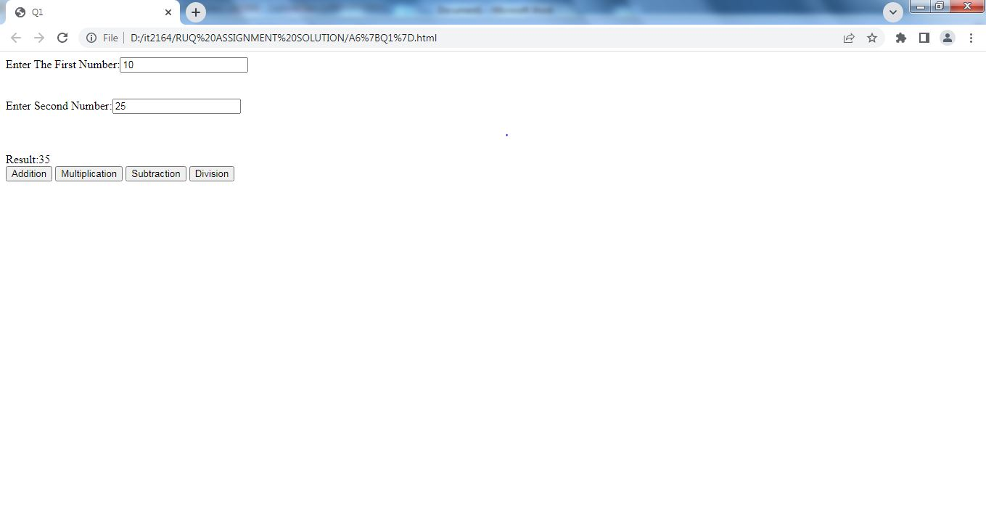

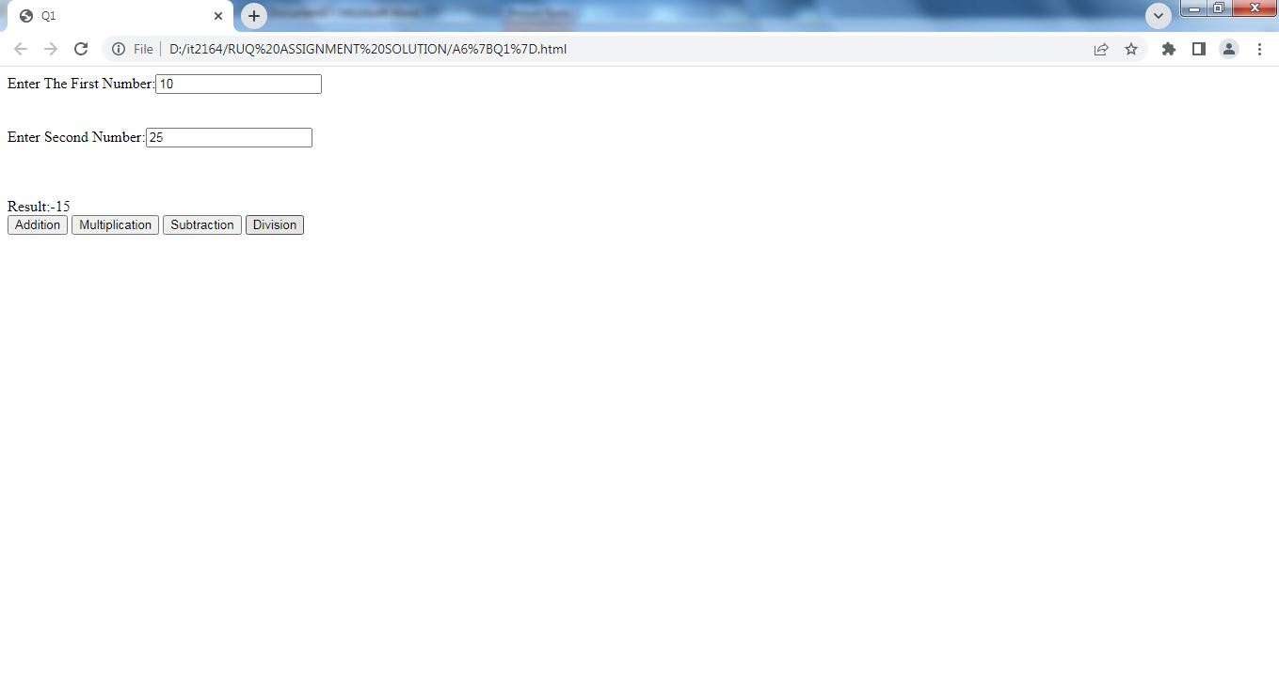

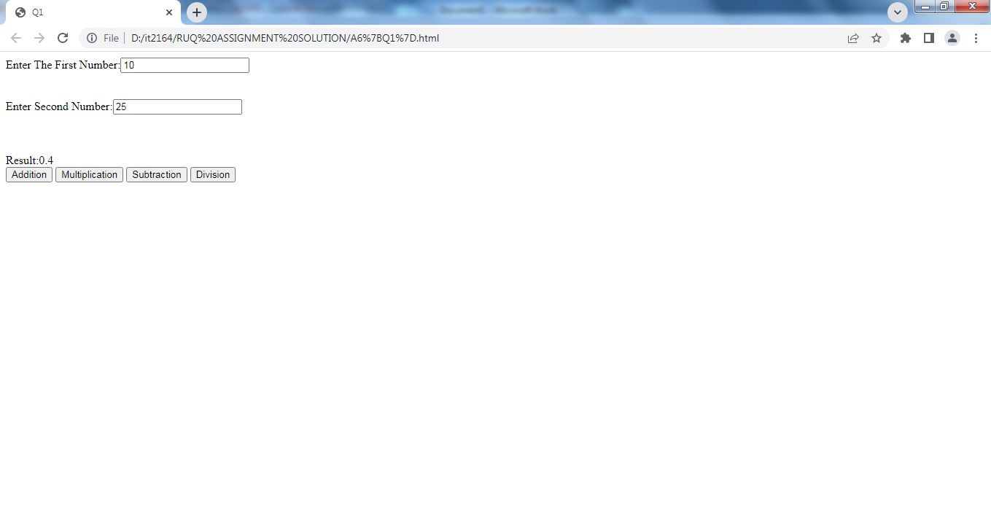

**1604-21-737-097**

**PROGRAM-2**

**AIM:** Write and test a HTML pages to demonstrate Angular JS services $location, $timeout and $interval

**CODE:**

<!DOCTYPE html>

<html>

<head>

<title>Q3</title>

<script type="text/javascript" src="D:\it2164\angular.min.js"></script>

</head>

<body>

<div ng-app="myApp" ng-controller="mYcrtl">

<p>The url of this page is:</p>

<h3>{{myUrl}}</h3>

<p>This header will change after two seconds:</p>

<h1>{{myHeader}}</h1>

<p>The time is:</p>

<h1>{{thetime}}</h1>

</div>

<p>This example uses the Built-in $location service to get the absolute url of the page.</p>

<p>The $timeout service runs a function after a specified number of milliseconds.</p>

<p>he $interval service runs a function every specified millisecond.</p>

<script type="text/javascript">

var app=angular.module('myApp',[]);

app.controller('mYcrtl',function($scope,$location,$timeout,$interval)

{

$scope.thetime=new Date().toLocaleTimeString();

$scope.myHeader="Hello World!";

$scope.myUrl=$location.absUrl();

$timeout(function(){

$scope.myHeader="How are you today?";

},2000);

$interval(function(){

$scope.thetime=new Date().toLocaleTimeString();

},1000);

});

</script>

</body>

</html>

**OUTPUT:**

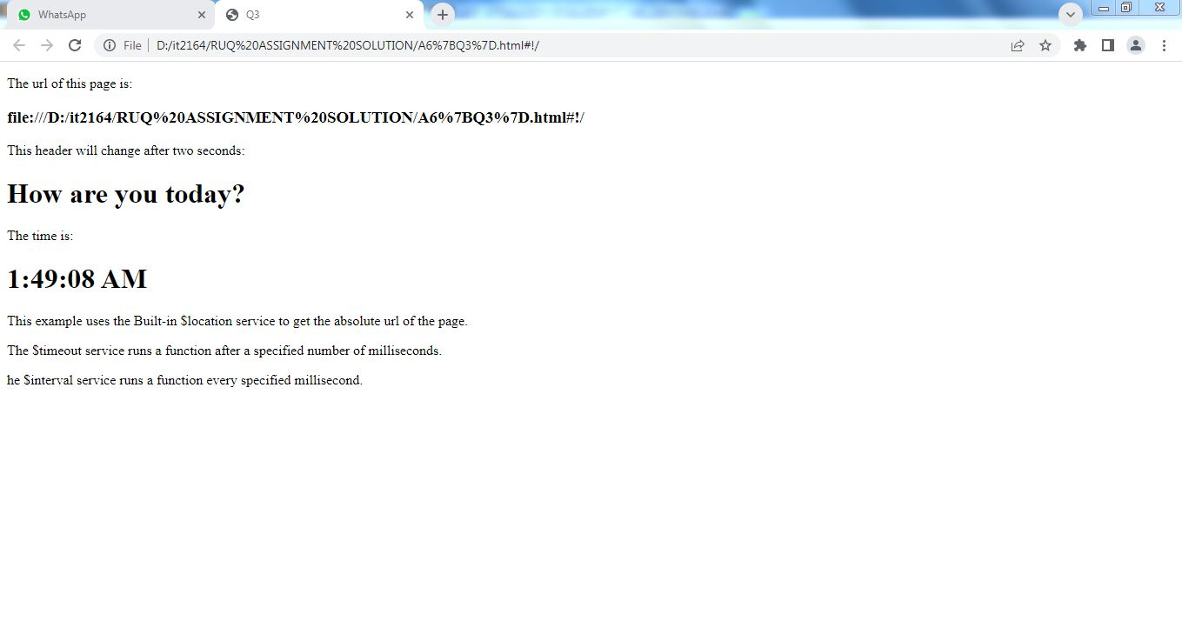

**1604-21-737-097**

**PROGRAM-3**

**AIM:** Write and test a HTML page to demonstrate the working of ng-repeat directive in an ordered list

**CODE:**

<!DOCTYPE html>

<html>

<head>

<script src="D:\wad lab\it2164\WAD lab software\angular.min.js"></script>

</head>

<body>

<div ng-app="" ng-init="names=['JACK','JAMES','JOHN','JAKUB','JONES']">

<p>looping with ng-repeat:</p>

<ol>

<li ng-repeat="x in names">

{{x}}

</li>

</ol>

</div>

</body>

</html>

**OUTPUT:**

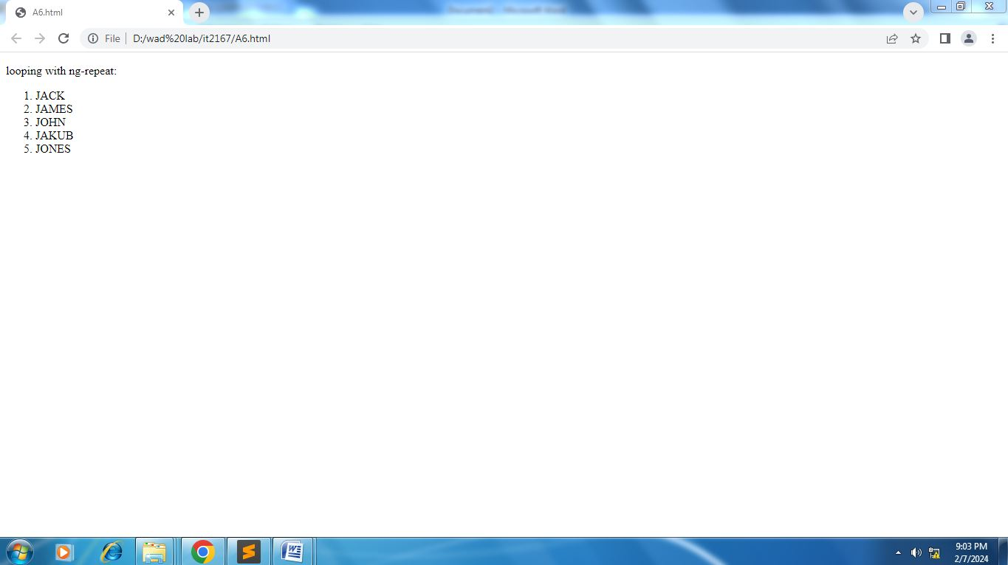

**1604-21-737-097**

**PROGRAM-4**

**AIM**:- Perform ‘required’ and ‘e-mail’ input validation on Student Form

**CODE**:

<!DOCTYPE html>

<html>

<script src="D:\it2164-wad lab\it2162\WAD lab software\angular.min.js"></script>

<body ng-app="">

<p>Try writing an E-mail address in the input field:</p>

<form name="myForm">

<input type="email" name="myInput" ng-model="myInput" required>

<input name="myInputs" ng-model="myInputs" type="email"required>

</form>

<p>The input's valid state is:</p>

<h1>{{myForm.myInput.$valid}}</h1>

<h1>{{myForm.myInputs.$valid}}</h1>

</body>

</html>

**OUTPUT:**

