

[Ausbildung zum Web Developer - PHP/MySQL](https://lernplattform.wifi.at/cstart/course/11449" \o "Ausbildung zum Web  Developer  - PHP/MySQL - Diplom-Lehrgang (18295017))

[Diplom-Lehrgang (18295017)](https://lernplattform.wifi.at/cstart/course/11449" \o "Ausbildung zum Web  Developer  - PHP/MySQL - Diplom-Lehrgang (18295017))

29.05.2018

Project – Atlas CRM

Eray Yilmaz

1. Motivation
2. Project Description
3. ER Diagram
4. Features and Programming
5. **Motivation**

I am interested in CRM Projects because today any kind of big or small business needs a CRM Software basically. There a lot of different solutions on market but I think it is still not easy to choose best solutions that fits perfectly for firms. That why companies still investing on programming their own CRM solution like my company. Working on this project helped me to understand the basics of a CRM Solution and its features. On the other hand it gives me to experience working on PHP project with using an MVC based framework.

1. **Project Description**

Atlas is a basic CRM Project includes basic CRUD (Crate, Read, Update and Delete) functions on Customers, Products, Product Categories and Orders.

It is programmed on CodeIgniter Framework v.3.1.7 with a MySQL database.

**External Libraries:**

**a. Simplicity Template Library**

--> https://www.grocerycrud.com/codeigniter-simplicity

It comes with its own Controller and series of different views that made easy to set different views for different types of sections.

**b. Ion Auth 2 - authentication Library**

--> <https://github.com/benedmunds/CodeIgniter-Ion-Auth>

It includes its own Controller, Views, Config files and a SQL import file that add different tables like users, users_groups, groups and login_attempts. It provides a full control of users and user groups.

**c. Bootstrap 4.0 and many JS libraries based template called "Pages".**

--> https://themeforest.net/item/pages-admin-dashboard-template-web-app/9694847

1. **JQuery for Creating Order Process**

Stepwise placing order is programmed by JavaScript.

1. **ER Diagramm**

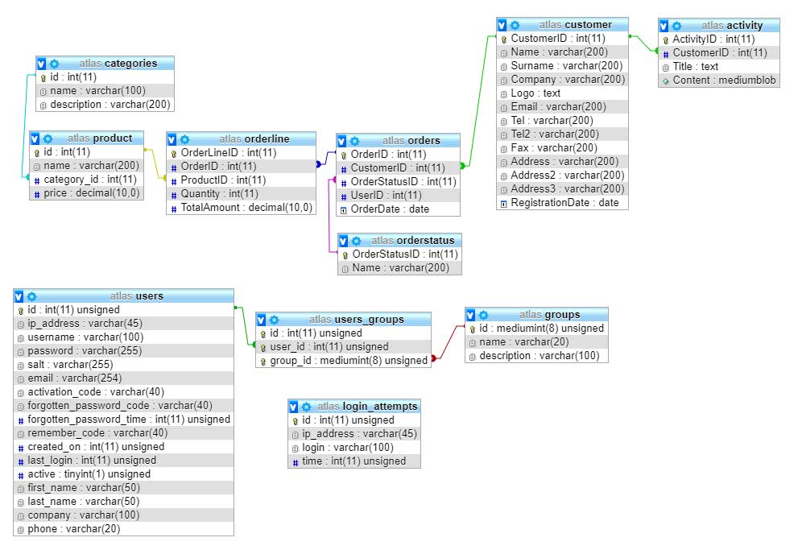

1. **Project**

**Main Features**

1. **User Management**
2. **Create, Edit, Delete and Update Products**
3. **Create, Edit, Delete and Update Product Categories**
4. **Create, Edit, Delete and Update Customer**
5. **Create, Edit, Delete and Update Order**

Project has 4 main modules; Product, Product Categories, Customers and Orders. Orders have a collect information’s from Products, Customers and write for every order in item, quantity in order lines. These order lines for every order try collecting together by same order id.

Every module has a controller that includes different actions of CRUD events like create, add, delete and edit. These controllers use some queries on database with a help of models. All changes or queries on database made by models and collections of answers are showed with help of views.

An external library called “Ion Auth 2” is used for authentication for the project. It comes with an extended feature on user management. It contains its own controller, sample views and database tables to import on existing project.

This Project uses Simplicity Template Library for control different types of views. It is also possible to control loading CSS and JavaScript files separately. It is also possible to collect static parts of different parts and includes them easily.