



**[*SUDHEERA- 10615230*]**

**AWS Intermediate Level**

Assignment

# Introduction

This section explains the brief introduction about the application which is developed using AWS. List down the name of the AWS Services which are used in the application.

## Logical overview of landscape

In this section, show the landscape of the Application

For e.g.

[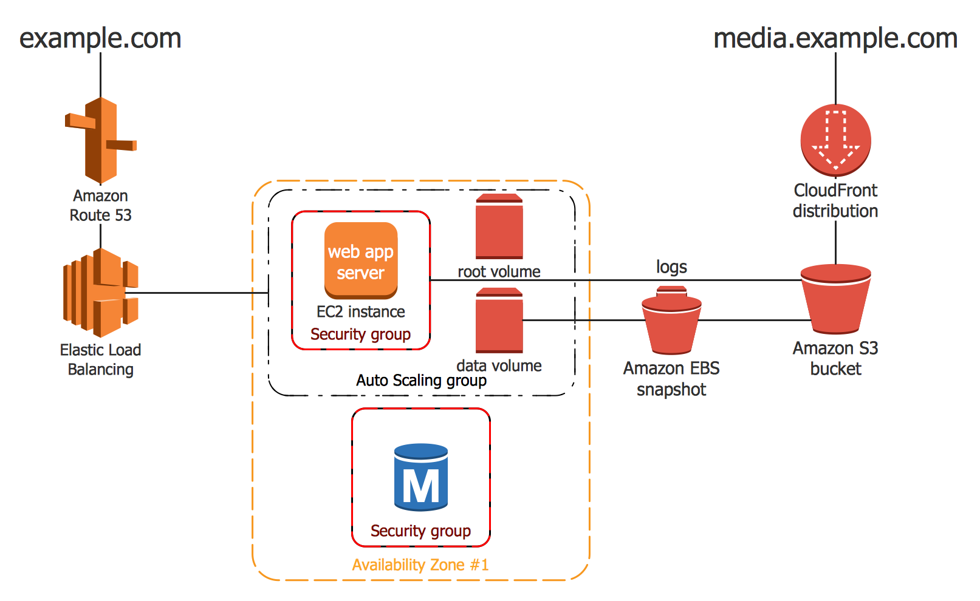](http://www.google.co.in/url?sa=i&rct=j&q=&esrc=s&source=images&cd=&cad=rja&uact=8&ved=0ahUKEwinkIaMmqrXAhXMvY8KHWXtC0gQjRwIBw&url=http://www.conceptdraw.com/solution-park/computer-networks-aws&psig=AOvVaw1rUQCW-ZOgBl7PvZPmXq_N&ust=1510066448071865)

# AWS Services Configuration

Mention in detail all the services used in the Application.

### *EC2* (including auto-scaling)

**EC2 Instance:**

Created a Linux Free tier Instance in ‘Mumbai’ region with in ‘ap-south-1a’ availability zone.

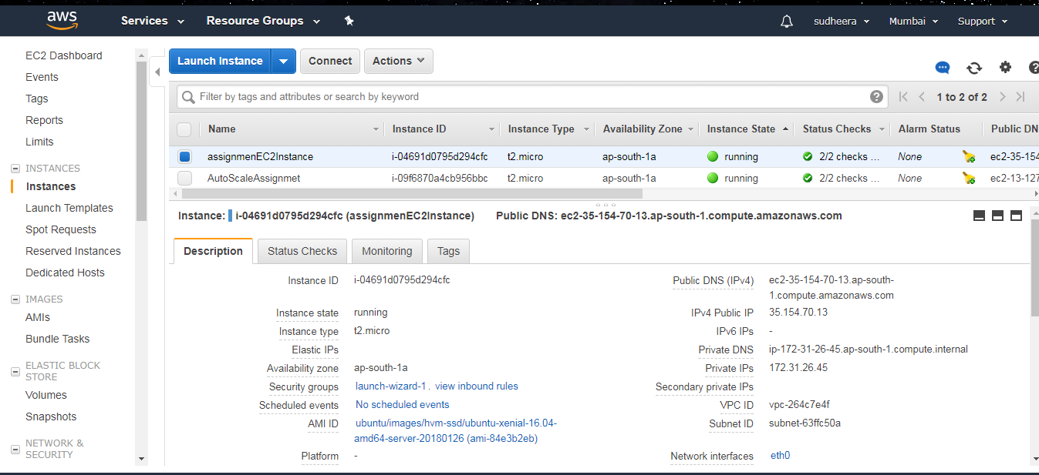

**Auto Scaling Groups:**

Auto scaling ‘AutoScaleAssignment’ is attached to the instance to handle the load on the server, so that it creates a new instance whenever required in the group. Here configured 1 instance per group.

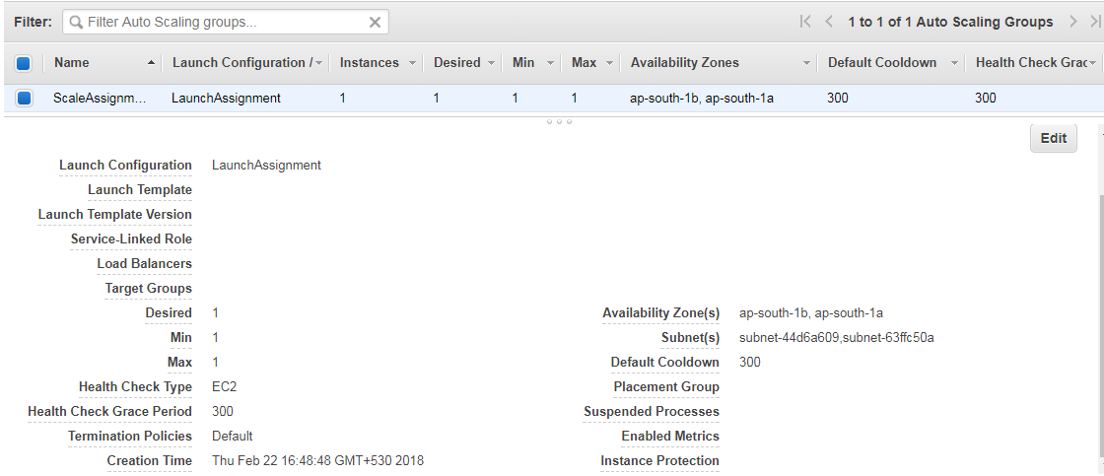

### *Object Storage S3*

* Created a bucket with name ‘segassignmentbucket’.
* Created a folder ‘assignment’ with the bucket.
* Uploaded a file to folder. The storage class being standard.

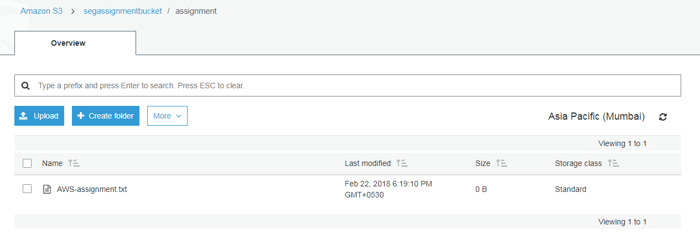

### *AWS RDS*

Explain how the service is been used, along with the screen shot of the configuration done in AWS Console.

### Elastic Load Balancer

Created a load balancer which monitors the health of the EC2 instance and distributes it across the availability zones(attached 2 subnets here.)

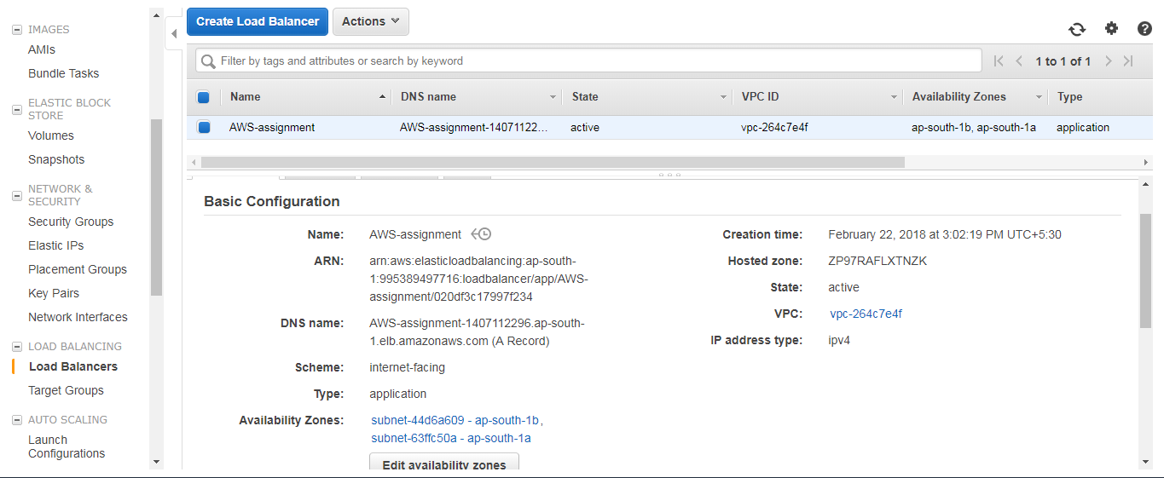

Alarm in Load Balancer:

Created an alarm to send notifications to the user email whenever threshold limit is crossed.

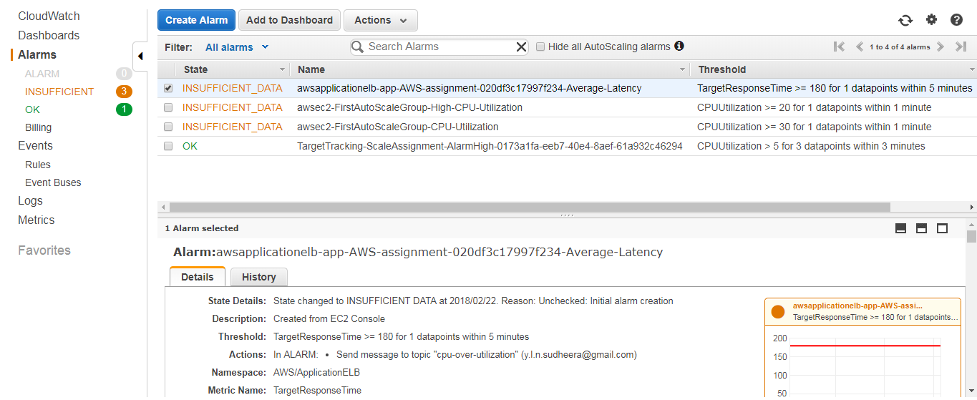

### AWS VPC and Security Group

Used the default VPC.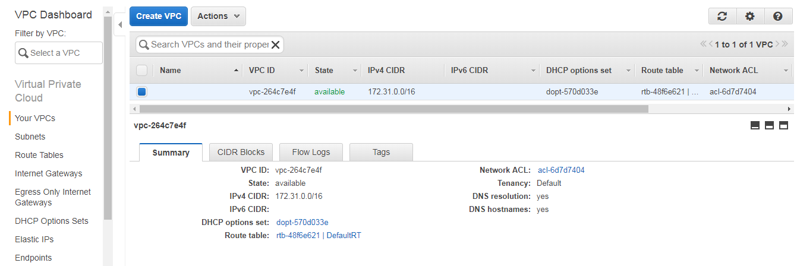

**Security Groups:**

Launch Wizard- 1 Security group has been used across EC2, Auto Scaling and Load Balancers.

Security group with its inbound rules are in below screen shot.

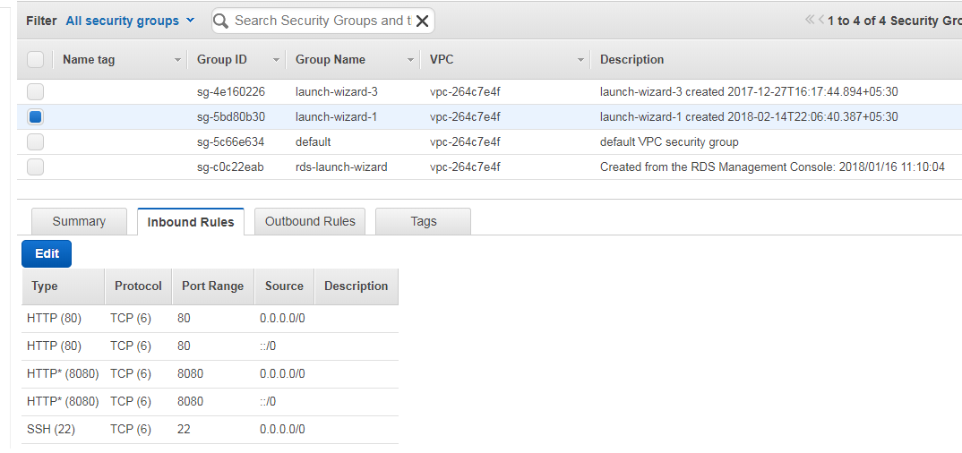

# Application Usage

This section shows the demo of the application developed along with the screen shot for each steps.

Sample E.g.

1. Create a User in the Application

[Screen Shot]

1. Access the Application Home Page

[Screen Shot]

1. User Fills the Data in the Web Form

[Screen Shot]

1. User Saves the data and the data is now visible in Database

[Screen Shot]