A simple demonstration of a MList :

bookmark0  
**dangling reference for bookmark id1bookmarkRef1**  
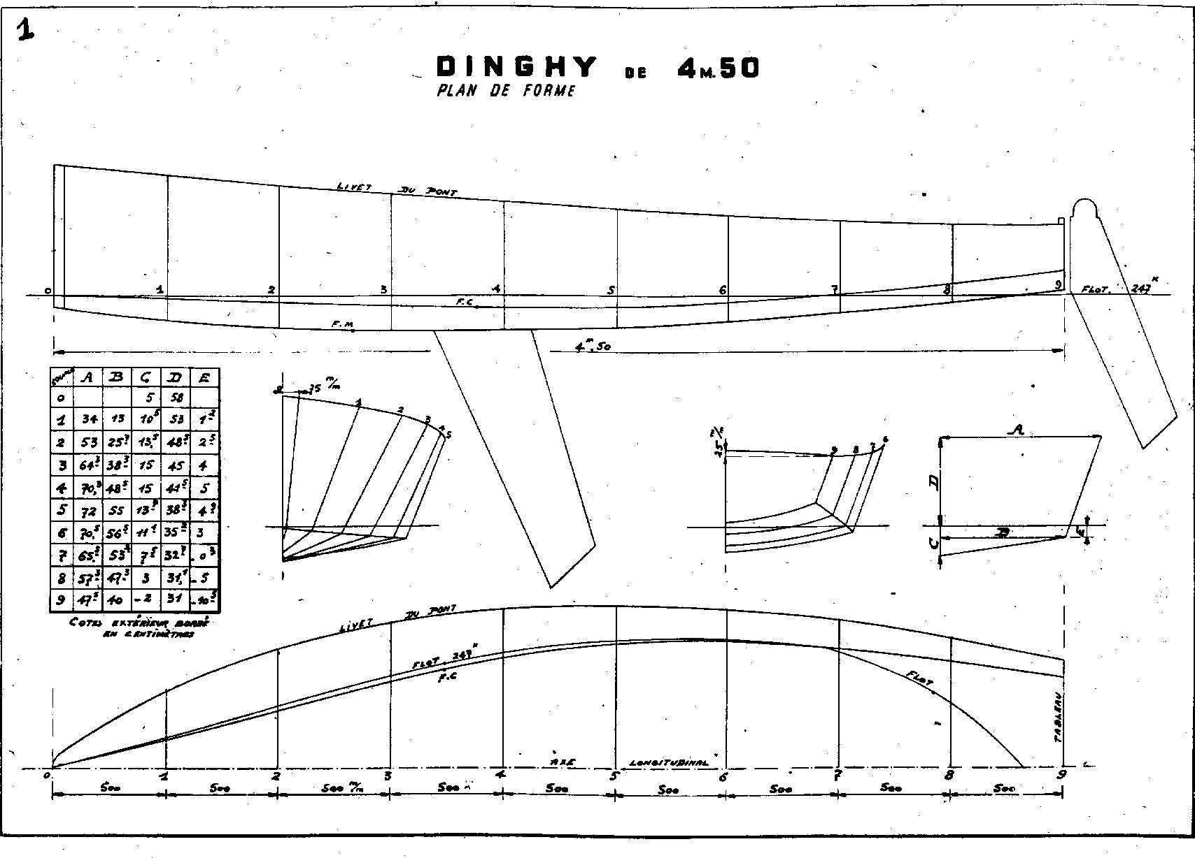  
**sample table  
sample table*sample tablesome text*sample table  
sample tablesample tabletext in a listsample table  
sample table**

|  |  |  |  |  |
| --- | --- | --- | --- | --- |
|  | **Bold** | *Italic* | Underline | ~~Strike through~~ |
| **Bold** | **0** | ***1*** | **2** | **~~3~~** |
| *Italic* | ***4*** | *5* | *6* | *~~7~~* |
| Underline | **8** | *9* | 10 | ~~11~~ |
| ~~Strike through~~ | **~~12~~** | *~~13~~* | ~~14~~ | ~~15~~ |

End of demonstration.