2026-2027学年第一学期
《高级语言程序设计(C++语言)》
实验报告
实验名称：C++简单程序设计
实验日期：2026年10月16日 | 实验地点：
学 号：2025302132118 | 姓 名：孙子恒
学 院：遥感信息工程学院 | 专 业：遥感科学与技术
指导老师：

一、实验目的
掌握基本数据类型、常量与变量、输入输出和各类运算符；运用顺序、分支、循环结构解决简单问题，并使用IDE断点、单步执行和变量观察功能检查程序。
二、实验环境
Windows，Visual Studio 2026 Insiders，MSVC 14.52.37025；C++17，Debug x64。每题一个独立控制台项目，共22个项目。
三、实验过程及结果
按课件02完成补充2-1至2-14及第38页的8道编程题。代码、项目和运行记录随报告一并提交。结果图展示本机程序实际输出的记录窗口；第一题另附实际控制台截图。完整多组输入输出见run-results.txt。
题目1 Ex01_ReadInteger 读入并显示整数
输入3和8，变量radius依次保存这两个整数。
解答代码
#include <iostream>
using namespace std;
int main()
{
int radius;
cout << "Please enter the radius!\n";
cin >> radius;
cout << "The radius is:" << radius << '\n';
cout << "PI is:" << 3.14 << '\n';
cout << "Please enter a different radius!\n";
cin >> radius;
cout << "Now the radius is changed to:" << radius << '\n';
return 0;
}
运行结果记录窗口截图
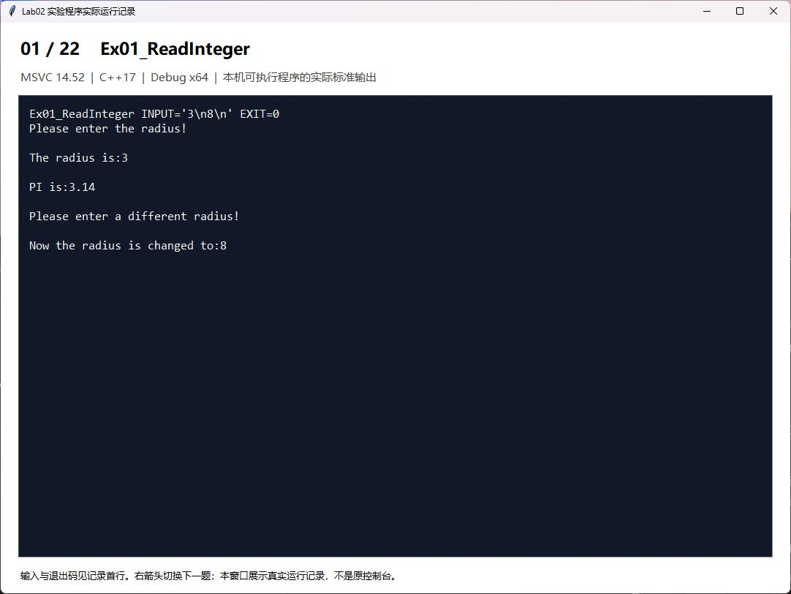
实际控制台运行截图 输入3和8
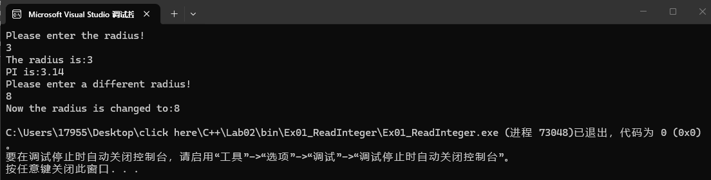
题目2 Ex02_Constant 为常量命名
pi为只读常量，不能通过cin修改；定义const常量时应初始化。
解答代码
#include <iostream>
using namespace std;
int main()
{ const double pi(3.14159);
int radius;
cout<<"Please enter the radius!\n";
cin>>radius;
cout<<"The radius is:"<<radius<<'\n';
cout<<"PI is:"<<pi<<'\n';
cout<<"Please enter a different radius!\n";
cin>>radius;
cout<<"Now the radius is changed to:"<<radius<<'\n';
cout<<"PI is still:"<<pi<<'\n';
//cin>>pi;
return 0;
}
运行结果记录窗口截图
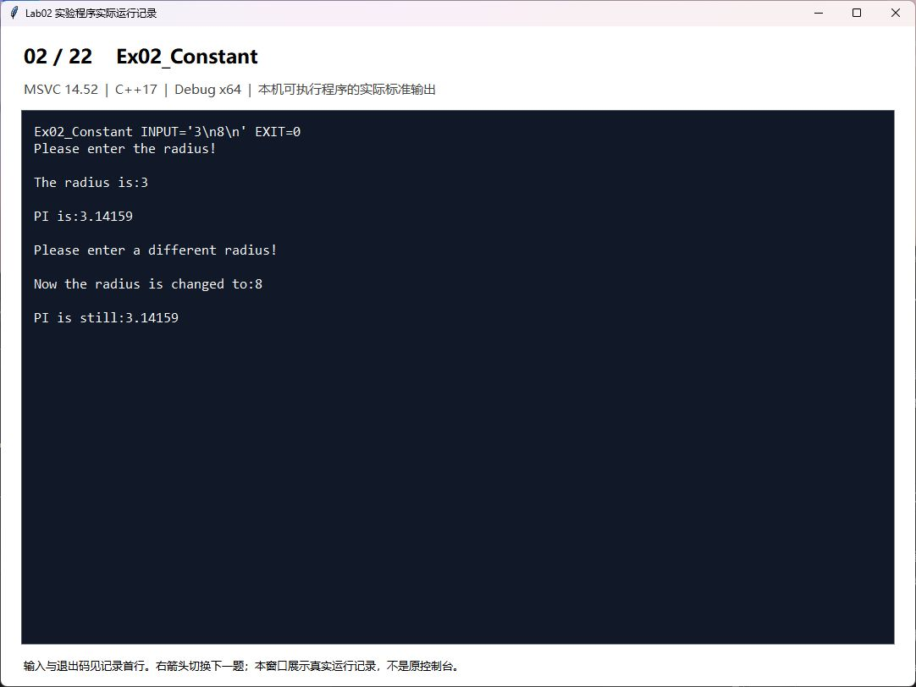
题目3 Ex03_Initialize 变量的初始化
radius初始化为0，随后由输入更新。
解答代码
#include <iostream>
using namespace std;
int main()
{
const double pi(3.14159);
int radius(0);
cout << "The initial radius is:" << radius << '\n';
cout << "PI is:" << pi << '\n';
cout << "Please enter a different radius!\n";
cin >> radius;
cout << "Now the radius is changed to:" << radius << '\n';
cout << "PI is still:" << pi << '\n';
return 0;
}
运行结果记录窗口截图
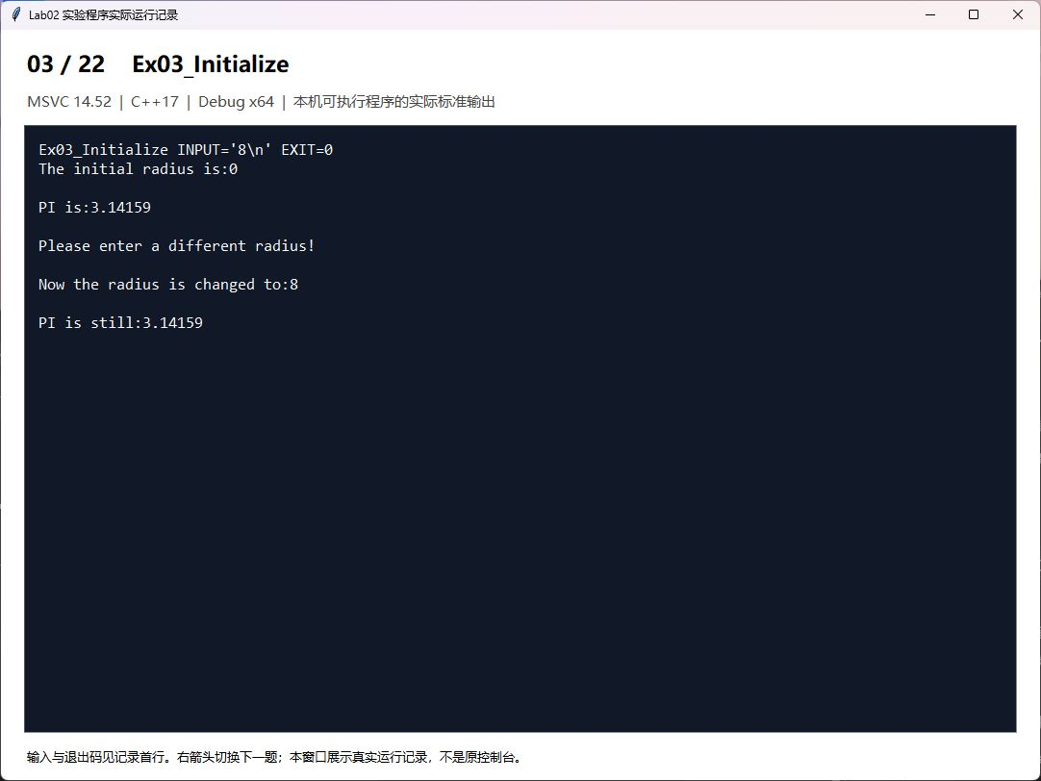
题目4 Ex04_IntegerConversion 整数变量的定义与输出
本机short为16位，50000转为short后显示-15536；unsigned short保持50000。
解答代码
#include <iostream>
using namespace std;
int main()
{
short int i;
unsigned short int j;
j = 50000;
i = j;
cout << "Short int is:"<<i<<endl;
cout << "Short unsigned int is: "<<j<<endl;
return 0;
}
运行结果记录窗口截图
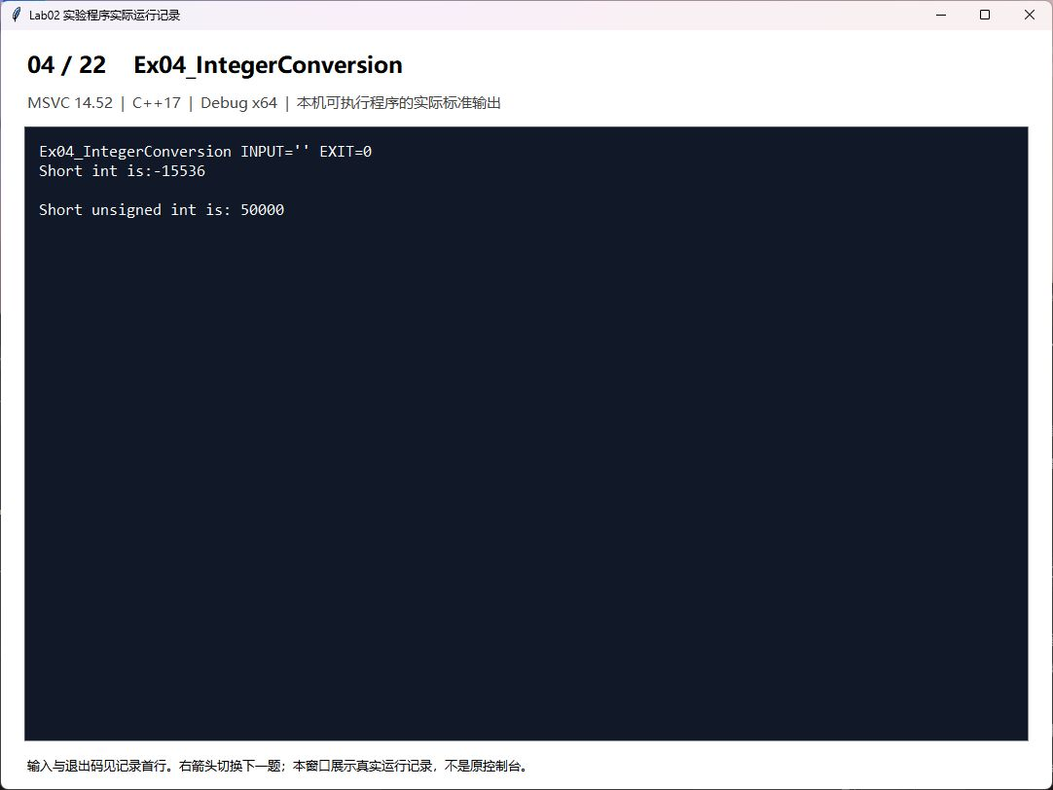
题目5 Ex05_IntegerLimits 不同类型整数的最值
整数类型的范围由实现决定，以climits中的常量为准。
解答代码
#include <iostream>
#include <climits>
using namespace std;
int main()
{ cout <<"Min of short is: "<<SHRT_MIN<<endl;
cout <<"Max of short is: "<<SHRT_MAX<<endl;
cout <<"Min of int is: "<<INT_MIN<<endl;
cout <<"Max of int is: "<<INT_MAX<<endl;
cout <<"Min of long is: "<<LONG_MIN<<endl;
cout <<"Max of long is: "<<LONG_MAX<<endl;
cout <<"Max of unsigned short is: "<<USHRT_MAX<<endl;
cout <<"Max of unsigned int is: "<<UINT_MAX<<endl;
cout <<"Max of unsigned long is: "<<ULONG_MAX<<endl;
return 0;
}
运行结果记录窗口截图
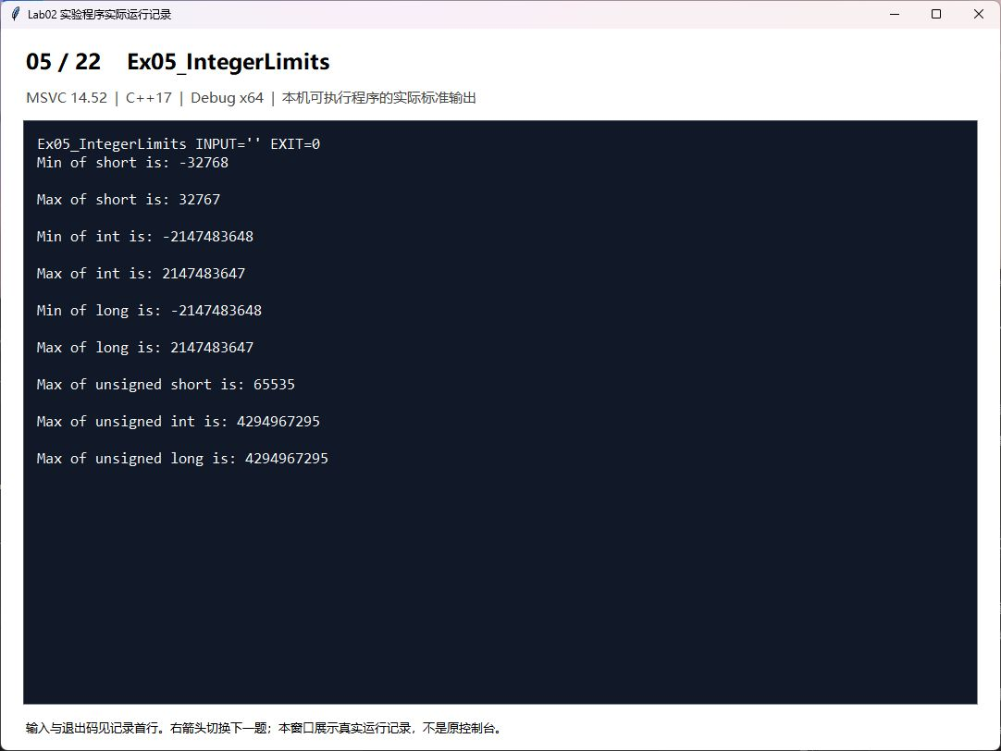
题目6 Ex06_NumberBases 整型文字常量的应用
十进制123、八进制173和十六进制7b表示同一个数；流操纵符会影响后续输入输出。
解答代码
#include <iostream>
#include <limits>
using namespace std;
int main()
{
int isample, osample, hsample;
unsigned long ulsample;
cin>>isample>>oct>>osample>>hex>>hsample;
cout<<isample<<';'<<oct<<osample<<';'<<hex<<hsample<<endl;
isample=123;
osample=0173;
hsample=0x7B;
ulsample=4294967295UL;
cout<<dec<<isample<<';'<<oct<< isample <<';'<<hex<< isample <<endl;
cout<<dec<< osample<<';' <<oct<<osample <<';'<<hex<< osample <<endl;
cout<< dec<<hsample <<';'<<oct<< hsample<<';' <<hex<<hsample<<endl;
cout<<dec<< ulsample <<';'<<oct<<ulsample<<';' <<hex<<ulsample<<endl;
return 0;
}
运行结果记录窗口截图
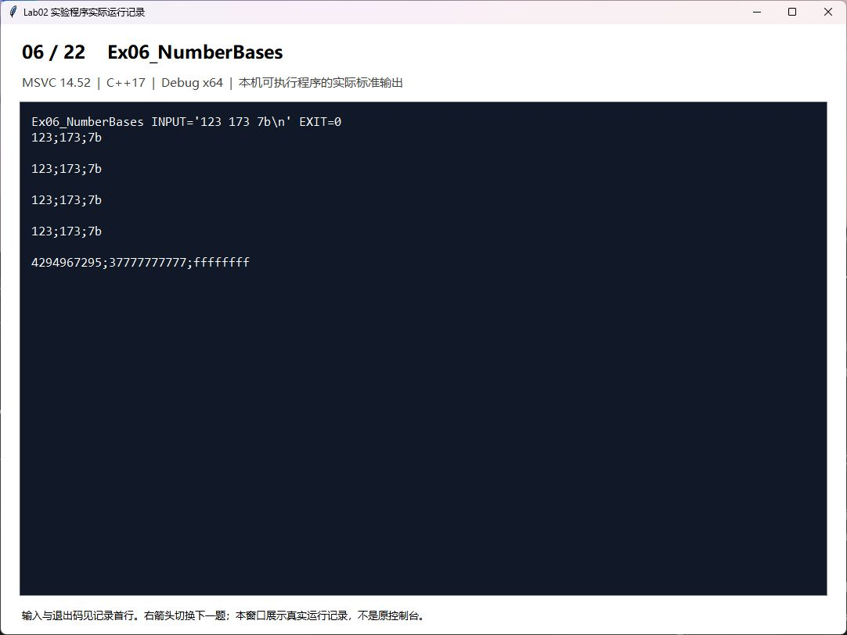
题目7 Ex07_FloatingPoint 不同类型浮点数的应用
float、double、long double计算圆面积；本机MSVC下double与long double均为8字节。
解答代码
#include <iostream>
using namespace std;
const float PI_FLOAT = 3.1415926f;
const double PI_DOUBLE = 3.1415926;
const long double PI_LDOUBLE = 3.1415926L; // 建议加 L 后缀
int main()
{
float nRadiusFloat = 5.5f, nAreaFloat;
double nRadiusDouble = 5.5, nAreaDouble;
long double nRadiusLDouble = 5.5L, nAreaLDouble;
nAreaFloat = PI_FLOAT * nRadiusFloat * nRadiusFloat;
nAreaDouble = PI_DOUBLE * nRadiusDouble * nRadiusDouble;
nAreaLDouble = PI_LDOUBLE * nRadiusLDouble * nRadiusLDouble;
cout << "nAreaFloat = " << nAreaFloat
<< " , sizeof(nAreaFloat) = " << sizeof(nAreaFloat) << endl;
cout << "nAreaDouble = " << nAreaDouble
<< " , sizeof(nAreaDouble) = " << sizeof(nAreaDouble) << endl;
cout << "nAreaLDouble = " << nAreaLDouble
<< " , sizeof(nAreaLDouble) = " << sizeof(nAreaLDouble) << endl;
return 0;
}
运行结果记录窗口截图
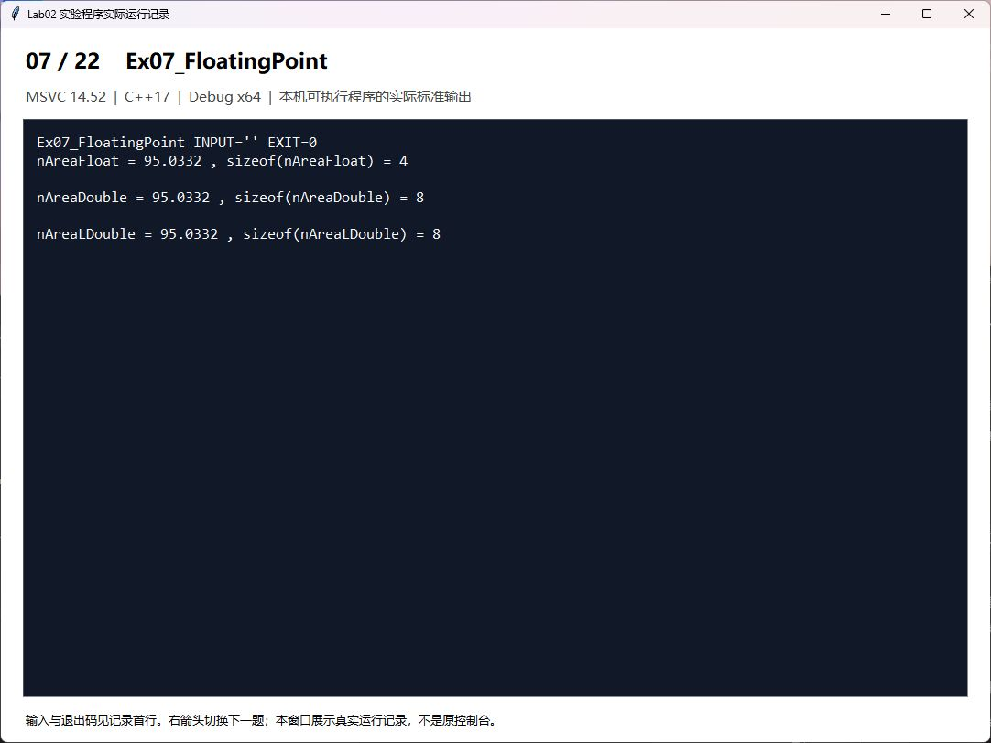
题目8 Ex08_Characters 字符数据的应用
观察普通字符、制表符、退格符和响铃；显示效果受控制台影响。
解答代码
#include <iostream>
using namespace std;
int main()
{
cout << 'A'<< ' '<<'a'<<endl; //输出普通字符
cout << "one\ttwo\tthree\n"; //使用水平制表符
cout << "123\b\b45\n"; //使用退格符
cout << "Alert\a\n"; //使用响铃键
return 0;
}
运行结果记录窗口截图
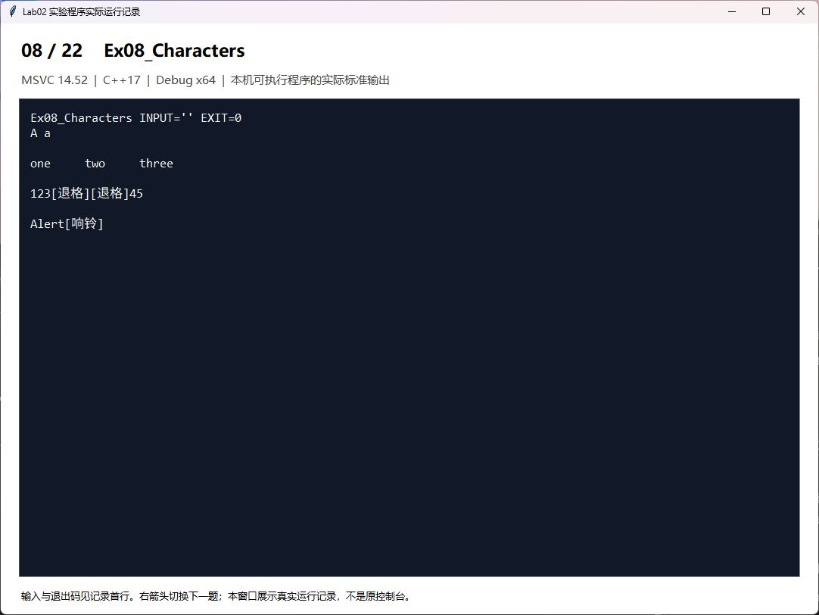
题目9 Ex09_Boolean bool类型及转换
true转为int是1，false是0；整数0转为false，非0转为true。
解答代码
#include <iostream>
using namespace std;
int main()
{
bool bV1= true, bV2= false;
cout <<"bool value bV1 = "<<bV1<<endl;
cout <<"bool value bV2 = "<<bV2<<endl;
int nV1=bV1, nV2 = 0;
bV1 = nV2;
cout <<"int value nV1 = "<< nV1<<endl;
cout <<"bool value bV1 = "<<bV1<<endl;
return 0;
}
运行结果记录窗口截图
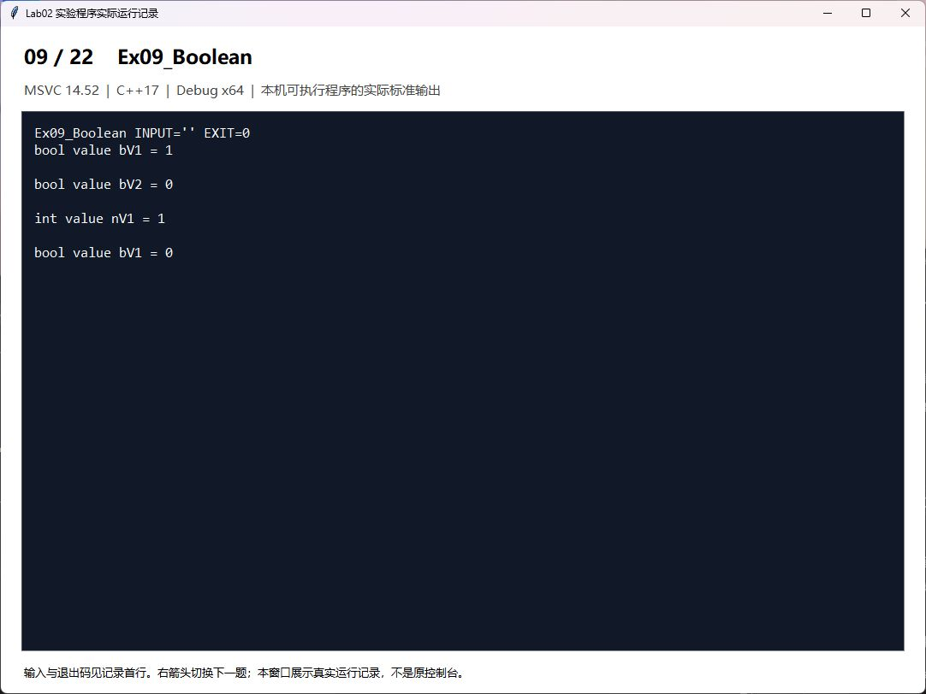
题目10 Ex10_Arithmetic 算术运算
24/5的整数结果为4，24%5为4，浮点除法为4.8；区分前置与后置自增。项目采用C++17，链式输出表达式的求值应按所用标准理解。
解答代码
#include <iostream>
using namespace std;
int main()
{
int val1 = 24;
int val2 = 5;
double val3 = 24;
double val4 = 5;
cout << "int/int, 24/5= " << val1 / val2 << endl;
cout << "int/int, 24%5= " << val1 % val2 << endl;
val2 = -5;
cout << "int/int, 24%(-5)= " << val1 % val2 << endl;
cout << "double/double, 24/5= " << val3 / val4 << endl;
// cout << "double/double, 24%5= " << val3 % val4 << endl; // 浮点数不能取模
cout << "double/int, 24/5= " << val3 / val2 << endl;
cout << "int/double, 24/5= " << val1 / val4 << endl;
val1 = 5;
cout << "val1 = " << val1 << endl;
cout << val1++ << ", ";
cout << ++val1 << ", ";
cout << val1-- << ", ";
cout << --val1 << endl;
val1 = 5;
cout << "val1 = " << val1 << endl;
cout << val1++<<", "<<++val1<<", "<<val1--<<", "<<--val1<<endl; //不同的编译器求值顺序可能不同
return 0;
}
运行结果记录窗口截图
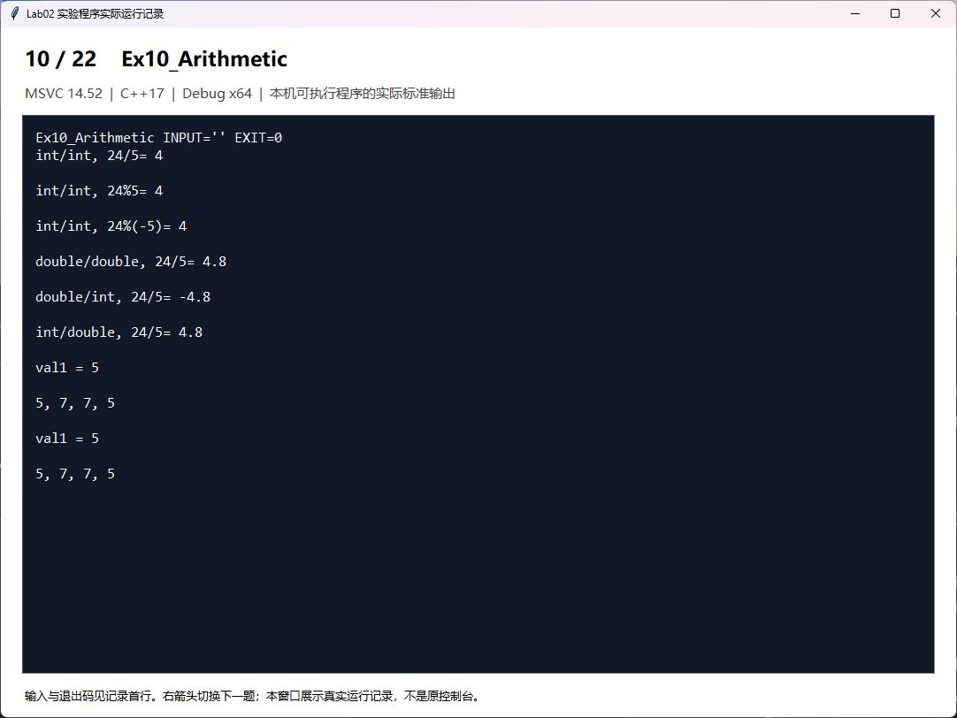
题目11 Ex11_Assignment 赋值运算
连续赋值从右向左结合；double转int可能丢失小数，因此编译器报告C4244警告。
解答代码
#include <iostream>
using namespace std;
int main()
{
int ival1, ival2;
double fval;
char cval;
ival1 = 1;
ival2 = 2;
cout << "ival1= " << ival1 << endl;
cout << "ival2= " << ival2 << endl;
ival1 = ival2 = 0;
ival1 = fval = 0;
ival1 = cval = 'a';
cout << "ival1= " << ival1 << endl;
cout << "ival2= " << ival2 << endl;
cout << "fval= " << fval << endl;
cout << "cval= " << cval << endl;
int ival3 = fval = 8;
cout << "ival3= " << ival3 << endl;
cout << "fval= " << fval << endl;
cout << "ival1 = " << ival1 << ", ival2 = " << ival2 << endl;
ival2 = -ival1++;
cout << "ival2 = -ival1++, ival1= " << ival1
<< ", ival2 = " << ival2 << endl;
ival1 = ++ival2 + ival1;
cout << "ival1 = ++ival2+ival1, ival1= " << ival1 << endl;
return 0;
}
运行结果记录窗口截图
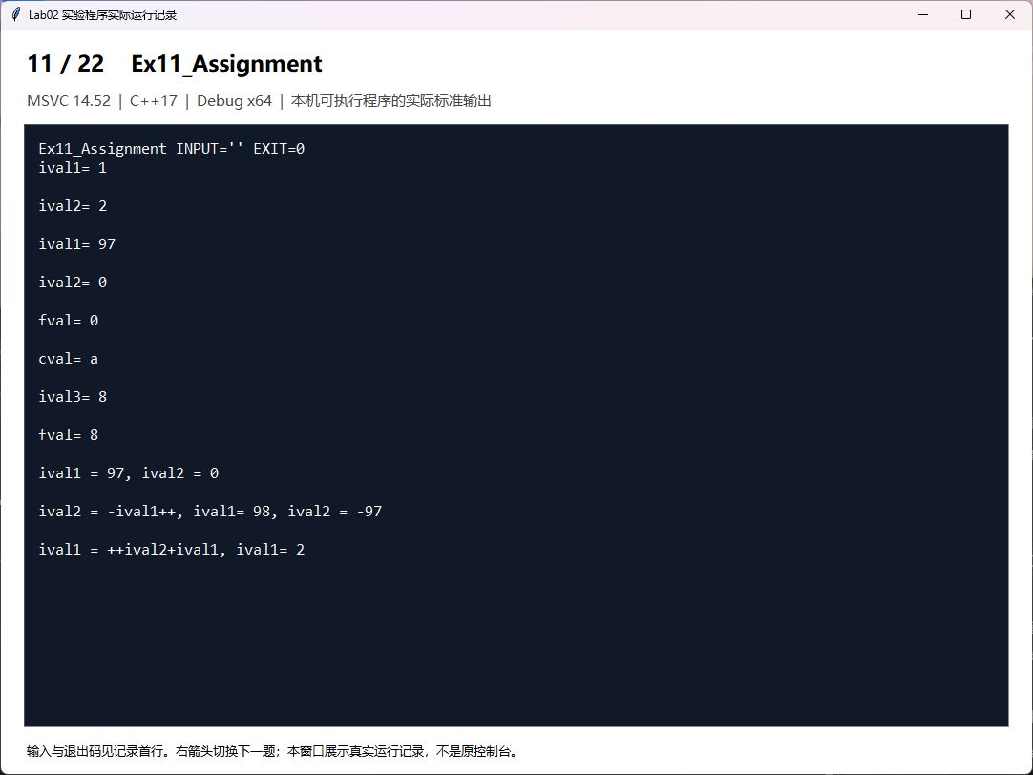
题目12 Ex12_Comparison 关系和逻辑运算
关系、相等及逻辑运算的结果是bool，默认输出0或1。
解答代码
#include <iostream>
using namespace std;
int main()
{
int ival1=1, ival2=2, ival3=3, ival4=4;
bool nFlag;
nFlag = ival1==ival2?true:false;
cout <<"Is 1 equals 2?: "<<nFlag<<endl;
nFlag = ival1<ival2?true:false;
cout <<"Is 1less than 2?: "<<nFlag<<endl;
nFlag = (ival1<ival2 && ival3<ival4)?true:false;
cout <<"Is 1less than 2 and 3 less than 4: "<<nFlag<<endl;
return 0;
}
运行结果记录窗口截图
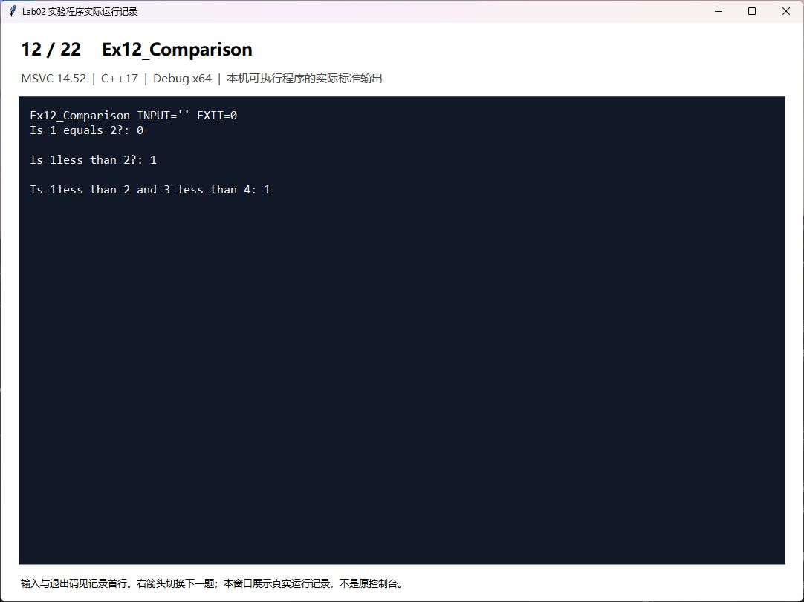
题目13 Ex13_Sizeof sizeof运算符
使用sizeof取得当前编译环境中的实际字节数，不能假定各平台都相同。
解答代码
#include <iostream>
#include <string>
using namespace std;
int main()
{
cout <<"sizeof(short)= "<<sizeof(short)<<endl;
cout <<"sizeof(unsigned short)= "<<sizeof(unsigned short)<<endl;
cout <<"sizeof(int)= "<<sizeof(int)<<endl;
cout <<"sizeof(unsigned int)= "<<sizeof(unsigned int)<<endl;
cout <<"sizeof(long)= "<<sizeof(long)<<endl;
cout <<"sizeof(unsigned long)= "<<sizeof(unsigned long)<<endl;
cout <<"sizeof(float)= "<<sizeof(float)<<endl;
cout <<"sizeof(double)= "<<sizeof(double)<<endl;
cout <<"sizeof(long double)= "<<sizeof(long double) <<endl;
cout <<"sizeof(char)= "<<sizeof(char)<<endl;
return 0;
}
运行结果记录窗口截图
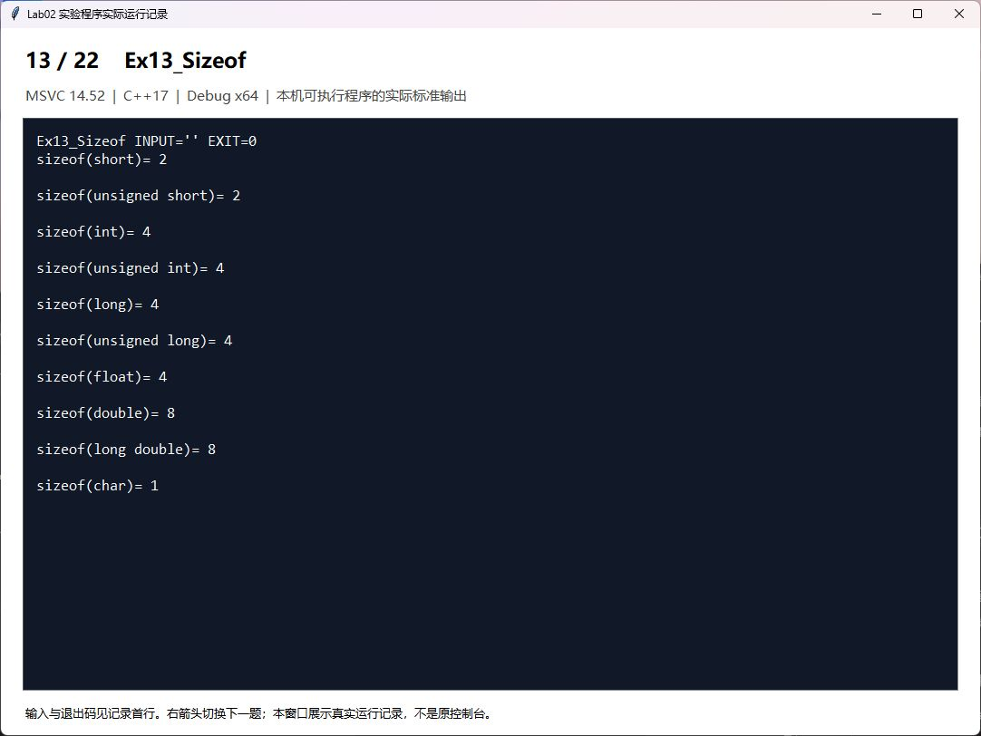
题目14 Ex14_Bitwise 位运算符
按位与可清零或检测位，按位或可置位，按位异或可翻转位；按课件对低16位逐位翻转。
解答代码
#include <iostream>
#include <bitset>
using namespace std;
int main()
{
cout << "~15 = "<<(~15)<<endl;
cout << "15 & 21 = "<<(15&21)<<endl;
cout << "15 ^ 21 = "<<(15^21)<<endl;
cout << "15 | 21 = "<<(15|21)<<endl;
unsigned int nTest = 9;
cout <<"nTest = "<<nTest<<endl;
nTest |= 1<<4; //将第4位置为1
cout <<"After set the position 4 to 1, nTest = "<<nTest<<endl;
nTest &= ~(1<<4); //将第4位置0
cout <<"After set the position 4 to 0, nTest = "<<nTest<<endl;
bool nFlag;
for (int i=0; i<16; i++){ //实现翻转
nFlag = nTest & (1<<i);
if (nFlag) nTest &= ~(1<<i);
else nTest |= 1<<i;
}
cout <<"After flip, nTest = "<<nTest<<endl;
}
运行结果记录窗口截图
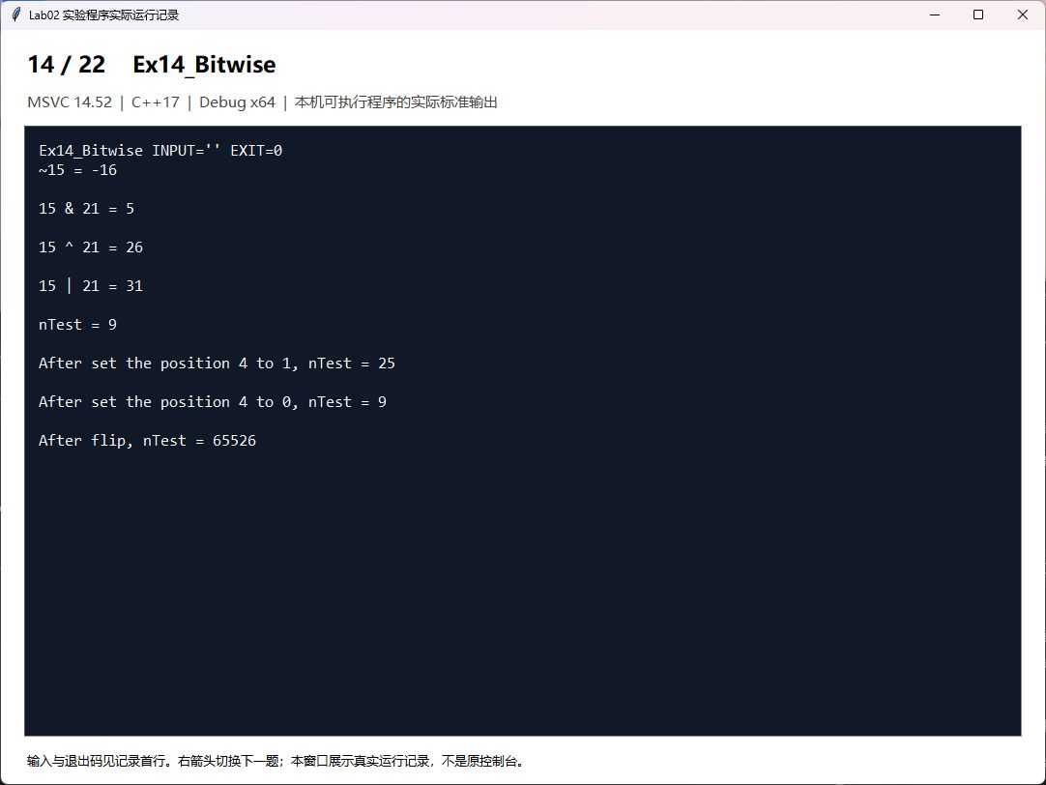
题目15 Task01_Bonus 分段计算奖金
各利润区间分别计提后累加，不能把全部利润按最高适用档计算。金额单位为元。
解答代码
#include <iostream>
#include <iomanip>
using namespace std;
int main() {
double profit;
cout << "Enter monthly profit (yuan): ";
if (!(cin >> profit) || profit < 0) { cout << "Invalid profit\n"; return 1; }
double bonus = 0, remaining = profit;
const double widths[] = {100000,100000,200000,200000,400000};
const double rates[] = {0.10,0.075,0.05,0.03,0.015};
for (int i=0; i<5 && remaining>0; ++i) {
double part = remaining < widths[i] ? remaining : widths[i];
bonus += part * rates[i]; remaining -= part;
}
bonus += remaining * 0.01;
cout << fixed << setprecision(2) << "Bonus: " << bonus << " yuan\n";
}
运行结果记录窗口截图
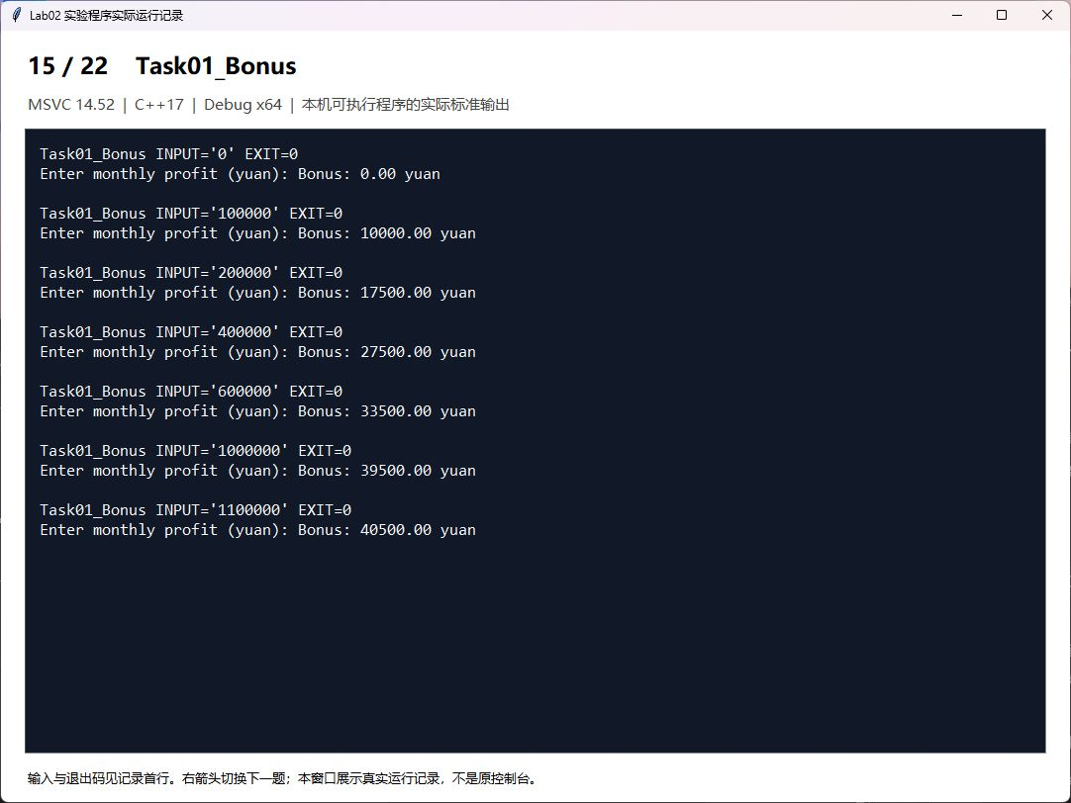
题目16 Task02_Movie 电影评分
按整数评分划分9~10、7~8、5~6及0~4四档；拒绝范围外评分。
解答代码
#include <iostream>
using namespace std;
int main() {
int score; cout << "请输入电影评分（0~10整数）：";
if (!(cin >> score) || score < 0 || score > 10) { cout << "评分无效\n"; return 1; }
cout << "你认为电影";
if (score >= 9) cout << "经典";
else if (score >= 7) cout << "非常好";
else if (score >= 5) cout << "一般";
else cout << "烂片";
cout << '\n';
}
运行结果记录窗口截图
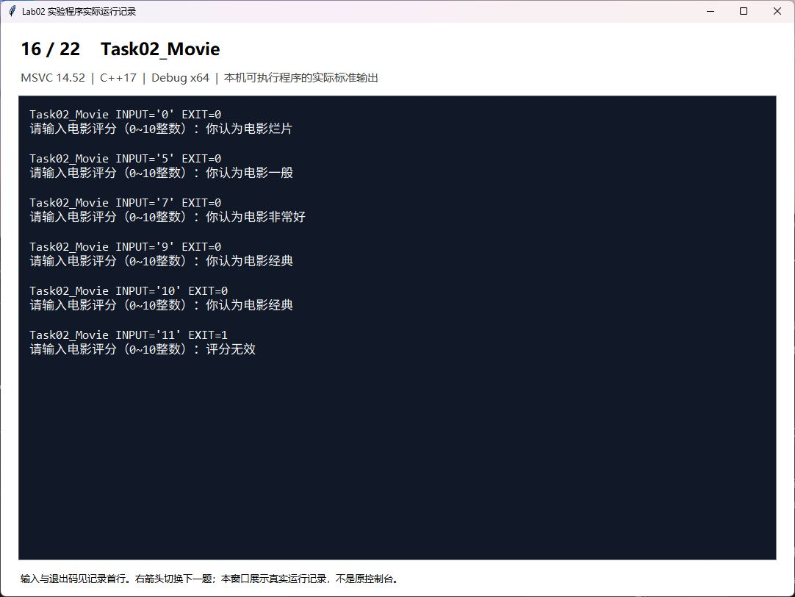
题目17 Task03_Palindrome 判断回文数
比较十进制字符串首尾对应字符，避免倒序计算导致整数溢出。负数不视为回文数。
解答代码
#include <iostream>
#include <string>
using namespace std;
int main() {
long long value; cout << "Enter an integer: ";
if (!(cin >> value)) return 1;
string digits = to_string(value);
bool palindrome = value >= 0;
for (size_t i=0; i<digits.size()/2; ++i)
if (digits[i] != digits[digits.size()-1-i]) palindrome = false;
cout << (palindrome ? "Palindrome" : "Not a palindrome") << '\n';
}
运行结果记录窗口截图
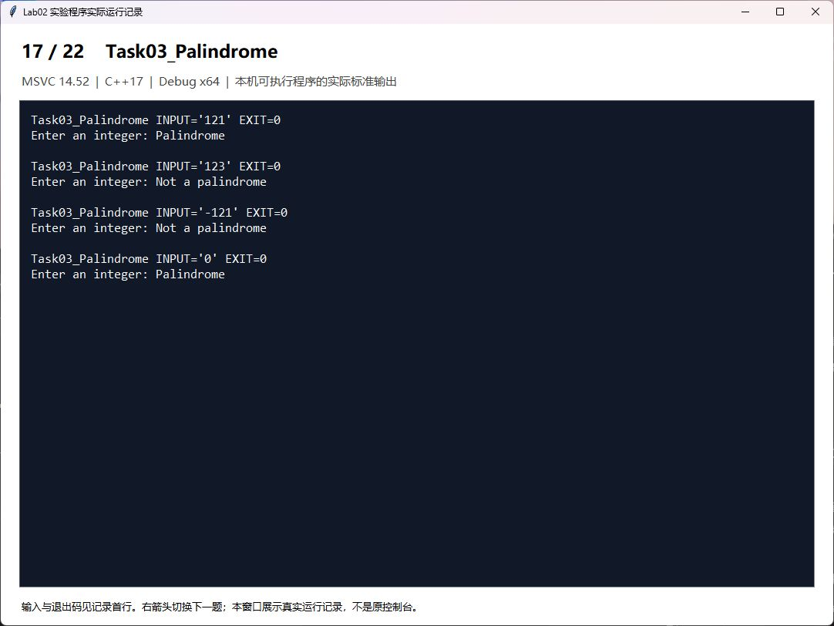
题目18 Task04_Armstrong 水仙花数
分别判断输入值，并枚举100到999，核对结果153、370、371、407。
解答代码
#include <iostream>
using namespace std;
int main() {
int value; cout << "Enter a three-digit integer: ";
if (!(cin >> value) || value < 100 || value > 999) { cout << "Invalid input\n"; return 1; }
int a=value/100, b=value/10%10, c=value%10;
cout << (value == a*a*a+b*b*b+c*c*c ? "Armstrong number\n" : "Not an Armstrong number\n");
cout << "All three-digit Armstrong numbers: ";
for (int n=100; n<=999; ++n) {
a=n/100; b=n/10%10; c=n%10;
if (n==a*a*a+b*b*b+c*c*c) cout << n << ' ';
}
cout << '\n';
}
运行结果记录窗口截图
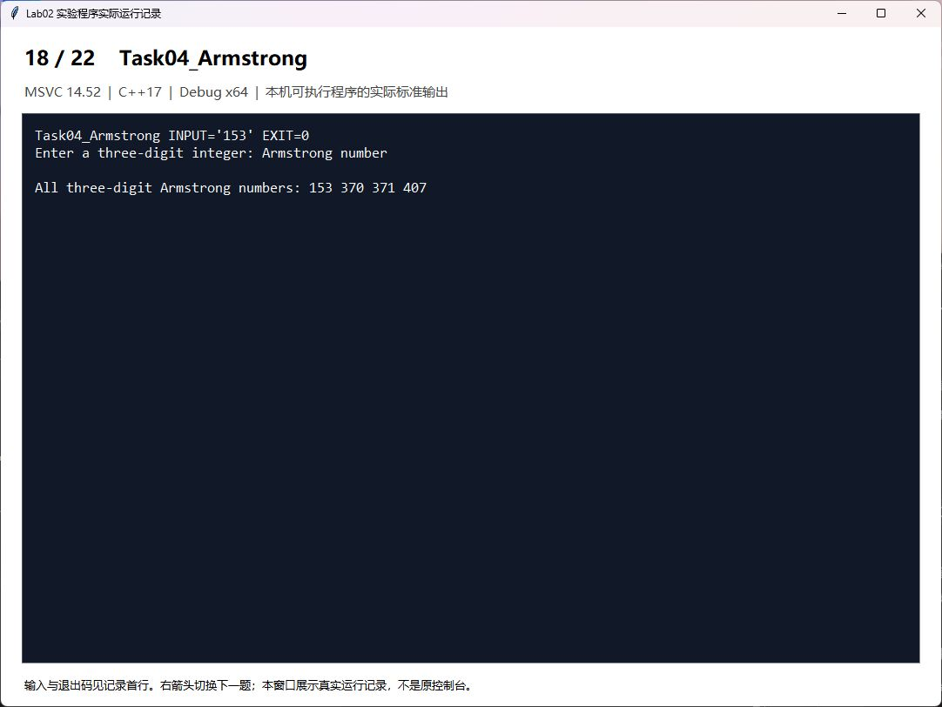
题目19 Task05_Series 重复数字数列求和
逐项构造term=term*10+a，累加sum；在乘10与加法前检测整数范围。
解答代码
#include <iostream>
#include <limits>
using namespace std;
int main() {
int n,a; cout << "Enter n and digit a (1..9): ";
if (!(cin >> n >> a) || n<=0 || a<1 || a>9) { cout << "Invalid input\n"; return 1; }
unsigned long long term=0, sum=0, limit=numeric_limits<unsigned long long>::max();
for (int i=1; i<=n; ++i) {
if (term>(limit-a)/10) { cout << "Result exceeds integer range\n"; return 1; }
term=term*10+a;
if (sum>limit-term) { cout << "Result exceeds integer range\n"; return 1; }
sum+=term;
cout << term << (i==n ? "\n" : " + ");
}
cout << "Sum: " << sum << '\n';
}
运行结果记录窗口截图
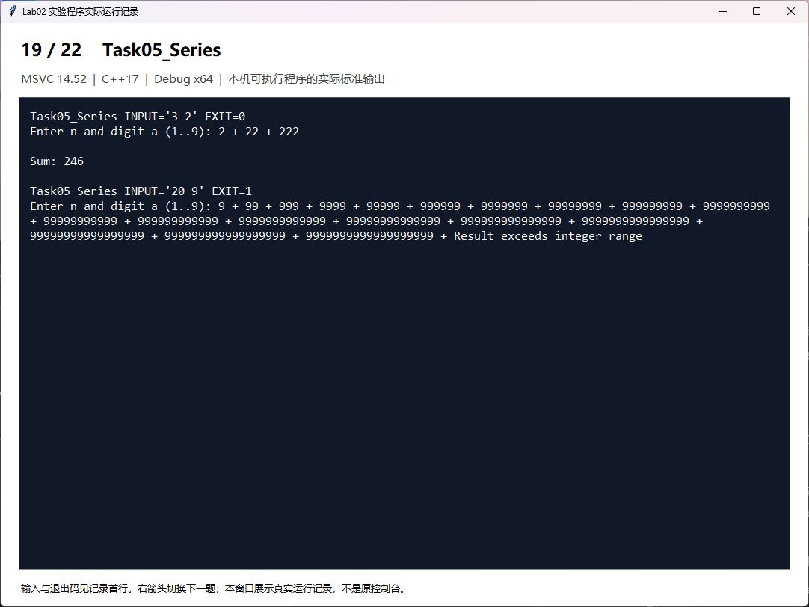
题目20 Task06_Multiplication 九九乘法表
外层控制行，内层输出1到当前行的乘法式。
解答代码
#include <iostream>
#include <iomanip>
using namespace std;
int main() {
for (int row=1; row<=9; ++row) {
for (int col=1; col<=row; ++col)
cout << col << '*' << row << '=' << setw(2) << col*row << " ";
cout << '\n';
}
}
运行结果记录窗口截图
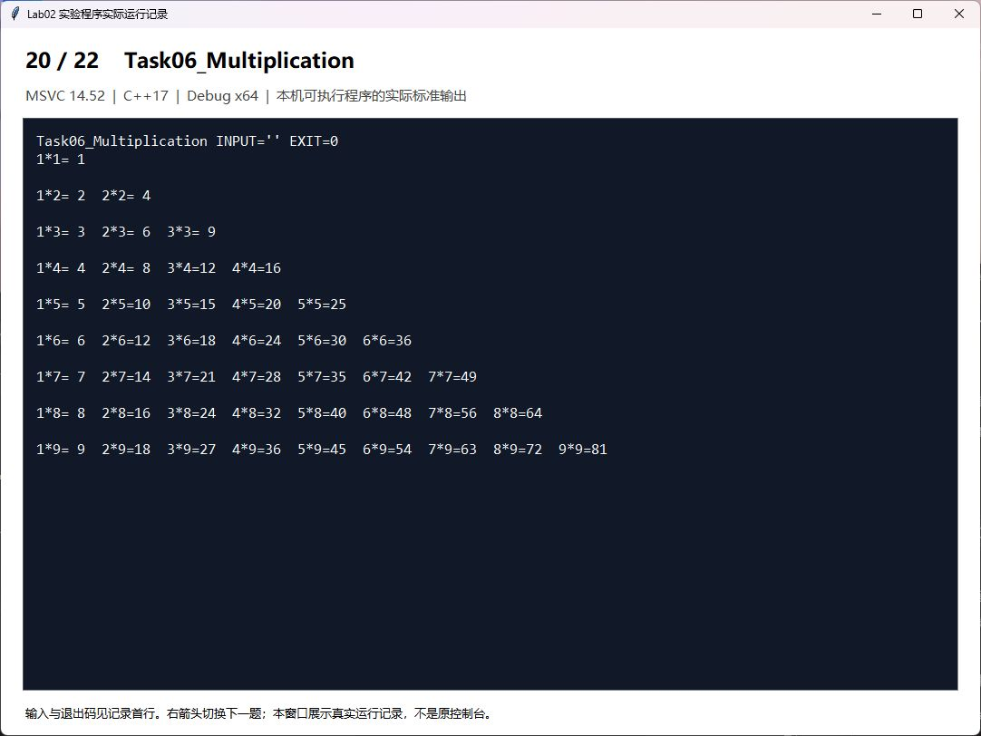
题目21 Task07_Rabbits 兔子繁殖
出生当月计为第1个月，第1、2月各1对；第3月开始繁殖，递推F(n)=F(n-1)+F(n-2)，只数为对数的2倍。
解答代码
#include <iostream>
using namespace std;
// Birth month is month 1. Each pair first reproduces in its third month.
int main() {
int previous=1, current=1;
cout << "Month\tPairs\tRabbits\n";
for (int month=1; month<=20; ++month) {
if (month>=3) { int next=previous+current; previous=current; current=next; }
cout << month << '\t' << current << '\t' << 2*current << '\n';
}
}
运行结果记录窗口截图
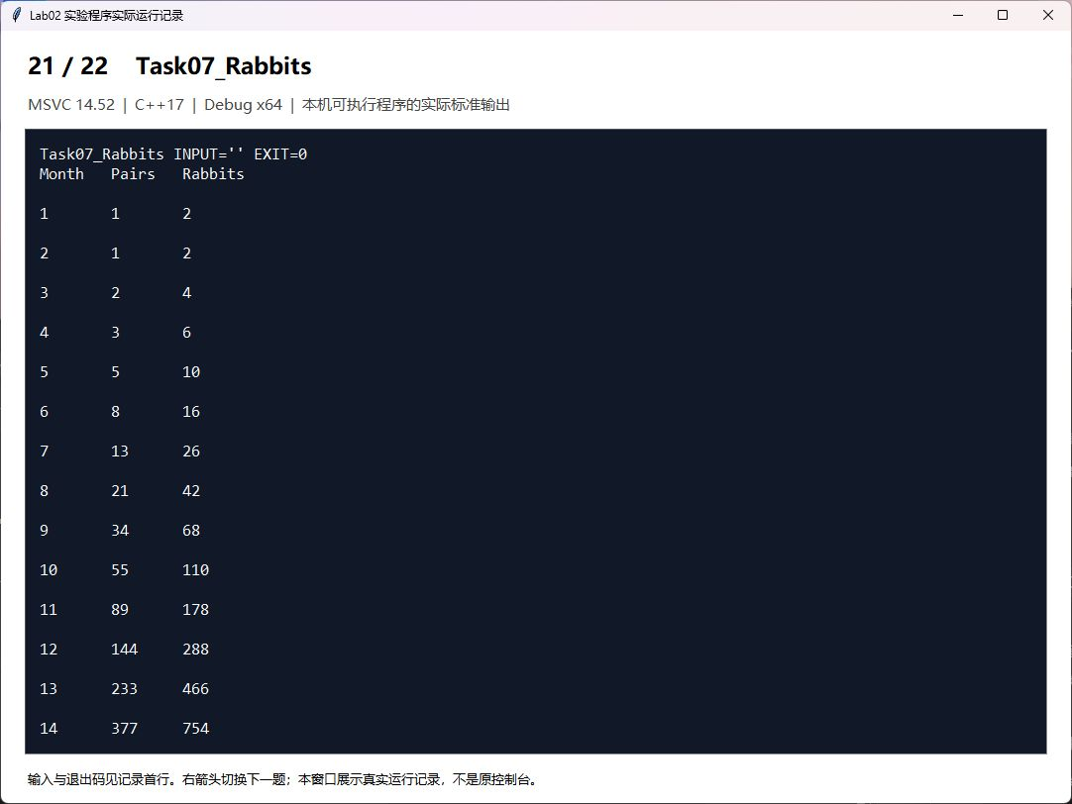
前20个月兔子只数：2，2，4，6，10，16，26，42，68，110，178，288，466，754，1220，1974，3194，5168，8362，13530。第20个月为6765对，即13530只。
题目22 Task08_Peaches 猴子吃桃
从第10天剩1个桃子倒推9次，每次用(剩余+1)*2，得到1534。
解答代码
#include <iostream>
using namespace std;
int main() {
int peaches=1;
for (int day=9; day>=1; --day) peaches=(peaches+1)*2;
cout << "Peaches picked on day 1: " << peaches << '\n';
}
运行结果记录窗口截图
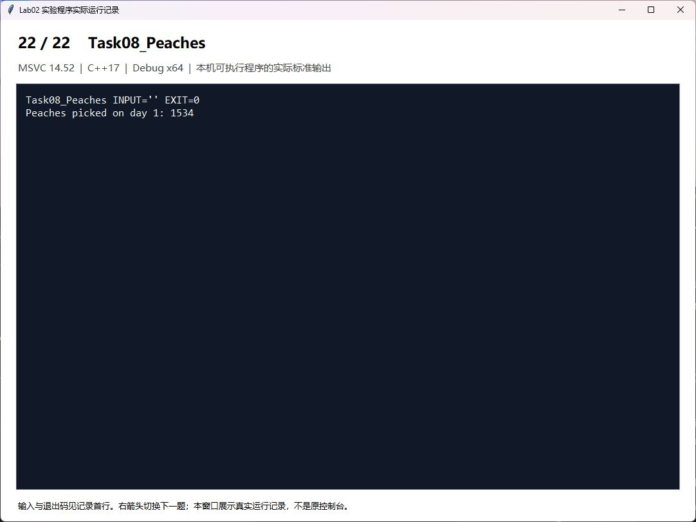
四、实验总结（本次实验的收获、体会、经验和教训）
本次实验完成了类型与运算符的观察，以及分段累计、循环枚举、数列构造和递推计算。整数除法会截去小数部分，double转换为int可能丢失精度；赋值示例的两条C4244警告与该转换有关。奖金题应按区间分别计提，兔子题应区分对数与只数，并统一月份计法。为每题建立独立项目可避免多个main函数同时参与链接。
验证时比较了奖金各档边界、评分分档、回文正反例及数列溢出情况；所有22个项目均已编译并运行。运行记录中的输入、退出码和输出可以用于复核结果。

