编译原理课程实验报告
实验3：语义分析
姓名 |  |  | 院系 |  |  |  |  | 学号
任课教师 |  |  |  |  |  | 指导教师
实验地点 |  |  |  |  |  | 实验时间
实验课表现 |  | 出勤、表现得分 |  |  |  | 实验报告  得分 |  |  |  | 实验总分
 |  | 操作结果得分
一、需求分析 |  |  |  |  |  |  |  |  |  |  | 得分
要求：阐述语义分析系统所要完成的功能。

在语法分析器的基础上设计实现类高级语言的语义分析器，基本功能如下：
- 能分析以下几类语句，并生成三地址码形式的中间代码：
- 声明语句（包括变量声明、数组声明、记录声明和过程声明）
- 表达式及赋值语句（包括自动类型转换，数组元素的引用和赋值）
- 分支语句：if_then_else
- 循环语句：do_while
- 过程调用语句
（2）具备语义错误处理能力，包括变量或函数重复声明、变量或函数引用前未赋值、运算符和运算分量之间的类型不匹配（如整型变量与数组变量相加减）等错误，能准确给出错误所在位置，并采用可行的错误恢复策略。输出的错误提示信息格式如下：
Error at Line [行号]：[说明文字]
（3）系统的输入形式：要求能够通过文件导入测试用例。测试用例要涵盖第（1）条中列出的各种类型的语句，以及第（2）条中列出的各种类型的错误。
（4）系统的输出格式如下图所示（以输入语句“while a<b do if c<d then x=y+z else x=y-z”为例）：

1 : if a < b goto 3
2 : goto 11
3 : if c < d goto 5
4 : goto 8
5 : t₁ = y + z
6 : x = t₁
7 : goto 1
8 : t₂ = y - z
9 : x = t₂
10 : goto 1

二、文法设计 |  |  |  |  |  |  |  |  |  |  | 得分
要求：给出如下语言成分所对应的语义动作
- 声明语句（包括变量声明、数组声明、记录声明和过程声明）
- 表达式及赋值语句（包括数组元素的引用和赋值）
- 分支语句：if_then_else
- 循环语句：do_while
- 过程调用语句

1．声明语句
class STFunctionDef_1 extends STFunctionDef
constructor: (@Type, @ID, @SLP, @ArgList, @SRP, @LLP, @Statements, @LRP) ->
analyze: (scope) ->
argScope = new Scope scope
childScope = new Scope scope
@ArgList.analyze argScope
args = argScope.allSymbols()
childScope.add i.name, i.type, 'arg' for i in args
@Statements.analyze childScope
@Type.analyze scope
scope.typeDef @ID.value,
name: @ID.value
type: 'function'
ret: @Type.value
arg: args
scope: childScope
scope.add @ID.value, @ID.value # 在全局作用域中添加指向这个函数的指针，它的值需要在程序初始化时补上它的值
childScope.fun = @ID.value
codegen: (scope, target) ->
target.gen "function #{@ID.value}:"
funcInfo = scope.getType @ID.value
funcInfo.pos = do target.nextPos
@Statements.codegen funcInfo.scope, target

class STRecordDef_1 extends STRecordDef
constructor: (@ID, @LLP, @Statements, @LRP) ->
analyze: (scope) ->
childScope = new Scope scope
@Statements.analyze childScope
scope.typeDef @ID.value,
name: @ID.value
type: 'record'
length: childScope.getLength()
fields: childScope.allSymbols()
codegen: ->

class STVarDef_1 extends STVarDef
constructor: (@Type, @ID) ->
analyze: (scope) ->
@Type.analyze scope
if scope.has @ID.value, false
errorCollector.add "error at #{@ID.start}: 重复定义变量#{@ID.value}"
else
scope.add @ID.value, @Type.value
codegen: ->

class STType_1 extends STType
constructor: (@INT, @Type_tail) ->
analyze: (scope) ->
@Type_tail.analyze scope
@value = ['INT', @Type_tail.value...].join '*'
codegen: ->

class STType_2 extends STType
constructor: (@FLOAT, @Type_tail) ->
analyze: (scope) ->
@Type_tail.analyze scope
@value = ['FLOAT', @Type_tail.value...].join '*'
codegen: ->

class STType_3 extends STType
constructor: (@BOOL, @Type_tail) ->
analyze: (scope) ->
@Type_tail.analyze scope
@value = ['BOOL', @Type_tail.value...].join '*'
codegen: ->

class STType_4 extends STType
constructor: (@STRING, @Type_tail) ->
analyze: (scope) ->
@Type_tail.analyze scope
@value = ['STRING', @Type_tail.value...].join '*'
codegen: ->

class STType_5 extends STType
constructor: (@CHAR, @Type_tail) ->
analyze: (scope) ->
@Type_tail.analyze scope
@value = ['CHAR', @Type_tail.value...].join '*'
codegen: ->

class STType_6 extends STType
constructor: (@RECORD, @ID, @Type_tail) ->
analyze: (scope) ->
@Type_tail.analyze scope
@value = [@ID.value, @Type_tail.value...].join '*'
codegen: ->

class STType_tail_1 extends STType_tail
constructor: ->
analyze: -> @value = []
codegen: ->

class STType_tail_2 extends STType_tail
constructor: (@MLP, @INTC, @MRP, @Type_tail)->
analyze: (scope) ->
@Type_tail.analyze scope
@value = [@INTC.value, @Type_tail.value...]
codegen: ->

2. 表达式和赋值语句
class STExpression_1 extends STExpression
constructor: (@Expression_atom, @Expression_tail) ->
analyze: (scope) ->
@Expression_atom.analyze scope
@Expression_tail.analyze scope
codegen: (scope, target) ->
@Expression_atom.codegen scope, target
@Expression_tail.codegen scope, target, @Expression_atom
@type = @Expression_tail.type
@value = @Expression_tail.value

class STExpression_tail_1 extends STExpression_tail
constructor: ->
analyze: ->
codegen: (scope, target, left) ->
@type = left.type
@value = left.value

class STExpression_tail_2 extends STExpression_tail
constructor: (@OP, @Expression_atom, @Expression_tail) ->
analyze: (scope) ->
@Expression_atom.analyze scope
@Expression_tail.analyze scope
codegen: (scope, target, left) ->
@Expression_atom.codegen scope, target
target.gen tempVal.curr(), '=', left.value, @OP.value, @Expression_atom.value
@Expression_tail.codegen scope, target, {type:left.type,value:tempVal.next()}
@type = @Expression_tail.type
@value = @Expression_tail.value

class STExpression_atom_1 extends STExpression_atom
constructor: (@SLP, @Expression, @SRP) ->
analyze: (scope) -> @Expression.analyze scope
codegen: (scope, target) ->
@Expression.codegen scope, target
@type = @Expression_tail.type
@value = @Expression.value

class STExpression_atom_2 extends STExpression_atom
constructor: (@Variable, @Expression_atom_call) ->
analyze: (scope) ->
@Variable.analyze scope
@Expression_atom_call.analyze scope
codegen: (scope, target) ->
@Variable.codegen scope, target
@Expression_atom_call.codegen scope, target, @Variable
@type = @Expression_atom_call.type
@value = @Expression_atom_call.value

class STExpression_atom_3 extends STExpression_atom
constructor: (@Const) ->
analyze: (scope) -> @Const.analyze scope
codegen: (scope, target) ->
@Const.codegen scope, target
@type = @Const.type
@value = @Const.value

class STExpression_atom_call_1 extends STExpression_atom_call
constructor: ->
analyze: ->
codegen: (scope, target, left) ->
@type = left.type
@value = left.value

class STExpression_atom_call_2 extends STExpression_atom_call
constructor: (@SLP, @VarList, @SRP) ->
analyze: (scope) -> @VarList.analyze scope
codegen: (scope, target, left) ->
@VarList.codegen scope, target
lambda = scope.getType left.type
if @VarList.value
target.gen 'goto', "pc+#{@VarList.value.length+1}"
target.gen 'param', param for param in @VarList.value
target.gen tempVal.curr(), '=', 'call', lambda.name, @VarList.value.length ? 0
@type = lambda.ret
@value = tempVal.next()

class STStatement_assignorcall_1 extends STStatement_assignorcall
constructor: (@EQ, @Expression, @LF) ->
analyze: (scope) -> @Expression.analyze scope
codegen: (scope, target, left) ->
@Expression.codegen scope, target
target.gen "error: 赋值类型不匹配" if left.type isnt @Expression.type
target.gen left.value, '=', @Expression.value

3. 分支
class STStatement_5 extends STStatement
constructor: (@IF, @SLP, @Expression, @SRP, @Statement, @Statement_else) ->
analyze: (scope) ->
@Expression.analyze scope
@Statement.analyze scope
@Statement_else.analyze scope
codegen: (scope, target) ->
@Expression.codegen scope, target
target.gen 'error: 条件不是INT' if @Expression.type isnt 'INT'
pos1 = target.nextPos()
target.gen 'if', @Expression.value, 'goto', null
@Statement_else.codegen scope, target
pos2 = target.nextPos()
target.gen 'goto', null
@Statement.codegen scope, target
pos3 = target.nextPos()
target.get(pos1)[3] = pos2 + 1
target.get(pos2)[1] = pos3

4. 循环
class STStatement_4 extends STStatement
constructor: (@WHILE, @SLP, @Expression, @SRP, @Statement) ->
analyze: (scope) ->
@Expression.analyze scope
@Statement.analyze scope
codegen: (scope, target) ->
pos1 = target.nextPos()
@Expression.codegen scope, target
pos2 = target.nextPos()
target.gen 'error: 条件不是INT' if @Expression.type isnt 'INT'
target.gen 'if', @Expression.value, 'goto', null
@Statement.codegen scope, target
target.gen 'goto', pos1
pos3 = target.nextPos()
target.get(pos2)[3] = pos3

5. 调用
class STStatement_assignorcall_2 extends STStatement_assignorcall
constructor: (@SLP, @VarList, @SRP, @LF) ->
analyze: (scope) -> @VarList.analyze scope
codegen: (scope, target, left) ->
@VarList.codegen scope, target
lambda = scope.getType left.type
if not lambda
return target.gen "error: #{left.value}不是函数"
if @VarList.value
target.gen 'goto', "pc+#{@VarList.value.length+1}"
target.gen 'param', param for param in @VarList.value
target.gen 'call', lambda.name, @VarList.value.length ? 0

class STExpression_atom_call_2 extends STExpression_atom_call
constructor: (@SLP, @VarList, @SRP) ->
analyze: (scope) -> @VarList.analyze scope
codegen: (scope, target, left) ->
@VarList.codegen scope, target
lambda = scope.getType left.type
if @VarList.value
target.gen 'goto', "pc+#{@VarList.value.length+1}"
target.gen 'param', param for param in @VarList.value
target.gen tempVal.curr(), '=', 'call', lambda.name, @VarList.value.length ? 0
@type = lambda.ret
@value = tempVal.next()

三、系统设计 |  |  |  |  |  |  |  |  |  |  | 得分
要求：分为系统概要设计和系统详细设计。
（1）系统概要设计：给出必要的系统宏观层面设计图，如系统框架图、数据流图、功能模块结构图等以及相应的文字说明。
（2）系统详细设计：对如下工作进行展开描述
- 核心数据结构的设计
- 主要功能函数说明
- 程序核心部分的程序流程图

1. 系统概要设计
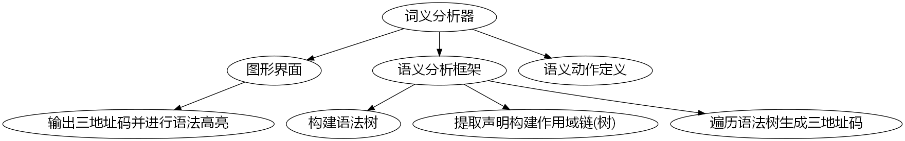
图一、系统框架图

2. 核心数据结构
class Scope
constructor: (@father) ->
@symbolTable = new Map
@typeDefs = @father?.typeDefs ? new Map # always use global's typeDefs
@pos = 0
find: (symbol) -> @symbolTable.get(symbol) ? @father?.find(symbol)
has: (symbol, rec=true) ->
if rec
@find(symbol)?
else
@symbolTable.has(symbol)
add: (symbol, type, pos) ->
@symbolTable.set symbol,
pos: pos ? @pos
name: symbol
type: type
@pos += getTypeLength type, @ if not pos?
allSymbols: -> Array.from @symbolTable.values()
getLength: -> @allSymbols()
.map extract('type')
.map (x) => getTypeLength x,@
.reduce (x, y) -> x + y
forEach: -> @symbolTable.forEach.apply @symbolTable, arguments
typeDef: -> @typeDefs.set.apply @typeDefs, arguments
getType: -> @typeDefs.get.apply @typeDefs, arguments

class Target
constructor: -> @code = []
get: (i) -> @code[i-1]
gen: (a,b,c,d,e) -> @code.push [a,b,c,d,e]
nextPos: -> @code.length+1
format: (formatter) -> formatter line,a,b,c,d,e for [a,b,c,d,e], line in @code

tempVal = do ->
n = 0
curr: -> "t#{n}"
next: -> "t#{n++}"

errorCollector = do ->
errors = []
add: (err) -> errors.push err
gen: (target) -> target.gen i for i in errors

class STNode // virtual class
constructor: ->
analyze: ->
codegen: ->

3. 主要功能函数
buildTree = (nodes) -> // 用语法分析得到的节点构建语法树
nodes = nodes[...]
buildOne = ->
node = do nodes.shift
return console.log 'an error occur' if not node
switch node.type
when 'terminal'
node.token
when 'nonterminal'
nodeType = classMap[node.rule.id]
new nodeType node.rule.right.filter(isNotIpsilon).map(buildOne)...
when 'error'
throw new SyntaxError 'abort compilng due to syntax errors'
do buildOne

analyze = (root) -> // 递归调用整棵树的analyze方法以获得作用域链(树)
global = new Scope
root.analyze global
global

loadBuiltIn = (scope) -> // 往全局作用域中添加特殊函数入口
scope.typeDef 'print(built-in)',
name: 'print(built-in)'
type: 'function'
ret: 'INT'
arg: [{pos:'#', name:'#', type:'#'}]
scope: new Scope
scope.add 'print', 'print(built-in)'

codegen = (STNode, scope) -> // 递归调用codegen方法生成Target对象(其中包含三地址码)
target = new Target
STNode.codegen scope, target
Target

getTypeLength = (type, scope) -> // 计算某个类型的长度
switch type
when 'INT'
4
when 'FLOAT'
4
when 'BOOL'
1
when 'STRING'
4
when 'CHAR'
1
else
if '*' in type # Array
[f,t...] = type.split '*'
length = t.reduce (x, y) -> x * y
length * getTypeLength f, scope
else # Record or Function
scope.getType(type).length ? 4

window.Semantic = (nodes) -> // 语义分析主入口函数
root = buildTree nodes
global = analyze root
loadBuiltIn global
target = codegen root, global
errorCollector.gen target
target

四、系统实现及结果分析 |  |  |  |  |  |  |  |  | 得分
要求：对如下内容展开描述。
- 系统实现过程中遇到的问题；
- 针对一测试程序输出其语义分析结果；
- 输出针对此测试程序经过语义分析后的符号表；
- 输出针对此测试程序对应的语义错误报告；
- 对实验结果进行分析。
注：其中的测试样例需先用已编写的词法分析程序进行处理。

测试用例:
point {
int x
int y
}

int main() {
int[2] x
int y
int i
i = 0
while(i < 2){
x[i] = 1
x = x + 1
}
int y //此处重复定义变量
y() //此处调用非函数的变量
y = add(x[0], x[1])
if(y != 0){
print(y)
}else{
}
return 0
}

int add(int a, int b) {
return a + b
}

输出结果
- function main:
- i:12 = 0
- t0 = i:12 < 2
- if t0 goto 10
- t1 = i:12 * 4
- x[t1]:0+t1 = 1
- t2 = x:0 + 1
- x:0 = t2
- goto 3
- error: y:8不是函数
- t3 = 0 * 4
- t4 = 1 * 4
- goto pc+3
- param x[t3]:0+t3
- param x[t4]:0+t4
- t5 = call add 2
- y:8 = t5
- t6 = y:8 != 0
- if t6 goto 21
- goto 24
- goto pc+2
- param y:8
- call print(built-in) 1
- return 0
- function add:
- t7 = a:arg + b:arg
- return t7
- error at 15:8: 重复定义变量y

运行截图
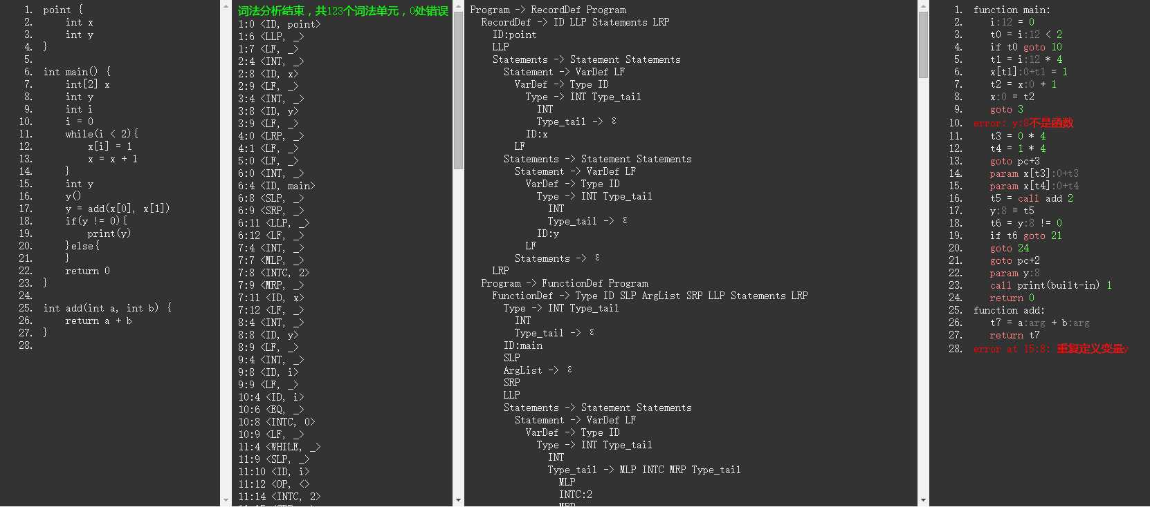
图二、运行截图
指导教师评语：

日期：

