Metabolomics of choice diet and serotonin signaling involvement

Section I: Background & Question

When flies are presented with a diet in which macronutrients (sugar and yeast) are separate (i.e., a choice diet) mortality rate and physiology are significantly impacted within 12 hours compared to siblings housed in on a fixed diet of equivalent caloric and nutrient composition (Fig. 1). These changes manifest despite no differences in feeding behavior (Fig. 2). Interestingly, serotonin signaling mutants (JhI-21/Trh/5HT2a) are immune to the mortality effects of a choice diet (Fig. 3). Therefore, we hypothesize that choice diet regulates lifespan by impacting a neuronal state reflective of perceived nutrient availability and that this state requires serotonin signaling as well as other neuronal substrates. In this proposal, we aim to explore the neuronal regulation of lifespan by a choice diet environment. Specific questions we hope to answer through the metabolomics experiment are listed below.

- Which metabolites are significantly different between flies on the choice diet and those on the fixed diet? Are any of these metabolites causal to the differences in lifespan between the diets?
- Which metabolites are responsive to dietary shift (i.e. from choice to fixed diet or the opposite) on a timescale reflective of changes in mortality? Do any of these metabolites overlap with those that are constitutively different on two different diets? Are they causal to the differences in lifespan between the diets?
- How does serotonin signaling impact the dynamics of metabolic changes in response to dietary shift? Metabolites that are significantly different between wide-type flies following dietary treatment but not different in 5HT-2a flies are strong candidates for causal molecules or molecules indicative of causal pathways.

 | 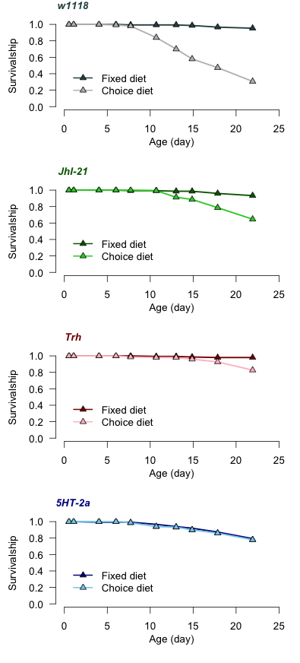
Figure 1. Mortality rate is rapidly changed after dietary shift.

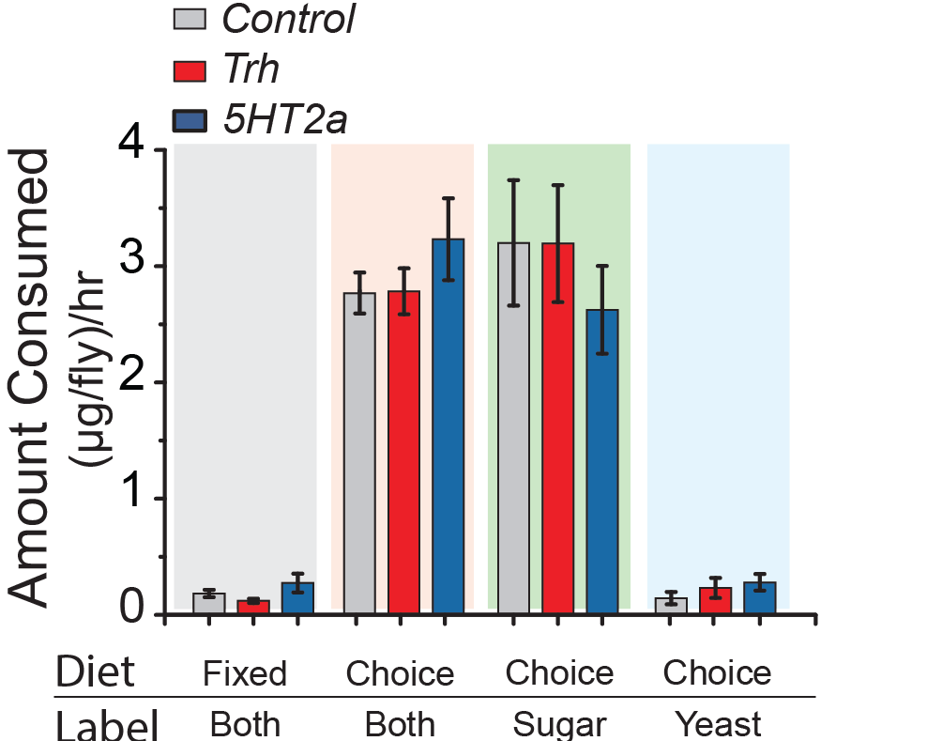

Figure 2. Loss of serotonin signaling does not change feeding on the choice diet. | Figure 3. Serotonin deficient mutants are immune to the mortality rate effect by choice diet.

Section II: Methods

2.1. Strains

We will use males because they have shorter lifespan. Canton-S, w1118 and 5HT-2a mutant that has been backcrossed to CS and w1118 backgrounds will be used.

2.2. Experimental design

We propose two experiments here:

Experiment #1 is a small scale experiment to quickly understand how 5HT-2a mutant flies respond to dietary shift, in the direction from CD* to FD* in particular. W1118 and 5HT-2a (in w1118 backgrounds) flies are ready and will be used.

Experiment #2 is a comprehensive setting to answer the questions in Section I. CS and cantonized 5HT-2a flies will be used. 5HT-2a is being backcrossed to CS and will be ready in two months. The reason for using CS flies is because white-eyed flies (such as w1118) may have abnormal dopamine and serotonin levels, which may affect longevity on choice diet.

*CD – choice diet, FD – Fixed diet

2.2.1 Experiment #1

Group | Treatment | Procedure
Group 1 (n=5) | W1118, CD to FD, before switching | Collect newly emerged flies using SY10 bottles. After 2 days, sort males into 12-well chamber, 30 flies per vial, preconditioned use SY10 plates. Transfer flies to choice diet after 24hrs. After 2 weeks (right before dietary switching), collect heads (n=50 for each replicate).
Group 2 (n=5) | W1118, CD to FD, after switching | Collect newly emerged flies using SY10 bottles. After 2 days, sort males into 12-well chamber, 30 flies per vial, preconditioned use SY10 plates. Transfer flies to choice diet after 24hrs. After 2 weeks, switch flies to fixed diet. Collect heads (n=50 for each replicate) after 12hrs (or 24hrs?).
Group 3 (n=5) | 5HT-2a, CD to FD, before switching | Collect newly emerged flies using SY10 bottles. After 2 days, sort males into 12-well chamber, 30 flies per vial, preconditioned use SY10 plates. Transfer flies to choice diet after 24hrs. After 2 weeks (right before dietary switching), collect heads (n=50 for each replicate).
Group 4 (n=5) | 5HT-2a, CD to FD, after switching | Collect newly emerged flies using SY10 bottles. After 2 days, sort males into 12-well chamber, 30 flies per vial, preconditioned use SY10 plates. Transfer flies to choice diet after 24hrs. After 2 weeks, switch flies to fixed diet. Collect heads (n=50 for each replicate) after 12hrs (or 24hrs?).

2.2.2 Experiment #2

Group | Treatment | Procedure
Group 1 (n=10) | CS, CD | Collect newly emerged flies using SY10 bottles. After 2 days, sort males into 12-well chamber, 30 flies per vial, preconditioned use SY10 plates. Transfer flies to choice diet after 24hrs. Collect heads (n=50 for each replicate) after 2 weeks.
Group 2 (n=10) | CS, FD | Collect newly emerged flies using SY10 bottles. After 2 days, sort males into 12-well chamber, 30 flies per vial, preconditioned use SY10 plates. Transfer flies to fixed diet after 24hrs. Collect heads (n=50 for each replicate) after 2 weeks.
Group 3 (n=10) | CS, CD to FD | Collect newly emerged flies using SY10 bottles. After 2 days, sort males into 12-well chamber, 30 flies per vial, preconditioned use SY10 plates. Transfer flies to choice diet after 24hrs. Switch flies to fixed diet after 2 weeks. Collect heads (n=50 for each replicate) 12hrs (or 24hrs?).
Group 4 (n=10) | CS, FD to CD | Collect newly emerged flies using SY10 bottles. After 2 days, sort males into 12-well chamber, 30 flies per vial, preconditioned use SY10 plates. Transfer flies to fixed diet after 24hrs. Switch flies to choice diet after 2 weeks. Collect heads (n=50 for each replicate) 12hrs (or 24hrs?).
Group 5 (n=10) | 5HT-2a, CD | Collect newly emerged flies using SY10 bottles. After 2 days, sort females into 12-well chamber, 30 flies per vial, preconditioned use SY10 plates. Transfer flies to choice diet after 24hrs. Collect heads (n=50 for each replicate) after 4 weeks.
Group 6 (n=10) | 5HT-2a, FD | Collect newly emerged flies using SY10 bottles. After 2 days, sort females into 12-well chamber, 30 flies per vial, preconditioned use SY10 plates. Transfer flies to fixed diet after 24hrs. Collect heads (n=50 for each replicate) after 4 weeks.
Group 7 (n=10) | 5HT-2a, CD to FD | Collect newly emerged flies using SY10 bottles. After 2 days, sort males into 12-well chamber, 30 flies per vial, preconditioned use SY10 plates. Transfer flies to choice diet after 24hrs. Switch flies to fixed diet after 2 weeks. Collect heads (n=50 for each replicate) 12hrs (or 24hrs?).
Group 8 (n=10) | 5HT-2a, FD to CD | Collect newly emerged flies using SY10 bottles. After 2 days, sort males into 12-well chamber, 30 flies per vial, preconditioned use SY10 plates. Transfer flies to fixed diet after 24hrs. Switch flies to choice diet after 2 weeks. Collect heads (n=50 for each replicate) 12hrs (or 24hrs?).

