**Analysis of dataset 4**

**Female vs male**

1. Descriptive Statistics

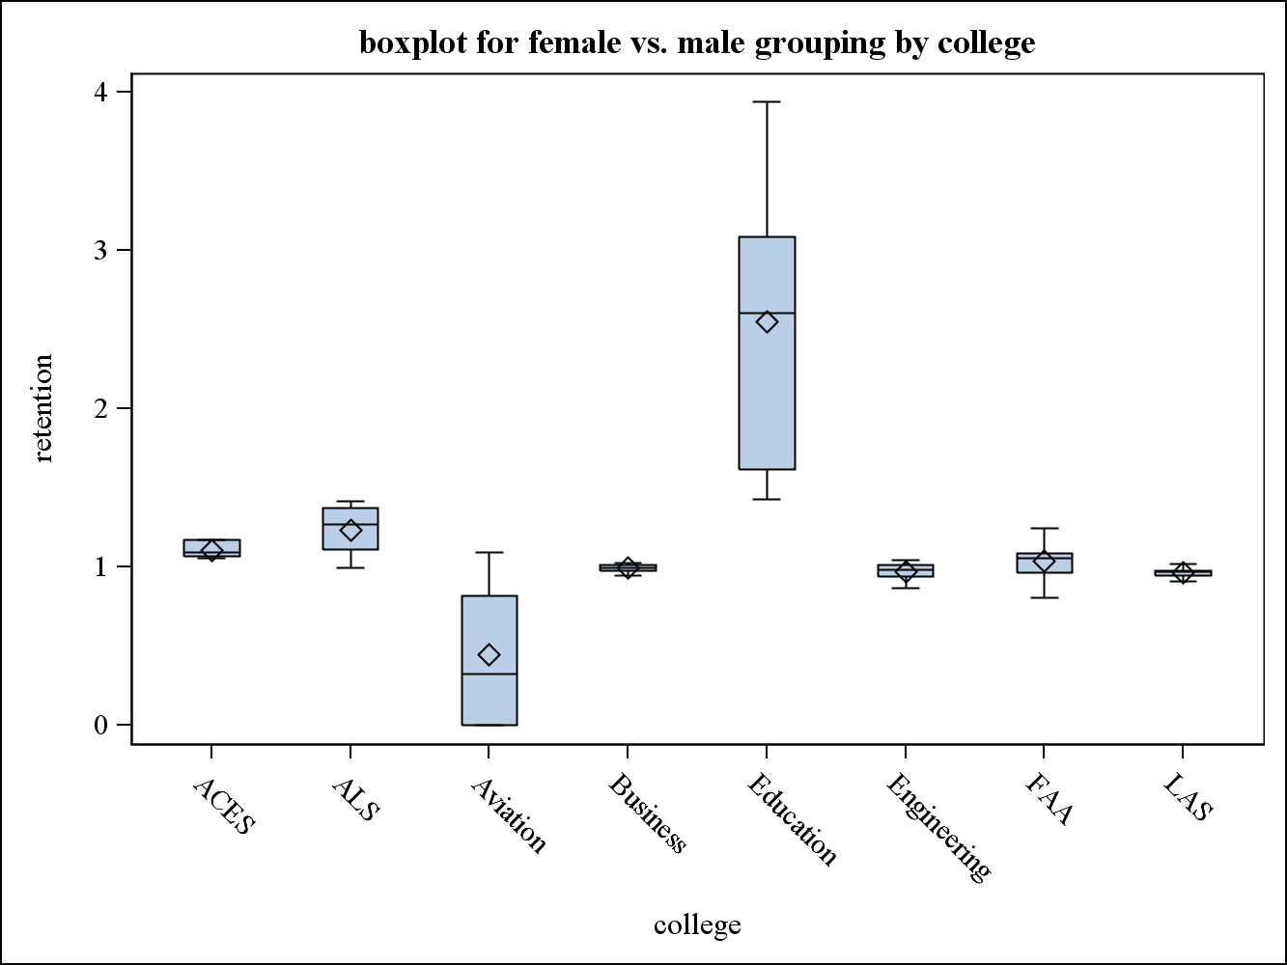

female retention rate vs. male retention rate(**c**)=

female retention rate/male retention rate

c>1: female retention rate>male retention rate

c<1: female retention rate<male retention rate

1. ANOVA

There are significant differences in female vs. male retention rate between different colleges.

| **Source** | **DF** | **Sum of Squares** | **Mean Square** | **F Value** | **Pr > F** |
| --- | --- | --- | --- | --- | --- |
| **Model** | 7 | 17.93855873 | 2.56265125 | 20.48 | <.0001 |
| **Error** | 48 | 6.00666545 | 0.12513886 |  |  |
| **Corrected Total** | 55 | 23.94522418 |  |  |  |

Engineering vs. Business:

No significant difference

| **Source** | **DF** | **Sum of Squares** | **Mean Square** | **F Value** | **Pr > F** |
| --- | --- | --- | --- | --- | --- |
| **Model** | 1 | 0.00177248 | 0.00177248 | 0.88 | 0.3655 |
| **Error** | 12 | 0.02404765 | 0.00200397 |  |  |
| **Corrected Total** | 13 | 0.02582013 |  |  |  |

Engineering vs. ACES:

Significant difference

| **Source** | **DF** | **Sum of Squares** | **Mean Square** | **F Value** | **Pr > F** |
| --- | --- | --- | --- | --- | --- |
| **Model** | 1 | 0.06350412 | 0.06350412 | 22.05 | 0.0005 |
| **Error** | 12 | 0.03456667 | 0.00288056 |  |  |
| **Corrected Total** | 13 | 0.09807079 |  |  |  |

Engineering vs. ALS:

Significant difference

| **Source** | **DF** | **Sum of Squares** | **Mean Square** | **F Value** | **Pr > F** |
| --- | --- | --- | --- | --- | --- |
| **Model** | 1 | 0.24259421 | 0.24259421 | 19.29 | 0.0009 |
| **Error** | 12 | 0.15093005 | 0.01257750 |  |  |
| **Corrected Total** | 13 | 0.39352426 |  |  |  |

Engineering vs. FAA:

No significant difference

| **Source** | **DF** | **Sum of Squares** | **Mean Square** | **F Value** | **Pr > F** |
| --- | --- | --- | --- | --- | --- |
| **Model** | 1 | 0.01553593 | 0.01553593 | 1.47 | 0.2480 |
| **Error** | 12 | 0.12643277 | 0.01053606 |  |  |
| **Corrected Total** | 13 | 0.14196870 |  |  |  |

Engineering vs. LAS:

No significant difference

| **Source** | **DF** | **Sum of Squares** | **Mean Square** | **F Value** | **Pr > F** |
| --- | --- | --- | --- | --- | --- |
| **Model** | 1 | 0.00010484 | 0.00010484 | 0.05 | 0.8308 |
| **Error** | 12 | 0.02637589 | 0.00219799 |  |  |
| **Corrected Total** | 13 | 0.02648072 |  |  |  |

Engineering vs. Education:

Significant difference

| **Source** | **DF** | **Sum of Squares** | **Mean Square** | **F Value** | **Pr > F** |
| --- | --- | --- | --- | --- | --- |
| **Model** | 1 | 8.72152178 | 8.72152178 | 22.10 | 0.0005 |
| **Error** | 12 | 4.73492997 | 0.39457750 |  |  |
| **Corrected Total** | 13 | 13.45645175 |  |  |  |

There are significant differences between Engineering College and ACES, ALS, Education. There are not significant differences between Engineering College and Business, FAA, LAS.

**URM vs. nonURM**

1. Descriptive statistics

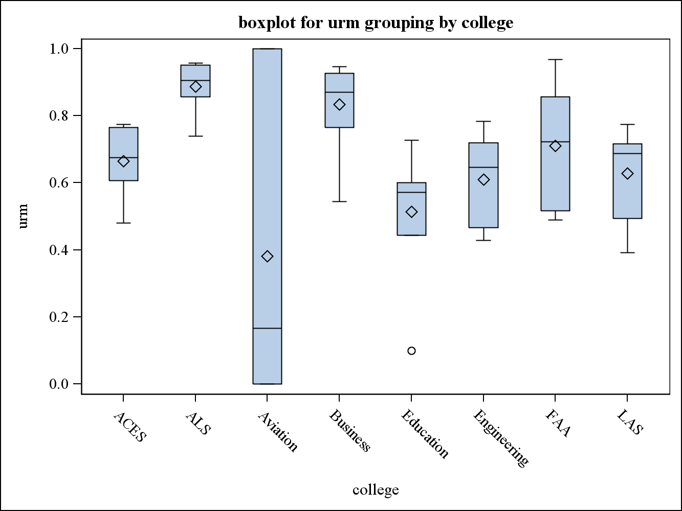

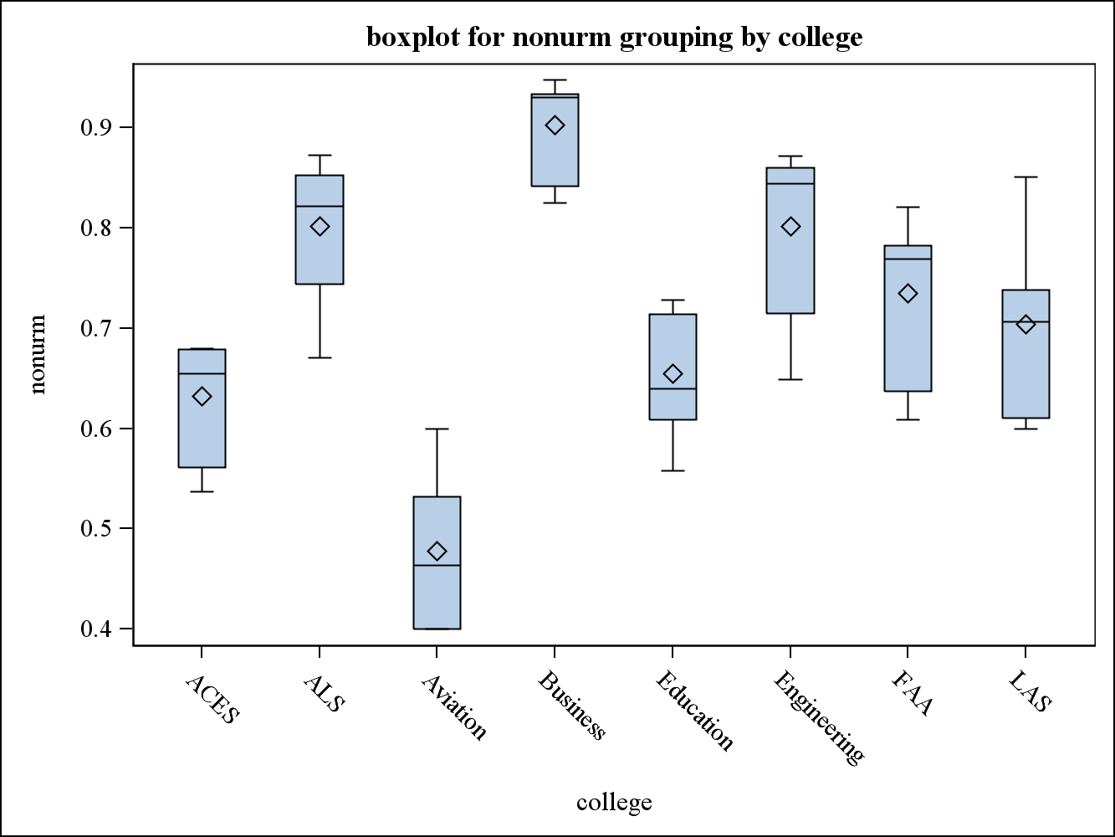

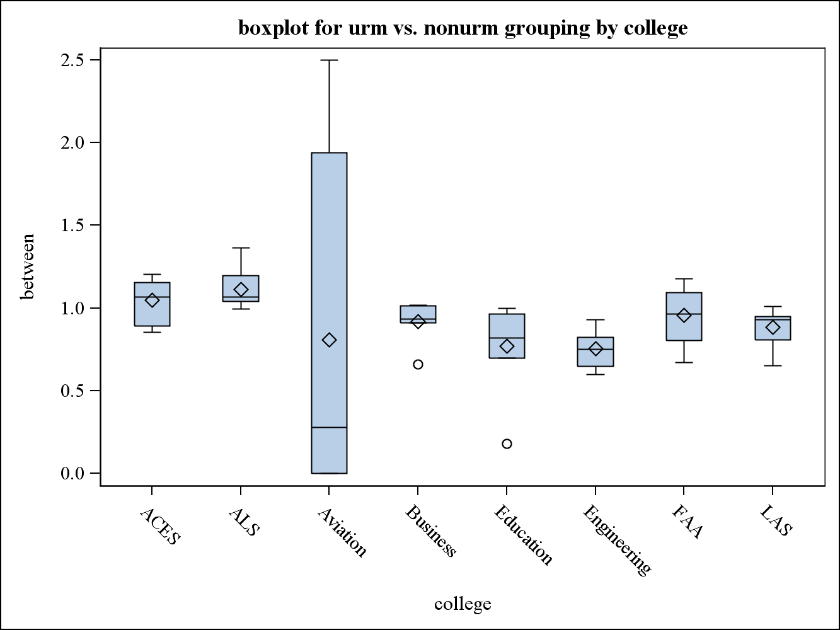

URM retention rate vs. nonURM retention rate (**m**)=

URM retention rate/nonURM retention rate

m>1:URM retention rate>nonURM retention rate

m<1:URM retention rate<nonURM retention rate

1. ANOVA

Both URM retention rate and nonURM retention rate have significant differences among colleges.

| **Source** | **DF** | **Sum of Squares** | **Mean Square** | **F Value** | **Pr > F** |
| --- | --- | --- | --- | --- | --- |
| **Model** | 7 | 1.30860428 | 0.18694347 | 4.21 | 0.0011 |
| **Error** | 48 | 2.13014371 | 0.04437799 |  |  |
| **Corrected Total** | 55 | 3.43874799 |  |  |  |

| **Source** | **DF** | **Sum of Squares** | **Mean Square** | **F Value** | **Pr > F** |
| --- | --- | --- | --- | --- | --- |
| **Model** | 7 | 0.82144969 | 0.11734996 | 22.83 | <.0001 |
| **Error** | 48 | 0.24674914 | 0.00514061 |  |  |
| **Corrected Total** | 55 | 1.06819884 |  |  |  |

For URM vs. nonURM retention rate, there are no significant differences among colleges.

| **Source** | **DF** | **Sum of Squares** | **Mean Square** | **F Value** | **Pr > F** |
| --- | --- | --- | --- | --- | --- |
| **Model** | 7 | 0.82775198 | 0.11825028 | 0.76 | 0.6261 |
| **Error** | 48 | 7.50487285 | 0.15635152 |  |  |
| **Corrected Total** | 55 | 8.33262483 |  |  |  |

Engineering vs. ACES:

Significant difference

| **Source** | **DF** | **Sum of Squares** | **Mean Square** | **F Value** | **Pr > F** |
| --- | --- | --- | --- | --- | --- |
| **Model** | 1 | 0.30311429 | 0.30311429 | 20.23 | 0.0007 |
| **Error** | 12 | 0.17982057 | 0.01498505 |  |  |
| **Corrected Total** | 13 | 0.48293486 |  |  |  |

Engineering vs. ALS:

Significant difference

| **Source** | **DF** | **Sum of Squares** | **Mean Square** | **F Value** | **Pr > F** |
| --- | --- | --- | --- | --- | --- |
| **Model** | 1 | 0.45108350 | 0.45108350 | 31.30 | 0.0001 |
| **Error** | 12 | 0.17294571 | 0.01441214 |  |  |
| **Corrected Total** | 13 | 0.62402921 |  |  |  |

Engineering vs. Business:

Significant difference

| **Source** | **DF** | **Sum of Squares** | **Mean Square** | **F Value** | **Pr > F** |
| --- | --- | --- | --- | --- | --- |
| **Model** | 1 | 0.09364464 | 0.09364464 | 6.91 | 0.0220 |
| **Error** | 12 | 0.16253629 | 0.01354469 |  |  |
| **Corrected Total** | 13 | 0.25618093 |  |  |  |

Engineering vs. Education:

No significant difference

| **Source** | **DF** | **Sum of Squares** | **Mean Square** | **F Value** | **Pr > F** |
| --- | --- | --- | --- | --- | --- |
| **Model** | 1 | 0.00070007 | 0.00070007 | 0.02 | 0.9038 |
| **Error** | 12 | 0.55100429 | 0.04591702 |  |  |
| **Corrected Total** | 13 | 0.55170436 |  |  |  |

Engineering vs. FAA:

Significant difference

| **Source** | **DF** | **Sum of Squares** | **Mean Square** | **F Value** | **Pr > F** |
| --- | --- | --- | --- | --- | --- |
| **Model** | 1 | 0.14382579 | 0.14382579 | 6.71 | 0.0236 |
| **Error** | 12 | 0.25711371 | 0.02142614 |  |  |
| **Corrected Total** | 13 | 0.40093950 |  |  |  |

Engineering vs. LAS:

No significant difference

| **Source** | **DF** | **Sum of Squares** | **Mean Square** | **F Value** | **Pr > F** |
| --- | --- | --- | --- | --- | --- |
| **Model** | 1 | 0.05915000 | 0.05915000 | 4.45 | 0.0567 |
| **Error** | 12 | 0.15966971 | 0.01330581 |  |  |
| **Corrected Total** | 13 | 0.21881971 |  |  |  |

There are significant differences between Engineering College and ACES, ALS, Business, FAA. There are not significant differences between Engineering College and Education, LAS.