**Lab Session 9**

**实验名：9. Mesh:**

Case Study 6.1 Meshes Stored in Files

Polygonalize a sphere with some control arguments to specify the resolution. The result should be written to a file which can also be read for mesh display.

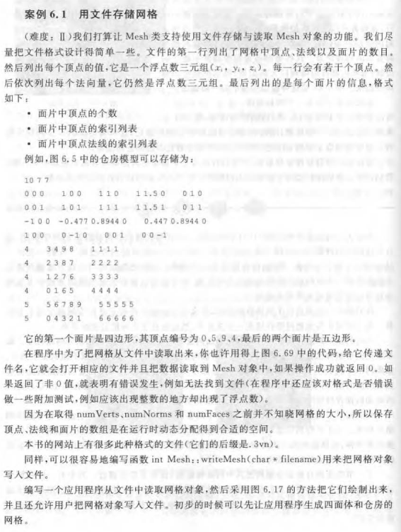

这里只要大家设置合适的camera模型，如使用下面的代码：

glMatrixMode(GL_PROJECTION)

glLoadIdenity();

glOrtho(left,right,botom,top,near,far)

然后对每个多边形使用glBegin(GL_LINE_LOOP)画出其线框即可。