Lab Session 1
实验名：1. Draw the function：
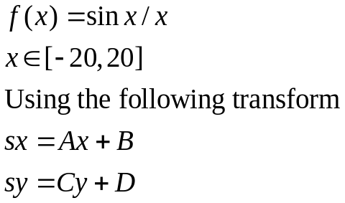

实验名：2.Polyline Editor:
Using a mouse and keyboard to do polyline editing.

(a)一个正在绘制的房子。用户刚刚点击了所画的位置，一条线已经从之前的点画到了鼠标所指定的位置。
(b)移动一个点。用户将光标放在某条多段线的顶点附近，按下鼠标按钮，在释放按钮前将所选的点 "拖 "到其他位置。松开按钮后，以前与该点相连的线被擦除，新的线被画到该点。
(c)从一条多段线上删除一个点。用户在某条多段线的顶点附近点击，与该顶点相连的两条线段被擦除。然后用一条线段连接刚刚擦除的线段的另外两个端点。
- A house in the process of being drawn. The user has just clicked at the position drawn, and a line has been drawn from the previous point to the one designated by the mouse.
- Moving a point. The user positions the cursor near the vertex of some polyline, presses down the mouse button, and “drags” the chosen point to some other location before releasing the button. Upon release of the button, the previous lines connected to this point are erased, and new lines are drawn to it.
- A point is deleted from a polyline. The user clicks near the vertex of some polyline, and the two line segments connected to that vertex are erased. Then the two other endpoints of the segments just erased are connected with a line segment.

The functionality of the program should include the following “actions”:

- Begin (‘b’) (create a new polyline)
- Delete (‘d’) (delete the next point pointed to)
- Move (‘m’) (drag the point pointed to to a new location)
- Refresh (‘r’) (erase the screen and redraw all the polylines)
- Quit (‘q’) (exit from the program)

(a)一个正在绘制的房子。用户刚刚点击了所画的位置，一条线已经从之前的点画到了鼠标所指定的位置。
(b)移动一个点。用户将光标放在某条多段线的顶点附近，按下鼠标按钮，在释放按钮前将所选的点 "拖 "到其他位置。松开按钮后，以前与该点相连的线被擦除，新的线被画到该点。
(c)从一条多段线上删除一个点。用户在某条多段线的顶点附近点击，与该顶点相连的两条线段被擦除。然后用一条线段连接刚刚擦除的线段的另外两个端点。

该程序的功能应包括以下 "动作"。

开始（'b'）（创建一条新的折线）
删除（'d'）（删除指向的下一个点）。
移动（'m'）（将指向的点拖到一个新的位置）
刷新（'r'）（擦除屏幕，重新绘制所有的多段线）。
退出 ('q') (退出程序)

