Lab Session 3-4
实验名：3. Cohen-Sutherland Clipper:

Please refer to the details in the ppt file. The bit operation should be handled carefully to improve efficiency.
Also please refer to the Case study 3.2. Page 115.
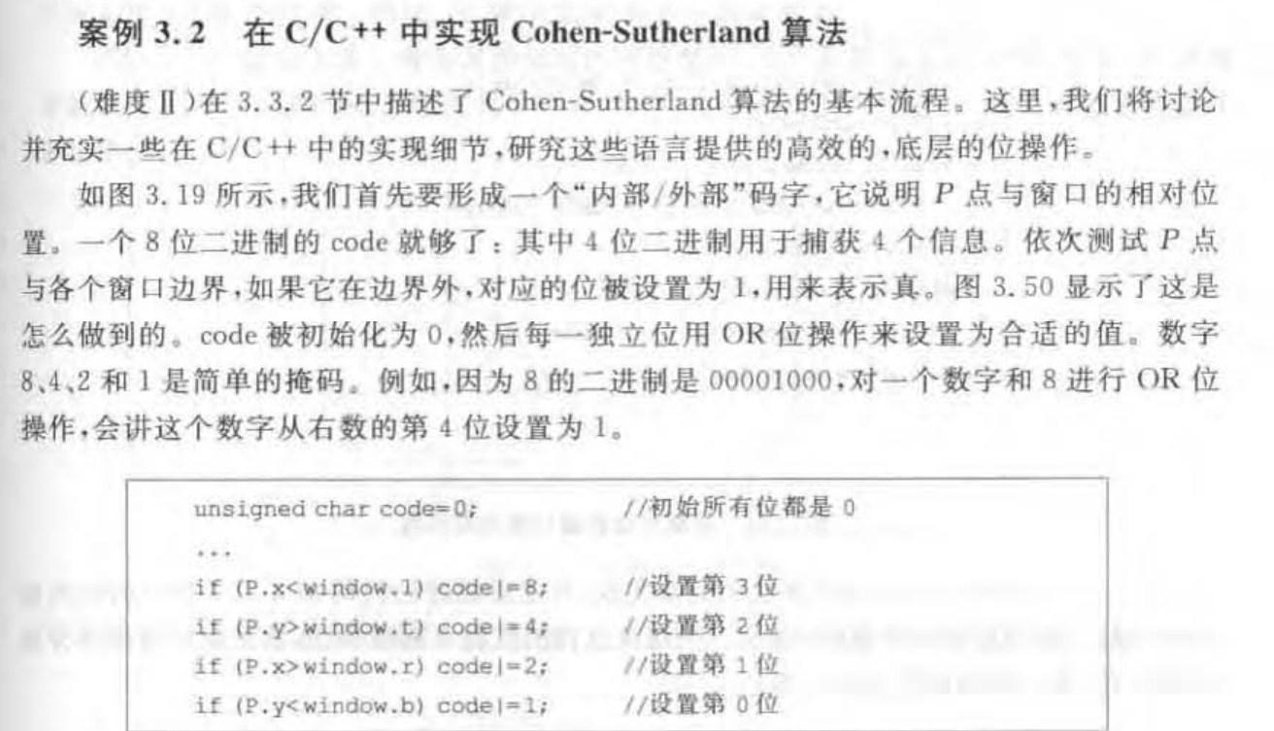
实验名：4.Animation with tweeing
Case Study 4.1 Page 168
