Conference Registration Guide
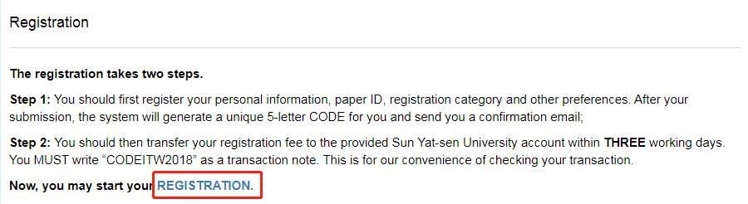
Click on the link to enter the registration system.

- Choose your registration type.

- Fill in the information.

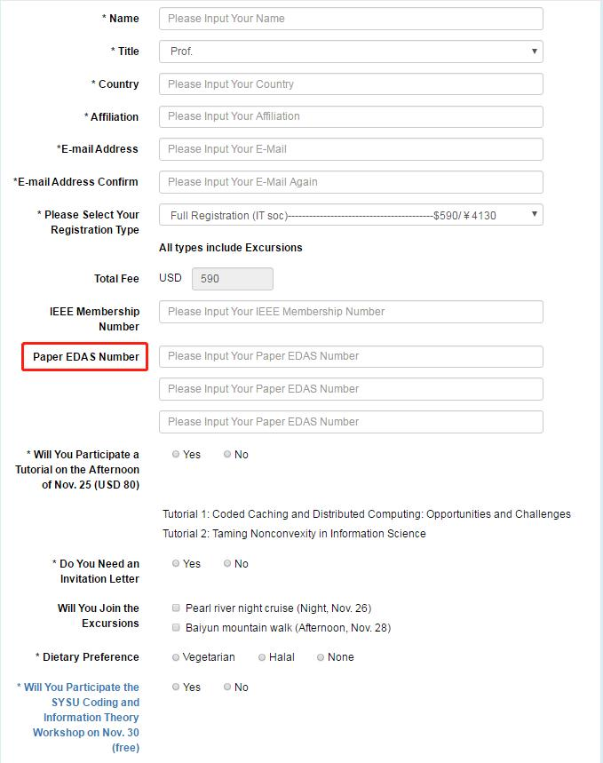
Up to 3 papers can be covered by a full registration. A student registration (reduced fee) covers one paper.

- Get your unique transaction note and transfer your registration fee to the following account.
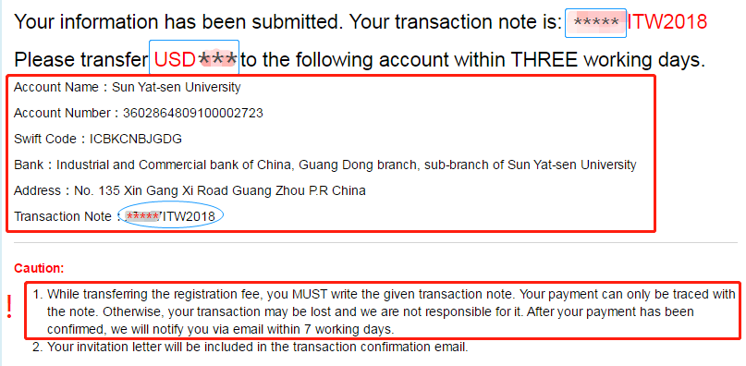
An unique 5-letter code.
Your total registration fee.

