# CORA Chatbot Topic Flows

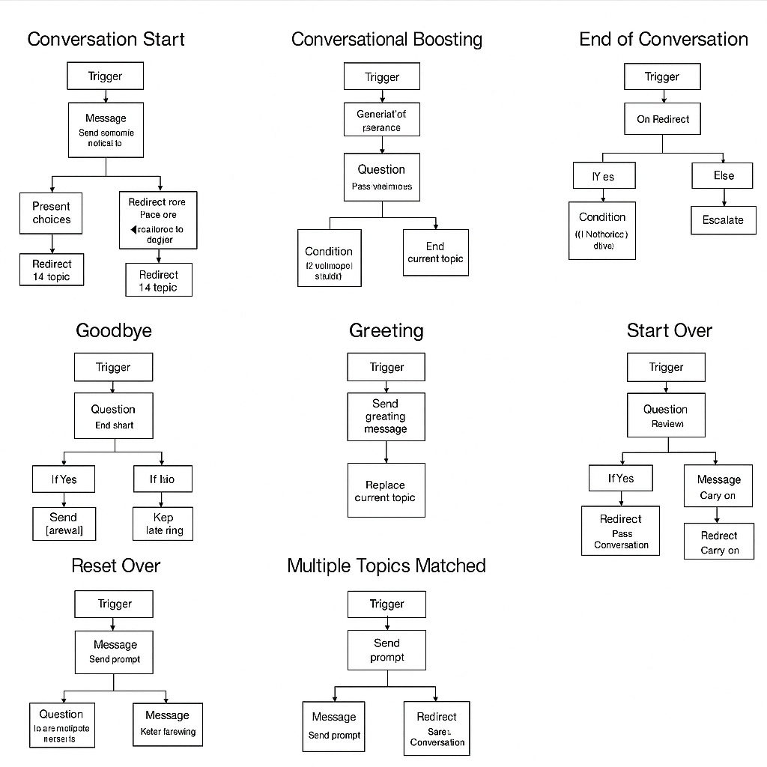

Each flowchart represents a topic configured in the CORA chatbot prototype, including Greeting, Fallback, End of Conversation, Start Over, and others. These visual flows help communicate the logic and interactions built in Microsoft Copilot Studio.