**Tableau Dashboards Documentation**

Version -V1.0

|  |  |  |  |
| --- | --- | --- | --- |
| Date | Version | Description | Author |
| 05/29/2018 | 1.0 | Initial Version | Yagnaraman Madhavan |
|  |  |  |  |
|  |  |  |  |

* **Version History**

Contents

Spark Batch Application 4

1.0 Logging into the REPL 4

2.0 Interactive Data Processing: REPL 5

3.0 Executing Spark Batch application using Spark submit 5

4.0 Executing hive queries using Spark SQL & JDBC connection in Beeline: 6

5.0 Talend Spark Batch Job 7

6.0 Best Practices: Spark Development 9

1. **Active Audit - Jobs Status Summary**

**Description of "Active Audit - Jobs Status Summary"**

% of Total Number of Records and sum of Number of Records. Color shows details about Pass Fail Status. Size shows sum of Number of Records. The marks are labeled by % of Total Number of Records and sum of Number of Records. The data is filtered on Proc Exec Beg Ts and Proc Exec Beg Ts Year. The Proc Exec Beg Ts filter includes the last 30 days. The filter associated with this field ranges from 4/30/2018 to 5/29/2018. The Proc Exec Beg Ts Year filter includes the last 160 days. The filter associated with this field ranges from 2017 to 2018. The view is filtered on Pass Fail Status, which has multiple members selected.

**Marks**

|  |
| --- |
| The mark type is Pie. |
| The marks are labeled by % of Total Number of Records and sum of Number of Records. |
| Stacked marks is on. |

**Shelves**

|  |  |
| --- | --- |
| **Filters:** | Pass Fail Status, Proc Exec Beg Ts, Year of Proc Exec Beg Ts |
| **Text:** | % of Total Number of Records and sum of Number of Records |
| **Color:** | Pass Fail Status |
| **Size:** | Sum of Number of Records |

**Dimensions**

**Pass Fail Status** has 3 members on this sheet

Members: FAILED; PASSED; RUNNING

The formula is IF ISNULL([Proc Sta Txt]) THEN "RUNNING"

ELSE

IF CONTAINS ("JOB COMPLETED",UPPER([Proc Sta Txt])) OR CONTAINS ("COMPLETED",UPPER([Proc Sta Txt])) THEN "PASSED"

ELSEIF CONTAINS ("FAILED",UPPER([Proc Sta Txt])) THEN "FAILED"

ELSE "RUNNING"

END

END

**Proc Exec Beg Ts** has the value Null on this sheet.

The filter associated with this field includes the last 30 days.

**Proc Exec Beg Ts Year** has the value Null on this sheet.

The filter associated with this field includes the last 160 days. The filter associated with this field ranges from 2017 to 2018.

**Measures**

**% of Total Number of Records** ranges from 0.13% to 94.37% on this sheet.

The formula is 1

Computes the current value as a percentage of the total. Totals summarize values from Pass Fail Status.

**Sum of Number of Records** ranges from 1 to 737 on this sheet.

The formula is 1

**Data Source Details**

|  |  |
| --- | --- |
| **Data Source:** | proc_exec_extract |
| **Type:** | federated |
| **Table:** | proc_exec_extract#csv |

1. **Active Audit - Jobs Phasewise Failure Summary**

**Description of "Active Audit - Jobs Phasewise Failure Summary"**

Sum of Count Of Failures for each Phase Name. Color shows sum of Count Of Failures. The marks are labeled by % of Total Count Of Failures and sum of Count Of Failures. The data is filtered on Phas Exec Beg Ts Month, Proc Exec Beg Ts and Proc Exec Beg Ts Year. The Phas Exec Beg Ts Month filter includes the last 120 days. The filter associated with this field ranges from January 2018 to May 2018. The Proc Exec Beg Ts filter includes the last 30 days. The filter associated with this field ranges from 4/30/2018 to 5/29/2018. The Proc Exec Beg Ts Year filter includes the last 160 days. The filter associated with this field ranges from 2017 to 2018. The view is filtered on sum of Count Of Failures and Phase Name. The sum of Count Of Failures filter ranges from 1 to 7,913. The Phase Name filter keeps 12 of 20 members.

**Marks**

|  |
| --- |
| The mark type is Bar (Automatic). |
| The marks are labeled by % of Total Count Of Failures and sum of Count Of Failures. |
| Stacked marks is on. |

**Shelves**

|  |  |
| --- | --- |
| **Rows:** | Phase Name |
| **Columns:** | Count Of Failures |
| **Filters:** | Count Of Failures, Phase Name, Month of Phas Exec Beg Ts, Proc Exec Beg Ts, Year of Proc Exec Beg Ts |
| **Text:** | % of Total Count Of Failures and sum of Count Of Failures |
| **Color:** | Sum of Count Of Failures |

**Dimensions**

**Phase Name** has 1 members on this sheet

Members: Duplicate check

Phase Name is sorted descending by sum of Count Of Failures.

**Proc Exec Beg Ts** has the value Null on this sheet.

The filter associated with this field includes the last 30 days. The filter associated with this field ranges from 4/30/2018 to 5/29/2018.

**Phas Exec Beg Ts Month** has the value Null on this sheet.

The filter associated with this field includes the last 120 days. The filter associated with this field ranges from January 2018 to May 2018.

**Proc Exec Beg Ts Year** has the value Null on this sheet.

The filter associated with this field includes the last 160 days. The filter associated with this field ranges from 2017 to 2018.

**Measures**

**% of Total Count Of Failures** has the value 100.0% on this sheet.

The formula is IF[Pass Fail Status]= "FAILED" THEN 1 ELSE 0 END

Computes the current value as a percentage of the total. Totals summarize values from Phase Name.

**Sum of Count Of Failures** has the value 43 on this sheet.

The filter associated with this field ranges from 1 to 7,913.

The formula is IF[Pass Fail Status]= "FAILED" THEN 1 ELSE 0 END

**Data Source Details**

|  |  |
| --- | --- |
| **Data Source:** | proc_exec_extract |
| **Type:** | federated |
| **Table:** | proc_exec_extract#csv |
| 1. **Active Audit - Filepattern Fail Detail Status Report**   **Description of "Active Audit - Filepattern Fail Detail Status Report"**  Pass Fail Status (color) broken down by Pass Fail Status vs. File Name Pattern Text, Process Name, File Nm and Phase Name. The data is filtered on FILENMPTTRNTXTNOTNULL, Action (Phase Name), Phas Exec Beg Ts Month and Proc Exec Beg Ts. The FILENMPTTRNTXTNOTNULL filter keeps True. The Action (Phase Name) filter keeps 1 member. The Phas Exec Beg Ts Month filter includes the last 120 days. The filter associated with this field ranges from January 2018 to May 2018. The Proc Exec Beg Ts filter includes the last 30 days. The filter associated with this field ranges from 4/30/2018 to 5/29/2018. The view is filtered on Pass Fail Status and Phase Name. The Pass Fail Status filter keeps FAILED. The Phase Name filter keeps 12 of 20 members.  **Marks**   |  | | --- | | The mark type is Circle. | | The marks are labeled automatically. | | Stacked marks is on. |   **Shelves**   |  |  | | --- | --- | | **Rows:** | File Name Pattern Text, Process Name, File Nm, Phase Name | | **Columns:** | Pass Fail Status | | **Filters:** | FILENMPTTRNTXTNOTNULL, Pass Fail Status, Phase Name, Action (Phase Name), Month of Phas Exec Beg Ts, Proc Exec Beg Ts | | **Color:** | Pass Fail Status |   **Dimensions**  **Pass Fail Status** has 1 members on this sheet  Members: FAILED  The formula is IF ISNULL([Proc Sta Txt]) THEN "RUNNING"  ELSE  IF CONTAINS ("JOB COMPLETED",UPPER([Proc Sta Txt])) OR CONTAINS ("COMPLETED",UPPER([Proc Sta Txt])) THEN "PASSED"  ELSEIF CONTAINS ("FAILED",UPPER([Proc Sta Txt])) THEN "FAILED"  ELSE "RUNNING"  END  END  **FILENMPTTRNTXTNOTNULL** has 1 members on this sheet  Members: True  The formula is NOT ISNULL([File Name Pattern Text])  **File Nm** has 34 members on this sheet  Members: CURRENT_BILLED_20180509_140954.TXT; EXTRACT_FND_TREE_VERSION_DAILY_20180404_000009.txt; HCSC.PROD.MAO.WIP0001.MAG.P.CARE.20170905100510.txt; HCSC.PROD.MAO.WIP0002.RPO.I.CARE.20170903122400.TXT; TEST_X6_OFF_HPS_DW_MONTHLY_BROKER_20180501124011.txt.pgp; ...  **File Name Pattern Text** has 24 members on this sheet  Members: CURRENT_BILLED_EXTRACT*.txt; EXTRACT_FND_TREE_VERSION*txt; HCSC.PROD.MAO.WIP*MAG.P.CARE*; HCSC.PROD.MAO.WIP0002.RPO.I.CARE*; HDFSIngest_HPS_OFF_DW_MONTHLY_BROKER.prm; ...  **Phase Name** has 1 members on this sheet  Members: Duplicate check  Phase Name is sorted in ascending alphabetic order.  **Proc Exec Beg Ts** has the value Null on this sheet.  The filter associated with this field includes the last 30 days. The filter associated with this field ranges from 4/30/2018 to 5/29/2018.  **Process Name** has 11 members on this sheet  Members: FSD_ERP_File_Ingestion_Process; FSD_ingestRuleOne_Data_PROCESS; TIS_Datalake_GPD_S47_File_Ingestion_Process; TIS_Datalake_GPD_S8_File_Ingestion_Process; TIS_Datalake_HPS_RawFile_Ingestion_Process; ...  **Phas Exec Beg Ts Month** has the value Null on this sheet.  The filter associated with this field includes the last 120 days. The filter associated with this field ranges from January 2018 to May 2018.  **Sets**  **Action (Phase Name)** has 1 members on this sheet  Members: Duplicate check  **Data Source Details**   |  |  | | --- | --- | | **Data Source:** | proc_exec_extract | | **Type:** | federated | | **Table:** | proc_exec_extract#csv | |  |

1. **Active Audit Process Failures - Trend Analysis**

**Description of "Active Audit Process Failures - Trend Analysis"**

The trend of sum of Count Of Failures for Proc Exec Beg Ts Week. Color shows sum of Count Of Failures. The data is filtered on Proc Exec Beg Ts Year and Proc Exec Beg Ts. The Proc Exec Beg Ts Year filter includes the last 160 days. The filter associated with this field ranges from 2017 to 2018. The Proc Exec Beg Ts filter includes the last 30 days. The filter associated with this field ranges from 4/30/2018 to 5/29/2018.

**Marks**

|  |
| --- |
| The mark type is Line (Automatic). |
| The marks are labeled automatically. |
| Stacked marks is off. |

**Shelves**

|  |  |
| --- | --- |
| **Rows:** | Count Of Failures |
| **Columns:** | Week of Proc Exec Beg Ts |
| **Filters:** | Year of Proc Exec Beg Ts, Proc Exec Beg Ts |
| **Color:** | Sum of Count Of Failures |

**Dimensions**

**Proc Exec Beg Ts** has the value Null on this sheet.

The filter associated with this field includes the last 30 days. The filter associated with this field ranges from 4/30/2018 to 5/29/2018.

**Proc Exec Beg Ts Week** ranges from April 29, 2018 to May 6, 2018 on this sheet.

**Proc Exec Beg Ts Year** has the value Null on this sheet.

The filter associated with this field includes the last 160 days. The filter associated with this field ranges from 2017 to 2018.

**Measures**

**Sum of Count Of Failures** ranges from 13 to 30 on this sheet.

The formula is IF[Pass Fail Status]= "FAILED" THEN 1 ELSE 0 END

**Data Source Details**

|  |  |
| --- | --- |
| **Data Source:** | proc_exec_extract |
| **Type:** | federated |
| **Table:** | proc_exec_extract#csv |

1. **Top10 Long Running Active Audit Processes**

**Description of "Top10 Long Running Active Audit Processes"**

Maximum of ExecutionTime and sum of Number of Times Active Audit Process Ran for each Process Name broken down by File Name Pattern Text. The marks are labeled by Label Minutes. For pane Sum of Number of Times Active Audit Process Ran: Color shows sum of Number of Times Active Audit Process Ran. The marks are labeled by Label Minutes, average of ExecutionTime and sum of Number of Times Active Audit Process Ran. For pane Maximum of ExecutionTime: Color shows maximum of ExecutionTime. The marks are labeled by Label Minutes, maximum of ExecutionTime and Number of Times Active Audit Process Ran. The data is filtered on COMPLETEDJOBSINDICATOR, Phas Exec Beg Ts Month and Proc Exec Beg Ts. The COMPLETEDJOBSINDICATOR filter keeps True. The Phas Exec Beg Ts Month filter includes the last 120 days. The filter associated with this field ranges from January 2018 to May 2018. The Proc Exec Beg Ts filter includes the last 30 days. The filter associated with this field ranges from 4/30/2018 to 5/29/2018. The view is filtered on Process Name, average of ExecutionTime, File Name Pattern Text and sum of Number of Times Active Audit Process Ran. The Process Name filter keeps 10 of 367 members. The average of ExecutionTime filter ranges from 1.00 to 113.25. The File Name Pattern Text filter has multiple members selected. The sum of Number of Times Active Audit Process Ran filter ranges from 1 to 7,247 and keeps Null values.

**Sum of Number of Times Active Audit Process Ran Properties**

**Marks**

|  |
| --- |
| The mark type is Bar (Automatic). |
| The marks are labeled by Label Minutes, average of ExecutionTime and sum of Number of Times Active Audit Process Ran. |
| Stacked marks is on. |

**Shelves**

|  |  |
| --- | --- |
| **Rows:** | File Name Pattern Text, Process Name |
| **Columns:** | Max. ExecutionTime, Sum of Number of Times Active Audit Process Ran |
| **Filters:** | COMPLETEDJOBSINDICATOR, Process Name, Avg. ExecutionTime, File Name Pattern Text, Sum of Number of Times Active Audit Process Ran, Month of Phas Exec Beg Ts, Proc Exec Beg Ts |
| **Text:** | Label Minutes, average of ExecutionTime and sum of Number of Times Active Audit Process Ran |
| **Color:** | Sum of Number of Times Active Audit Process Ran |

**Maximum of ExecutionTime Properties**

**Marks**

|  |
| --- |
| The mark type is Bar (Automatic). |
| The marks are labeled by Label Minutes, maximum of ExecutionTime and Number of Times Active Audit Process Ran. |
| Stacked marks is on. |

**Shelves**

|  |  |
| --- | --- |
| **Rows:** | File Name Pattern Text, Process Name |
| **Columns:** | Max. ExecutionTime, Sum of Number of Times Active Audit Process Ran |
| **Filters:** | COMPLETEDJOBSINDICATOR, Process Name, Avg. ExecutionTime, File Name Pattern Text, Sum of Number of Times Active Audit Process Ran, Month of Phas Exec Beg Ts, Proc Exec Beg Ts |
| **Text:** | Label Minutes, maximum of ExecutionTime and Number of Times Active Audit Process Ran |
| **Color:** | Maximum of ExecutionTime |

**Dimensions**

**Number of Times Active Audit Process Ran** has the value 1 on this sheet.

The formula is IF([COMPLETEDJOBSINDICATOR]==TRUE) THEN 1 END

**Label Minutes** has 1 members on this sheet

Members: mins

The formula is " mins"

**COMPLETEDJOBSINDICATOR** has 1 members on this sheet

Members: True

The formula is NOT ISNULL([Proc Exec End Ts]) AND [Pass Fail Status] == 'PASSED'

**File Name Pattern Text** has 1 members on this sheet

Members: EBAR_MEMCPYBM*.txt

File Name Pattern Text is sorted descending by maximum of ExecutionTime.

**Proc Exec Beg Ts** has the value Null on this sheet.

The filter associated with this field includes the last 30 days. The filter associated with this field ranges from 4/30/2018 to 5/29/2018.

**Process Name** has 1 members on this sheet

Members: FSD_ingestEBARS_Data_PROCESS

Process Name is sorted descending by average of ExecutionTime.

**Phas Exec Beg Ts Month** has the value Null on this sheet.

The filter associated with this field includes the last 120 days. The filter associated with this field ranges from January 2018 to May 2018.

**Measures**

**File Name Pattern Text as an attribute** has 1 members on this sheet

Members: EBAR_MEMCPYBM*.txt

**Phase Name as an attribute** has 1 members on this sheet

Members: Arrival check

**Average of ExecutionTime** has the value 59.00 on this sheet.

The filter associated with this field ranges from 1.00 to 113.25.

The formula is DATEDIFF('minute',[Proc Exec Beg Ts],[Proc Exec End Ts])

**Maximum of ExecutionTime** has the value 59 on this sheet.

The formula is DATEDIFF('minute',[Proc Exec Beg Ts],[Proc Exec End Ts])

**Sum of Number of Times Active Audit Process Ran** has the value 1 on this sheet.

The filter associated with this field ranges from 1 to 7,247 and keeps Null values.

The formula is IF([COMPLETEDJOBSINDICATOR]==TRUE) THEN 1 END

**Data Source Details**

|  |  |
| --- | --- |
| **Data Source:** | proc_exec_extract |
| **Type:** | federated |
| **Table:** | proc_exec_extract#csv |

1. **AF Active Audit Validation Summary**

**Description of "AF Active Audit Validation Summary"**

Duplicate Checks, File Name Checks, Record Count Checks, File External Checks, File Size Checks, Amt Balance Checks, File Check Sum Checks and Threshold Value Checks.

**Marks**

|  |
| --- |
| The mark type is Bar. |
| The marks are labeled automatically. |
| Stacked marks is on. |

**Shelves**

|  |  |
| --- | --- |
| **Rows:** | Measure Values |
| **Columns:** | Measure Names |
| **Filters:** | Measure Names |

**Dimensions**

**Measure Names** has 8 members on this sheet

Members: Duplicate Checks; File External Checks; File Name Checks; File Size Checks; Record Count Checks; ...

Measure Names is sorted manually.

**Measures**

**Measure Values** ranges from 28 to 3,943 on this sheet.

**Data Source Details**

|  |  |
| --- | --- |
| **Data Source:** | rec_file_config_extract |
| **Type:** | federated |
| **Table:** | rec_file_config_extract#csv |

1. **AF Active Audit Validation Controls**

**Description of "AF Active Audit Validation Controls"**

Minimum of One, minimum of One, minimum of One, minimum of One, minimum of One, minimum of One, minimum of One and minimum of One for each Sys Nm broken down by File Nm Pttrn Txt. For pane Minimum of One: Shape shows details about Amount Balance Check. For pane Minimum of One (2): Shape shows details about Duplicate Check. For pane Minimum of One (3): Shape shows details about File Check Sum. For pane Minimum of One (4): Shape shows details about File External Check. For pane Minimum of One (5): Shape shows details about File Name Check Value. For pane Minimum of One (6): Shape shows details about File Size Check Val. For pane Minimum of One (7): Shape shows details about Record Count Check Val Ind. For pane Minimum of One (8): Shape shows details about Threshold Check Val Ind. The data is filtered on File Nm Pttrn Txt (group) and DUPLICATES REMOVAL. The File Nm Pttrn Txt (group) filter has multiple members selected. The DUPLICATES REMOVAL filter has multiple members selected. The view is filtered on Amount Balance Check, Duplicate Check, File Check Sum, File External Check, File Name Check Value, File Size Check Val, Record Count Check Val Ind, Threshold Check Val Ind and Sys Nm. The Amount Balance Check filter keeps N. The Duplicate Check filter keeps N. The File Check Sum filter keeps N. The File External Check filter keeps N. The File Name Check Value filter keeps N. The File Size Check Val filter keeps N. The Record Count Check Val Ind filter keeps Y. The Threshold Check Val Ind filter keeps N. The Sys Nm filter has multiple members selected.

**Minimum of One Properties**

**Marks**

|  |
| --- |
| The mark type is Shape. |
| Stacked marks is on. |

**Shelves**

|  |  |
| --- | --- |
| **Rows:** | File Nm Pttrn Txt, Sys Nm |
| **Columns:** | Min. One, Min. One, Min. One, Min. One, Min. One, Min. One, Min. One, Min. One |
| **Filters:** | File Nm Pttrn Txt (group), Amount Balance Check, Duplicate Check, File Check Sum, File External Check, File Name Check Value, File Size Check Val, Record Count Check Val Ind, Threshold Check Val Ind, DUPLICATES REMOVAL, Sys Nm |
| **Shape:** | Amount Balance Check |

**Minimum of One (2) Properties**

**Marks**

|  |
| --- |
| The mark type is Shape. |
| Stacked marks is on. |

**Shelves**

|  |  |
| --- | --- |
| **Rows:** | File Nm Pttrn Txt, Sys Nm |
| **Columns:** | Min. One, Min. One, Min. One, Min. One, Min. One, Min. One, Min. One, Min. One |
| **Filters:** | File Nm Pttrn Txt (group), Amount Balance Check, Duplicate Check, File Check Sum, File External Check, File Name Check Value, File Size Check Val, Record Count Check Val Ind, Threshold Check Val Ind, DUPLICATES REMOVAL, Sys Nm |
| **Shape:** | Duplicate Check |

**Minimum of One (3) Properties**

**Marks**

|  |
| --- |
| The mark type is Shape. |
| Stacked marks is on. |

**Shelves**

|  |  |
| --- | --- |
| **Rows:** | File Nm Pttrn Txt, Sys Nm |
| **Columns:** | Min. One, Min. One, Min. One, Min. One, Min. One, Min. One, Min. One, Min. One |
| **Filters:** | File Nm Pttrn Txt (group), Amount Balance Check, Duplicate Check, File Check Sum, File External Check, File Name Check Value, File Size Check Val, Record Count Check Val Ind, Threshold Check Val Ind, DUPLICATES REMOVAL, Sys Nm |
| **Shape:** | File Check Sum |

**Minimum of One (4) Properties**

**Marks**

|  |
| --- |
| The mark type is Shape. |
| Stacked marks is on. |

**Shelves**

|  |  |
| --- | --- |
| **Rows:** | File Nm Pttrn Txt, Sys Nm |
| **Columns:** | Min. One, Min. One, Min. One, Min. One, Min. One, Min. One, Min. One, Min. One |
| **Filters:** | File Nm Pttrn Txt (group), Amount Balance Check, Duplicate Check, File Check Sum, File External Check, File Name Check Value, File Size Check Val, Record Count Check Val Ind, Threshold Check Val Ind, DUPLICATES REMOVAL, Sys Nm |
| **Shape:** | File External Check |

**Minimum of One (5) Properties**

**Marks**

|  |
| --- |
| The mark type is Shape. |
| Stacked marks is on. |

**Shelves**

|  |  |
| --- | --- |
| **Rows:** | File Nm Pttrn Txt, Sys Nm |
| **Columns:** | Min. One, Min. One, Min. One, Min. One, Min. One, Min. One, Min. One, Min. One |
| **Filters:** | File Nm Pttrn Txt (group), Amount Balance Check, Duplicate Check, File Check Sum, File External Check, File Name Check Value, File Size Check Val, Record Count Check Val Ind, Threshold Check Val Ind, DUPLICATES REMOVAL, Sys Nm |
| **Shape:** | File Name Check Value |

**Minimum of One (6) Properties**

**Marks**

|  |
| --- |
| The mark type is Shape. |
| Stacked marks is on. |

**Shelves**

|  |  |
| --- | --- |
| **Rows:** | File Nm Pttrn Txt, Sys Nm |
| **Columns:** | Min. One, Min. One, Min. One, Min. One, Min. One, Min. One, Min. One, Min. One |
| **Filters:** | File Nm Pttrn Txt (group), Amount Balance Check, Duplicate Check, File Check Sum, File External Check, File Name Check Value, File Size Check Val, Record Count Check Val Ind, Threshold Check Val Ind, DUPLICATES REMOVAL, Sys Nm |
| **Shape:** | File Size Check Val |

**Minimum of One (7) Properties**

**Marks**

|  |
| --- |
| The mark type is Shape. |
| Stacked marks is on. |

**Shelves**

|  |  |
| --- | --- |
| **Rows:** | File Nm Pttrn Txt, Sys Nm |
| **Columns:** | Min. One, Min. One, Min. One, Min. One, Min. One, Min. One, Min. One, Min. One |
| **Filters:** | File Nm Pttrn Txt (group), Amount Balance Check, Duplicate Check, File Check Sum, File External Check, File Name Check Value, File Size Check Val, Record Count Check Val Ind, Threshold Check Val Ind, DUPLICATES REMOVAL, Sys Nm |
| **Shape:** | Record Count Check Val Ind |

**Minimum of One (8) Properties**

**Marks**

|  |
| --- |
| The mark type is Shape. |
| Stacked marks is on. |

**Shelves**

|  |  |
| --- | --- |
| **Rows:** | File Nm Pttrn Txt, Sys Nm |
| **Columns:** | Min. One, Min. One, Min. One, Min. One, Min. One, Min. One, Min. One, Min. One |
| **Filters:** | File Nm Pttrn Txt (group), Amount Balance Check, Duplicate Check, File Check Sum, File External Check, File Name Check Value, File Size Check Val, Record Count Check Val Ind, Threshold Check Val Ind, DUPLICATES REMOVAL, Sys Nm |
| **Shape:** | Threshold Check Val Ind |

**Dimensions**

**File Nm Pttrn Txt (group)** has 3,674 members on this sheet

Members: *_PRIME_*_CLSUP_*.txt; *_PRIME_*_COMP_*.txt; *_detail_*.txt; *_flaggedevent_*.txt; *_message_*.txt; ...

**Duplicate Check** has 1 members on this sheet

Members: N

The formula is IF CONTAINS([Duplct Chk Val],'Y') THEN 'Y' ELSE 'N' END

**Amount Balance Check** has 1 members on this sheet

Members: N

The formula is IF ISNULL([Amt Bal Chk Ind]) THEN 'N'

ELSEIF CONTAINS([Amt Bal Chk Ind],'Y') THEN 'Y' ELSE 'N' END

**File Check Sum** has 1 members on this sheet

Members: N

The formula is IF CONTAINS ([File Chk Sum Ind],'Y') THEN 'Y' ELSE 'N' END

**File External Check** has 1 members on this sheet

Members: N

The formula is IF CONTAINS ([File Extrnl Ind],'Y') THEN 'Y' ELSE 'N' END

**File Name Check Value** has 1 members on this sheet

Members: N

The formula is IF CONTAINS([File Nm Chk Val],'Y') THEN 'Y' ELSE 'N' END

**File Size Check Val** has 1 members on this sheet

Members: N

The formula is IF CONTAINS([File Sz Chk Val],'Y') THEN 'Y' ELSE 'N' END

**Record Count Check Val Ind** has 1 members on this sheet

Members: Y

The formula is IF CONTAINS([Rec Cnt Chk Val],'Y') THEN 'Y' ELSE 'N' END

**Threshold Check Val Ind** has 1 members on this sheet

Members: N

The formula is IF CONTAINS([Thrhd Chk Val],'Y') THEN 'Y' ELSE 'N' END

**DUPLICATES REMOVAL** has 2 members on this sheet

Members: False; True

The formula is { FIXED [File Nm Pttrn Txt (group)],[Sys Nm] : COUNT([File Nm Pttrn Txt (group)]) } = 1

**File Nm Pttrn Txt** has 6 members on this sheet

Members: *HPS_FI_DAILY_CASH*; *HPS_FI_DAILY_MRP*; *HPS_FI_MONTHLY_CASH*; *HPS_FI_MONTHLY_MBP*; *HPS_FI_MONTHLY_MRP*; ...

**Sys Nm** has 1 members on this sheet

Members: HPS

Sys Nm is sorted descending by minimum of One.

**Measures**

**Minimum of One** has the value 1.000 on this sheet.

The formula is 1.0

**Data Source Details**

|  |  |
| --- | --- |
| **Data Source:** | rec_file_config_extract |
| **Type:** | federated |
| **Table:** | rec_file_config_extract#csv |

**Passive Audit - Job Status Summary**

**Description of "Passive Audit - Job Status Summary"**

% of Total Number of Records and sum of Number of Records. Color shows details about Job Status. Size shows sum of Number of Records. The marks are labeled by % of Total Number of Records and sum of Number of Records. The data is filtered on Proc Exec Beg Ts, which includes the last 50 days. The filter associated with this field ranges from 4/10/2018 to 5/29/2018.

**Marks**

|  |
| --- |
| The mark type is Pie. |
| The marks are labeled by % of Total Number of Records and sum of Number of Records. |
| Stacked marks is off. |

**Shelves**

|  |  |
| --- | --- |
| **Filters:** | Proc Exec Beg Ts |
| **Text:** | % of Total Number of Records and sum of Number of Records |
| **Color:** | Job Status |
| **Size:** | Sum of Number of Records |

**Dimensions**

**Job Status** has 2 members on this sheet

Members: FAILED; PASSED

The formula is IF ISNULL([Proc Exec End Ts]) THEN "RUNNING"

ELSE

IF CONTAINS ("SUCCESS",UPPER([Pasv Aud Ctl Col Sta Nm])) THEN "PASSED"

ELSEIF CONTAINS ("FAILED",UPPER([Pasv Aud Ctl Col Sta Nm])) THEN "FAILED"

ELSE "RUNNING"

END

END

**Proc Exec Beg Ts** has the value Null on this sheet.

The filter associated with this field includes the last 50 days. The filter associated with this field ranges from 4/10/2018 to 5/29/2018.

**Measures**

**% of Total Number of Records** ranges from 5.66% to 94.34% on this sheet.

The formula is 1

Computes the current value as a percentage of the total. Totals summarize values from Job Status.

**Sum of Number of Records** ranges from 190 to 3,164 on this sheet.

The formula is 1

**Data Source Details**

|  |  |
| --- | --- |
| **Data Source:** | pssv_exec_extract |
| **Type:** | federated |
| **Table:** | pssv_exec_extract#csv |

1. **Passive Audit - Phasewise Failure Summary**

**Description of "Passive Audit - Phasewise Failure Summary"**

Sum of Count Of Failures for each Phase Nm. Color shows sum of Count Of Failures. The marks are labeled by % of Total Count Of Failures and sum of Count Of Failures. The data is filtered on Proc Exec Beg Ts, which includes the last 50 days. The filter associated with this field ranges from 4/10/2018 to 5/29/2018.

**Marks**

|  |
| --- |
| The mark type is Bar (Automatic). |
| The marks are labeled by % of Total Count Of Failures and sum of Count Of Failures. |
| Stacked marks is on. |

**Shelves**

|  |  |
| --- | --- |
| **Rows:** | Phase Nm |
| **Columns:** | Count Of Failures |
| **Filters:** | Proc Exec Beg Ts |
| **Text:** | % of Total Count Of Failures and sum of Count Of Failures |
| **Color:** | Sum of Count Of Failures |

**Dimensions**

**Phase Nm** has 4 members on this sheet

Members: Amount Check; Count & Amount Check; Count Check; Match Check

The formula is IF [Amount Checks] =='Y' THEN 'Amount Check'

ELSEIF [Count Checks] =='Y' THEN 'Count Check'

ELSEIF [Match Checks] == 'Y' THEN 'Match Check'

ELSE 'Count & Amount Check'

END

Phase Nm is sorted descending by sum of Count Of Failures.

**Proc Exec Beg Ts** has the value Null on this sheet.

The filter associated with this field includes the last 50 days. The filter associated with this field ranges from 4/10/2018 to 5/29/2018.

**Measures**

**% of Total Count Of Failures** ranges from 0.00% to 58.42% on this sheet.

The formula is IF[Job Status]== "FAILED" THEN 1 ELSE 0 END

Computes the current value as a percentage of the total. Totals summarize values from Phase Nm.

**Sum of Count Of Failures** ranges from 0 to 111 on this sheet.

The formula is IF[Job Status]== "FAILED" THEN 1 ELSE 0 END

**Data Source Details**

|  |  |
| --- | --- |
| **Data Source:** | pssv_exec_extract |
| **Type:** | federated |
| **Table:** | pssv_exec_extract#csv |

1. **Passive Audit Process - Failure Details Report**

**Description of "Passive Audit Process - Failure Details Report"**

Job Status (color) broken down by Job Status vs. File Nm Pttrn Txt, Process Name, Phase Nm, Src Fld Ctl Val and Targ Fld Ctl Val Txt. The data is filtered on Action (Phase Nm) and Proc Exec Beg Ts. The Action (Phase Nm) filter keeps 1 member. The Proc Exec Beg Ts filter includes the last 50 days. The filter associated with this field ranges from 4/10/2018 to 5/29/2018. The view is filtered on Job Status, which keeps FAILED.

**Marks**

|  |
| --- |
| The mark type is Circle. |
| Stacked marks is on. |

**Shelves**

|  |  |
| --- | --- |
| **Rows:** | File Nm Pttrn Txt, Process Name, Phase Nm, Src Fld Ctl Val, Targ Fld Ctl Val Txt |
| **Columns:** | Job Status |
| **Filters:** | Job Status, Action (Phase Nm), Proc Exec Beg Ts |
| **Color:** | Job Status |

**Dimensions**

**Job Status** has 1 members on this sheet

Members: FAILED

The formula is IF ISNULL([Proc Exec End Ts]) THEN "RUNNING"

ELSE

IF CONTAINS ("SUCCESS",UPPER([Pasv Aud Ctl Col Sta Nm])) THEN "PASSED"

ELSEIF CONTAINS ("FAILED",UPPER([Pasv Aud Ctl Col Sta Nm])) THEN "FAILED"

ELSE "RUNNING"

END

END

**Phase Nm** has 1 members on this sheet

Members: Match Check

The formula is IF [Amount Checks] =='Y' THEN 'Amount Check'

ELSEIF [Count Checks] =='Y' THEN 'Count Check'

ELSEIF [Match Checks] == 'Y' THEN 'Match Check'

ELSE 'Count & Amount Check'

END

**File Nm Pttrn Txt** has 1 members on this sheet

Members: EXTRACT_GL_BUDGET_BALANCE_MONTHLY*txt

**Proc Exec Beg Ts** has the value Null on this sheet.

The filter associated with this field includes the last 50 days. The filter associated with this field ranges from 4/10/2018 to 5/29/2018.

**Process Name** has 1 members on this sheet

Members: FSD_ERP_File_Ingestion_Process

**Src Fld Ctl Val** has 1 members on this sheet

Members: 1|

**Targ Fld Ctl Val Txt** has 1 members on this sheet

Members: 1|

**Sets**

**Action (Phase Nm)** has 1 members on this sheet

Members: Match Check

**Data Source Details**

|  |  |
| --- | --- |
| **Data Source:** | pssv_exec_extract |
| **Type:** | federated |
| **Table:** | pssv_exec_extract#csv |

1. **Passive Audit Validation Summary**

**Description of "Passive Audit Validation Summary"**

Count Checks, Amount Checks, Match Checks and Count & Amount Checks .

**Marks**

|  |
| --- |
| The mark type is Bar (Automatic). |
| The marks are labeled automatically. |
| Stacked marks is on. |

**Shelves**

|  |  |
| --- | --- |
| **Rows:** | Measure Values |
| **Columns:** | Measure Names |
| **Filters:** | Measure Names |
| **Level of detail:** | Count Check Count, Amount Check Count, Count & Amount Checks Count, Match Check Count |

**Dimensions**

**Measure Names** has 4 members on this sheet

Members: Amount Checks; Count & Amount Checks ; Count Checks; Match Checks

Measure Names is sorted manually.

**Measures**

**Measure Values** ranges from 5.0 to 179.0 on this sheet.

**Match Check Count** has the value 5 on this sheet.

The formula is COUNT(IF([Match Checks]=='Y') THEN [File Nm Pttrn Txt] END)

**Count Check Count** has the value 179 on this sheet.

The formula is COUNT(IF([CountChecks]=='Y') THEN [File Nm Pttrn Txt] END)

**Amount Check Count** has the value 45 on this sheet.

The formula is COUNT(IF([Amount Checks]=='Y') THEN [File Nm Pttrn Txt] END)

**Count & Amount Checks Count** has the value 45 on this sheet.

The formula is COUNT(IF([Count & Amount Checks]=='Y') THEN [File Nm Pttrn Txt] END)

**Data Source Details**

|  |  |
| --- | --- |
| **Data Source:** | pssv_rec_file_config |
| **Type:** | federated |
| **Table:** | pssv_rec_file_config#csv |

1. **Passive Audit Validation Detail**

**Description of "Passive Audit Validation Detail"**

Minimum of one, minimum of one, minimum of one and minimum of one for each Src Sys Nm broken down by File Nm Pttrn Txt. For pane Minimum of one: Shape shows details about CountChecks. For pane Minimum of one (2): Shape shows details about Amount Checks. For pane Minimum of one (4): Shape shows details about Count & Amount Checks. For pane Minimum of one (3): Shape shows details about Match Checks. The view is filtered on File Nm Pttrn Txt, CountChecks, Amount Checks, Match Checks and Count & Amount Checks. The File Nm Pttrn Txt filter has multiple members selected. The CountChecks filter keeps Y. The Amount Checks filter keeps N. The Match Checks filter keeps N. The Count & Amount Checks filter keeps N.

**Minimum of one Properties**

**Marks**

|  |
| --- |
| The mark type is Shape. |
| Stacked marks is off. |

**Shelves**

|  |  |
| --- | --- |
| **Rows:** | File Nm Pttrn Txt, Src Sys Nm |
| **Columns:** | Min. one, Min. one, Min. one, Min. one |
| **Filters:** | File Nm Pttrn Txt, CountChecks, Amount Checks, Match Checks, Count & Amount Checks |
| **Shape:** | CountChecks |

**Minimum of one (2) Properties**

**Marks**

|  |
| --- |
| The mark type is Shape. |
| Stacked marks is off. |

**Shelves**

|  |  |
| --- | --- |
| **Rows:** | File Nm Pttrn Txt, Src Sys Nm |
| **Columns:** | Min. one, Min. one, Min. one, Min. one |
| **Filters:** | File Nm Pttrn Txt, CountChecks, Amount Checks, Match Checks, Count & Amount Checks |
| **Shape:** | Amount Checks |

**Minimum of one (4) Properties**

**Marks**

|  |
| --- |
| The mark type is Shape. |
| Stacked marks is off. |

**Shelves**

|  |  |
| --- | --- |
| **Rows:** | File Nm Pttrn Txt, Src Sys Nm |
| **Columns:** | Min. one, Min. one, Min. one, Min. one |
| **Filters:** | File Nm Pttrn Txt, CountChecks, Amount Checks, Match Checks, Count & Amount Checks |
| **Shape:** | Count & Amount Checks |

**Minimum of one (3) Properties**

**Marks**

|  |
| --- |
| The mark type is Shape. |
| Stacked marks is off. |

**Shelves**

|  |  |
| --- | --- |
| **Rows:** | File Nm Pttrn Txt, Src Sys Nm |
| **Columns:** | Min. one, Min. one, Min. one, Min. one |
| **Filters:** | File Nm Pttrn Txt, CountChecks, Amount Checks, Match Checks, Count & Amount Checks |
| **Shape:** | Match Checks |

**Dimensions**

**Match Checks** has 1 members on this sheet

Members: N

The formula is IF CONTAINS(UPPER([Pasv Aud Typ Nm]),'MATCH') THEN 'Y' ELSE 'N' END

**CountChecks** has 1 members on this sheet

Members: Y

The formula is IF CONTAINS(UPPER([Pasv Aud Typ Nm]),'COUNT') THEN 'Y' ELSE 'N' END

**Amount Checks** has 1 members on this sheet

Members: N

The formula is IF CONTAINS([Pasv Aud Typ Nm],'AMOUNT') THEN 'Y' ELSE 'N' END

**Count & Amount Checks** has 1 members on this sheet

Members: N

The formula is IF CONTAINS([Pasv Aud Typ Nm],'COUNT|AMOUNT') OR CONTAINS([Pasv Aud Typ Nm],'AMOUNT|COUNT') THEN 'Y' ELSE 'N' END

**File Nm Pttrn Txt** has 134 members on this sheet

Members: FSD_BSTAR_GSB_DAILY_INCOMING_SMITHRAW_CNT; MEMSYS.INCR.MES3657.*; avro_mkt_seg_val_ref; bgw_cons_incoming_passive_audit_SECURED_GROUP_count; dw_daily_Daily_receipt_payment_activity_Audit*; ...

**Src Sys Nm** has 29 members on this sheet

Members: BGW; BGW_SECURED_GROUP; Bluestar; OPERMART; TEST_FSD_INCOMING_GSB_DAILY; ...

**Measures**

**Minimum of one** has the value 1.000 on this sheet.

The formula is 1.0

**Data Source Details**

|  |  |
| --- | --- |
| **Data Source:** | pssv_rec_file_config |
| **Type:** | federated |
| **Table:** | pssv_rec_file_config#csv |
| 1. **Top10 Long Running Passive Audit Process** |  |

**Description of "Top10 Long Running Passive Audit Process"**

Maximum of Pssv Audit Execution Time and sum of No of Times Pssv Audit Process Ran for each Process Name broken down by File Nm Pttrn Txt. The marks are labeled by Label Minutes. For pane Maximum of Pssv Audit Execution Time: Color shows maximum of Pssv Audit Execution Time. The marks are labeled by maximum of Pssv Audit Execution Time and Label Minutes. For pane Sum of No of Times Pssv Audit Process Ran: Color shows sum of No of Times Pssv Audit Process Ran. The marks are labeled by Label Minutes and sum of No of Times Pssv Audit Process Ran. The data is filtered on Proc Exec Beg Ts, which includes the last 50 days. The filter associated with this field ranges from 4/10/2018 to 5/29/2018. The view is filtered on maximum of Pssv Audit Execution Time, Process Name, File Nm Pttrn Txt and sum of No of Times Pssv Audit Process Ran. The maximum of Pssv Audit Execution Time filter ranges from 40 to 20,003. The Process Name filter has multiple members selected. The File Nm Pttrn Txt filter keeps no members. The sum of No of Times Pssv Audit Process Ran filter keeps all values.

**Maximum of Pssv Audit Execution Time Properties**

**Marks**

|  |
| --- |
| The mark type is Bar (Automatic). |
| The marks are labeled by maximum of Pssv Audit Execution Time and Label Minutes. |
| Stacked marks is on. |

**Shelves**

|  |  |
| --- | --- |
| **Rows:** | File Nm Pttrn Txt, Process Name |
| **Columns:** | Max. Pssv Audit Execution Time, No of Times Pssv Audit Process Ran |
| **Filters:** | Max. Pssv Audit Execution Time, Process Name, File Nm Pttrn Txt, No of Times Pssv Audit Process Ran, Proc Exec Beg Ts |
| **Text:** | Maximum of Pssv Audit Execution Time and Label Minutes |
| **Color:** | Maximum of Pssv Audit Execution Time |

**Sum of No of Times Pssv Audit Process Ran Properties**

**Marks**

|  |
| --- |
| The mark type is Bar (Automatic). |
| The marks are labeled by Label Minutes and sum of No of Times Pssv Audit Process Ran. |
| Stacked marks is on. |

**Shelves**

|  |  |
| --- | --- |
| **Rows:** | File Nm Pttrn Txt, Process Name |
| **Columns:** | Max. Pssv Audit Execution Time, No of Times Pssv Audit Process Ran |
| **Filters:** | Max. Pssv Audit Execution Time, Process Name, File Nm Pttrn Txt, No of Times Pssv Audit Process Ran, Proc Exec Beg Ts |
| **Text:** | Label Minutes and sum of No of Times Pssv Audit Process Ran |
| **Color:** | Sum of No of Times Pssv Audit Process Ran |

**Dimensions**

**Label Minutes** has 1 members on this sheet

Members: mins

The formula is " mins"

**File Nm Pttrn Txt** has 4 members on this sheet

Members: FSD_AUTO_GL_BUDG_BAL_VIEWS_BASETABLE_AMT_CNT; FSD_BSTAR_ALLOCATED_COLLECTION_RECORD_INCOMING_SMITHRAW_CNT; FSD_BSTAR_CURRENT_BILLED_INCOMING_SMITHRAW_CNT; FSD_BSTAR_FIN_GRP_CD_INCOMING_SMITHRAW_CNT

File Nm Pttrn Txt is sorted descending by maximum of Pssv Audit Execution Time.

**Proc Exec Beg Ts** has the value Null on this sheet.

The filter associated with this field includes the last 50 days. The filter associated with this field ranges from 4/10/2018 to 5/29/2018.

**Process Name** has 4 members on this sheet

Members: FSD_AUTO_GL_BUDG_BAL_VIEWS_BASETABLE_PASSIVE_AUDIT; FSD_BSTAR_ALLOCATED_COLLECTION_RECORD_INCOMING_SMITHRAW_PASSIVE_AUDIT; FSD_BSTAR_CURRENT_BILLED_INCOMING_SMITHRAW_PASSIVE_AUDIT; FSD_BSTAR_FIN_GRP_CD_INCOMING_SMITHRAW_PASSIVE_AUDIT

Process Name is sorted descending by average of Pssv Audit Execution Time.

**Measures**

**Phas Nm as an attribute** has 2 members on this sheet

Members: *; PASSIVE_AUDIT_COUNT

**Maximum of Pssv Audit Execution Time** ranges from 79 to 161 on this sheet.

The filter associated with this field ranges from 40 to 20,003.

The formula is DATEDIFF('minute',[Proc Exec Beg Ts],[Proc Exec End Ts])

**Sum of No of Times Pssv Audit Process Ran** ranges from 5 to 15 on this sheet.

The filter associated with this field keeps all values.

The formula is IF([CompletionStatus]==TRUE) THEN 1 END

**Data Source Details**

|  |  |
| --- | --- |
| **Data Source:** | pssv_exec_extract |
| **Type:** | federated |
| **Table:** | pssv_exec_extract#csv |

1. **Passive Audit Process Failures - Trend Analysis**

**Description of "Passive Audit Process Failures - Trend Analysis"**

The trend of sum of Count Of Failures for Proc Exec Beg Ts Week. Color shows sum of Count Of Failures. The data is filtered on Proc Exec Beg Ts and Proc Exec Beg Ts (pssv_exec_extract). The Proc Exec Beg Ts filter includes the last 180 days. The filter associated with this field ranges from 12/1/2017 to 5/29/2018. The Proc Exec Beg Ts (pssv_exec_extract) filter includes the last 50 days. The filter associated with this field ranges from 4/10/2018 to 5/29/2018.

**Marks**

|  |
| --- |
| The mark type is Line (Automatic). |
| The marks are labeled automatically. |
| Stacked marks is off. |

**Shelves**

|  |  |
| --- | --- |
| **Rows:** | Count Of Failures |
| **Columns:** | Week of Proc Exec Beg Ts |
| **Filters:** | Proc Exec Beg Ts, Proc Exec Beg Ts |
| **Color:** | Sum of Count Of Failures |

**Dimensions**

**Proc Exec Beg Ts (pssv_exec_extract)** has the value Null on this sheet.

The filter associated with this field includes the last 50 days. The filter associated with this field ranges from 4/10/2018 to 5/29/2018.

**Proc Exec Beg Ts** has the value Null on this sheet.

The filter associated with this field includes the last 180 days. The filter associated with this field ranges from 12/1/2017 to 5/29/2018.

**Proc Exec Beg Ts Week** ranges from April 8, 2018 to May 6, 2018 on this sheet.

**Measures**

**Sum of Count Of Failures** ranges from 13 to 63 on this sheet.

The formula is IF[Pass Fail Status]= "FAILED" THEN 1 ELSE 0 END

**Data Source Details**

|  |  |
| --- | --- |
| **Data Source:** | proc_exec_extract |
| **Type:** | federated |
| **Table:** | proc_exec_extract#csv |

|  |  |
| --- | --- |
| **Data Source:** | pssv_exec_extract |
| **Type:** | federated |
| **Table:** | pssv_exec_extract#csv |

pssv_exec_extract is grouped by Proc Exec Beg Ts Week, and joined to proc_exec_extract using Proc Exec Beg Ts Week.

**Active Audit - Job Status Dashboard**

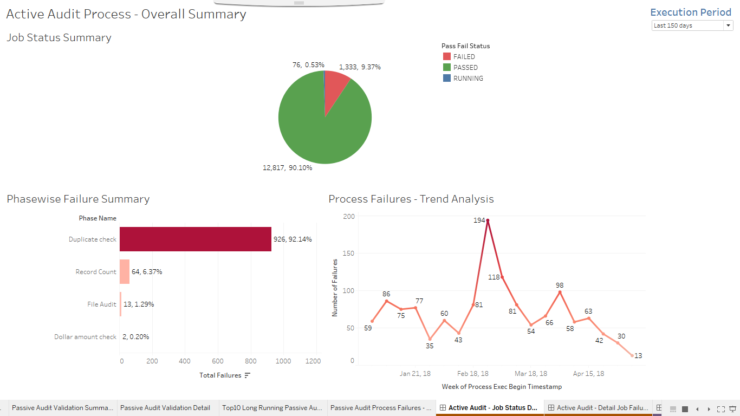

**Active Audit - Detail Job Failure Status**

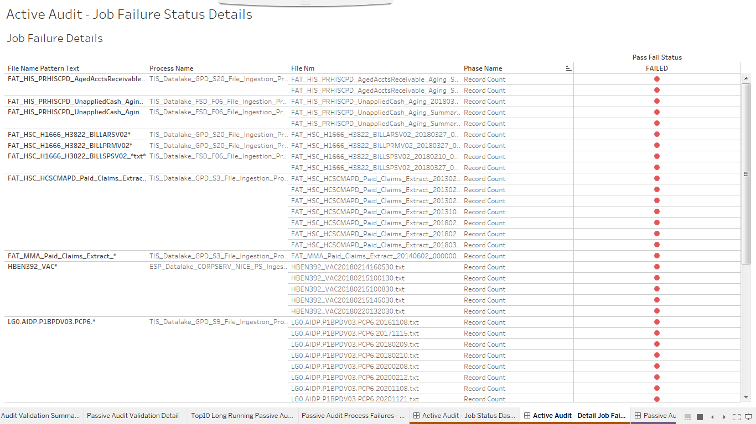

**Passive Audit Process - Job Status Dashboard**

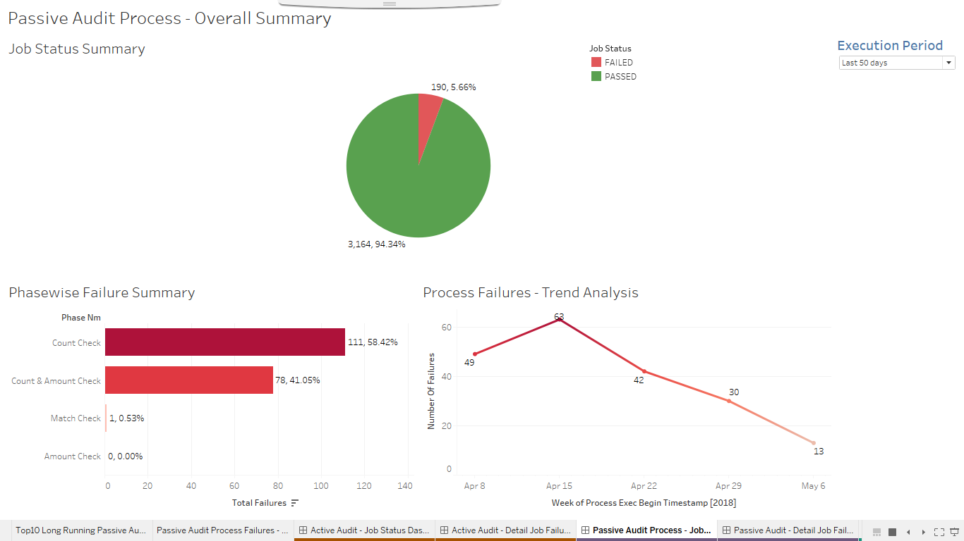

**Passive Audit - Detail Job Failure Details**

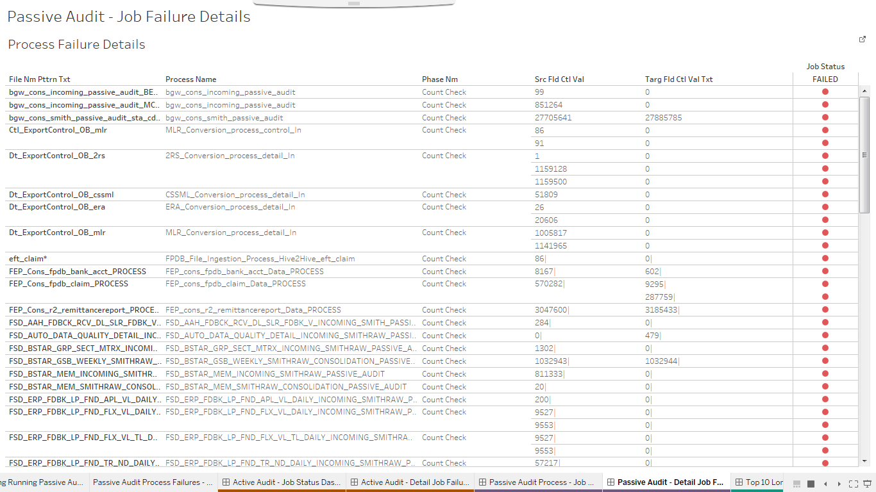

**Top 10 Long Running Processes**

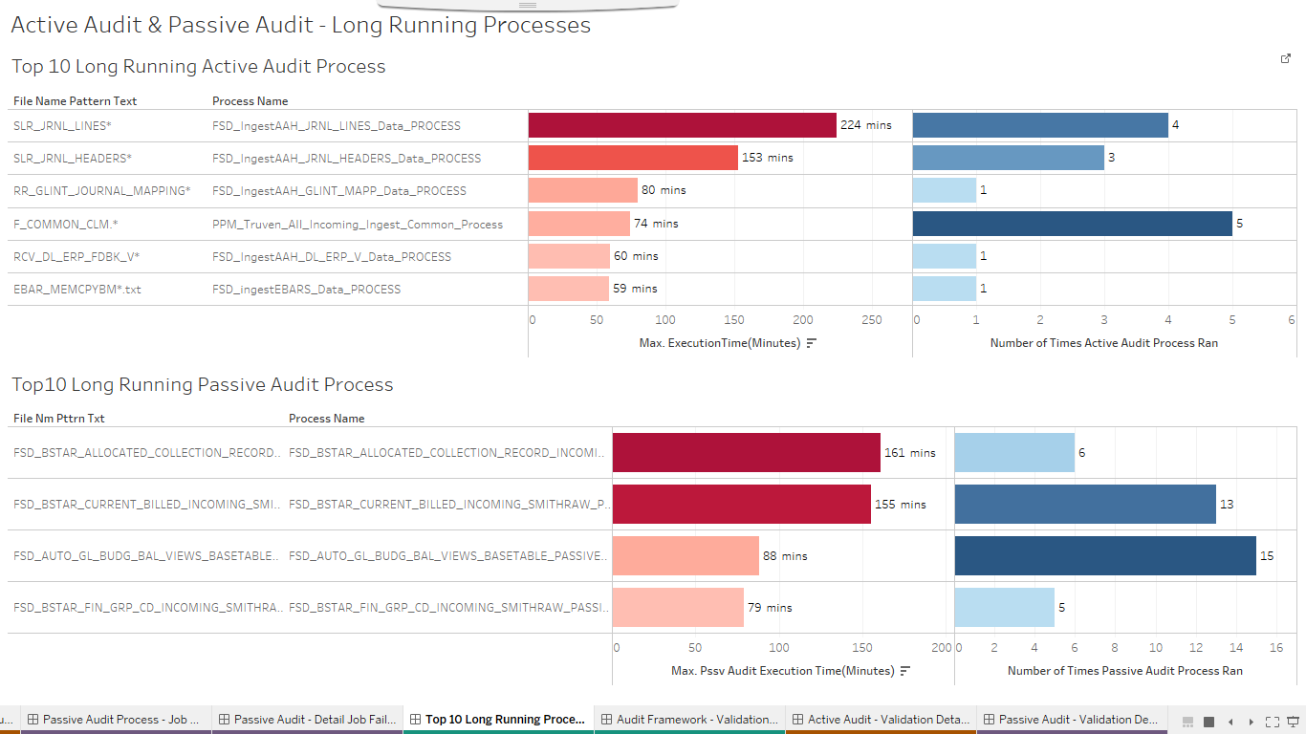

**Audit Framework - Validation Summary**

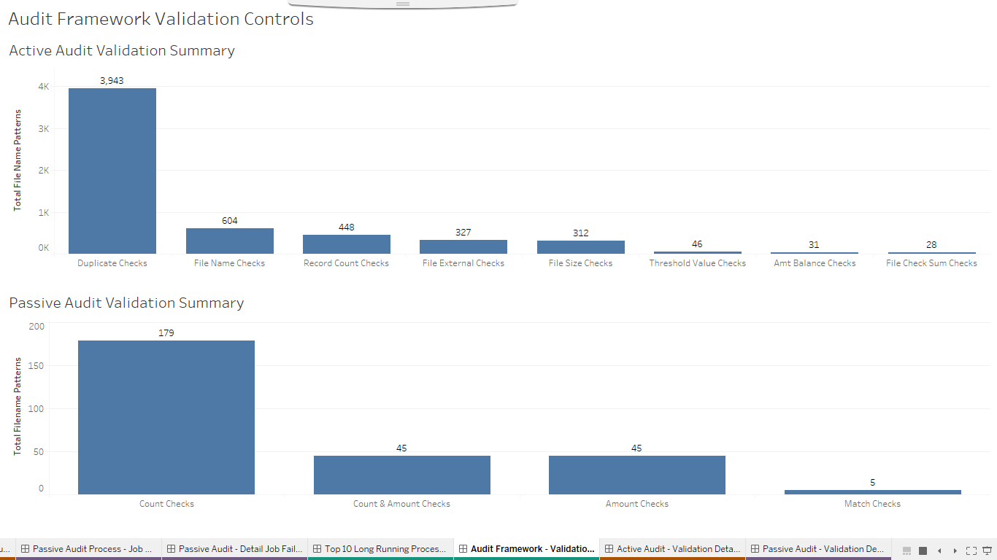

**Active Audit - Validation Details**

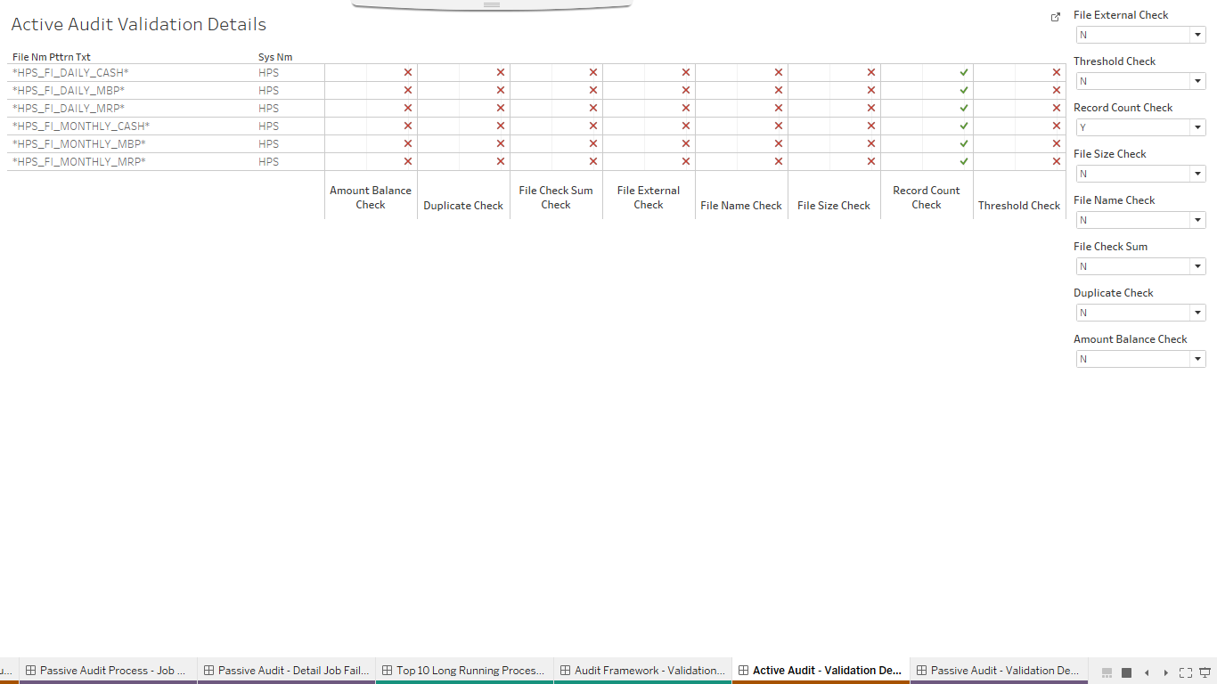

**Passive Audit - Validation Details**

