Reproducible Research: Peer Assessment 1

by Yiannis Manatos, © Feb. 2016

## R libraries initialization

# R libraries initialization  
library(scales)  
library(ggplot2)

## Warning: package 'ggplot2' was built under R version 3.2.3

library(dplyr)

## Warning: package 'dplyr' was built under R version 3.2.3

##   
## Attaching package: 'dplyr'

## The following objects are masked from 'package:stats':  
##   
## filter, lag

## The following objects are masked from 'package:base':  
##   
## intersect, setdiff, setequal, union

tz <- Sys.getenv("TZ")  
Sys.setenv(TZ = "GMT")

## I) Loading and preprocessing the data

# Read data from file  
all_data <- read.csv("activity.csv", header = TRUE)  
str(all_data)

## 'data.frame': 17568 obs. of 3 variables:  
## $ steps : int NA NA NA NA NA NA NA NA NA NA ...  
## $ date : Factor w/ 61 levels "2012-10-01","2012-10-02",..: 1 1 1 1 1 1 1 1 1 1 ...  
## $ interval: int 0 5 10 15 20 25 30 35 40 45 ...

# Add 'Date' column, from 'date'  
all_data$Date <- as.Date(all_data$date,   
 tz = "GMT")  
# Add 'Interval' column, from 'interval'  
all_data$Interval <- as.POSIXct(paste("2016-01-01", sprintf("%04d", all_data$interval)),   
 tz = "GMT",   
 format = "%Y-%m-%d %H%M")  
  
# Examine all data read  
str(all_data)

## 'data.frame': 17568 obs. of 5 variables:  
## $ steps : int NA NA NA NA NA NA NA NA NA NA ...  
## $ date : Factor w/ 61 levels "2012-10-01","2012-10-02",..: 1 1 1 1 1 1 1 1 1 1 ...  
## $ interval: int 0 5 10 15 20 25 30 35 40 45 ...  
## $ Date : Date, format: "2012-10-01" "2012-10-01" ...  
## $ Interval: POSIXct, format: "2016-01-01 00:00:00" "2016-01-01 00:05:00" ...

head(all_data)

## steps date interval Date Interval  
## 1 NA 2012-10-01 0 2012-10-01 2016-01-01 00:00:00  
## 2 NA 2012-10-01 5 2012-10-01 2016-01-01 00:05:00  
## 3 NA 2012-10-01 10 2012-10-01 2016-01-01 00:10:00  
## 4 NA 2012-10-01 15 2012-10-01 2016-01-01 00:15:00  
## 5 NA 2012-10-01 20 2012-10-01 2016-01-01 00:20:00  
## 6 NA 2012-10-01 25 2012-10-01 2016-01-01 00:25:00

summary(all_data)

## steps date interval Date   
## Min. : 0.00 2012-10-01: 288 Min. : 0.0 Min. :2012-10-01   
## 1st Qu.: 0.00 2012-10-02: 288 1st Qu.: 588.8 1st Qu.:2012-10-16   
## Median : 0.00 2012-10-03: 288 Median :1177.5 Median :2012-10-31   
## Mean : 37.38 2012-10-04: 288 Mean :1177.5 Mean :2012-10-31   
## 3rd Qu.: 12.00 2012-10-05: 288 3rd Qu.:1766.2 3rd Qu.:2012-11-15   
## Max. :806.00 2012-10-06: 288 Max. :2355.0 Max. :2012-11-30   
## NA's :2304 (Other) :15840   
## Interval   
## Min. :2016-01-01 00:00:00   
## 1st Qu.:2016-01-01 05:58:45   
## Median :2016-01-01 11:57:30   
## Mean :2016-01-01 11:57:30   
## 3rd Qu.:2016-01-01 17:56:15   
## Max. :2016-01-01 23:55:00   
##

## II) What is mean total number of steps taken per day?

# Filter out incomplete cases   
good_data <- all_data[complete.cases(all_data),]  
str(good_data)

## 'data.frame': 15264 obs. of 5 variables:  
## $ steps : int 0 0 0 0 0 0 0 0 0 0 ...  
## $ date : Factor w/ 61 levels "2012-10-01","2012-10-02",..: 2 2 2 2 2 2 2 2 2 2 ...  
## $ interval: int 0 5 10 15 20 25 30 35 40 45 ...  
## $ Date : Date, format: "2012-10-02" "2012-10-02" ...  
## $ Interval: POSIXct, format: "2016-01-01 00:00:00" "2016-01-01 00:05:00" ...

# Calculate the total number of steps taken per day  
steps_by_day <- summarise( group_by(good_data, Date), sum(steps) )  
str(steps_by_day)

## Classes 'tbl_df', 'tbl' and 'data.frame': 53 obs. of 2 variables:  
## $ Date : Date, format: "2012-10-02" "2012-10-03" ...  
## $ sum(steps): int 126 11352 12116 13294 15420 11015 12811 9900 10304 17382 ...

steps_per_day <- steps_by_day[[2]]  
  
# Make a histogram of the total number of steps taken each day  
hist( steps_per_day,   
 xlab = "# of steps per day",   
 main = "Total # steps taken each day" )

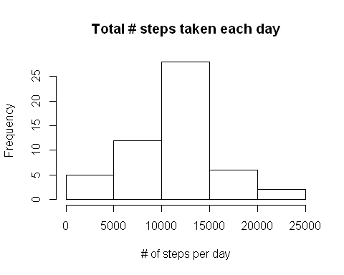

# Calculate and report the mean and median of the total number of steps taken per day  
mean_steps_per_day <- format(mean(steps_per_day))  
median_steps_per_day <- format(median(steps_per_day))

#### The **mean** of the total number of steps taken per day is: **10766.19** .

#### The **median** of the total number of steps taken per day is: **10765** .

## III) What is the average daily activity pattern?

# Calculate the total number of steps taken per 5-minute interval (across all days)  
steps_by_interval <- summarise( group_by(good_data, Interval), sum(steps), mean(steps) )  
str(steps_by_interval)

## Classes 'tbl_df', 'tbl' and 'data.frame': 288 obs. of 3 variables:  
## $ Interval : POSIXct, format: "2016-01-01 00:00:00" "2016-01-01 00:05:00" ...  
## $ sum(steps) : int 91 18 7 8 4 111 28 46 0 78 ...  
## $ mean(steps): num 1.717 0.3396 0.1321 0.1509 0.0755 ...

names(steps_by_interval) <- c("Interval", "steps_sum", "steps_mean")  
# Examine the interval-grouped data  
str(steps_by_interval)

## Classes 'tbl_df', 'tbl' and 'data.frame': 288 obs. of 3 variables:  
## $ Interval : POSIXct, format: "2016-01-01 00:00:00" "2016-01-01 00:05:00" ...  
## $ steps_sum : int 91 18 7 8 4 111 28 46 0 78 ...  
## $ steps_mean: num 1.717 0.3396 0.1321 0.1509 0.0755 ...

head(steps_by_interval)

## Source: local data frame [6 x 3]  
##   
## Interval steps_sum steps_mean  
## (time) (int) (dbl)  
## 1 2016-01-01 00:00:00 91 1.7169811  
## 2 2016-01-01 00:05:00 18 0.3396226  
## 3 2016-01-01 00:10:00 7 0.1320755  
## 4 2016-01-01 00:15:00 8 0.1509434  
## 5 2016-01-01 00:20:00 4 0.0754717  
## 6 2016-01-01 00:25:00 111 2.0943396

summary(steps_by_interval)

## Interval steps_sum steps_mean   
## Min. :2016-01-01 00:00:00 Min. : 0.0 Min. : 0.000   
## 1st Qu.:2016-01-01 05:58:45 1st Qu.: 131.8 1st Qu.: 2.486   
## Median :2016-01-01 11:57:30 Median : 1808.0 Median : 34.113   
## Mean :2016-01-01 11:57:30 Mean : 1981.3 Mean : 37.383   
## 3rd Qu.:2016-01-01 17:56:15 3rd Qu.: 2800.2 3rd Qu.: 52.835   
## Max. :2016-01-01 23:55:00 Max. :10927.0 Max. :206.170

# Make a simple time-series plot of the 5-minute interval (x-axis)  
# and the average number of steps taken, averaged across all days (y-axis)  
with(steps_by_interval, plot( Interval, steps_mean, type = "l",   
 xlab = "5-min interval",  
 ylab = "# of steps",   
 main = c("Average # steps per 5-min interval",   
 "across all days",   
 "(simple version, see below for a better one)") ))

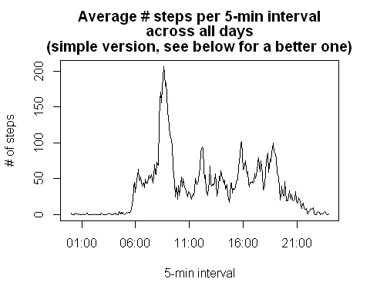

# Make a better time-series plot, handling intervals scale more accurately  
ggplot(steps_by_interval,   
 mapping = aes(Interval, steps_mean)) +   
 geom_line() +   
 labs( x = "5-min interval",   
 y = "# of steps",   
 title = "Average # steps per 5-min interval\nacross all days\n(more accurate intervals version)") +  
 scale_x_datetime(breaks = date_breaks("2 hour"),   
 labels = date_format("%H:%M"))

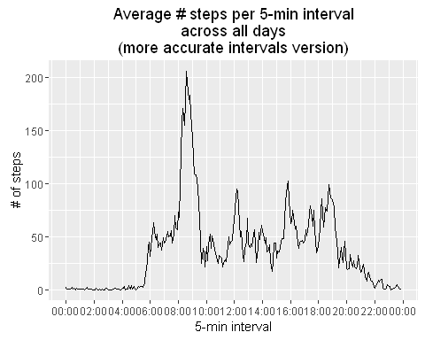

# Calculate and report the 5-min interval, on average across all the days  
# in the dataset, that contains the maximum number of steps  
max_i_mean <- max(steps_by_interval$steps_mean)  
max_i_row <- steps_by_interval[steps_by_interval$steps_mean == max_i_mean, ]  
max_interval <- format(max_i_row[1, 1],  
 tz = "GMT",   
 format = "%H:%M")

#### The **5-min interval** in the dataset containing the **maximum number of steps**, on average across all the days, is: **08:35** .

## IV) Imputing missing values

# 1. Calculate and report the total number of missing values in the dataset  
# (i.e. the total number of rows with NAs)  
na_rows <- sum( is.na(all_data$steps) )

#### 1. The **total number of missing values** in the dataset (i.e. the total number of rows with NAs), is: **2304** .

# 2. Devise a strategy for filling in all of the missing values in the dataset.  
# The strategy does not need to be sophisticated. For example, you could use the mean/median for  
# that day, or the mean for that 5-minute interval, etc na_rows <- sum( is.na(all_data$steps) )

#### 2. The strategy chosen to follow for filling in all of the missing values in the dataset is to use **the rounded mean for the 5-minute interval**.

# 3. Create a new dataset that is equal to the original dataset but with the missing data filled in.  
new_data <- all_data[, c("steps", "Date", "Interval")]  
str(new_data)

## 'data.frame': 17568 obs. of 3 variables:  
## $ steps : int NA NA NA NA NA NA NA NA NA NA ...  
## $ Date : Date, format: "2012-10-01" "2012-10-01" ...  
## $ Interval: POSIXct, format: "2016-01-01 00:00:00" "2016-01-01 00:05:00" ...

# Fill in missing values, using the rounded mean of the 5-minute interval  
n <- nrow(new_data)  
for (i in 1:n)  
 if (is.na(new_data[i, 'steps']))  
 {  
 t <- new_data[i, 'Interval']  
 m <- steps_by_interval[steps_by_interval$Interval == t,   
 'steps_mean']  
 new_data[i, 'steps'] <- round(m)  
 }  
# Examine all data read  
str(new_data)

## 'data.frame': 17568 obs. of 3 variables:  
## $ steps : num 2 0 0 0 0 2 1 1 0 1 ...  
## $ Date : Date, format: "2012-10-01" "2012-10-01" ...  
## $ Interval: POSIXct, format: "2016-01-01 00:00:00" "2016-01-01 00:05:00" ...

head(new_data)

## steps Date Interval  
## 1 2 2012-10-01 2016-01-01 00:00:00  
## 2 0 2012-10-01 2016-01-01 00:05:00  
## 3 0 2012-10-01 2016-01-01 00:10:00  
## 4 0 2012-10-01 2016-01-01 00:15:00  
## 5 0 2012-10-01 2016-01-01 00:20:00  
## 6 2 2012-10-01 2016-01-01 00:25:00

summary(new_data)

## steps Date Interval   
## Min. : 0.00 Min. :2012-10-01 Min. :2016-01-01 00:00:00   
## 1st Qu.: 0.00 1st Qu.:2012-10-16 1st Qu.:2016-01-01 05:58:45   
## Median : 0.00 Median :2012-10-31 Median :2016-01-01 11:57:30   
## Mean : 37.38 Mean :2012-10-31 Mean :2016-01-01 11:57:30   
## 3rd Qu.: 27.00 3rd Qu.:2012-11-15 3rd Qu.:2016-01-01 17:56:15   
## Max. :806.00 Max. :2012-11-30 Max. :2016-01-01 23:55:00

# 4. Make a histogram of the total number of steps taken each day  
new_steps_by_day <- summarise( group_by(new_data, Date), sum(steps) )  
str(new_steps_by_day)

## Classes 'tbl_df', 'tbl' and 'data.frame': 61 obs. of 2 variables:  
## $ Date : Date, format: "2012-10-01" "2012-10-02" ...  
## $ sum(steps): num 10762 126 11352 12116 13294 ...

new_steps_per_day <- new_steps_by_day[[2]]  
hist( new_steps_per_day,   
 xlab = "# of steps per day",   
 main = c("Total # steps taken each day", "(after NAs imputing)") )

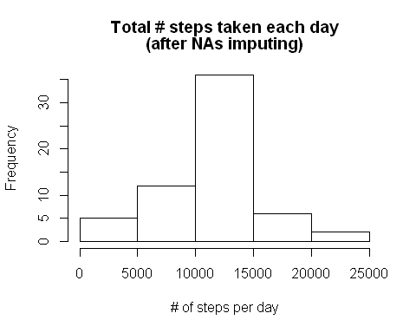

# Calculate and report the mean and median total number of steps taken per day.  
# Do these values differ from the estimates from the first part of the assignment?   
# What is the impact of imputing missing data on the estimates of the total daily number of steps?  
new_mean_steps_per_day <- format(mean(new_steps_per_day))  
new_median_steps_per_day <- format(median(new_steps_per_day))

#### The new **mean** of the total number of steps taken per day is: **10765.64** (before NAs imputing it was **10766.19**) .

#### The new **median** of the total number of steps taken per day is: **10762** (before NAs imputing it was **10765**) .

## V) Are there differences in activity patterns between weekdays and weekends?

# 1. Create a new factor variable in the dataset with two levels – “weekday” and “weekend”   
# indicating whether a given date is a weekday or weekend day.  
#new_data$Weekday <- factor(NA, levels = c("weekday", "weekend"))  
#new_data$Weekday <- weekdays(new_data$Date)  
weekday <- "weekday"  
weekend <- "weekend"  
days <- c(weekend,   
 weekday, weekday, weekday, weekday, weekday,   
 weekend)  
new_data$Weekday <- as.factor( days[ as.POSIXlt(new_data$Date)$wday + 1 ] )  
# Examine new_data updated  
str(new_data)

## 'data.frame': 17568 obs. of 4 variables:  
## $ steps : num 2 0 0 0 0 2 1 1 0 1 ...  
## $ Date : Date, format: "2012-10-01" "2012-10-01" ...  
## $ Interval: POSIXct, format: "2016-01-01 00:00:00" "2016-01-01 00:05:00" ...  
## $ Weekday : Factor w/ 2 levels "weekday","weekend": 1 1 1 1 1 1 1 1 1 1 ...

head(new_data)

## steps Date Interval Weekday  
## 1 2 2012-10-01 2016-01-01 00:00:00 weekday  
## 2 0 2012-10-01 2016-01-01 00:05:00 weekday  
## 3 0 2012-10-01 2016-01-01 00:10:00 weekday  
## 4 0 2012-10-01 2016-01-01 00:15:00 weekday  
## 5 0 2012-10-01 2016-01-01 00:20:00 weekday  
## 6 2 2012-10-01 2016-01-01 00:25:00 weekday

summary(new_data)

## steps Date Interval   
## Min. : 0.00 Min. :2012-10-01 Min. :2016-01-01 00:00:00   
## 1st Qu.: 0.00 1st Qu.:2012-10-16 1st Qu.:2016-01-01 05:58:45   
## Median : 0.00 Median :2012-10-31 Median :2016-01-01 11:57:30   
## Mean : 37.38 Mean :2012-10-31 Mean :2016-01-01 11:57:30   
## 3rd Qu.: 27.00 3rd Qu.:2012-11-15 3rd Qu.:2016-01-01 17:56:15   
## Max. :806.00 Max. :2012-11-30 Max. :2016-01-01 23:55:00   
## Weekday   
## weekday:12960   
## weekend: 4608   
##   
##   
##   
##

# 2. Make a panel plot containing a time series plot (i.e. type = "l") of the 5-min interval (x-axis)   
# and the average number of steps taken, averaged across all weekday days or weekend days (y-axis).  
# See the README file in the GitHub repository to see an example of what this plot should look like.  
  
# Calculate the total number of steps taken per 5-minute interval (across all days)  
new_steps_by_interval <- summarise( group_by(new_data, Weekday, Interval), sum(steps), mean(steps) )  
str(new_steps_by_interval)

## Classes 'grouped_df', 'tbl_df', 'tbl' and 'data.frame': 576 obs. of 4 variables:  
## $ Weekday : Factor w/ 2 levels "weekday","weekend": 1 1 1 1 1 1 1 1 1 1 ...  
## $ Interval : POSIXct, format: "2016-01-01 00:00:00" "2016-01-01 00:05:00" ...  
## $ sum(steps) : num 103 18 7 8 4 71 34 52 0 78 ...  
## $ mean(steps): num 2.2889 0.4 0.1556 0.1778 0.0889 ...  
## - attr(*, "vars")=List of 1  
## ..$ : symbol Weekday  
## - attr(*, "drop")= logi TRUE

names(new_steps_by_interval) <- c("Weekday", "Interval", "steps_sum", "steps_mean")  
# Examine the interval-grouped data  
str(new_steps_by_interval)

## Classes 'grouped_df', 'tbl_df', 'tbl' and 'data.frame': 576 obs. of 4 variables:  
## $ Weekday : Factor w/ 2 levels "weekday","weekend": 1 1 1 1 1 1 1 1 1 1 ...  
## $ Interval : POSIXct, format: "2016-01-01 00:00:00" "2016-01-01 00:05:00" ...  
## $ steps_sum : num 103 18 7 8 4 71 34 52 0 78 ...  
## $ steps_mean: num 2.2889 0.4 0.1556 0.1778 0.0889 ...  
## - attr(*, "vars")=List of 1  
## ..$ : symbol Weekday  
## - attr(*, "drop")= logi TRUE

head(new_steps_by_interval)

## Source: local data frame [6 x 4]  
## Groups: Weekday [1]  
##   
## Weekday Interval steps_sum steps_mean  
## (fctr) (time) (dbl) (dbl)  
## 1 weekday 2016-01-01 00:00:00 103 2.28888889  
## 2 weekday 2016-01-01 00:05:00 18 0.40000000  
## 3 weekday 2016-01-01 00:10:00 7 0.15555556  
## 4 weekday 2016-01-01 00:15:00 8 0.17777778  
## 5 weekday 2016-01-01 00:20:00 4 0.08888889  
## 6 weekday 2016-01-01 00:25:00 71 1.57777778

summary(new_steps_by_interval)

## Weekday Interval steps_sum   
## weekday:288 Min. :2016-01-01 00:00:00 Min. : 0.00   
## weekend:288 1st Qu.:2016-01-01 05:58:45 1st Qu.: 58.75   
## Median :2016-01-01 11:57:30 Median : 778.00   
## Mean :2016-01-01 11:57:30 Mean : 1140.11   
## 3rd Qu.:2016-01-01 17:56:15 3rd Qu.: 1587.75   
## Max. :2016-01-01 23:55:00 Max. :10366.00   
## steps_mean   
## Min. : 0.000   
## 1st Qu.: 2.106   
## Median : 28.125   
## Mean : 38.987   
## 3rd Qu.: 61.230   
## Max. :230.356

# Make the 2-facet plot  
ggplot(new_steps_by_interval,   
 mapping = aes(Interval, steps_mean)) +   
 geom_line() +   
 facet_grid(Weekday ~ .) +  
 labs( x = "5-min interval",   
 y = "# of steps",   
 title = "Average # steps per 5-min interval\nacross all days\n(accurate intervals grouped version)") +  
 scale_x_datetime(breaks = date_breaks("2 hour"),   
 labels = date_format("%H:%M"))

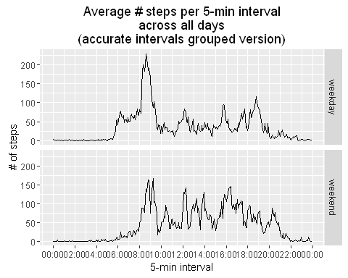

## -- END-OF-REPORT --

Sys.setenv(TZ = tz)