Supplementary material. Does language change the outcome? A trilingual study of language-conditioned outcome variation in LLM legal reasoning
Yiolanti Maou. Repository: https://github.com/ymaou/language-legal-outcome-variation
Supplementary Table 1. Main run (the model decides the application as a judge): what each model decided in Greek, its agreement with the courts' orders, and the pre-specified rates. Each model decided each case 31 times in each version and 62 times in Greek. Agreement with court is the share of the ten cases on which the Greek modal outcome matched the court's order (majority-class baseline 0.40); MCC is the Matthews correlation coefficient. F (noise floor), W (rewording rate) and L (language rate) are shares of the ten cases on which the modal outcome changed: between two random halves of the Greek draws (F), between a Greek half and the back-translation (W), and between a Greek half and the translation (L); "en" and "de" denote the English and German routes. Δ_EN = L_EN − W_en, with a 95% interval from a paired bootstrap over cases (10,000 resamples). Mean D is the share of draws granting relief in English minus that share across all Greek draws, averaged over cases. "Ground differs" is the share of comparisons, among those in which the modal outcome held, in which the modal ground differed.
Model | Greek draws dismissed | Greek draws granting relief | Agreement with court | MCC | F | W_en | L_EN | Δ_EN [95% CI] | W_de | L_DE | Mean D [95% CI] | Ground differs: EN / BT-en
GPT-5.6 Terra | 620/620 | 0/620 | 0.40 | 0.00 | 0.00 | 0.00 | 0.00 | 0.00 [0.00, 0.00] | 0.00 | 0.00 | 0.00 [0.00, 0.01] | 0.10 / 0.00
GPT-5.6 Terra, reasoning off | 597/620 | 23/620 | 0.40 | 0.00 | 0.00 | 0.00 | 0.00 | 0.00 [0.00, 0.00] | 0.00 | 0.00 | −0.04 [−0.11, 0.00] | 0.40 / 0.20
Claude Sonnet 5 | 546/620 | 74/620 | 0.40 | 0.00 | 0.00 | 0.20 | 0.00 | −0.20 [−0.50, 0.00] | 0.10 | 0.00 | −0.10 [−0.18, −0.04] | 0.36 / 0.11
Gemini 3.6 Flash | 577/620 | 43/620 | 0.50 | 0.29 | 0.00 | 0.00 | 0.00 | 0.00 [0.00, 0.00] | 0.10 | 0.10 | −0.01 [−0.03, 0.01] | 0.00 / 0.00

Supplementary Table 2. Decide against predict, Greek and English versions. Under "decide" (main run) the model decides the application as a judge, 31 draws per version and 62 in Greek; under "predict" (exploratory run, designed after the main results were known) it predicts the court's decision as a legal analyst, 15 draws per version and 30 in Greek. Measures as in Supplementary Table 1. The predictive run had no back-translation version, so its language rate is not net of rewording.
Model | Framing | Greek draws dismissed | Agreement with court | F | L_EN | Mean D [95% CI] | Cases flipping to refusal in English
GPT-5.6 Terra | decide | 620/620 | 0.40 | 0.00 | 0.00 | 0.00 [0.00, 0.01] | 0
GPT-5.6 Terra | predict | 300/300 | 0.40 | 0.00 | 0.00 | 0.02 [0.00, 0.06] | 0
GPT-5.6 Terra, reasoning off | decide | 597/620 | 0.40 | 0.00 | 0.00 | −0.04 [−0.11, 0.00] | 0
GPT-5.6 Terra, reasoning off | predict | 300/300 | 0.40 | 0.00 | 0.00 | 0.00 [0.00, 0.00] | 0
Claude Sonnet 5 | decide | 546/620 | 0.40 | 0.00 | 0.00 | −0.10 [−0.18, −0.04] | 0
Claude Sonnet 5 | predict | 196/300 | 0.50 | 0.18 | 0.33 | −0.31 [−0.47, −0.15] | 3
Gemini 3.6 Flash | decide | 577/620 | 0.50 | 0.00 | 0.00 | −0.01 [−0.03, 0.01] | 0
Gemini 3.6 Flash | predict | 277/300 | 0.50 | 0.01 | 0.01 | 0.00 [−0.03, 0.03] | 0

Supplementary Table 3. Considerations invoked in the models' reasoning in the main run: the share of each model's 2,170 valid replies, across all ten cases and six versions, in which an automated keyword screen in Greek, English and German matched the consideration. A screen, not hand coding; the patterns are in scripts/keyword_screen.py.
Consideration invoked in the reasoning | GPT-5.6 Terra | GPT-5.6 Terra, reasoning off | Claude Sonnet 5 | Gemini 3.6 Flash
Disputed facts / conflicting evidence | 74% | 73% | 82% | 71%
Credibility / cross-examination | 11% | 11% | 63% | 3%
Trial or full hearing needed | 34% | 46% | 77% | 57%
Fanciful / realistic distinction | 19% | 18% | 16% | 16%
Documents / expert evidence needed | 7% | 9% | 11% | 4%
Real prospect (the limb (a) phrase) | 76% | 75% | 70% | 99%
Compelling reason (the limb (b) phrase) | 18% | 27% | 22% | 6%
Mini-trial | 0% | 0% | 0% | 0%

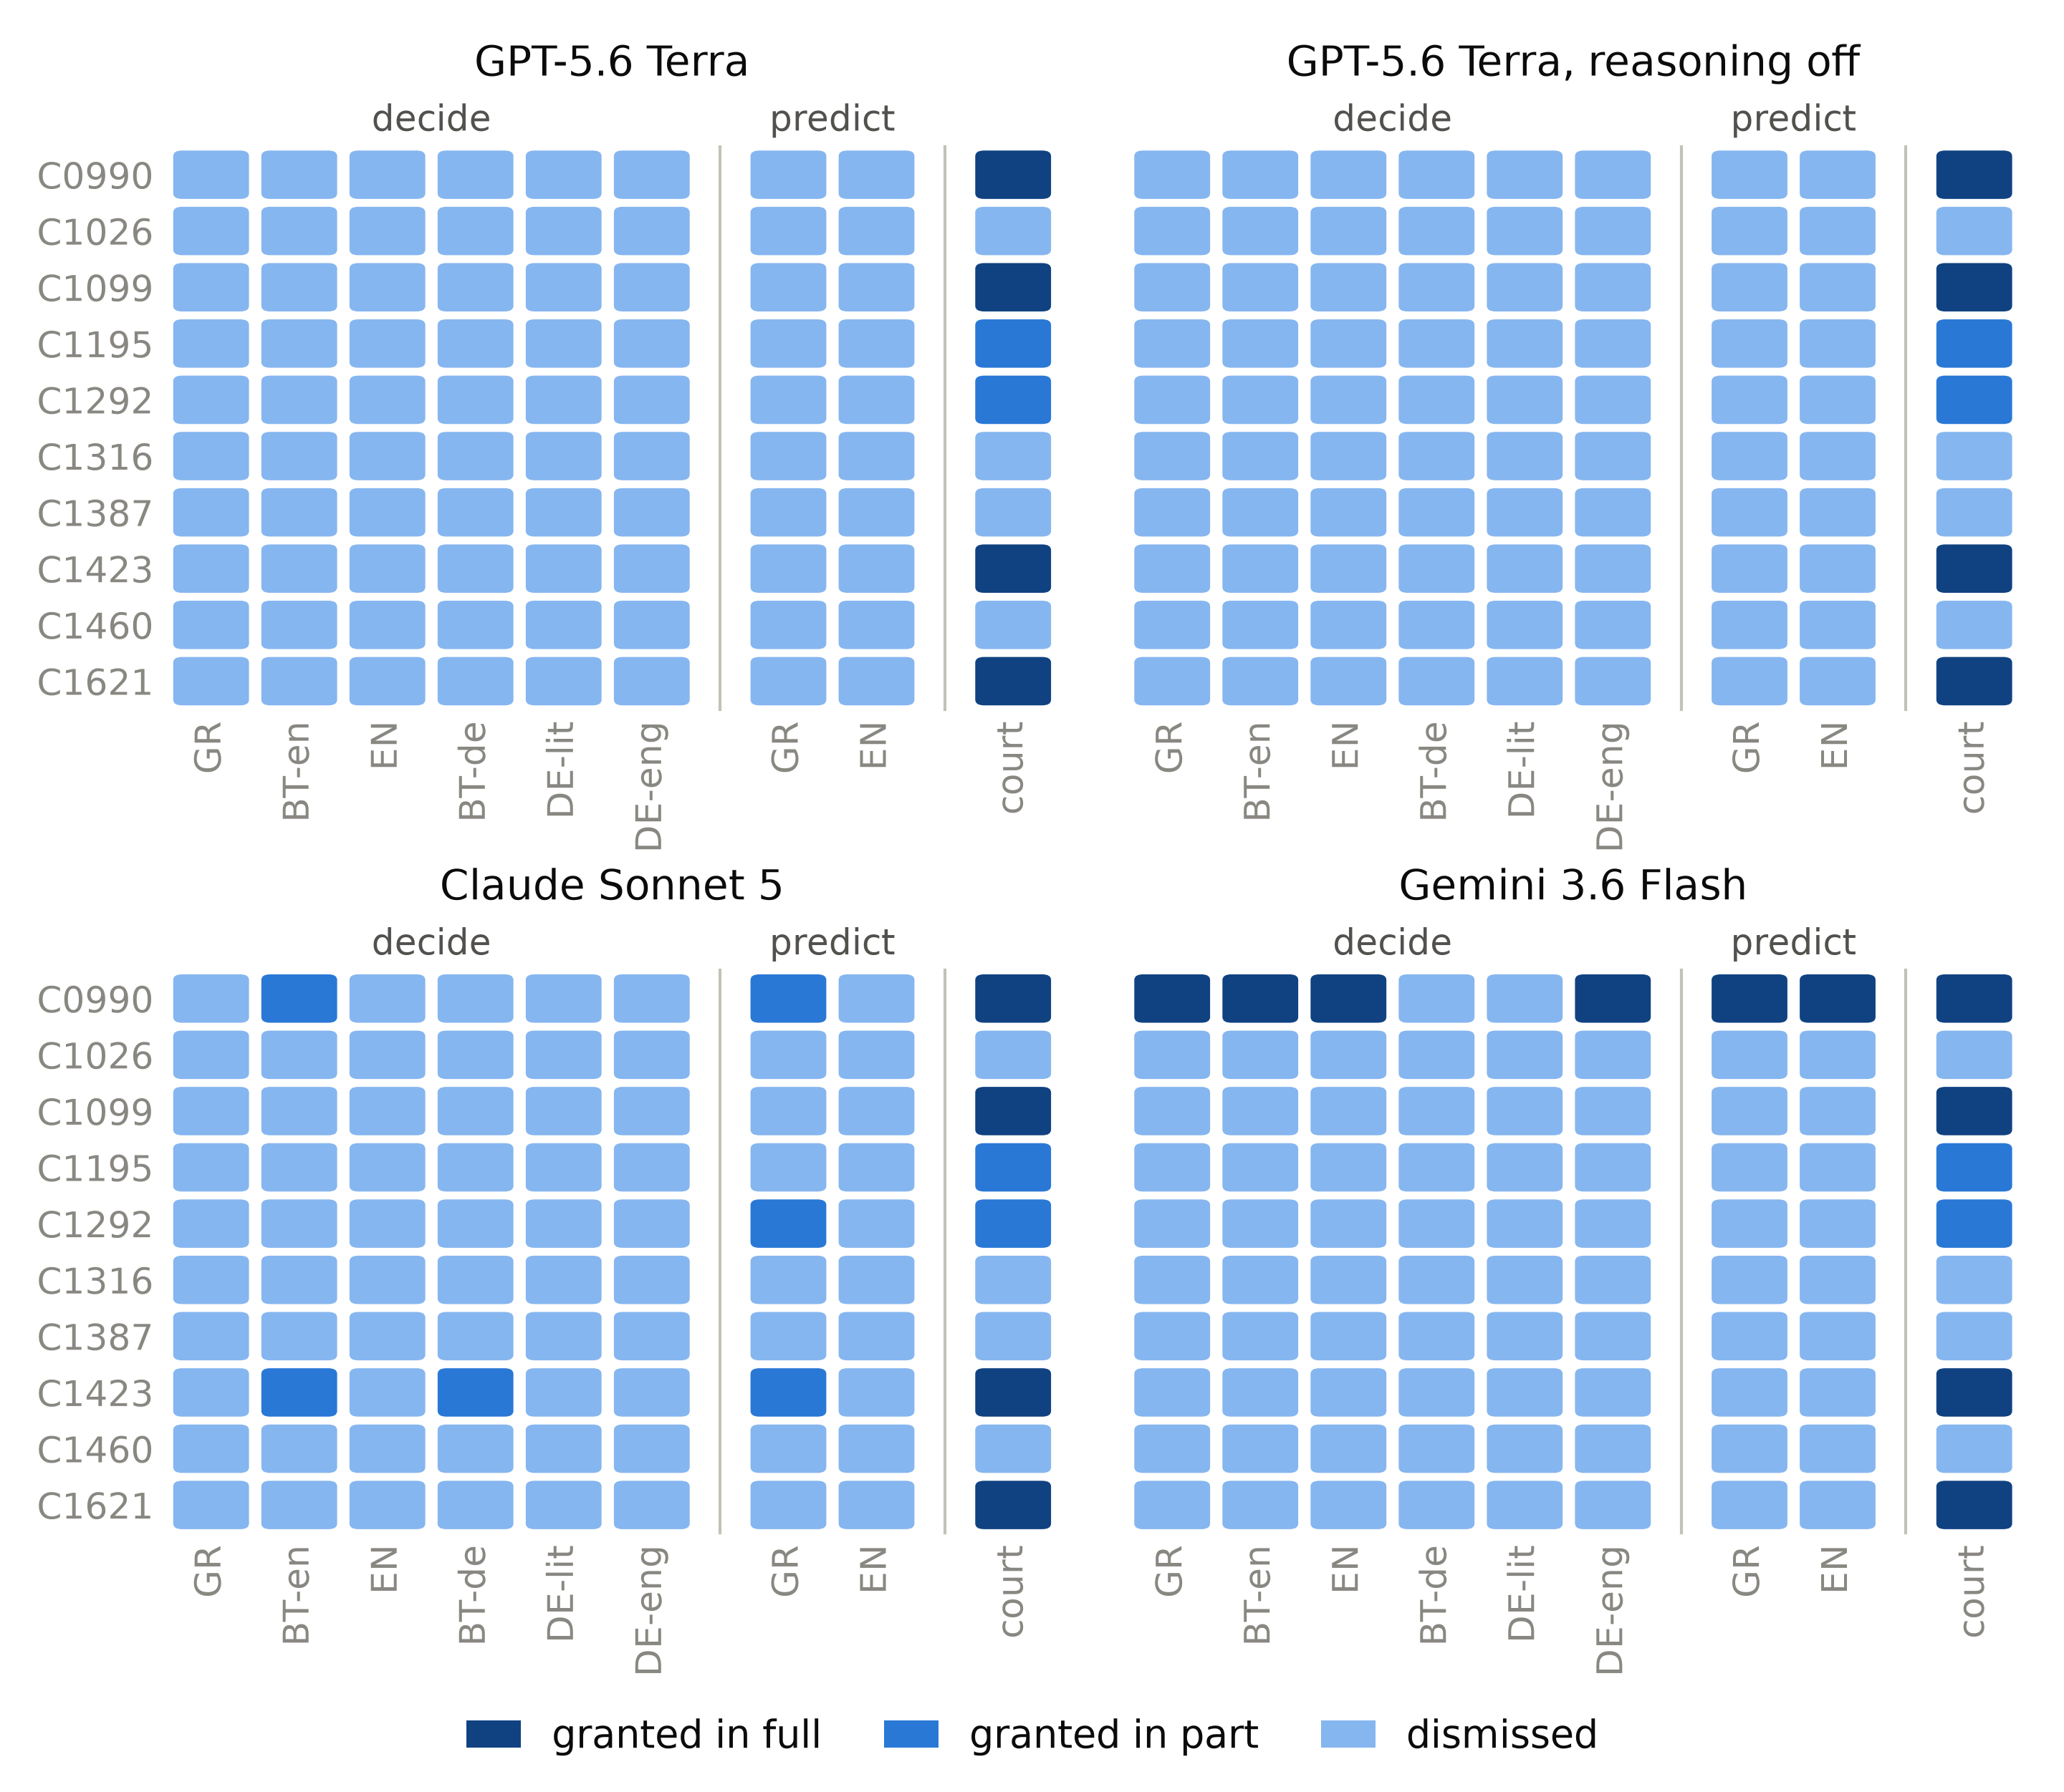
Supplementary Figure 1. Modal outcome per case for each model, with the court's order. Each cell is the outcome chosen most often across the draws for that case: 31 per version (62 for Greek) under the decide framing, 15 (30 for Greek) under the predict framing. GR: Greek original; BT-en: Greek back-translation of the English; EN: English; BT-de: Greek back-translation of the German; DE-lit: German with German Part 24 terms; DE-eng: German with the English Part 24 terms.

