Does language change the outcome? Tables and figures (generated from results/main-1 and results/predict-1, commit 420cdbc; regenerate with scripts/paper_figures.py and scripts/results_package.py).
Table 1. Main run: what each model decided in Greek, its agreement with the court, and the pre-specified rates. F, W and L are the noise floor, rewording rate and language rate, each a share of the ten cases comparing 31 draws with 31 (Greek halves of 62); Δ_EN = L_EN − W_en, paired bootstrap over cases (10,000 resamples). Mean D is the grant share in English minus the grant share across all Greek draws, averaged over cases. "Ground differs" is the share of comparisons, among those where the modal outcome held, in which the modal ground differed: Greek against English, and Greek against the back-translation.
Model | Dismissed (Greek) | Granted, full or part (Greek) | Agreement with court | MCC | F | W_en | L_EN | Δ_EN [95% CI] | W_de | L_DE | Mean D [95% CI] | Ground differs, EN / BT-en
GPT-5.6 Terra | 100% | 0% | 0.40 | 0.00 | 0.00 | 0.00 | 0.00 | 0.00 [0.00, 0.00] | 0.00 | 0.00 | 0.00 [0.00, 0.01] | 0.10 / 0.00
Terra, reasoning off | 96% | 4% | 0.40 | 0.00 | 0.00 | 0.00 | 0.00 | 0.00 [0.00, 0.00] | 0.00 | 0.00 | -0.04 [-0.11, 0.00] | 0.40 / 0.20
Claude Sonnet 5 | 88% | 12% | 0.40 | 0.00 | 0.00 | 0.20 | 0.00 | -0.20 [-0.50, 0.00] | 0.10 | 0.00 | -0.10 [-0.18, -0.04] | 0.36 / 0.11
Gemini 3.6 Flash | 93% | 7% | 0.50 | 0.29 | 0.00 | 0.00 | 0.00 | 0.00 [0.00, 0.00] | 0.10 | 0.10 | -0.01 [-0.03, 0.01] | 0.00 / 0.00

Table 2. Decide against predict. The main run (the model decides as a judge; 31 draws per arm, 62 Greek) and the exploratory predictive run (the model predicts the court's decision as a legal analyst; 15 draws per arm, 30 Greek), Greek and English arms. Flips are cases whose Greek and English modal outcomes differ. The predictive run had no back-translation arm, so its language rate is not net of rewording.
Model | Dismissed (Greek), decide | Agreement with court, decide | F, decide | L_EN, decide | Mean D [95% CI], decide | Flips to refusing in EN, decide | Dismissed (Greek), predict | Agreement with court, predict | F, predict | L_EN, predict | Mean D [95% CI], predict | Flips to refusing in EN, predict
GPT-5.6 Terra | 100% | 0.40 | 0.00 | 0.00 | 0.00 [0.00, 0.01] | 0 | 100% | 0.40 | 0.00 | 0.00 | 0.02 [0.00, 0.06] | 0
Terra, reasoning off | 96% | 0.40 | 0.00 | 0.00 | -0.04 [-0.11, 0.00] | 0 | 100% | 0.40 | 0.00 | 0.00 | 0.00 [0.00, 0.00] | 0
Claude Sonnet 5 | 88% | 0.40 | 0.00 | 0.00 | -0.10 [-0.18, -0.04] | 0 | 65% | 0.50 | 0.18 | 0.33 | -0.31 [-0.47, -0.15] | 3
Gemini 3.6 Flash | 93% | 0.50 | 0.00 | 0.00 | -0.01 [-0.03, 0.01] | 0 | 92% | 0.50 | 0.01 | 0.01 | -0.00 [-0.03, 0.03] | 0

Table 3. Considerations invoked in the models' reasoning, as the share of all valid replies in the main run (10 cases × 6 arms per model) in which an automated keyword screen, in Greek, English and German, matched the consideration. A screen, not hand coding.
Consideration invoked in the reasoning (share of valid replies) | GPT-5.6 Terra | Terra, reasoning off | Claude Sonnet 5 | Gemini 3.6 Flash
disputed facts / conflicting evidence | 74% | 73% | 82% | 71%
credibility / cross-examination | 11% | 11% | 63% | 3%
trial or full hearing needed | 34% | 46% | 77% | 57%
fanciful / realistic distinction | 19% | 18% | 16% | 16%
documents / expert evidence needed | 7% | 9% | 11% | 4%
real prospect (the limb (a) phrase) | 76% | 75% | 70% | 99%
compelling reason (the limb (b) phrase) | 18% | 27% | 22% | 6%
mini-trial | 0% | 0% | 0% | 0%

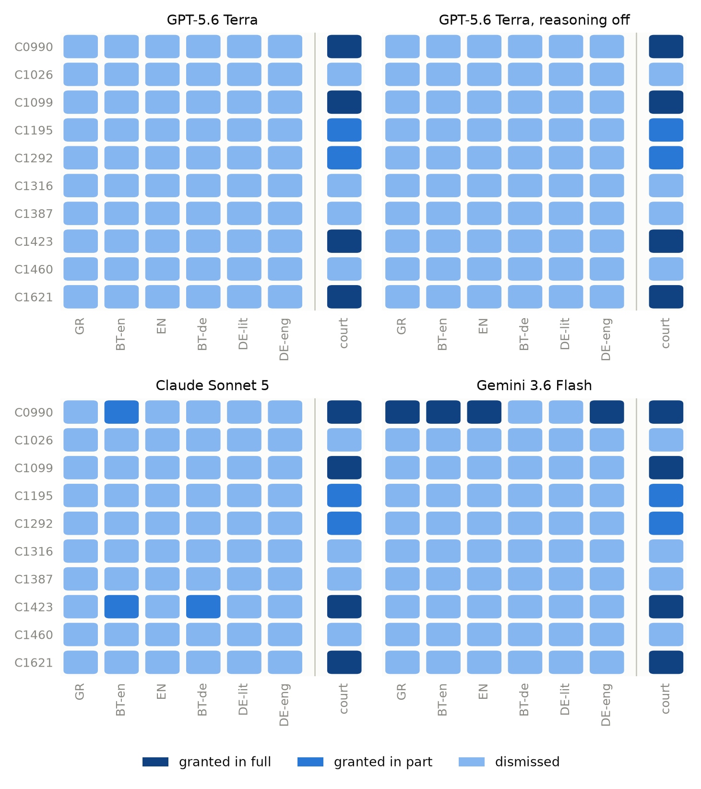
Figure 1. Modal outcome per case, arm and model in the main run, with the court's order in the separated right-hand column. Each cell is the outcome chosen by most of the block's draws (31; 62 for Greek). GR Greek; BT-en Greek back-translated from the English; EN English; BT-de Greek back-translated from the German; DE-lit German with German Part 24 terms; DE-eng German with the English Part 24 terms.
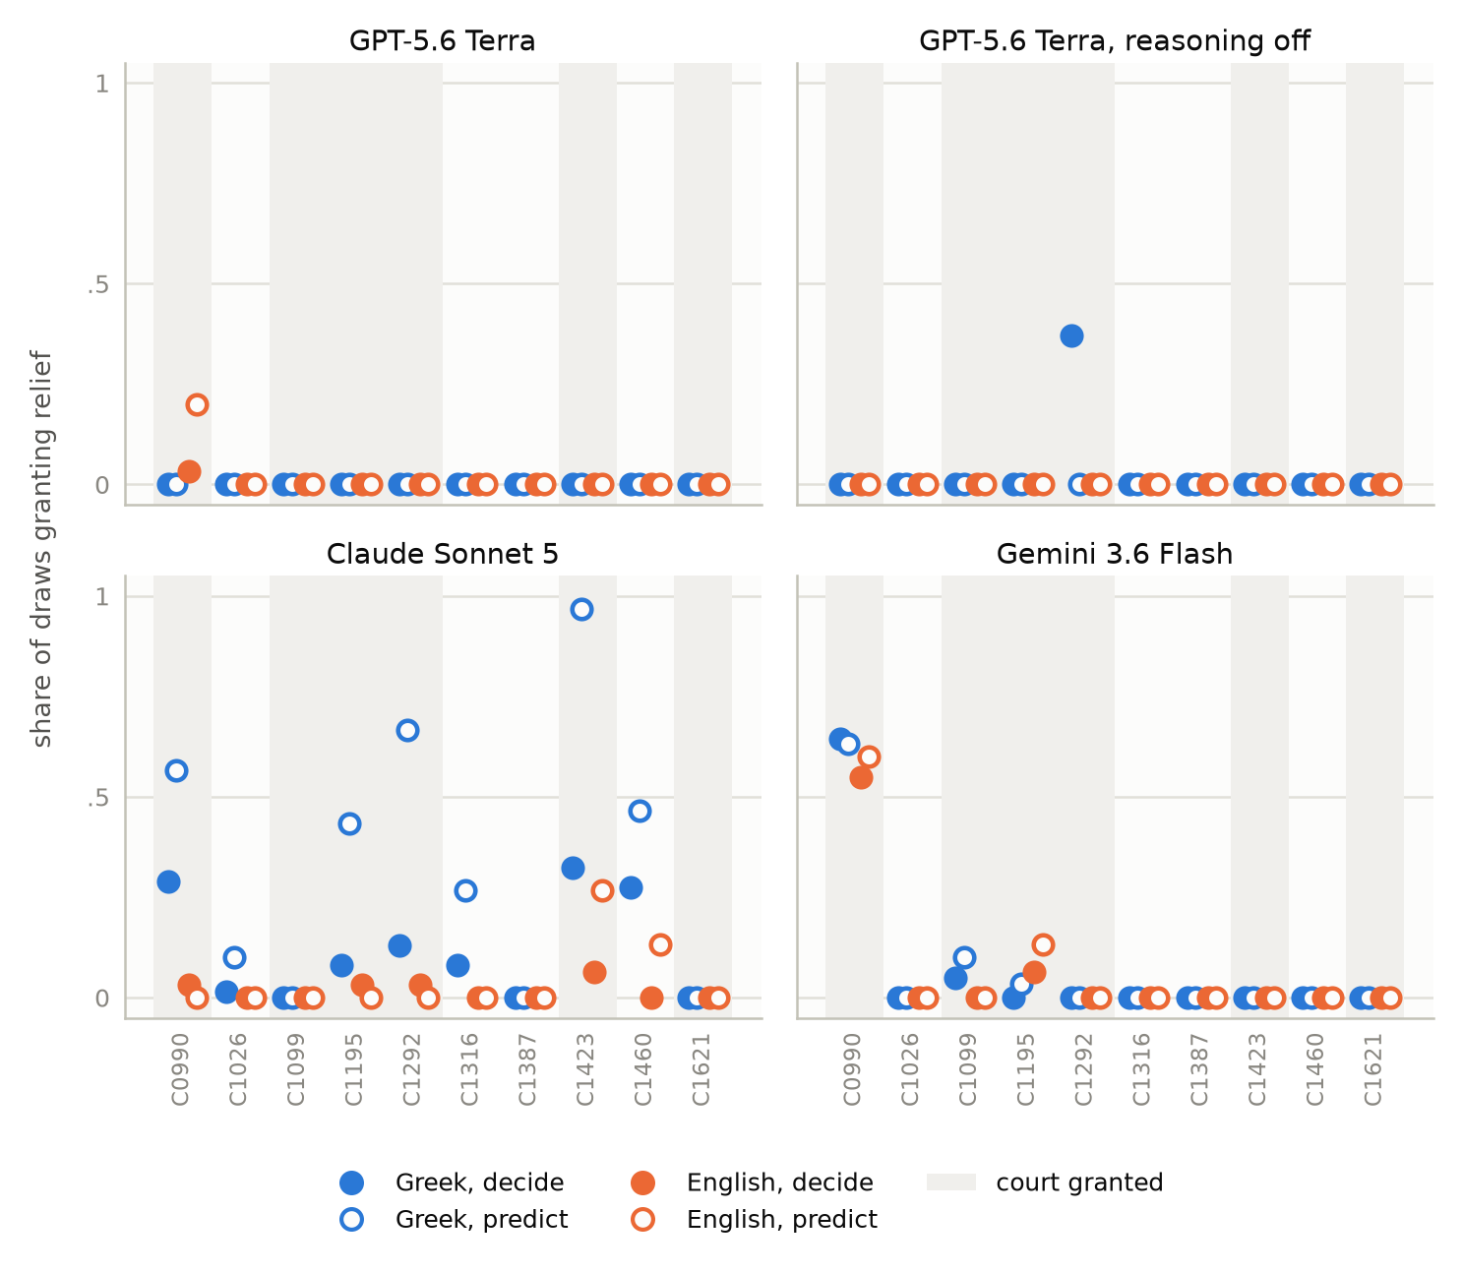
Figure 2. Grant share per case (share of draws granting the application in full or in part) under the decide framing (filled markers) and the predict framing (hollow), Greek (blue) and English (orange), one panel per model. Shaded columns are the cases the court granted in full or in part.

