[**TMA Warehouse**](https://github.com/ymatko/TMAWarehouse)

**Author:**

Yevhen Matko

Contents

1. Introduction 2

2. Microservices Overview 2

3. Directory Structure 3

4. Roles and Permissions The system defines various roles for users, including: 4

5. Database Schema 4

6. Gallery 5

# Introduction

This document serves as documentation for the Trade and Material Assets (TMA) Warehouse application. It provides an overview of the system, its features, roles, and database schema. The application consists of three microservices and utilizes Razor Pages for the view layer. Each microservice serves a specific purpose, contributing to the overall functionality of the system.

# Microservices Overview

1. Items Catalog Service:  
   a. Responsible for managing goods (addition, deletion, updating).  
   b. Provides an API for viewing the list of items, filtering, searching, and sorting.  
   c. Interacts with the database to store and retrieve information about items.
2. Purchase Requests Service:  
   a. Manages purchase requests for items.  
   b. Provides an API for creating new requests, viewing the list of requests, rejecting, and confirming requests.  
   c. Interacts with the database to store and retrieve information about purchase requests.
3. User Management & Authentication Service:  
   a. Handles user authentication and manages user accounts.  
   b. Provides API for user registration, login, role management, and access control.  
   c. Ensures security and access control to the microservices. Implements encryption using tokens.

# Directory Structure

The directory structure of the application includes separate folders for each microservice, along with a folder for the Razor Pages view:

Items Catalog Service

- Controllers  
 - Data  
 - Extensions

- Models  
 - Dto

- Utility

Purchase Requests Service

- Controllers  
 - Data  
 - Extensions

- Models  
 - Dto

- Utility

User Management & Authentication Service  
 - Controllers  
 - Data  
 - Extensions

- Models  
 - Dto  
 - Service

- Utility

View  
 - Controllers

- Models  
 - Dto  
 - Service

- Utility

- Views

# Roles and Permissions The system defines various roles for users, including:

1. Employee: Can create purchase requests.
2. Coordinator: Manages goods and purchase requests.
3. Administrator: Manages user accounts and access rights.

# Database Schema

Each microservice interacts with its own database, storing relevant information.

# 6. Gallery

Login & Register:

Employee:

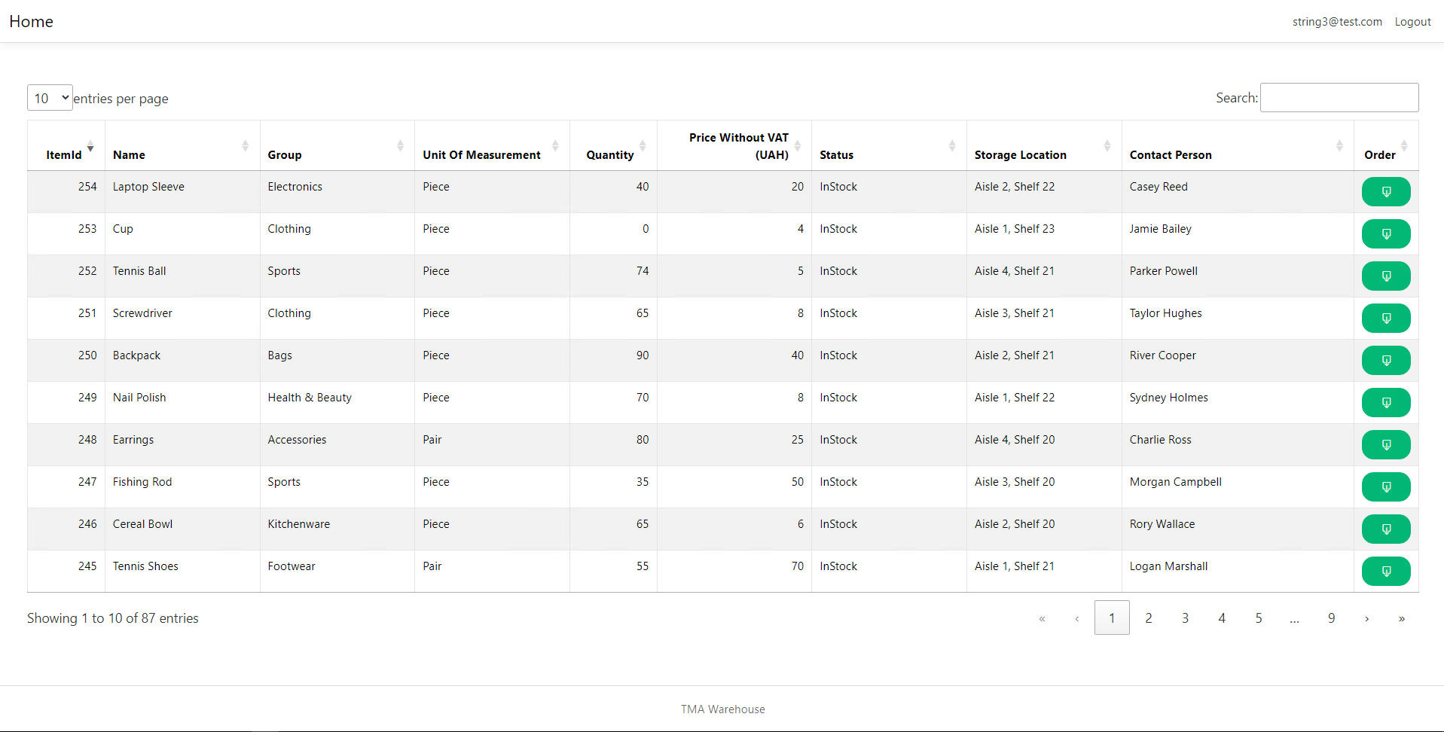

Coordinator: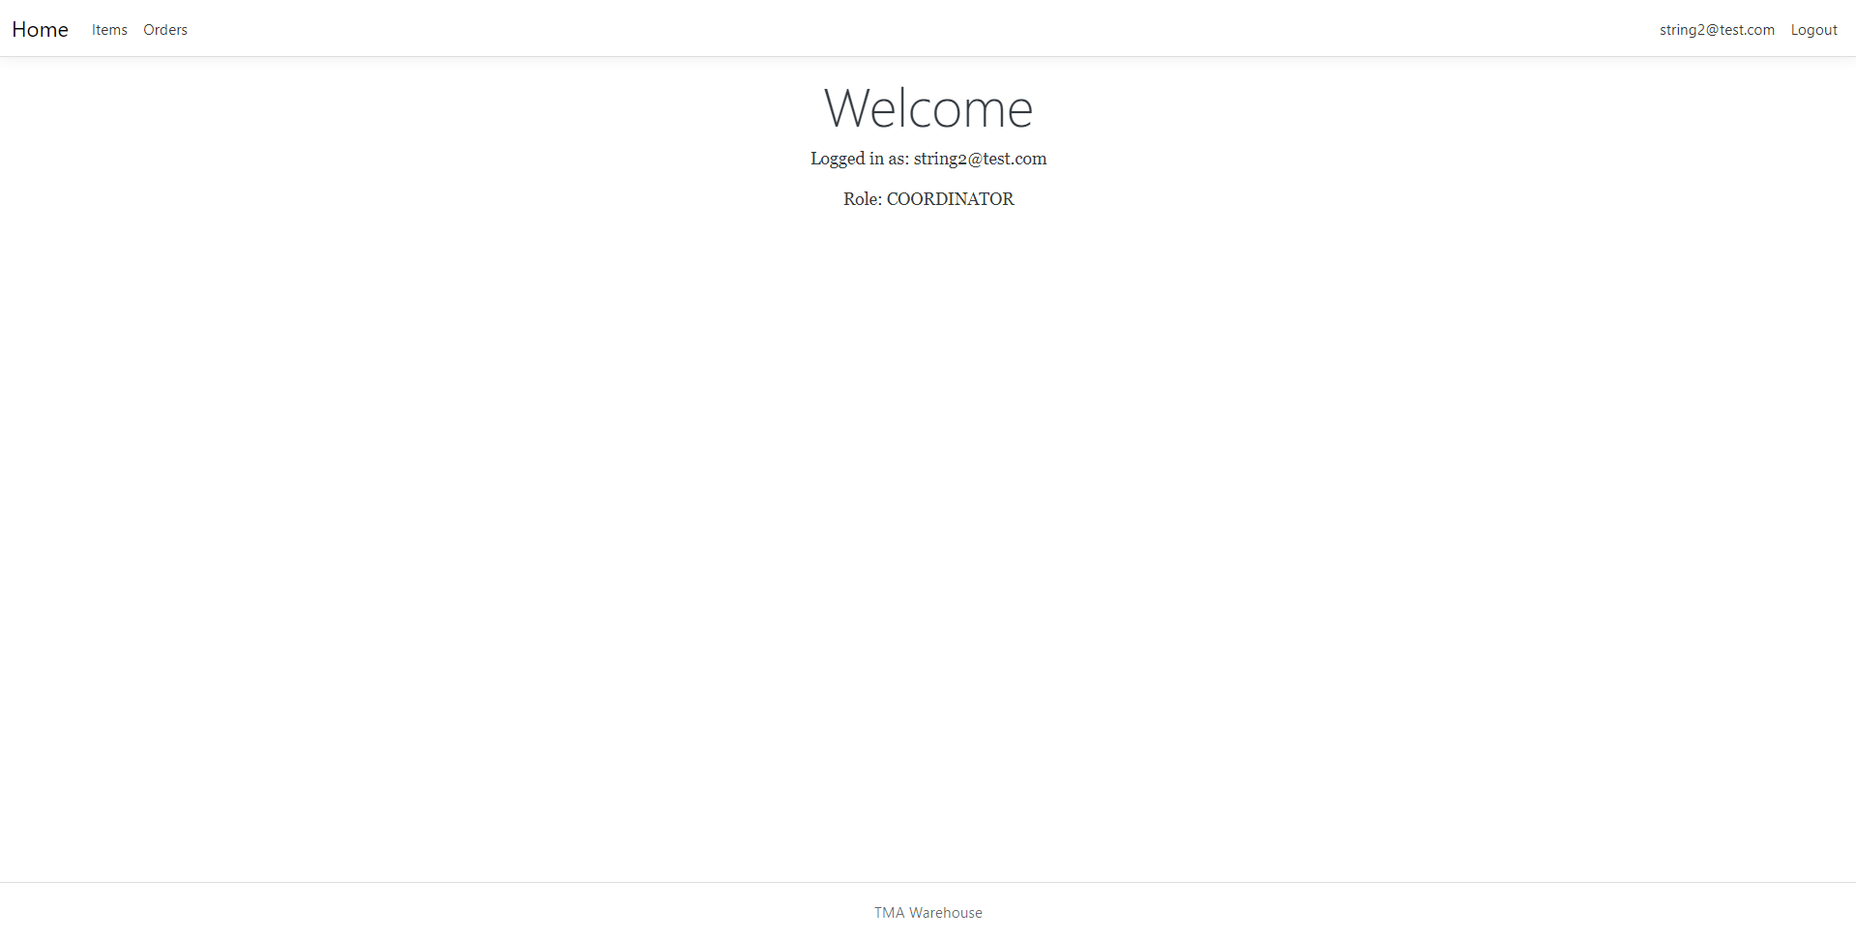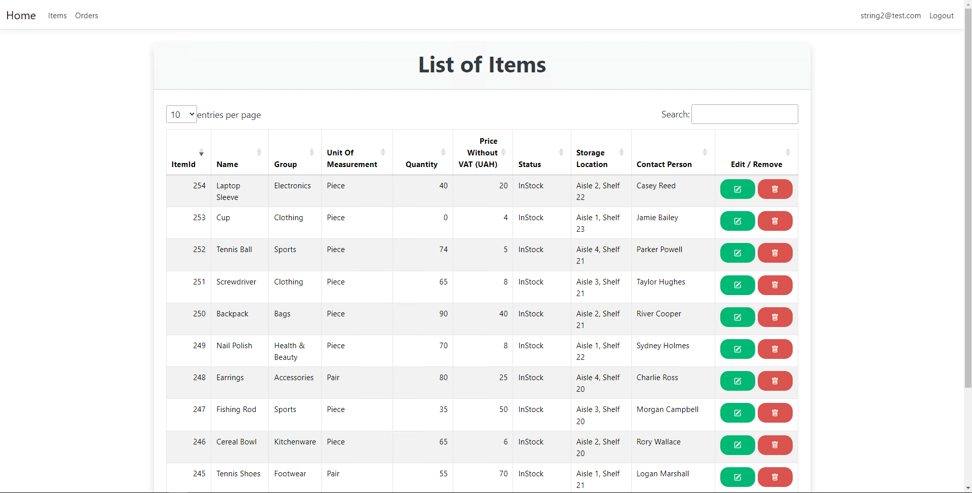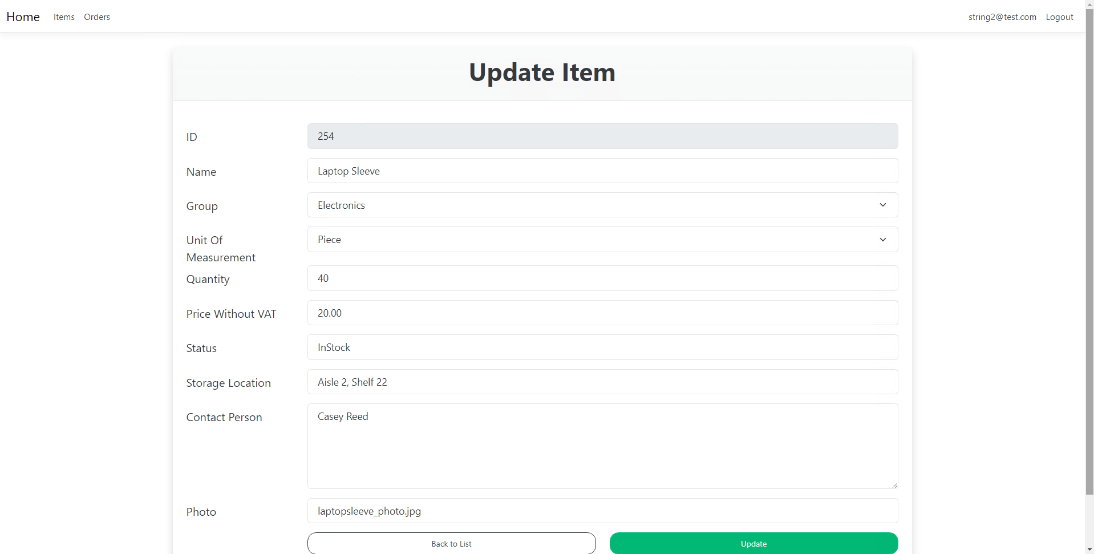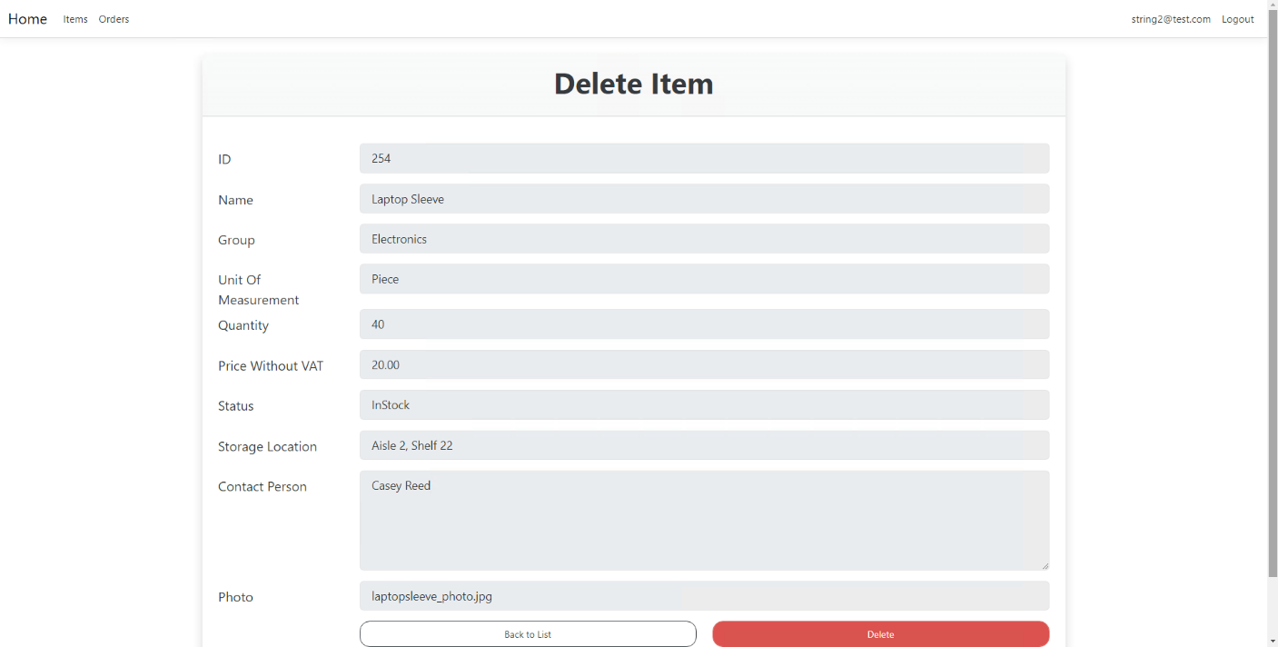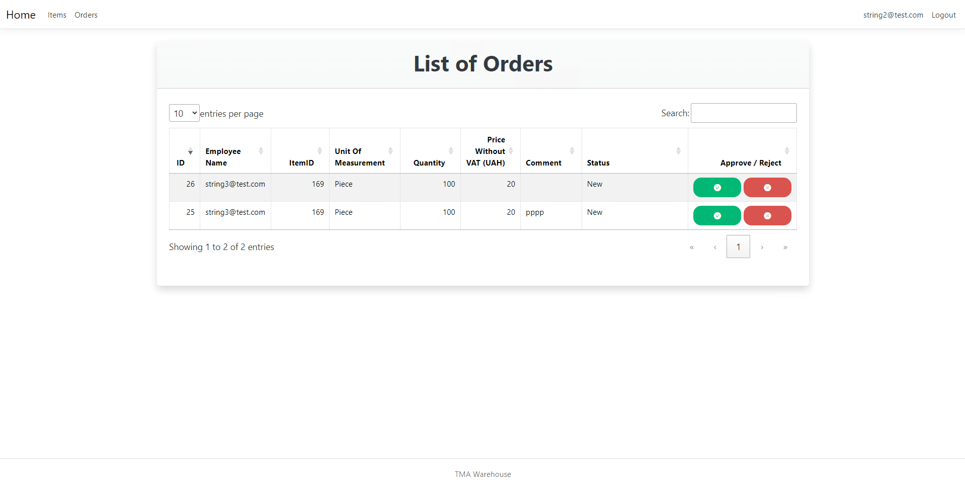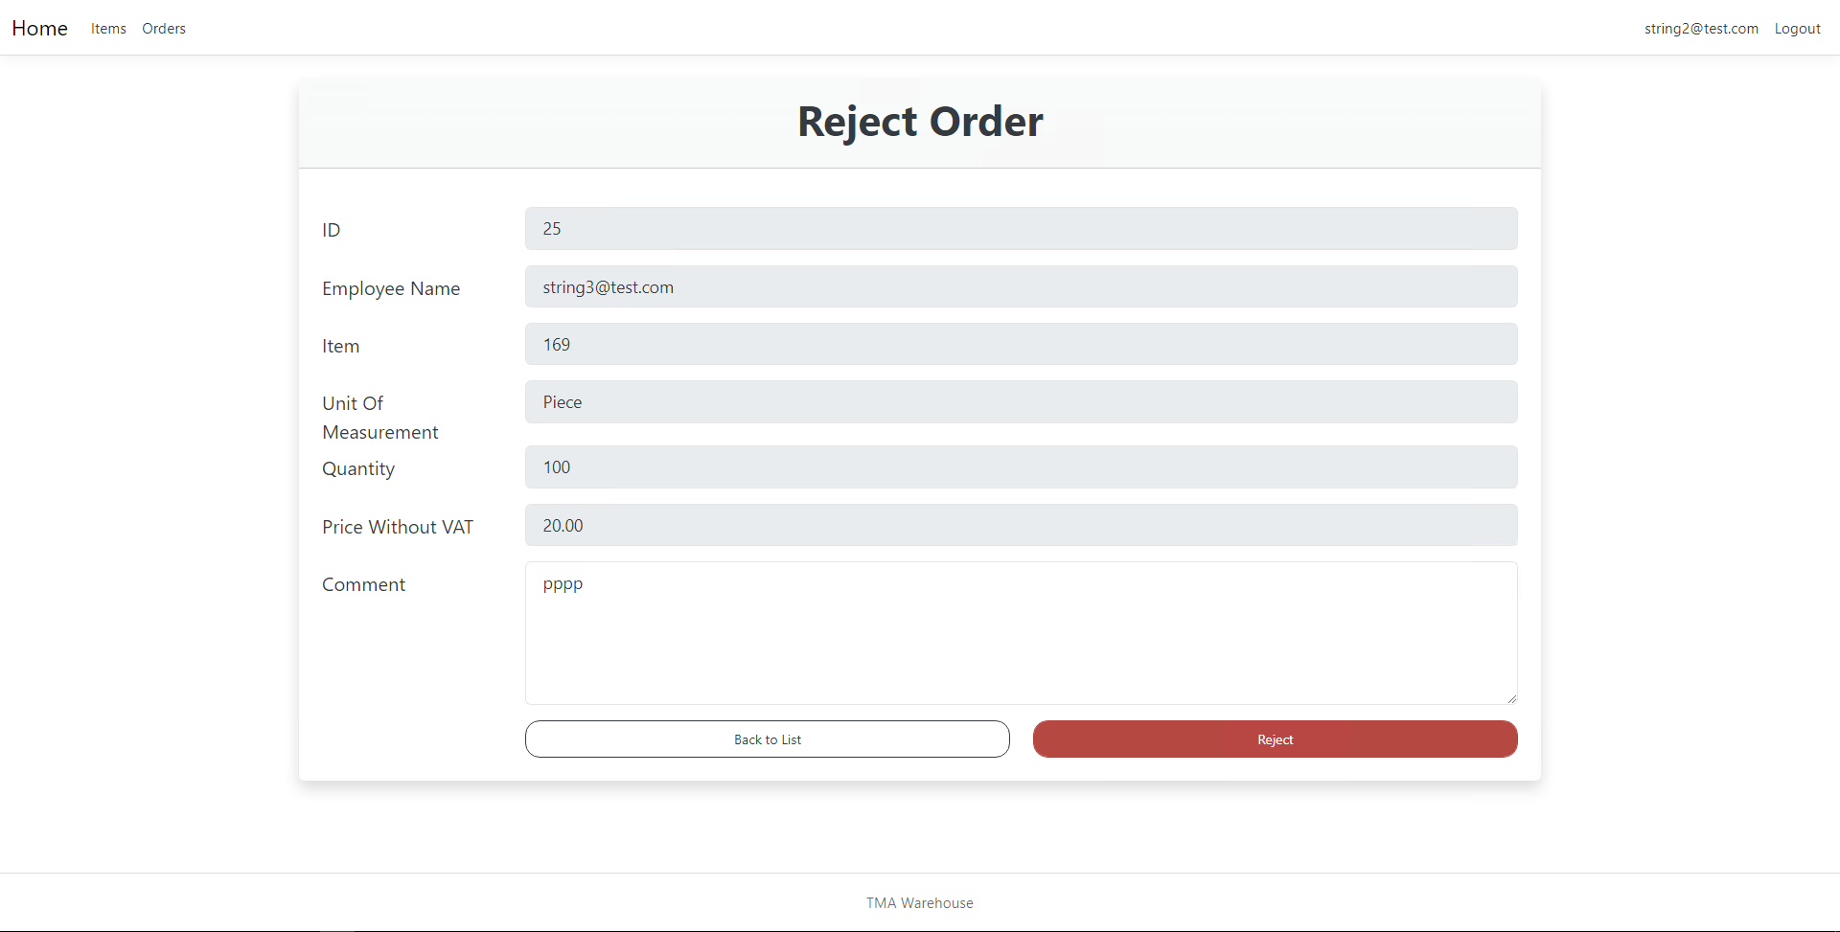

Admin:

