Yazan Bawaqna

CS152-B

Project04

**Penguin Population Viability Analysis Report**

**Abstract**

This project’s aim is to perform projections for the penguin population in Galapagos over years given certain ecological conditions and predictions. The eventual goal at the end is to calculate the probability of the penguin population going extinct after a certain number of years. To give a better background, it is essential to understand an ecological condition known as the “El Nino year” that happens every 5-9 years. During El Nino, the usual warming of the surface hits the Pacific Ocean which results in many creatures being affected negatively by the conditions.[1]

The program will first run a certain number of individuals and assign them to gender randomly, next the program will take those individuals and run them into a year simulation with the probability of El Nino year occurring considered. The program will then return the population after the year. If it was El Nino year the population has a good chance of decreasing otherwise the population is predicted to increase. Building upon this function, the program will then run the simulation for N number of years, where N is a value that we input. If the population became non-viable at any point (on the way to extinction) the program will give back the year number for this specific simulation. Otherwise, it will return back the latest population according to the year number projected. The program was developed to use this code to project the probability of running the simulation X times and outputting the probability of Extinction. At the end of the program, the cumulative extinction probability distribution of CEPD for short will be calculated. This will calculate the cumulative probability of extinction throughout the whole years simulated.

The project offers a wide usage of computational thinking commands, including “if statements” and “nested if statements”. The way they work is that they offer a condition for the program to run, for instance, if it is El Nino year, then run this, else run this. Moreover, the project includes a random generator function “random. Random” this commands generates a random number that can be used for probability purposes. To explain, we can input that if the number generated is greater than 5 then it is El Nino year”. Randomization offer real-life simulations, as it would be impossible to predict with certainty the conditions and outcomes of any simulation.

**Results**

By running the first function, we can see that it gives us back ten indiviuals with there sexes assigned.

We can also see that the proportion is approximately equivalent as the probabilbity of females is the same as the probability of a male probability

This function returns back the individuals after El Nino year and normal years.

As expected, the penguins population will decrease during El Nino and increase during a standard year

The function run simulation

Returns back to the year the population got extinct in the simulation. An example below shows the year 146 for a random simulation

Main function returns back the probability of the penguins getting extinct measured/calculated every ten years.

Below is the data representation in a graph. We can see that the probability keeps accumulating until it reaches a max around 90%.

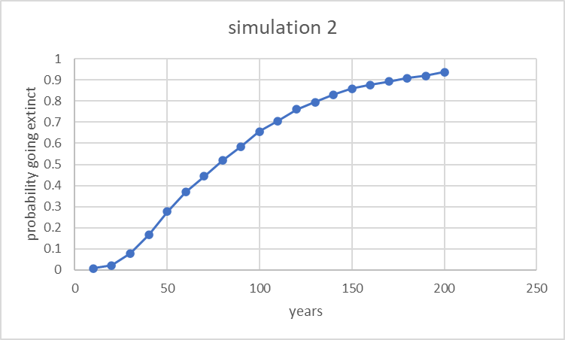

**Discussion**

**Follow up questions**

1. *What is the difference between the following two code snippets?*

# example 1

a = [5, 10, 15, 20]

for i in range(len(a)):

    print(a[i])

# example 2

a = [5, 10, 15, 20]

for x in a

     print(x)

There is not any difference in the output, however, the first example I is an index between 0 and 3, and the program will print the items with the indexes of “I”. For example 2, the program will simply print out the items in list “a”.

1. *Why do we test code incrementally? Why not write all of the code and test it once?*

Simply incrementation offers a simplified version of the main code, by dividing it into parts. This allows for any bugs to be debugged earlier, so it does not affect the whole program. Furthermore, it allows for code reuse by other programmers, as shorter more specific codes will target a wider range of programmers and can be reused in multiple projects.

1. Why do we use random numbers in this population model?

Random numbers allow the usage of probability. For instance, we can indicatein the code if the probability of a condition occurring is higher than the random number, then it should occur in the simulation, and so on. Random numbers will give space for random variation in the simulation to occur, which gives us a better sense of real-life high unpredictability.

1. *What is your favorite wild (undomesticated) animal?*

*This is the toughest part of the project so far as I have been obsessed with animals my entire life and never settled into a favorite. However, I mostly lean toward reptiles so Alligators would be the one. I mostly enjoy their lifestyle in the rivers and the way they hunt.*

**Reflection**

The combination of both real-life knowledge about animal simulation and a computer science background made this project achievable. We saw how we used our knowledge of the existing phenomenon of El Nino year and how we incorporated it into the project using our CS background. We also input real-life test values for viability such as the required existence of both genders within a population for a population to be marked as viable. This was done using CS tricks as we checked the list using if statements. The usage of random number generation allows us to use the project for different simulations and to include more accurate variables like the probability of being faced with predators (sea lions, seals, Orcas). All of this can be taken into account by finding data calculating the probability of a penguin dying as a result of a predator.

**Acknowledgments**

*El Niño* (no date) *National Geographic Society*. Available at: https://education.nationalgeographic.org/resource/el-nino (Accessed: October 18, 2022).

Kalyan, demonstrated to me how to correctly use the “Argv” and sys commands

Saad, fixed a major mistake in my main() function

1. *El Niño* (no date) *National Geographic Society*. Available at: https://education.nationalgeographic.org/resource/el-nino (Accessed: October 18, 2022).