Transcriptional Dysregulation and Candidate Biomarker Discovery in Non-Smoking Female Lung Cancer
Dataset: GSE19804 (GEO) Lung Cancer

Student: Divyanshu Jha
St. Xavier’s College, Ahmedabad
Cancer Transcriptomics & Data Analysis Internship

Final Project Report
June 2026
1. DATASET DESCRIPTION
This study used GSE19804, a publicly available gene expression dataset from the NCBI Gene Expression Omnibus (GEO), profiling non-smoking female lung cancer patients in Taiwan.
Field | Value
Accession | GSE19804
Title | Genome-wide screening of transcriptional modulation in non-smoking female lung cancer in Taiwan
Organism | Homo sapiens
Platform | GPL570 — Affymetrix Human Genome U133 Plus 2.0 Array
Design | Paired tumor and adjacent normal lung tissue
Total samples | 120 (60 tumor, 60 matched normal)
Cancer subtype | Non-smoking female lung cancer (predominantly NSCLC)

This dataset was selected because it offers a clinically distinct and well-defined patient population: lung cancer arising in non-smokers, which has a different molecular pathogenesis than smoking-associated lung cancer (more frequent EGFR mutations, fewer KRAS/TP53 mutations), and is disproportionately common in East Asian women. The paired tumor/normal design (each patient contributing matched tumor and adjacent normal tissue) allows for a statistically powerful paired comparison that controls for inter-patient genetic variability.
Project question: Which genes and pathways are transcriptionally dysregulated in non-smoking female lung cancer compared to matched normal lung tissue, and which candidates show potential as diagnostic biomarkers for this clinically distinct lung cancer subgroup?
2. METHODOLOGY
2.1 Data Preparation
The GEO series matrix file was downloaded directly via the GEO FTP server and parsed in Python. Sample metadata (sample ID, tumor/normal condition, and patient pair ID) were extracted from the series matrix header and verified against the expression matrix column order. The expression matrix (54,675 probes × 120 samples) was confirmed to be RMA-normalized, log2-scale data (range 3.04–14.89), requiring no further normalization.
2.2 Differential Expression Analysis
Because the dataset has a paired design (each patient contributing one tumor and one matched normal sample), a paired t-test (scipy.stats.ttest_rel) was used to compare tumor versus normal expression for each probe, with samples aligned by patient pair ID prior to testing. log2 fold change was calculated directly as the difference in mean log2 expression between groups. Resulting p-values were corrected for multiple testing using the Benjamini-Hochberg false discovery rate (FDR) procedure. Genes were defined as significantly differentially expressed at FDR < 0.05 and |log2FC| > 1. Probe IDs were mapped to gene symbols using the GPL570 platform annotation (retrieved via GEOparse); where multiple probes mapped to the same gene, the probe with the lowest FDR was retained.
2.3 Visualization
Volcano plots, hierarchically clustered heatmaps (top 50 DEGs by FDR, z-score normalized), and principal component analysis (PCA, using both the full gene set and significant DEGs only) were generated using matplotlib, seaborn, and scikit-learn.
2.4 Functional Enrichment
Gene Ontology Biological Process and KEGG pathway enrichment were performed separately for upregulated and downregulated gene sets using Enrichr (via the gseapy Python interface), allowing direction-specific biological interpretation.
2.5 PPI Network Analysis
A protein-protein interaction network was constructed using the STRING database API (high-confidence interactions, score ≥ 700) for the top 75 upregulated and top 75 downregulated genes by FDR. The network was analyzed in NetworkX, and hub genes were identified using degree centrality.
2.6 Biomarker Selection and Validation
Candidate biomarkers were selected using a multi-criteria approach combining statistical significance (FDR), network hub status (PPI degree), and pathway relevance. A logistic regression classifier was trained on the resulting candidate gene panel. To prevent data leakage from the paired design, train-test splitting and 5-fold cross-validation were performed at the patient level (grouping both samples from each patient together), rather than at the individual sample level. Feature scaling was fit only on training data.
2.7 Literature Validation
Each candidate biomarker was cross-referenced against published literature for diagnostic, prognostic, predictive, and biological relevance in lung cancer.
3. RESULTS
Out of 54,675 probes tested, 1,401 unique genes met the significance threshold (FDR < 0.05, |log2FC| > 1) after duplicate-probe collapsing: 453 upregulated and 948 downregulated in tumor tissue relative to normal.
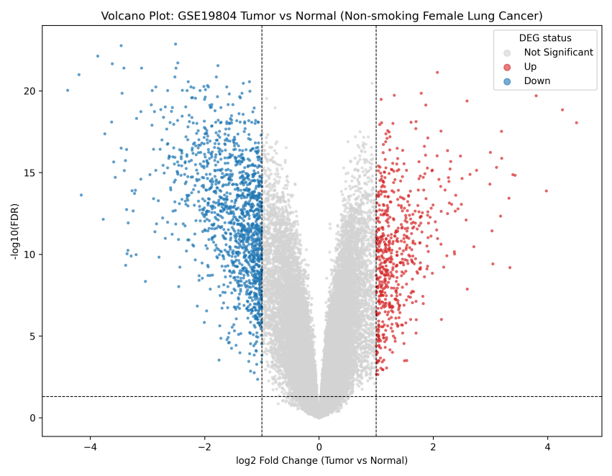
Figure 1: Volcano plot of differential expression. Red: significantly upregulated genes; blue: significantly downregulated genes; grey: not significant. Dashed lines indicate significance thresholds (|log2FC| > 1, FDR < 0.05.
The top differentially expressed gene by FDR was AGER (log2FC = −3.46, FDR = 1.7×10⁻²³), consistent with prior reports of AGER downregulation in lung cancer.
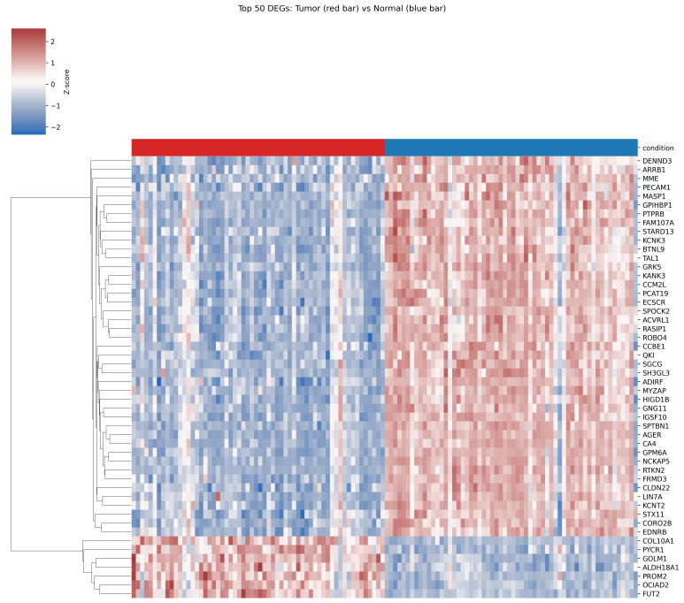
Figure 2: Hierarchically clustered heatmap of the top 50 differentially expressed genes (z-score normalized) across all 120 samples. Column color bar indicates Tumor (red) versus Normal (blue) status.
The heatmap shows clear block-level separation of expression patterns between tumor and normal samples, visually confirming the validity of the DEG calls.
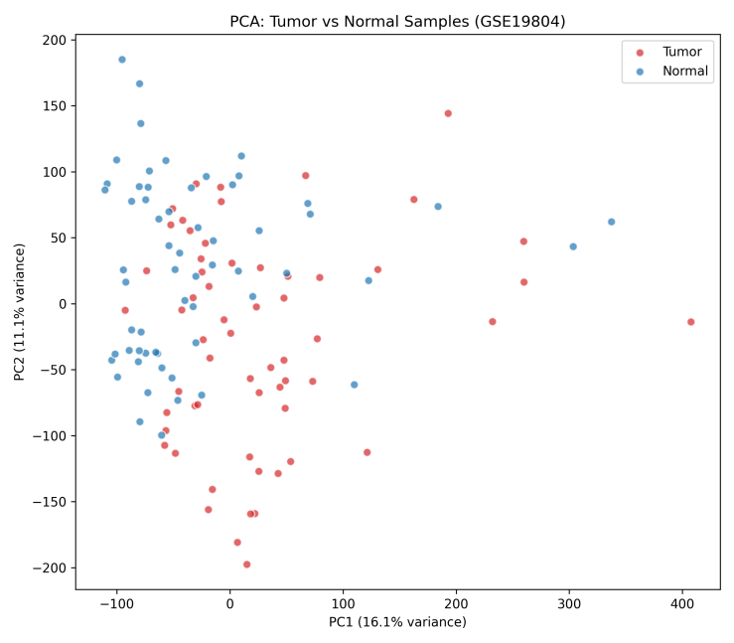
Figure 3: Principal component analysis (PCA) using all 54,675 genes, colored by sample condition.
Global PCA using all genes showed substantial overlap between tumor and normal samples, with PC1 and PC2 together explaining only ~27% of total variance. This likely reflects inter-patient biological variability dominating the global expression signal, a known phenomenon in human tissue transcriptomic studies, and the principal motivation for using a paired statistical design in the DEG analysis itself, which controls for this patient-level variance directly. A supplementary PCA restricted to significant DEGs only showed visibly improved separation; however, this is expected by construction (the genes were selected for differing between groups) and should not be interpreted as independent confirmation.
4. BIOLOGICAL INTERPRETATION & CLINICALLY RELEVANT INSIGHTS
Observation | Clinical/biological interpretation
Cell cycle and mitotic checkpoint genes are upregulated | Tumor samples show increased proliferative activity; candidate biomarkers from this group (e.g., ZWINT) may reflect aggressive growth rather than passive tissue change.
Immune and inflammatory signaling genes are downregulated | The tumor microenvironment may show reduced immune surveillance, though this may partly reflect a lower proportion of immune cells in bulk tumor tissue rather than suppressed signaling within individual cells.
Vascular/endothelial genes (CDH5, TEK, PECAM1) are downregulated | May indicate altered or reduced relative vascular tissue in tumor samples; notably, this contrasts with some published reports of vascular gene upregulation measured at the per-vessel protein level, a discrepancy discussed further in Limitations.
ECM/collagen genes (COL1A1, COL3A1, COL10A1) are upregulated | Suggests active extracellular matrix remodeling, a process associated with tumor invasion and metastasis in lung cancer.
CDH5 and COL1A1 are PPI network hubs | These genes may be biologically central to the dysregulated network, but hub status alone does not confirm functional or clinical importance without further validation.
Classifier AUC is high (0.996) | The 9-gene panel separates tumor and normal samples within this dataset; this does not establish clinical diagnostic utility, which requires external validation.

5. CANDIDATE BIOMARKER
Nine candidate genes were selected using combined evidence from differential expression strength, PPI hub status, and pathway relevance:
Gene | Direction | log2FC | FDR | Pathway/Role
AGER | Down | -3.46 | 1.7e-23 | AGE-RAGE signaling
COL1A1 | Up | +3.00 | 5.9e-17 | ECM-receptor interaction
PECAM1 | Down | -1.88 | 9.7e-20 | Cell adhesion / vascular
TEK | Down | -2.60 | 8.6e-19 | Angiogenesis (Tie2)
CDH5 | Down | -2.20 | 9.2e-19 | Vascular signaling (top hub)
COL3A1 | Up | +1.98 | 7.0e-16 | ECM organization
ROBO4 | Down | -2.39 | 9.3e-21 | Vascular integrity
COL10A1 | Up | +3.80 | 2.0e-20 | ECM organization
ZWINT | Up | +1.77 | 1.6e-15 | Cell cycle / mitotic checkpoint

ZWINT had the strongest independent external support, backed by a meta-analysis of 2,847 lung adenocarcinoma patients across 16 datasets confirming its association with advanced stage and poor prognosis. COL1A1 was independently identified as a PPI hub gene in a separate published study using the same general DEG + network analysis approach used here, and was reported to achieve a diagnostic AUC of 0.909 in combination with CEA in an external lung cancer cohort.
Classifier Performance
A logistic regression classifier using the 9-gene candidate panel was trained and evaluated using a patient-level train-test split (45 train / 15 test patients; no overlap) and patient-grouped 5-fold cross-validation.
Metric | Value
Test set ROC-AUC | 0.996
Sensitivity (Tumor recall) | 0.933
Specificity (Normal recall) | 1.000
Precision | 1.000
F1 score | 0.966
5-fold cross-validated AUC | 0.993 ± 0.010

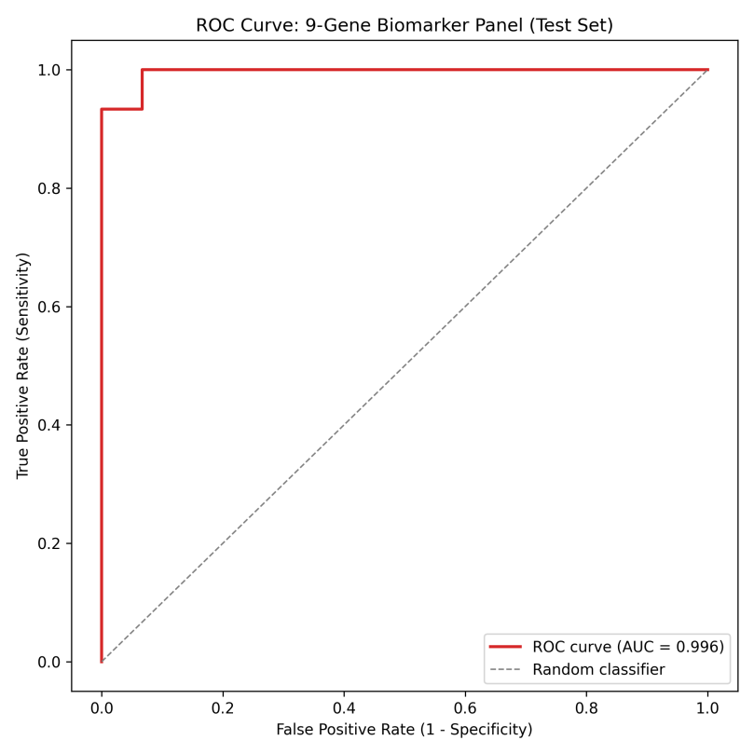
Figure 4: ROC curve for the 9-gene candidate biomarker panel, evaluated on held-out test patients.
This near-perfect performance is expected given that the candidate genes were selected specifically for their strong differential expression between tumor and normal groups; the classifier's high accuracy reflects the strength of the underlying DEG signal rather than independent validation of clinical utility. True biomarker validation requires testing on an independent patient cohort not used in gene selection, which remains an important direction for future work (Section 9).
Literature Validation
Seven of nine candidate genes (AGER, COL1A1, PECAM1, ROBO4, ZWINT, COL10A1, COL3A1) showed direction-consistent support in published lung cancer literature, with documented diagnostic, prognostic, and/or predictive relevance. Two genes (CDH5, TEK) showed cancer relevance in the literature but with an opposite reported direction (literature generally describes upregulation in tumor vasculature via immunohistochemistry, while this bulk-tissue analysis found downregulation as most plausibly explained by differences in tissue composition between bulk RNA measurement and per-vessel protein staining.
6. LIMITATIONS AND FUTURE WORK
All findings have been derived from one GEO dataset (GSE19804); generalizability to other lung cancer populations (smokers, other ethnicities, other histological subtypes) is not established. Also, the Bulk tissue composition having expression differences, particularly for immune and vascular genes, may partly reflect differences in cell type proportions between tumor and normal tissue rather than purely transcriptional regulation within individual cells. The 9-gene panel was selected based on differential expression strength, then evaluated for its ability to classify tumor versus normal; these are related tasks, so the near-perfect AUC reflects DEG signal strength rather than independent predictive validation. Moreover, no protein-level (e.g., Human Protein Atlas immunohistochemistry) or independent cohort (e.g., TCGA) validation was performed in this iteration of the project.
Direction discrepancies for CDH5 and TEK relative to some published literature, requires further investigation (e.g., single-cell deconvolution) to resolve. Candidate biomarkers are not clinically validated and should not be interpreted as diagnostic or prognostic tools without further experimental and clinical validation. Therefore, Extended GSEA analysis is needed using a fully ranked gene list for additional pathway-level confirmation beyond Enrichr's over-representation approach. The survival/outcome data (where available) should be formally tested for the prognostic value of the candidate panel.
5. REFERENCES
Edward Y. Chen. (n.d.). Enrichr. Maayanlab.cloud. https://maayanlab.cloud/Enrichr/
GEO Accession viewer. (n.d.). Www.ncbi.nlm.nih.gov. https://www.ncbi.nlm.nih.gov/geo/query/acc.cgi?acc=GSE19804
STRING. (2000). STRING: functional protein association networks. String-Db.org. https://string-db.org/
Literature Validation Sources
Dai, C., Gong, Q., Cheng, Y., & Su, G. (2019). Regulatory mechanisms of Robo4 and their effects on angiogenesis. Bioscience Reports, 39(7). https://doi.org/10.1042/bsr20190513
Fei, H., Chen, S., & Xu, C. (2020). Interactive Verification Analysis of Multiple Sequencing Data for Identifying Potential Biomarker of Lung Adenocarcinoma. BioMed Research International, 2020, 8931419. https://doi.org/10.1155/2020/8931419
Geng, Q., Shen, Z., Li, L., & Zhao, J. (2021). COL1A1 is a prognostic biomarker and correlated with immune infiltrates in lung cancer. PeerJ, 9, e11145. https://doi.org/10.7717/peerj.11145
Liang, Y., Xia, W., Zhang, T., Chen, B., Wang, H., Song, X., Zhang, Z., Xu, L., Dong, G., & Jiang, F. (2020). Upregulated Collagen COL10A1 Remodels the Extracellular Matrix and Promotes Malignant Progression in Lung Adenocarcinoma. Frontiers in Oncology, 10. https://doi.org/10.3389/fonc.2020.573534
Takahama, M., Tsutsumi, M., Tsujiuchi, T., Nezu, K., Kushibe, K., Taniguchi, S., Kotake, Y., & Konishi, Y. (1999). Enhanced expression of Tie2, its ligand angiopoietin-1, vascular endothelial growth factor, and CD31 in human non-small cell lung carcinomas. Clinical Cancer Research : An Official Journal of the American Association for Cancer Research, 5(9), 2506–2510. https://pubmed.ncbi.nlm.nih.gov/10499626/
Wang, L., Son, Y., & Guo, Z. (2022). COL3A1 Overexpression Associates with Poor Prognosis and Cisplatin Resistance in Lung Cancer. Balkanmedicaljournal.org. https://balkanmedicaljournal.org/text.php?lang=en&id=2436
Wang, Q., Zhu, W., Xiao, G., Ding, M., Chang, J., & Liao, H. (2020). Effect of AGER on the biological behavior of non-small cell lung cancer H1299 cells. Molecular Medicine Reports, 22(2), 810–818. https://doi.org/10.3892/mmr.2020.11176
Yang, J., Lin, M., Zhang, M., Wang, Z., Lin, H., Yu, Y., Zheng, Q., Chen, X., Wu, Y., Yao, Q., & Li, J. (2023). Advanced Glycation End Products’ Receptor DNA Methylation Associated with Immune Infiltration and Prognosis of Lung Adenocarcinoma and Lung Squamous Cell Carcinoma. Genetics Research, 2023, 1–18. https://doi.org/10.1155/2023/7129325
Zhu, R., Wang, H., & Lin, L. (2021). Prognostic and Clinicopathological Value of ZWINT Expression Levels in Patients with Lung Adenocarcinoma: A Systematic Review and Meta-analysis. Clinics (Sao Paulo, Brazil), 76, e3222. https://doi.org/10.6061/clinics/2021/e3222

