Shape files can be downloaded from http://www.gbrmpa.gov.au/geoportal/catalog/main/home.page

- Great Barrier Reef Features
Data citation: Great Barrier Reef Marine Park Authority 1998, Great Barrier Reef Features (Version 1.4) [Dataset] 2164DB88-FD79-449E-920F-61C37ADE634B. Retrieved from http://www.gbrmpa.gov.au/geoportal.
Abstract: Coastal features within and adjacent to the Great Barrier Reef World Heritage area (such as the Queensland Mainland and Islands, Indicative Reef boundaries and Rocks.). Major coral cay features,major and other coral reef structures (as defined by the reef shoal edge) and tidal, drying or emergent reef areas within the Great Barrier Reef World Heritage Area.

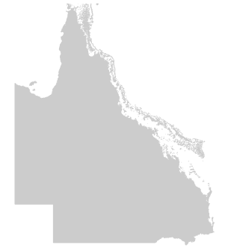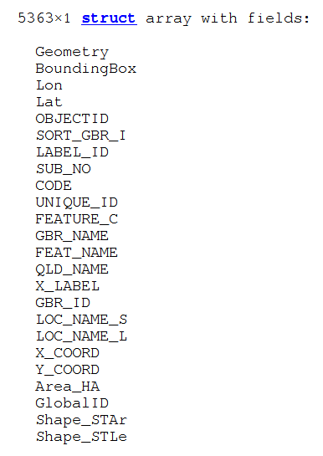
- Marine Bioregions of the Great Barrier Reef (Reef)
Data citation: Great Barrier Reef Marine Park Authority 2001, Marine Bioregions of the Great Barrier Reef (Reef) (v2.0) [Dataset] 7281CEF3-B806-4975-B71A-EF65B4146A1C. Retrieved from http://www.gbrmpa.gov.au/geoportal.
Abstract: Reef bioregions in the Great Barrier Reef Wolrd Heritage Area
Purpose: To depict locations of Reef bioregions
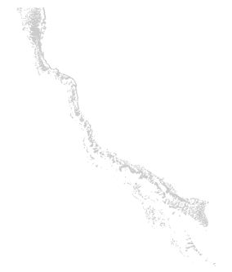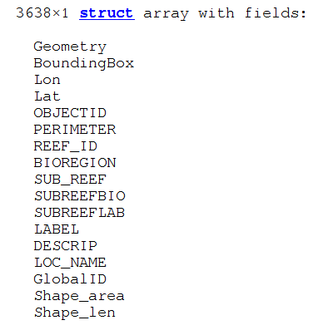

- Great Barrier Reef Marine Park Boundary
Data citation: Great Barrier Reef Marine Park Authority 2004, Great Barrier Reef Marine Park Boundary (Version 2) [Dataset] 1A604884-6982-4B05-93E3-F025623CB1E3. Retrieved from http://www.gbrmpa.gov.au/geoportal.
Abstract: Derived from the Amalgamated Great Barrier Reef (AGBR) Section that replaces all previously existing sections.The AGBR was proclaimed under subsection 31 (1) of the Act in 2003 (Gazette No S119) dated 21 April 2004.
Purpose: Depiction of the boundary of the Great Barrier Reef Marine Park.
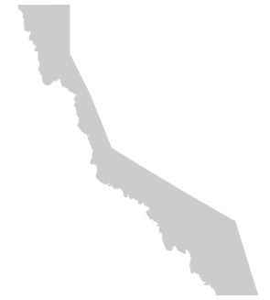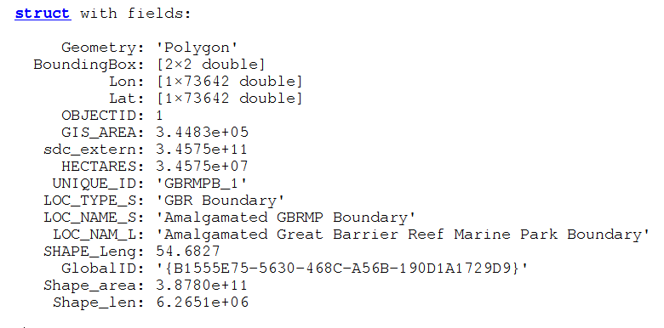
- Great Barrier Reef (Mainland and Islands, Cays, Reefs, Rocks) - Centroids
Data citation: Great Barrier Reef Marine Park Authority 1998, Great Barrier Reef (Mainland and Islands, Cays, Reefs, Rocks) - Centroids (Version 1) [Dataset] EAE05604-D713-492B-A190-89792B03B639. Retrieved from http://www.gbrmpa.gov.au/geoportal.
Abstract: Coastal features within and adjacent to the Great Barrier Reef World Heritage area (such as islands, rocks and the Queensland mainland). Major coral cay features,major and other coral reef structures (as defined by the reef shoal edge) and tidal, drying or emergent reef areas within the Great Barrier Reef World Heritage Area.
Purpose: To represent the centroids of Great Barrier Reef Marine Park features within and adjacent to the Great Barrier Reef World Heritage Area.

- Great Barrier Reef Marine Park Zoning
Data citation: Great Barrier Reef Marine Park Authority 2004, Great Barrier Reef Marine Park Zoning (Version 1) [Dataset] EC12E1A4-36AE-4D5A-AB53-89D662FDF34E. Retrieved from http://www.gbrmpa.gov.au/geoportal.
File Identifier: EC12E1A4-36AE-4D5A-AB53-89D662FDF34E
Abstract: The Great Barrier Reef Marine Park Act 1975 (the Act) provides for the establishment, control, care and development of the Great Barrier Reef Marine Park (the Marine Park). The Great Barrier Reef Marine Park Authority (the Authority) is responsible for the management of the Marine Park. The Great Barrier Reef Marine Park Zoning Plan 2003 is the primary planning instrument for the conservation and management of the Marine Park. In having regard to the objects set out in subsection 32 (7) of the Act, this Zoning Plan takes account of the world heritage values of the Marine Park and the principles of ecologically sustainable developments. This Zoning Plan aims, in conjection with other management mechanisms, to protect and conserve the biodiversity of the Great Barrier Reef ecosystem within a network of highly protected zones, while providing opportunities for the ecologically sustainable use of, and access to, the Great Barrier Reef Region by current and future generations. In addition to the protection of representative areas of biodiversity, this Zoning Plan also provides for the protection of other areas of high conservation value by assigning protective zoning to a range of habitats such as coral reefs, sponge beds, seagrass beds and deep water areas, as well as important dugong habitats and other special or unique sites. The Marine Park is managed as a multiple use area. This means that, while enhancing the conservation of the Marine Park, this Zoning Plan also provides for a range of recreational, commercial and research opportunities, and for the continuation of traditional activities. This Zoning Plan expressly acknowledges the rights and interests of indigenous Autralians in the Marine Park by providing for the management of the traditional use of marine resources, including traditional hunting, in accordance with Aboriginal and Torres Strait Islander custom and tradition. The contributions of scientific research to the management and understanding of the Marine Park are also acknowledged in this Zoning Plan, which provides for the management of researh in the Marine Park, including a system of Scientific Research Zones to facilitate research around scientific research stations.(Extract from "Preface A, Introduction; Great Barrier Reef Marine Park Zoning Plan 2003)
Purpose: Representation of the schedules for describing zones within the Great Barrier Reef Marine Park. The zones are Buffer, Commonwealth Island (GBRMPA), Commonwealth Island (Other), Conservation Park, General Use, Habitat Protection, Marine National Park, Preservation, Scientific Research and Scientific Reseach (closed to public access).

