**ClipItPack**

**(An extension of SimplyClip 4.0)**

**Use-case Tutorial**

**Changing colour of copied text**

For these tutorials, we assume that you have successfully installed all the requirements and have been able to run the server.

Following is the tutorial:

1. After successfully copying the text, you can click on the drop down to select different colours for your selected copied text.

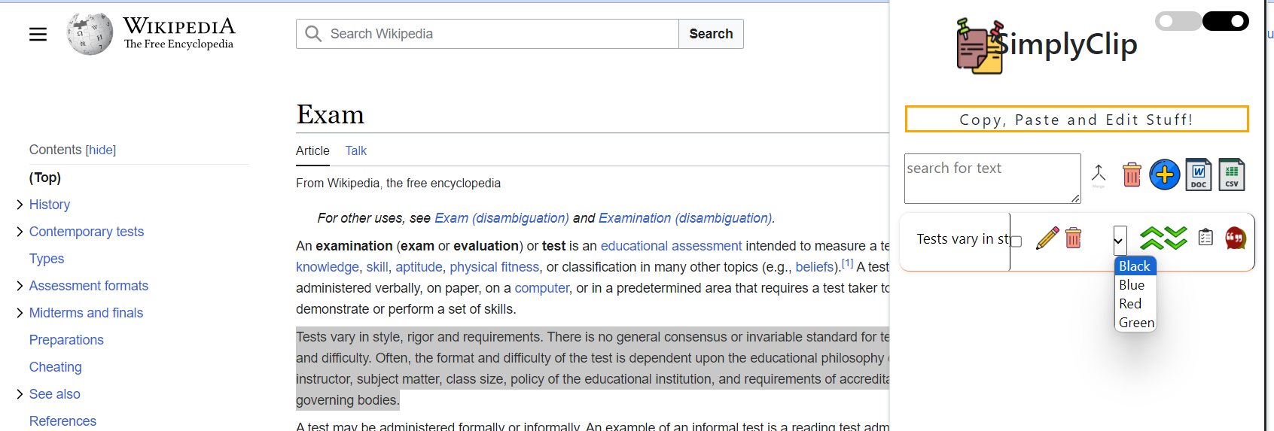

1. Now, when we select different colours, we can see that the copied text colour is changed.

