**ClipItPack**

**(An extension of SimplyClip 4.0)**

**Use-case Tutorial**

**Using the generate citation functionality**

For these tutorials, we assume that you have successfully installed all the requirements and have been able to run the server.

1. The server must be up and running for this and once you have achieved that your terminal or git bash or whatever control terminal you are using should look like this:

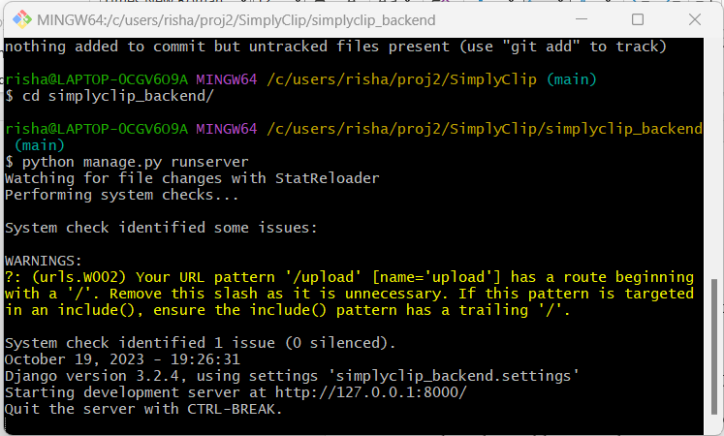

1. After this, we must have text copied in our extension.

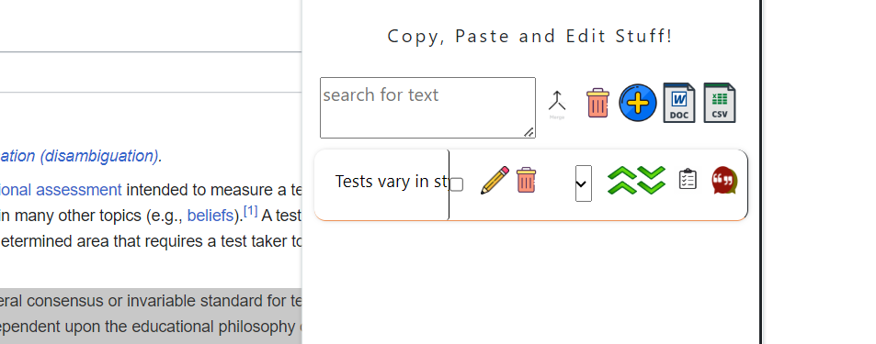

1. Now, we can click on the citation button, which is the first button from the right side.
2. As we do that with a doi link in the copied text, we need to then click on the Doc download button. Citations are generated.

