**ClipItPack**

**(An extension of SimplyClip 4.0)**

**Use-case Tutorial**

**Copying the text**

For these tutorials, we assume that you have successfully installed all the requirements and have been able to run the server.

Following is the tutorial:

1. After successfully unpacking the extension in Chrome, just visit the page you want to copy the data from and open the extension. Here we have visited Wikipedia.org. Make sure to enable the extension by toggling the right switch on the top right corner.

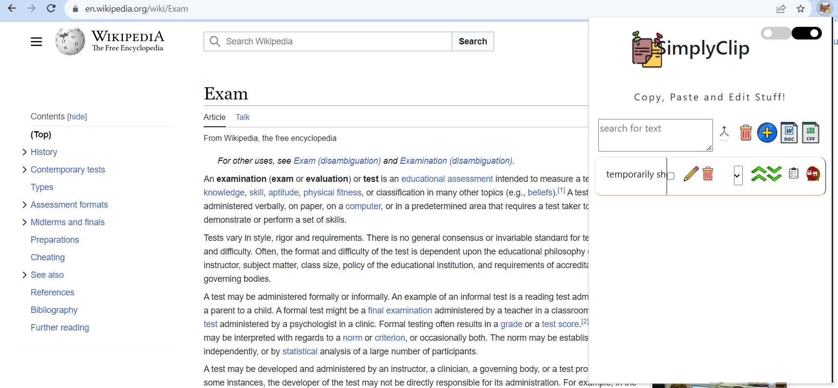

1. Now, we select our text and copy it. It will automatically be copied to our SimplyClip text box.

