**ClipItPack**

**(An extension of SimplyClip 4.0)**

**Use-case Tutorial**

**Using darkmode**

For these tutorials, we assume that you have successfully installed all the requirements and have been able to run the server.

1. We simply need to enable the first toggle switch on the top right corner of the extension to switch to dark mode.

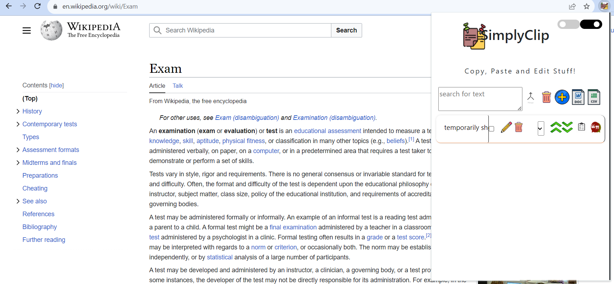

1. Once, we click that, dark mode will automatically be enabled and it will look as follows:

