**ClipItPack**

**(An extension of SimplyClip 4.0)**

**Use-case Tutorial**

**Using the merge functionality**

For these tutorials, we assume that you have successfully installed all the requirements and have been able to run the server.

1. First, we need to have at least 2 lists of text copied in our extension.
2. Make sure the checkbox after both the text lists is checked.

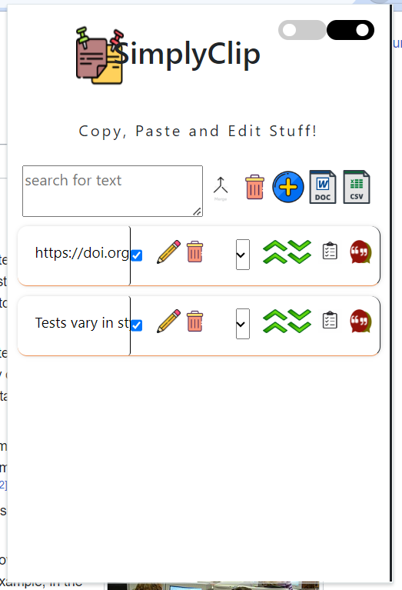

1. After this, we just click on the merge icon.



1. This will result in the texts being successfully merged. In the following image you can see that the newly created text box has the merged text.

