Palo Verde Website Corrections — Confirmation
Prepared for Michael Bustard, IT Director • August 31, 2026

Email draft
To: Michael Bustard <mbustard@pvcancer.com>
Subject: Palo Verde website corrections completed — ready for your review
Hi Mike,
The corrections from your list have been completed on the Palo Verde website.
- Confirmed the physician assignments: WVO / Estrella — Dr. Zafar, Dr. Mamani and Dr. Rakkar; TBO / Glendale — Dr. Rakkar, Dr. Mamani, Dr. Grover and Dr. Ahmad; SDO / Scottsdale — Dr. Halepota, Dr. Grover and Dr. Ahmad; GTO / Gilbert — Dr. Grover and Dr. Halepota.
- Added Dr. Demetrio Mamani to the Your Team page and confirmed that his profile opens correctly.
- Added the Gilbert office to the homepage location-photo rotation.
- Replaced the old low-resolution office photos for Estrella, Glendale, Scottsdale and Gilbert with full-resolution images.
- Rebuilt the PET Scan Imaging page with a consistent location-detail layout, the PET address and a dedicated map. The unrelated list of every office was removed from the bottom.
- Checked the updated pages on desktop and mobile after publishing.
Please review the pages using the clickable links below and let me know if anything else needs to be adjusted.
Thanks,
Yasir
AZ Web Corp

Clickable review links
- Your Team: https://875051.us16.myftpupload.com/your-team/
- Dr. Mamani: https://875051.us16.myftpupload.com/your-team/dr-mamani/
- Estrella: https://875051.us16.myftpupload.com/estrella-location/
- Glendale: https://875051.us16.myftpupload.com/glendale-location/
- Scottsdale: https://875051.us16.myftpupload.com/scottsdale-location/
- Gilbert / East Valley: https://875051.us16.myftpupload.com/east-valley-location/
- PET Scan Imaging: https://875051.us16.myftpupload.com/pet-scan-imaging/

Confirmation screenshots
Updated Your Team page — Dr. Mamani is included
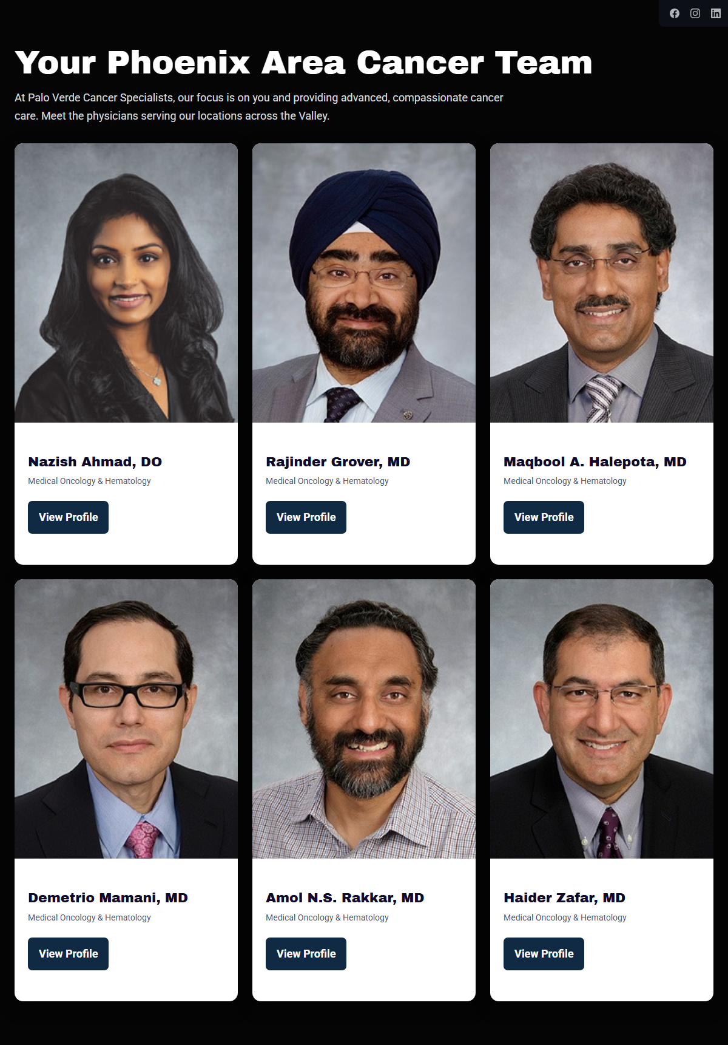

Gilbert office added to the homepage photo rotation


Estrella full-resolution office photo
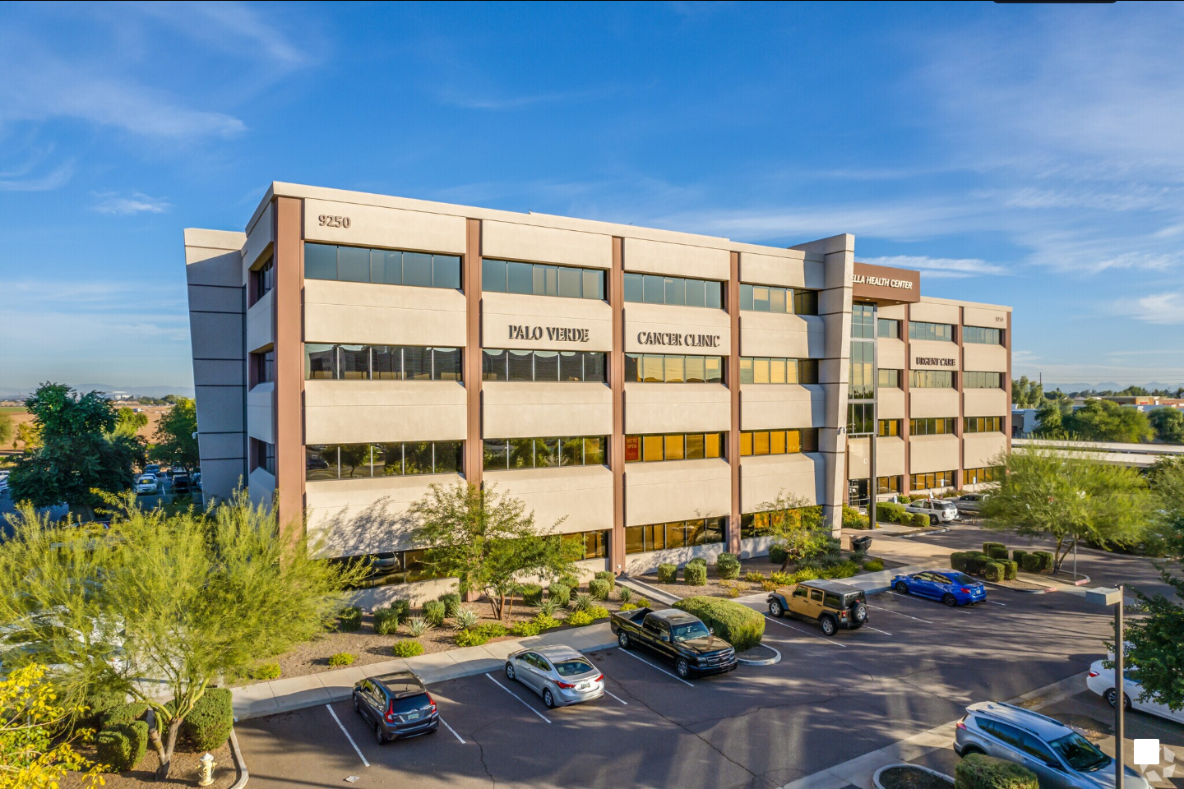

Glendale full-resolution office photo
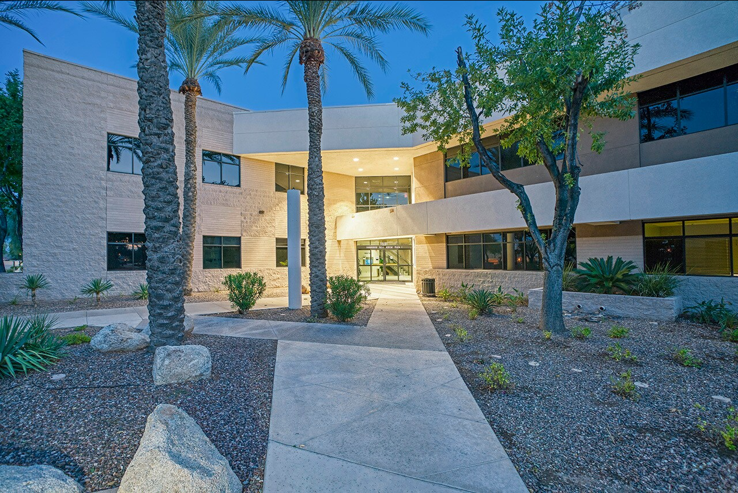

Scottsdale full-resolution office photo
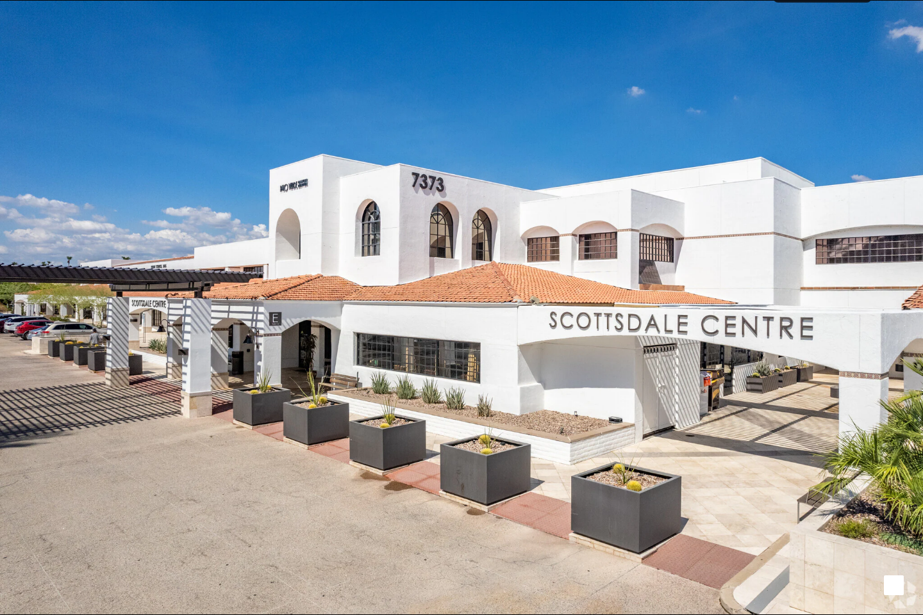

Gilbert / East Valley full-resolution office photo
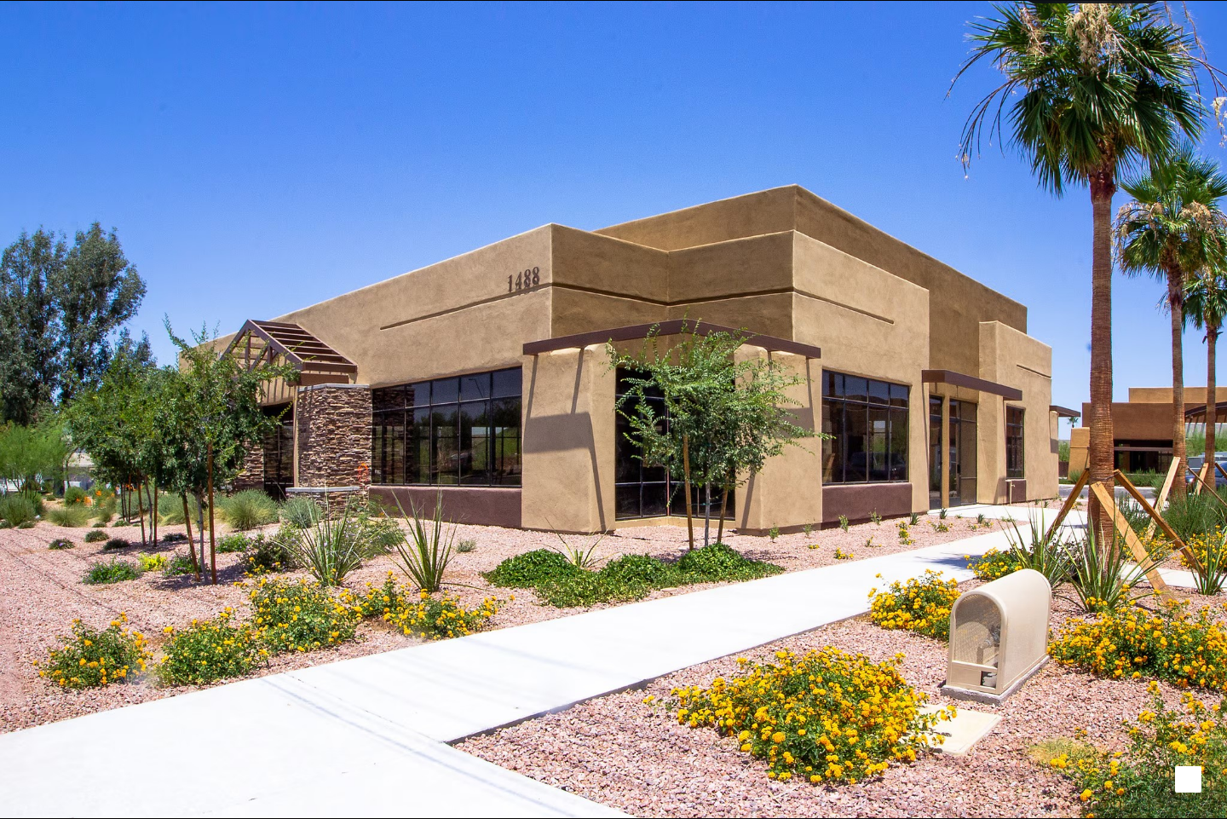

Rebuilt PET Scan Imaging page
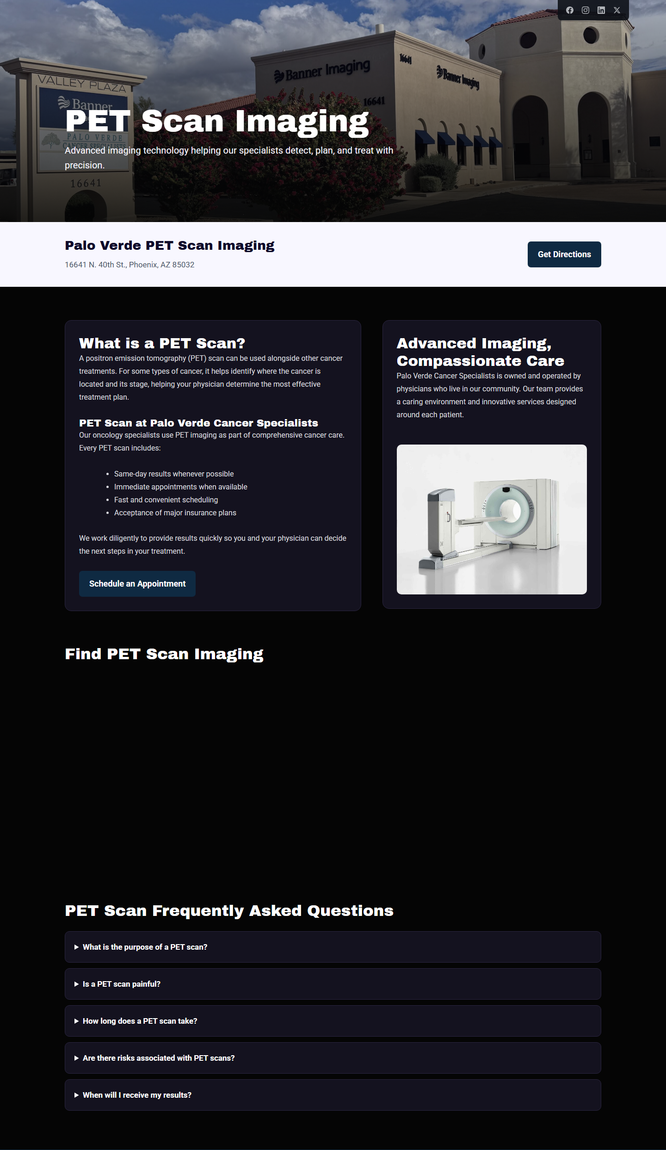

Dedicated PET Scan Imaging map
