AZ Web Corp
Monthly Google Performance Report
August 1–27, 2026 compared with July 1–27, 2026
Google Search Console + Google Analytics 4

Executive summary
During August 1–27, AZ Web Corp received 14 Google clicks from 4,376 search appearances. During the matching July period, it received 13 clicks from 6,250 appearances. This report uses equal-length periods so the comparison is fair.
Measure | August 1–27 | July 1–27 | Change
Google clicks | 14 | 13 | +7.7%
Google impressions | 4,376 | 6,250 | -30.0%
Click-through rate | 0.32% | 0.21% | +0.11 points
Average Google position | 57.1 | 49.3 | -7.9 positions

Two quick graphs for non-technical readers:
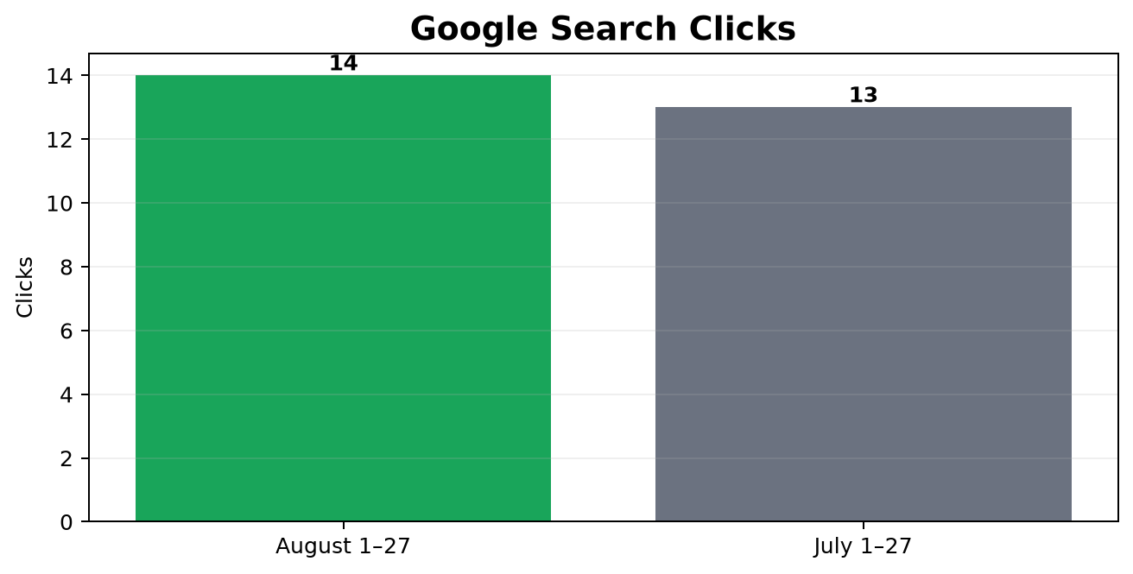
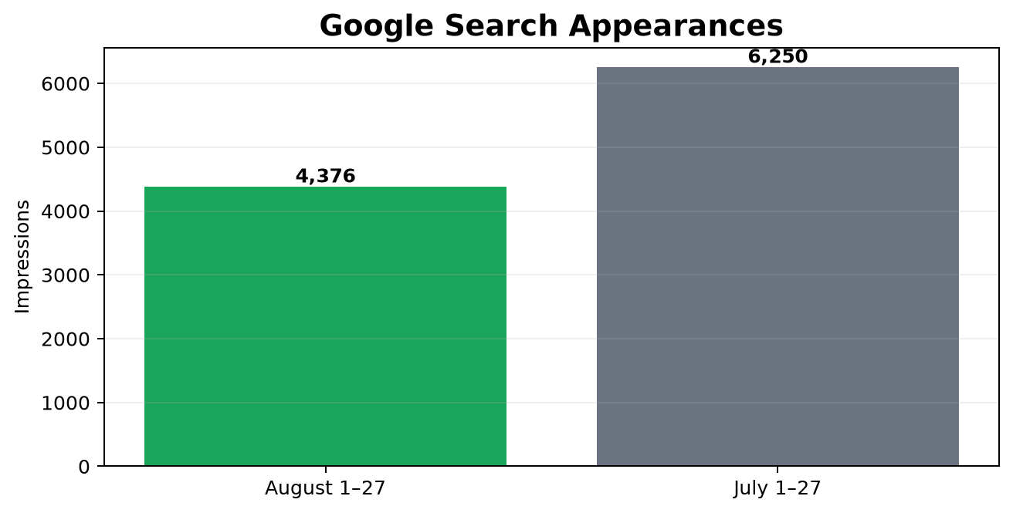

Where the clicks and visits came from
Search Console reports clicks from Google Search only. It does not include direct visits, social media, referrals or advertising. GA4 identifies the broader traffic source after a visitor reaches the website. Because correct GA4 tracking began only on August 27, the source figures below cover the first three tracked days, not the entire month.
Measurement system | Source represented | Recorded volume | Plain-English meaning
Google Search Console | Google organic search | 14 clicks | People clicked AZ Web Corp in unpaid Google results
Google Analytics 4 | Direct | 33 sessions | Typed/bookmarked visits or visits whose source could not be identified
Google Analytics 4 | Organic Search | 3 sessions | Visits identified as coming from an unpaid search engine result
Google Analytics 4 | Paid advertising | 0 sessions | No Google Ads traffic was returned
Google Analytics 4 | Ecommerce | 0 transactions | No online purchase activity was returned

GA4 source and medium detail
Source / medium | Sessions | Users | Engagement rate | Key events
(direct) / (none) | 33 | 25 | 45.45% | 0
google / organic | 2 | 2 | 50.00% | 0
bing / organic | 1 | 1 | 0.00% | 0

Recorded referring pages
Referring page | Sessions | Users | Page views | Key events
nan | 29 | 25 | 30 | 0
https://azwebcorp.com/free-seo-audit/ | 10 | 4 | 12 | 0
https://azwebcorp.com/ | 8 | 5 | 10 | 0
https://azwebcorp.com/seo-audit-results/?target=azwebcorp.com | 2 | 1 | 1 | 0
https://www.google.com/ | 2 | 2 | 2 | 0
https://azwebcorp.com/contact-us/ | 1 | 1 | 1 | 0
https://azwebcorp.com/seo-audit-results/?target=khemia.com | 1 | 1 | 1 | 0
https://www.bing.com/ | 1 | 1 | 1 | 0

Important: ‘Direct’ does not always mean the visitor manually typed the address. It also includes traffic where campaign tags or referral information were unavailable.

Partner and referral links
Referral source | Link status | GA4-attributed sessions | Explanation
Everything IT (everythingit.ie) | Positive | Not separately attributed | Verified live footer link to AZ Web Corp on the homepage and location pages
Google | Positive | 2 referring-page sessions | Google appears as a recorded external referring page in recovered data
Bing | Positive | 1 referring-page session | Bing appears as a recorded external referring page in recovered data

Why Everything IT has no exact GA4 count: the footer backlink is active and capable of passing referral information, but the available Analytics rows do not name everythingit.ie. During most of the period, AZ Web Corp was sending analytics to the wrong property, and many recovered visits are classified as Unassigned or Direct. The report therefore confirms the backlink without claiming an unsupported number.

1. Search queries
These are the searches that produced the most clicks and visibility during August.
Search query | Clicks | Impressions | CTR | Position
arizona web company | 1 | 14 | 7.14% | 1.8
50 free instagram followers | 1 | 4 | 25.00% | 81.8
get 50 free instagram followers | 1 | 3 | 33.33% | 108.3
free instagram followers 50 | 1 | 2 | 50.00% | 98.0
insta free 50 followers | 1 | 2 | 50.00% | 109.5
get free 50 followers instagram | 1 | 1 | 100.00% | 111.0
web design arizona | 0 | 150 | 0.00% | 62.9
arizona web design | 0 | 80 | 0.00% | 70.2
arizona website design | 0 | 80 | 0.00% | 73.0
web design company arizona | 0 | 69 | 0.00% | 46.4
web developer phoenix | 0 | 69 | 0.00% | 86.9
arizona seo company | 0 | 61 | 0.00% | 51.2
arizona seo | 0 | 59 | 0.00% | 53.2
az web design | 0 | 58 | 0.00% | 72.4
arizona web developer | 0 | 57 | 0.00% | 47.9

Queries gaining month over month
Query | Click change | Impression change | Position improvement
free instagram followers 50 | +1 | +2 | -98.0
insta free 50 followers | +1 | +2 | -109.5
get free 50 followers instagram | +1 | +1 | -111.0
arizona web company | +1 | -2 | +3.4
50 free instagram followers | +1 | -3 | +18.4
web design arizona | +0 | +133 | -7.4
web design company arizona | +0 | +51 | +3.5
arizona website design | +0 | +45 | -15.9
web developer phoenix | +0 | +41 | -19.5
arizona web design | +0 | +26 | -17.4

Queries losing month over month
Query | Click change | Impression change | Position improvement
free followers instagram 50k | -1 | -1 | +105.0
web development phoenix | +0 | -108 | -16.2
wordpress critical error | +0 | -60 | +60.5
affordable seo company ahwatukee | +0 | -54 | +23.3
arizona web development | +0 | -42 | -16.8
seo for home services arizona | +0 | -42 | -11.2
seo services tempe | +0 | -39 | -9.2
arizona seo services | +0 | -36 | -6.1
web projects in phoenix | +0 | -30 | -12.8
az web design | +0 | -29 | -25.6

2. Landing pages from Google
This section shows which pages gained or lost Google visibility and clicks between the two months.
Page | Aug clicks | Jul clicks | Aug impressions | Jul impressions
/ | 6 | 8 | 1,905 | 1,747
/arizona-seo-services/ | 1 | 1 | 1,572 | 2,302
/2020/07/29/how-much-does-seo-cost-in-arizona/ | 0 | 0 | 348 | 1,077
/arizona-web-development/ | 0 | 0 | 265 | 286
/our-featured-projects/ | 0 | 0 | 163 | 157
/arizona-digital-marketing/ | 0 | 0 | 112 | 69
/how-much-does-seo-cost-in-arizona/ | 0 | 0 | 107 | 0
/seo-company-phoenix-az/ | 0 | 0 | 98 | 0
/arizona-backend-development/ | 0 | 0 | 75 | 79
/domain-registration/ | 0 | 0 | 51 | 0
/hosting-domains/ | 0 | 0 | 48 | 0
/about-azwebcorp/ | 0 | 0 | 46 | 80
/hire-our-services/ | 0 | 0 | 45 | 53
/2020/07/29/free-instagram-followers-hack/ | 8 | 3 | 41 | 44
/web-hosting-plus/ | 0 | 0 | 41 | 0
/frontend-development/ | 0 | 0 | 33 | 196
/phoenix-web-development/ | 0 | 0 | 31 | 0
/2025/12/05/phoenix-seo-expert-local-search/ | 0 | 0 | 30 | 292
/mobile-app-development-services-arizona/ | 0 | 0 | 30 | 290
/web-development/ | 0 | 0 | 25 | 0

3. Countries and devices
Country | Aug clicks | Jul clicks | Aug impressions | Jul impressions
usa | 2 | 7 | 4,066 | 5,742
per | 0 | 0 | 52 | 0
gbr | 0 | 0 | 43 | 197
ind | 3 | 3 | 40 | 108
rus | 0 | 0 | 25 | 27
phl | 0 | 0 | 22 | 5
idn | 1 | 0 | 15 | 5
vnm | 0 | 0 | 12 | 18
tur | 0 | 0 | 10 | 4
bgd | 0 | 0 | 10 | 6
fra | 2 | 0 | 6 | 3
pak | 1 | 1 | 6 | 7
mex | 0 | 0 | 6 | 3
tha | 0 | 0 | 5 | 0
mys | 0 | 0 | 5 | 1

Device | Aug clicks | Jul clicks | Aug impressions | Jul impressions | Aug CTR
Desktop | 2 | 6 | 4,142 | 5,898 | 0.05%
Mobile | 12 | 7 | 232 | 348 | 5.17%
Tablet | 0 | 0 | 2 | 4 | 0.00%

Top three countries by recorded website traffic
These GA4 sessions were recovered by filtering the previously incorrect property specifically for the azwebcorp.com hostname.
Rank | Country | Sessions | Users | Page views
1 | United States | 17 | 9 | 37
2 | Netherlands | 7 | 7 | 7
3 | Poland | 4 | 4 | 4

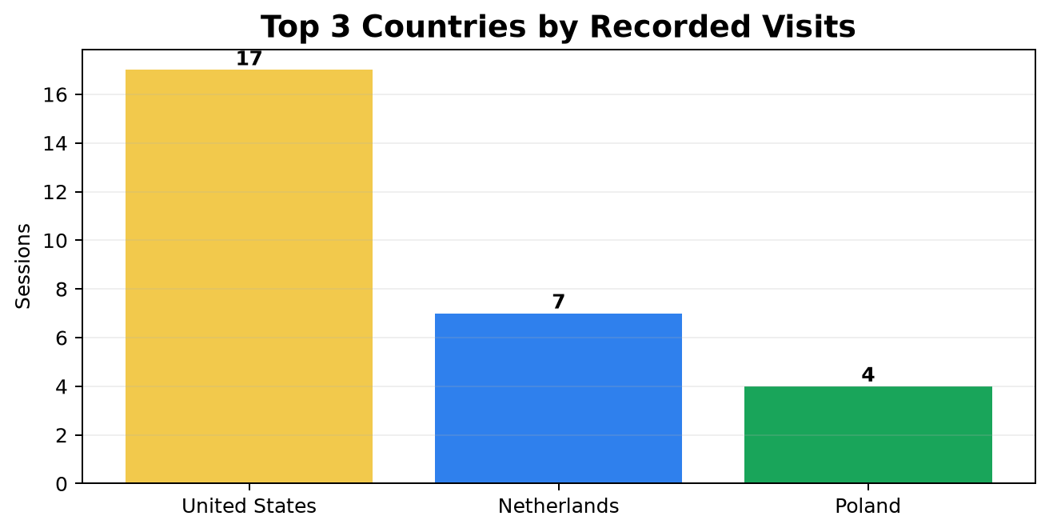

4. Search appearance and image search
Google returned 0 special search-appearance categories for August. Image Search generated 2 query-level impressions in the export. The supporting workbook contains the complete image-query tables for both months.

5. Google Analytics monthly comparison
The correct AZ Web Corp GA4 property began receiving data on August 27. Therefore, July contains no GA4 data and August contains only three days. The figures below are a tracking baseline, not a complete month-over-month business comparison.
GA4 measure | August recorded | July recorded | Meaning
Sessions | 36 | 0 | 36 visits were tracked after collection began
Users | 28 | 0 | 28 people were recorded
Page views | 58 | 0 | 58 pages were viewed
Engagement rate | 44.44% | 0% | 44.44% of sessions were engaged
Key events / conversions | 0 | 0 | Conversions are not configured yet

6. Acquisition: how visitors arrived
Channel | Sessions | Users | Engagement rate | Key events
Direct | 33 | 25 | 45.45% | 0
Organic Search | 3 | 3 | 33.33% | 0

7. GA4 landing pages and content
Landing page | Sessions | Users | Page views | Engagement
/ | 24 | 20 | 46 | 54.17%
/web-development/ | 3 | 3 | 3 | 0.00%
/arizona-seo-services/ | 2 | 2 | 2 | 50.00%
(not set) | 1 | 1 | 0 | 100.00%
/?gtm_latency=1 | 1 | 1 | 1 | 0.00%
/arizona-digital-marketing/ | 1 | 1 | 1 | 0.00%
/contact-us/ | 1 | 1 | 1 | 0.00%
/seo-audit-results/?target=Azwebcorp.com | 1 | 1 | 1 | 0.00%
/seo-audit-results/?target=Prestigewindowsz.com | 1 | 1 | 2 | 100.00%
/seo-audit-results/?target=Rtilab.com | 1 | 1 | 1 | 0.00%

8. Events and lead activity
Event | Times recorded | Users | Marked as conversion?
page_view | 58 | 28 | No
session_start | 36 | 28 | No
first_visit | 28 | 28 | No
user_engagement | 24 | 12 | No
form_start | 14 | 7 | No
scroll | 13 | 5 | No
form_submit | 1 | 1 | No

Important: GA4 recorded 14 form starts and one form submission, but form submission is not marked as a key event. Reported conversions therefore remain zero.

9. Audience location and technology
The workbook contains full country, region, city, device, browser, operating system, language, screen-resolution and hour-of-day tables. Early GA4 counts are too small for reliable strategic conclusions.
Report category | Rows available
Countries | 10
Regions | 13
Cities | 15
Devices | 2
Browsers | 4
Operating systems | 4
Languages | 1
Day and hour combinations | 20

10. Advertising, ecommerce and referrals
- Google Ads campaign rows: 0. No linked advertising activity was returned.
- Ecommerce item rows: 0. No ecommerce transactions were returned.
- Referrer rows: 8. The detailed sources are preserved in the supporting workbook.
- Organic landing-page rows: 2. Organic GA4 history is currently limited to the new three-day baseline.

11. Actions recommended from this monthly comparison
Priority | Action | Why
Immediate | Purge Cloudflare and verify G-R5RNDSH327 publicly | The origin is corrected, but cached HTML can still contain the Lootertech ID
Immediate | Mark form_submit, phone clicks and email clicks as GA4 key events | Monthly reports must show leads, not only visits
This week | Improve pages and snippets for queries ranking positions 4–20 | These are the fastest opportunities for qualified clicks
This week | Review pages that lost impressions or clicks from July to August | Stops avoidable month-over-month decline
Monthly | Repeat equal-day monthly comparisons until complete months are available | Keeps reporting fair while Search Console data is delayed

12. Report inventory
This master report covers Google Search performance, queries, pages, query-to-page relationships, countries, devices, search appearance, image search, GA4 acquisition, campaigns, landing pages, content, events, conversions, geography, technology, referrals, Google Ads and ecommerce. The accompanying monthly Excel workbook retains the exact underlying rows for audit and filtering.

Tracking ownership
Item | Confirmed value
Google account | yasirmemon1976@gmail.com
Access level | Administrator
GA4 property | 247570709
Correct stream | G-R5RNDSH327

Overall assessment
AZ Web Corp has meaningful search visibility and several realistic page-one opportunities, but the site is not yet converting that visibility into enough qualified clicks or measurable leads. The month should be viewed as a rebuilding and measurement-baseline period rather than a finished success story.
Area | Assessment | What it means
Search visibility | Negative | Google appearances are lower than the matching July period.
Search clicks | Positive | Clicks are higher than the matching July period.
Referral visibility | Positive | Everything IT's footer backlink is verified live, alongside recorded Google and Bing referrals.
Analytics reliability | Negative | The wrong GA4 property captured part of the period; the correct ID is deployed at origin but Cloudflare must serve the corrected version.
Lead measurement | Negative | Form activity exists, but key events/conversions are not configured.
Growth opportunity | Positive | Several commercial web-development searches already rank close to page one.

Overall rating: PROMISING, BUT TRACKING AND CONVERSION MEASUREMENT NEED IMMEDIATE ATTENTION.

