
Prepared by AZ Web Corp for AZ Web Corp LinkedIn audience

AZ Web Corp
Digital Growth Snapshot
GA4 results: August 23–29 vs. August 16–22
Full-month acquisition: July 31–August 29
↑ ORGANIC SEARCH SESSIONS GREW 600%
Unpaid search traffic increased from 2 to 14 sessions in one week.

↑ REFERRAL SESSIONS GREW 440%
Referral traffic increased from 5 to 27 sessions. EverythingIT.ie generated 22 sessions during the full-month period.

TRACKING NOTE
Percentages are large because the starting numbers were small. The direction is encouraging, but sustained growth over several weeks matters more than one isolated spike.

The week in one view
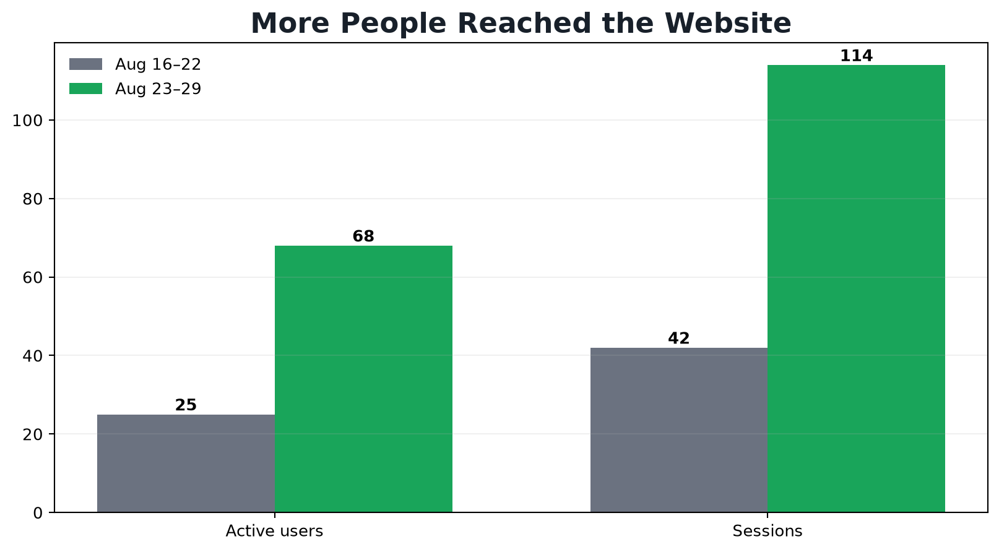
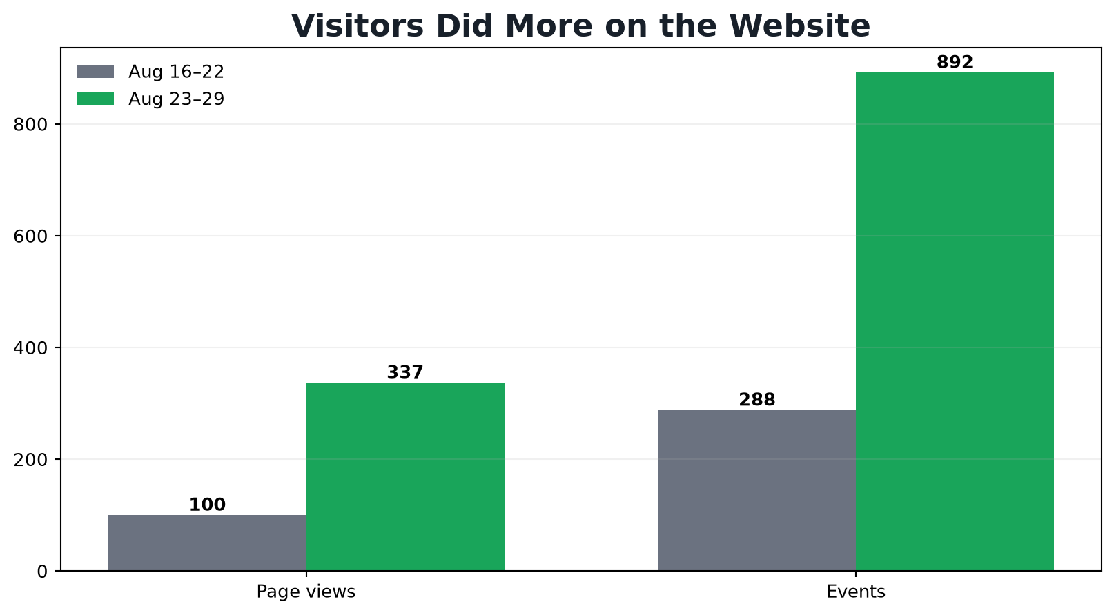
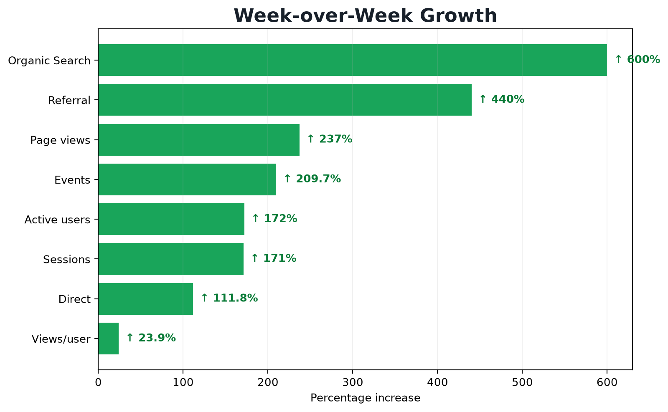

What improved
Metric | Previous week | Current week | Change
Active users | 25 | 68 | ↑ +43 (+172%)
Sessions | 42 | 114 | ↑ +72 (+171%)
Page views | 100 | 337 | ↑ +237 (+237%)
Views per user | 4.00 | 4.96 | ↑ +0.96 (+23.9%)
Events | 288 | 892 | ↑ +604 (+209.7%)
Organic Search sessions | 2 | 14 | ↑ +12 (+600%)
Referral sessions | 5 | 27 | ↑ +22 (+440%)
Direct sessions | 34 | 72 | ↑ +38 (+111.8%)

Where the full month's traffic came from
The monthly view recorded 234 sessions, up from 79—an increase of 155 sessions or 196%.
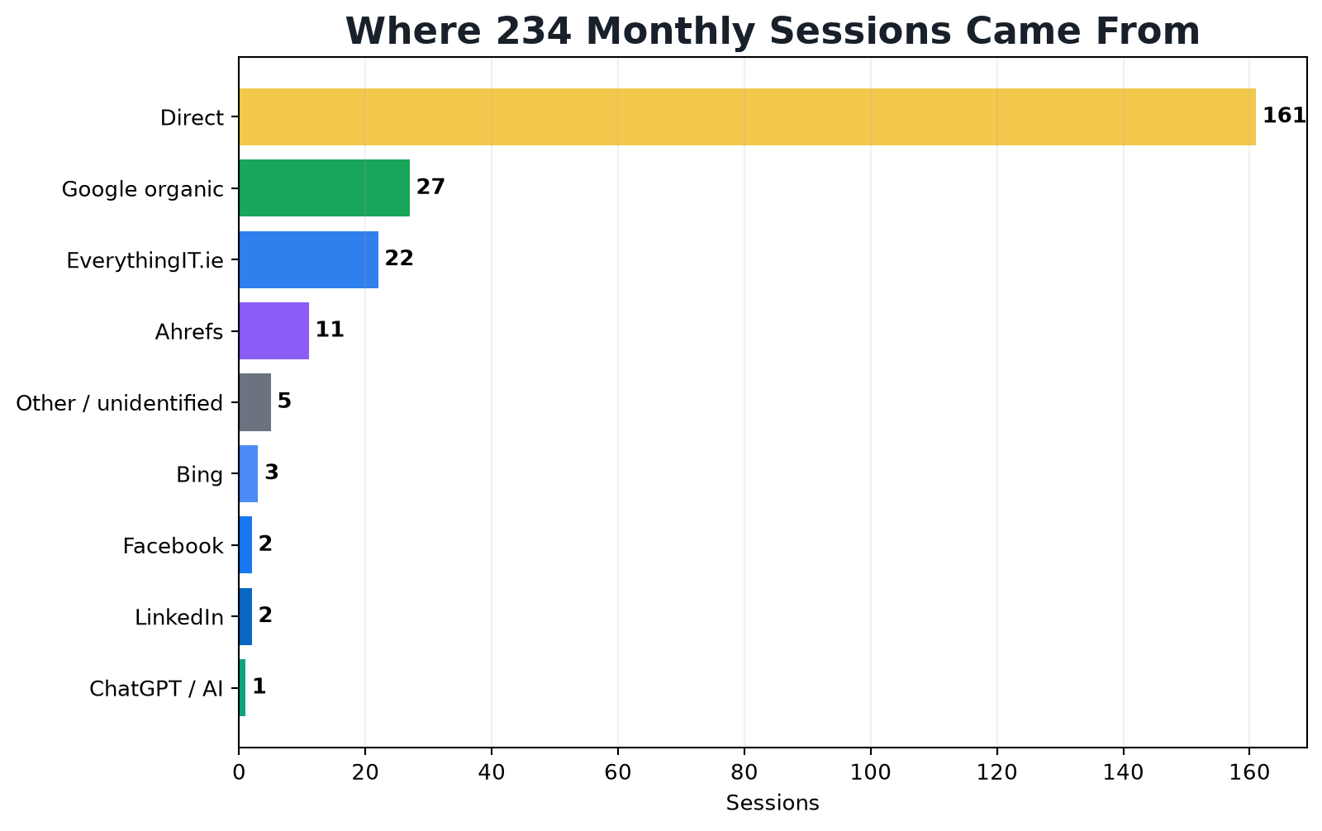

The referral win
EverythingIT.ie delivered 22 referral sessions. The most likely path is the AZ Web Corp footer credit link displayed across Everything IT's website and location pages. This is measurable evidence that a live partner backlink can generate website visits—not merely link authority.
Ahrefs generated 11 sessions. These may include SEO research or team activity, so they should not automatically be counted as prospective customers.
Direct accounted for 161 sessions. GA4 uses Direct when it cannot identify another source, so this should not all be interpreted as brand awareness.

Search traffic is moving
↑ GOOGLE ORGANIC: 13 → 27 MONTHLY SESSIONS
That is an increase of 14 sessions, or approximately 107.7%, across the full monthly comparison.

The weekly organic increase of 2 to 14 sessions supports the same direction. This is encouraging SEO evidence, but the campaign should be judged on whether organic sessions continue rising over the next several weeks.

Geographic growth
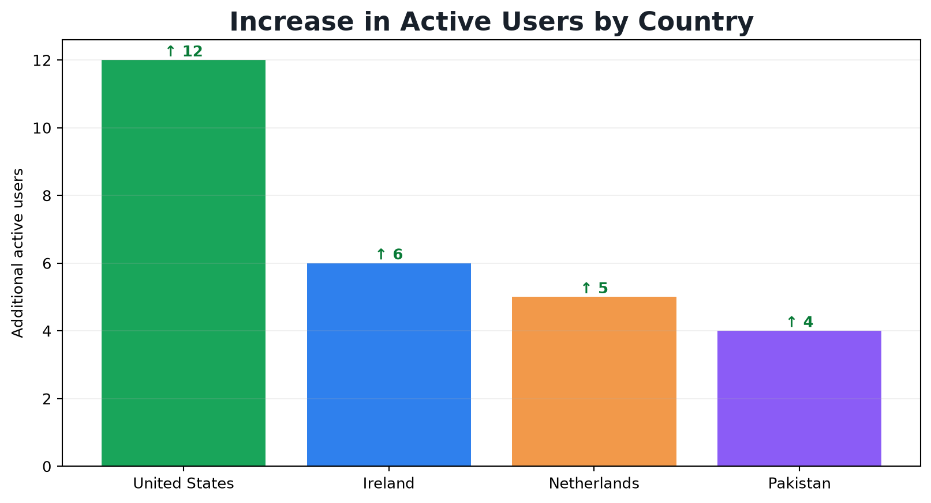
U.S. growth is the most commercially relevant for AZ Web Corp. Ireland may partly reflect partner activity involving Everything IT. Pakistan may include developer or team activity. Netherlands traffic should be monitored for quality, bots or VPN usage before treating it as prospective business.

Overall assessment
PROMISING AND MEASURABLE GROWTH
Users, sessions, page views, engagement, organic search and referrals all improved in the same direction. That is a stronger signal than a single-day spike.

The results are encouraging, not conclusive. Organic volume is still modest, Direct attribution is unusually high, and some referral activity may come from tools or team testing. The next priority is to sustain organic growth, identify every referral source, and measure completed leads—not only visits and events.

What to watch next
- Whether Organic Search continues from 14 toward 20, 35 and 50+ weekly sessions.
- Which Google queries and landing pages generate the organic visits.
- Whether Everything IT referrals engage and convert into enquiries.
- Completed forms, phone clicks and email clicks configured as GA4 key events.
- U.S. traffic growth separated from team, bot, VPN and tool activity.
Source: Google Analytics 4 figures supplied by AZ Web Corp. Charts were recreated from the supplied GA4 figures for clear LinkedIn presentation.

