Everything IT
Monthly Google Performance Report
August 1–27, 2026 compared with July 1–27, 2026
Google Search Console + Google Analytics 4

KEY POINTS AT A GLANCE
Status | What immediately matters
Positive | GA4 G-927C6L1W1C is publicly live across the homepage and Cork, Galway, Limerick and Waterford pages.
Needs improvement | Google clicks changed from 187 in July to 174 in August.
Positive | Google appearances changed from 28,690 to 29,876.
Needs improvement | GA4 is newly installed, so reliable traffic and lead trends need another full month of collection.

Monthly results
Measure | August 1–27 | July 1–27 | Change
Clicks | 174 | 187 | ↓ -7.0%
Impressions | 29,876 | 28,690 | ↑ +4.1%
CTR | 0.58% | 0.65% | ↓ -0.07 points
Average position | 27.7 | 26.6 | ↓ -1.2 positions

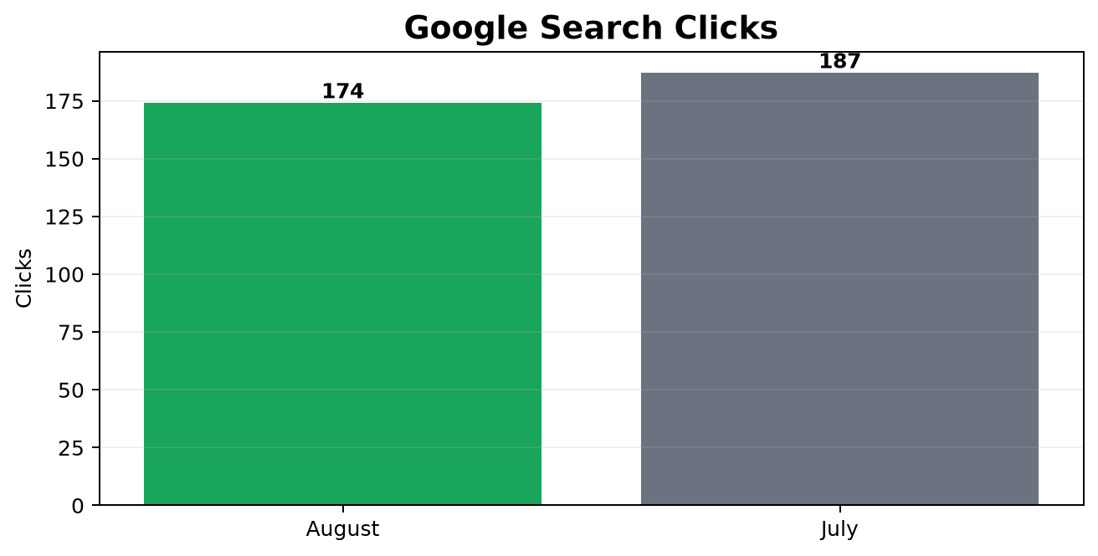
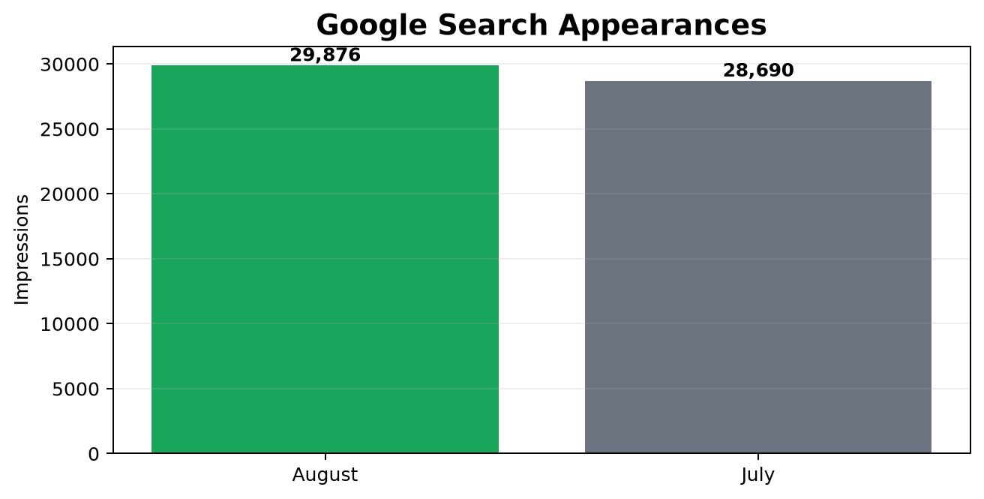

Where traffic came from
GA4 was installed at the end of August, so no dependable source rows are available yet. Search Console clicks below are all unpaid Google Search clicks.

Top queries and monthly movement
Query | Clicks | Impressions | CTR | Position
everything it | 49 | 228 | 21.49% | 6.4
everythingit | 6 | 32 | 18.75% | 3.7
it support dublin | 3 | 690 | 0.43% | 27.9
it support | 2 | 514 | 0.39% | 18.9
everythingit.ie | 2 | 2 | 100.00% | 1.0
it support limerick | 1 | 616 | 0.16% | 7.9
it services dublin | 1 | 414 | 0.24% | 42.9
it services | 1 | 368 | 0.27% | 24.7
it support ireland | 1 | 272 | 0.37% | 20.9
it support in dublin | 1 | 198 | 0.51% | 16.7
it support for companies | 1 | 97 | 1.03% | 3.0
it support naas | 1 | 97 | 1.03% | 9.6
it services ireland | 1 | 94 | 1.06% | 26.2
it support and services | 1 | 88 | 1.14% | 27.9
it companies galway | 1 | 39 | 2.56% | 24.8
it support bangor | 1 | 16 | 6.25% | 8.0
mdm ireland | 1 | 16 | 6.25% | 6.0
it support kilkenny | 1 | 11 | 9.09% | 8.1
it services cork | 1 | 5 | 20.00% | 25.2
every it | 1 | 1 | 100.00% | 1.0

Query | Click change | Impression change | Position improvement
everythingit.ie | ↑ +2 | ↑ +2 | ↓ -1.0
everythingit | ↑ +2 | ↓ -9 | ↑ +0.1
it support limerick | ↑ +1 | ↑ +279 | ↑ +5.2
it support kilkenny | ↑ +1 | ↑ +9 | ↓ -1.6
it support bangor | ↑ +1 | ↑ +3 | ↑ +0.6
every it | ↑ +1 | ↑ +1 | ↓ -1.0
mdm ireland | ↑ +1 | ↑ +0 | ↓ -0.9
managed it provider | ↑ +1 | ↓ -1 | ↑ +8.5
it companies galway | ↑ +1 | ↓ -2 | ↑ +6.5
it support providers | ↑ +1 | ↓ -2 | ↑ +2.3
it support for companies | ↑ +1 | ↓ -3 | ↑ +0.3
it support naas | ↑ +1 | ↓ -9 | ↓ -1.2

Location pages: Cork, Galway, Limerick and Waterford
Location page | Clicks | Impressions | CTR | Position
/it-support-limerick/ | 9 | 2,101 | 0.43% | 27.8
/it-support-galway/ | 6 | 1,271 | 0.47% | 40.4
/cork/ | 7 | 876 | 0.80% | 34.4
/galway/ | 1 | 831 | 0.12% | 30.9
/it-support-waterford/ | 3 | 698 | 0.43% | 36.2
/it-support-cork-2/ | 0 | 164 | 0.00% | 43.3
/limerick/ | 0 | 64 | 0.00% | 49.2
/it-support-cork/ | 0 | 39 | 0.00% | 44.9
/it-support-limerick-2/ | 0 | 6 | 0.00% | 50.8
/it-support-galway-2/ | 0 | 4 | 0.00% | 32.5
/it-support-waterford-2/ | 0 | 3 | 0.00% | 44.0

Location keyword | Clicks | Impressions | Position
it support limerick | 1 | 616 | 7.9
it companies galway | 1 | 39 | 24.8
it services cork | 1 | 5 | 25.2
outsourced it provider limerick | 0 | 475 | 7.8
galway it companies | 0 | 43 | 19.7
it support galway | 0 | 42 | 20.5
galway it | 0 | 39 | 32.8
it company galway | 0 | 36 | 15.5
it services limerick | 0 | 36 | 4.9
network specialists cork | 0 | 35 | 15.3
managed it services cork | 0 | 33 | 20.5
top it companies in galway | 0 | 33 | 20.5
it consultants cork | 0 | 32 | 18.8
website maintenance waterford | 0 | 32 | 26.7
it companies in galway | 0 | 30 | 19.8
business wireless solutions waterford | 0 | 28 | 17.9
it companies in galway ireland | 0 | 27 | 26.3
it galway | 0 | 25 | 32.4
•it support cork. | 0 | 25 | 19.2
high speed business broadband waterford | 0 | 23 | 24.7
technology companies in galway | 0 | 21 | 26.6
managed it support limerick | 0 | 20 | 39.9
software galway | 0 | 20 | 40.2
business it support waterford | 0 | 16 | 8.4
computer software galway | 0 | 15 | 38.3

Products and services customers searched for
Product / service keyword | Clicks | Impressions | CTR | Position
it support dublin | 3 | 690 | 0.43% | 27.9
it support | 2 | 514 | 0.39% | 18.9
it support limerick | 1 | 616 | 0.16% | 7.9
it services dublin | 1 | 414 | 0.24% | 42.9
it services | 1 | 368 | 0.27% | 24.7
it support ireland | 1 | 272 | 0.37% | 20.9
it support in dublin | 1 | 198 | 0.51% | 16.7
it support for companies | 1 | 97 | 1.03% | 3.0
it support naas | 1 | 97 | 1.03% | 9.6
it services ireland | 1 | 94 | 1.06% | 26.2
it support and services | 1 | 88 | 1.14% | 27.9
it support bangor | 1 | 16 | 6.25% | 8.0
it support kilkenny | 1 | 11 | 9.09% | 8.1
it services cork | 1 | 5 | 20.00% | 25.2
it support providers | 1 | 1 | 100.00% | 1.0
managed it provider | 1 | 1 | 100.00% | 11.0
information technology procurement services | 0 | 541 | 0.00% | 5.4
managed it services | 0 | 485 | 0.00% | 23.8
managed it services dublin | 0 | 451 | 0.00% | 23.6
managed it services ireland | 0 | 243 | 0.00% | 22.9
it support services | 0 | 192 | 0.00% | 24.2
support it dublin | 0 | 176 | 0.00% | 36.5
business it support | 0 | 174 | 0.00% | 29.5
cloud pbx | 0 | 131 | 0.00% | 36.1
it support near me | 0 | 127 | 0.00% | 25.1

Top pages
Page | Aug clicks | Jul clicks | Aug impressions | Jul impressions
/ | 79 | 93 | 6,653 | 7,321
https://www.everythingit.ie/ | 20 | 15 | 4,825 | 5,982
/business-continuity-services/third-party-services/business-broadband/ | 1 | 0 | 3,564 | 1,200
/it-support-limerick/ | 9 | 7 | 2,101 | 928
/south-dublin/ | 3 | 3 | 1,670 | 2,177
/it-support-ireland-nationwide/ | 1 | 3 | 1,615 | 2,621
/business-continuity-services/procurement/ | 1 | 0 | 1,394 | 1,041
/it-support-galway/ | 6 | 5 | 1,271 | 899
/contact/ | 8 | 12 | 1,046 | 437
/business-continuity-services/third-party-services/managed-print-services/ | 0 | 0 | 985 | 253
/cork/ | 7 | 4 | 876 | 1,159
/business-continuity-services/managed-services/voip-cloud-pbx-technology/ | 0 | 0 | 872 | 864
/it-support-dublin-city-centre/ | 1 | 2 | 844 | 963
/galway/ | 1 | 2 | 831 | 1,245
/it-support-waterford/ | 3 | 3 | 698 | 1,207
/kildare/ | 4 | 3 | 690 | 719
/business-continuity-services/procurement/supply-chain-logistics-amp-quality-control/ | 0 | 0 | 663 | 705
/mdm-services-dublin/ | 5 | 4 | 658 | 740
/cybersecurity-dublin/ | 0 | 0 | 490 | 0
/it-support-kilkenny/ | 2 | 1 | 476 | 181

Top three countries
Rank | Country | Google impressions
1 | irl | 21,316
2 | usa | 2,970
3 | gbr | 2,052

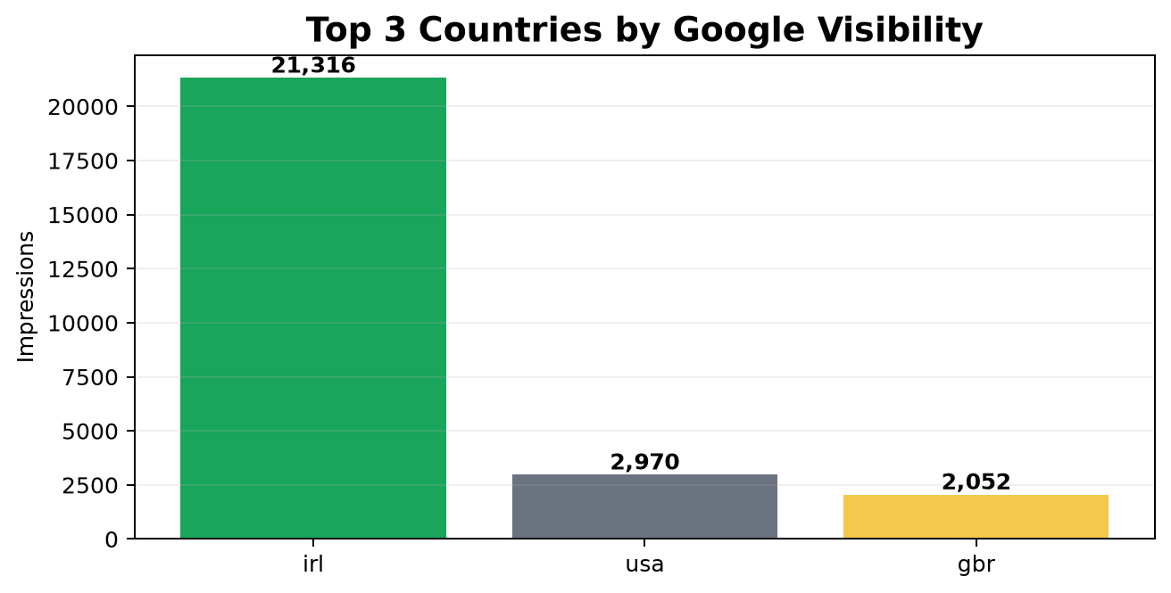

Devices and technical audience
Device | Aug clicks | Jul clicks | Aug impressions | CTR
Desktop | 97 | 131 | 20,899 | 0.46%
Mobile | 76 | 56 | 8,816 | 0.86%
Tablet | 1 | 0 | 161 | 0.62%

Overall assessment
Area | Assessment | What it means
Search visibility | Positive | Visibility is higher than the matching July period.
Search clicks | Needs improvement | Clicks are lower than the matching July period.
Location visibility | Positive | Cork, Galway, Limerick and Waterford performance is now separated and measurable.
Analytics setup | Positive | The correct GA4 ID is live publicly across the tested pages.
Trend reliability | Needs improvement | GA4 needs a full month before customer traffic and leads can be compared reliably.

What the customer should remember
- Everything IT now has working analytics across the main site and four location pages.
- The report shows which locations, services, pages and keywords generated the strongest Google visibility this month.
- Green upward arrows show improvement; red downward arrows identify the areas that need attention.
- The next report will be more valuable because GA4 will have a complete month of source, referral and engagement data.

