CS 499 ePortfolio Category 2 Narrative
Jeremy Kansas
Southern New Hampshire University

To fulfill the second category of the ePortfolio, which is centered on data structures and algorithms, I have chosen to add a hash table to my Emerging Systems final project. The original artifact is a script for gathering weather data using a Raspberry Pi and Grove Pi attachment with sensors. The project is simple in that its main function is to periodically record values for temperature and humidity from the attached sensors. These values are then stored in a list and written to a JSON file. I had always felt that the data storage aspect could be improved upon and so decided to implement a simple hash table in which to store the values instead (which again could easily be formated in JSON if necessary).
For this category, I initially had trouble coming up with an idea that didn’t feel contrived or redundant. In the end, I settled on the hash table idea because I felt it would be an interesting challenge, an opportunity to build a useful data structure from scratch, and to weigh all the various algorithmic and storage considerations that come along with that. Of course, in a real world scenario, it would be a lot easier to just use a built-in structure – such as Python’s dictionary, or if more complex data storage is desired, a full-fledged database – but only through creating my own hash table and thinking through the different considerations and trade-offs did I actually feel I was exercising my knowledge and abilities. With my hash table, the data can now be looked up by a specific date and time with much better performance than simply linearly searching through a list of all items. Compared to the built-in Python dictionary, however, my hash table is almost 10 times slower. Still, given that mine was created in a short period of time while the Python data structure is something that’s been improved and fine-tuned over many versions, I consider that a success.
This enhancement met the course objectives I expected it to. Its primary purpose, as far as objectives were concerned, was to showcase my problem solving ability, my ability to think algorithmically and apply computer science practices, and also my ability to evaluate the various trade-offs, such as efficiency or memory usage, one must consider in any solution. But this enhancement, as any, also allows for further demonstration of coding best practices – whether for readability and collaboration or for security. Also, it provides yet another opportunity for showing my ability to communicate in writing, in both a descriptive and analytical fashion.
In the end, this piece of the project taught me a lot, but in ways that initially surprised me. The actual implementation of the core structure of the hash table class and its methods was much easier than I had anticipated, but fine-tuning its operation proved to be very challenging. The date/times used as keys were difficult to hash effectively because they were generally regularly spaced values (each was ‘rounded,’ so to speak, to the nearest half hour mark). I tried various tricks to make the values hash more randomly, but nothing worked to my liking, so I returned to my original plan, which was just performing a modulus operation of a numerical representation of the key by the size of the table. Because of this simplicity of the hash function, the table size became more important and really needed to be a prime-valued size to help spread out the entries. I toyed with non-prime tables since they would be easier to resize, but ultimately found them to have far too many collisions. Next, my initial plan had been to resize the table when it reached about 75% capacity, but this proved to be too high given that my collision resolution strategy was straightforward linear probing (inserting the data into the first non-colliding index) so I settled for about 50% capacity. From this we come to the most glaring example of a difficult trade-off: I can perform over 10,000 random look-ups on my hash table in a fraction of a second (based on my simple performance tests) but at the cost of memory – at any time there are empty spaces equaling anywhere from about 1 to 3 times the number of actual data points.
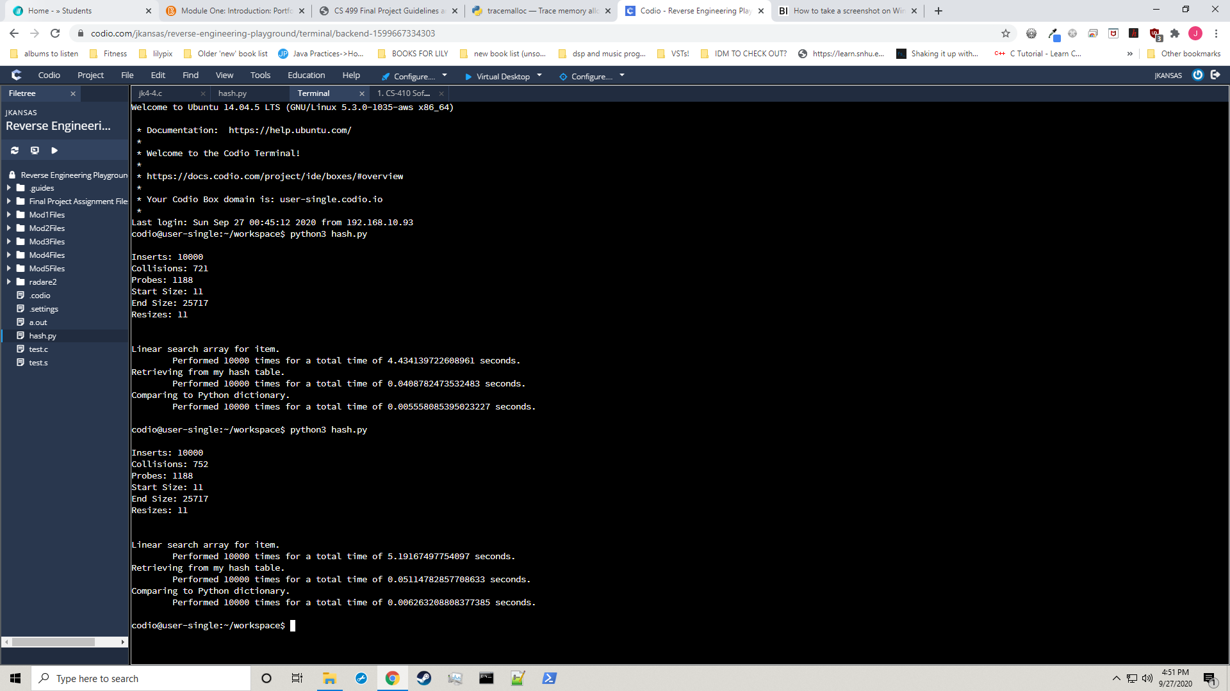
I have also included a screenshot showing two runs of inserting dummy data and then looking that data up:

