The Proposal of Spectrometer Experiment (Group 4)

Guo Yiming (PHY2009481), Yang Ziou(PHY2009487), Wang Yiran (PHY2009484)

Table of Content

1 Introduction 3

1.1 Literature Review 3

1.1.1 Diffraction Grating by slits 3

1.1.2 CD and DVD discs 4

1.1.3 Planck’s Constant 5

1.1.4 LED light-emitting principle 5

1.1.5 Absorption spectrum of copper sulfate 6

1.1.6 Beer–Lambert law 6

1.2 Objective 6

1.2.1 Diffraction Grating by slits 6

1.2.2 Planck’s Constant with LEDs 6

1.2.3 Investigate the absorption spectrum of copper sulfate solution 6

2 Experiment Setup 8

2.1 Experiment 1: Diffraction grating of CD/DVD discs 8

In this experiment we have some simple instrument to conduct the experiment: 8

2.1.1 Projection Screen 8

2.1.2 Coordinate Paper 8

2.1.3 Distance Ruler 8

2.1.4 Grating platform 9

2.1.5 Grating / disc fragment 9

2.2 Design of Spectrometer 9

2.2.1 Main body 11

2.2.2 Spectrometer cover 11

2.2.3 Camera Dock 12

2.2.4 Disc Dock 12

2.2.5 Others 12

2.3 Experiment 2: Measure the Planck constant by LED 13

2.4 Experiment 3: Investigate the absorption spectrum of copper sulfate solution 13

3 Diffraction grating of CD/DVD discs 14

3.1 Hypothesis 14

3.2 Methodology 14

3.3 Data Analysis method 15

3.4 Result 16

4 Measure the Planck constant by LED 17

4.1 Hypothesis 17

4.2 Methodology 17

4.2.1 Specific Experiment Steps: 18

4.3 Data Analysis method 18

4.4 Expected Result 18

5 Investigate the absorption spectrum of copper sulfate solution 20

5.1 Hypothesis 20

5.2 Methodology 20

5.2.1 Material 20

5.2.2 Solution Preparation 20

5.2.3 Experiment Procedure 20

5.3 Data Analysis method 21

5.4 Expected Result 21

6 Conclusion and Improvement 23

6.1 Conclusion 23

6.1.1 Measuring Diffraction Grating of CD/DVD 23

6.2 Further Improvement 23

7 Experiment Management 25

7.1 Budget 25

7.2 Distribution of Work 25

7.3 Timeline & Milestone 26

8 Reference 27

Abstract

In this experiment, the spectrometer was made by using the optical disc as the diffraction grating. The Planck constant was measured by using the LED lamp, and the absorption rate of copper sulfate solution was explored. At the same time, the problems related to the grating properties and diffraction phenomena are studied.

# Introduction

## Literature Review

In this experiment, we will mainly study the influence of measuring the solution on the light absorptivity with a self-made spectrometer, as well as some scientific facts in the DIY process and their influence on spectrometer. Therefore before we start out experiment, we first do some research and literature review in several topic: Diffraction Grating of Slits, CD and DVD discs, Planck’s constant, LED.

### Diffraction Grating by slits

Diffraction is a phenomenon caused by the wave principle of light. 1 When the light enters the slit or the edge of the object, according to the explanation of Huygens wavelet principle, the light forms countless wavelet, and each wavelet forms a spherical wavefront origin at the slit and spreading in the whole space. On the projection screen, countless wavefronts form superposition at a certain angle to form a brighter spot and form diffraction fringes. In multiple-slit diffraction, more clear and uniform fringes can be formed than single slit diffraction. Because the position of the diffraction spot of light is related to the optical path difference (see formula), it is often related to the angle between the optical axes in the experiment. At the same time, because different colors of light have different wavelengths, it leads to fringes in different optical path differences. In the experiment, fringes of different colors are produced at different angles We can separate light of different wavelengths.2

Figure 1: Phenomenon of Diffraction(Simulation)

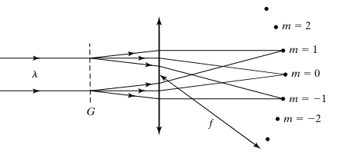

Figure 2: Distribution of the diffraction

[1][2]

Where represent the index numbers of the diffraction fringe, that the center corresponding to . And represent to the angle of the diffraction fringe corresponding to each index number of diffraction fringe.

In this process, we use angular dispersion to describe the ability of the medium to separate light of different wavelengths, which is often calculated by the following formula 2.

[3]Where, a is grating constant or groove separation, the distance between each wavelet. For multiple slits diffraction it is the reciprocal of the density of the slits.

Figure 3 Optical Principle of diffraction Grating Spectrometer

### CD and DVD discs

Next, we found that the plastic after removing the reflective film on CD / DVD was a very typical multi slit diffraction grating. They are composed of countless dents with equal spacing, which are highly similar to professional diffraction gratings and are easy to obtain. Therefore, in this experiment, we use the fragments of optical disc as the diffraction grating in the experiment.

[4]

Figure 4 AFM image of unburned DVD

### Planck’s Constant

As one of the most important constants in modern physics, the Planck’s Constant ‘h’ becomes the boundary between macroscopic and microscopic objects. It used to describe quantum size and shows for the first time the discontinuity of radiated energy. 3,4

Planck believed that matter could radiate only an integral multiple of some minimum energy. Such a minimum energy is called a quantum of energy, each of which is .

### LED light-emitting principle

Since the core parts of LEDs are wafers made up of P-type and N-type semiconductors. And there exists a transition layer between P-N junction and P-N junction. 5

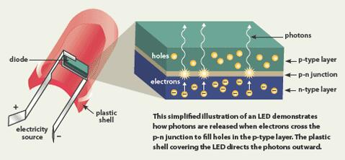[5]As the p-N junction of the semiconductor material is applied to a forward voltage, the combination of injected minority and majority carriers releases excess energy as light, converting electrical energy directly into light energy. As the current flows from LED anode flows to the cathode, the semiconductor body emits different colors lights from ultraviolet to infrared. And the intensity of light in different colors is related to current.

Figure 5 Principle of LED emitting

### Absorption spectrum of copper sulfate

In an experiment carried out by the Los Angeles City College, aimed at finding out the relationship between concentration of the solution and the absorbance of solution, which draw out a colored solution's distribution of absorbance line is highly related to its color and the absorbance and concentration is of linear relationship 6.

In this experiment, two wavelengths of light are used, one is close to the actual light the color CuSO4 shows (500nm, shallow blue), another is far from its original color (650nm, red). For the blue-colour CuSO4 solution, theoretically, the absorbance of 500nm light will be significantly lower than the 650nm light.

### Beer–Lambert law

The Beer–Lambert law, also known as Beer's law, the Lambert–Beer law, or the Beer–Lambert–Bouguer law relates the attenuation of light to the properties of the material through which the light is travelling.

* is the absorbance
* is the molar attenuation coefficient or absorptivity of the attenuating species
* L is the optical path length in cm
* c is the concentration of the attenuating species

The Beer–Lambert law can be applied to the analysis of a mixture by spectrophotometry, without the need for extensive pre-processing of the sample. The amount concentration c is then given by

## Objective

### Diffraction Grating by slits

* To investigate the relation between grating constant and grating angle.
* To determine the grating constant of CD and DVD discs.
* To determine the disc that is more suitable using in Spectrometer.
* To verify the diffraction equation.

### Planck’s Constant with LEDs

* To investigate the relation between LED forward voltage and LED wavelength.
* To measure the value of the Planck’s Constant with LEDs bulbs series and Spectrometer.

### Investigate the absorption spectrum of copper sulfate solution

* To determine the absorption spectrum of copper sulfate solution.
* To compare the absorptivity of different wavelengths
* To investigate the changes of absorbance of light with specified wavelength in different concentrations of solution
* To determine the wavelength (color) of maximum absorbance for a copper (II) sulfate solution.

# Experiment Setup

## Experiment 1: Diffraction grating of CD/DVD discs

## In this experiment we have some simple instrument to conduct the experiment:

### Projection Screen

In the experiment, we use a piece of cardboard as the projection screen of the experiment, use a bracket to fix it vertically on the desktop, and apply a small amount of glue on the place facing the experimental equipment to fix the coordinate paper. We use weights to fix the screen position to prevent displacement when marking later.

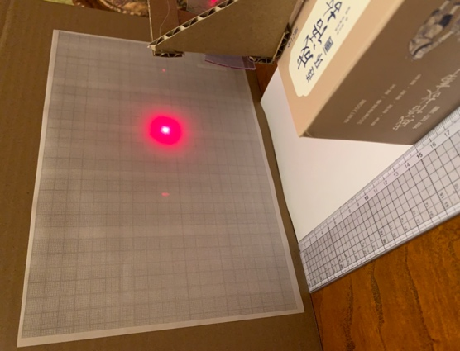

Figure 6 The Projection Screen with Red Laser emitting



Figure 7 The Blank coordinate paper

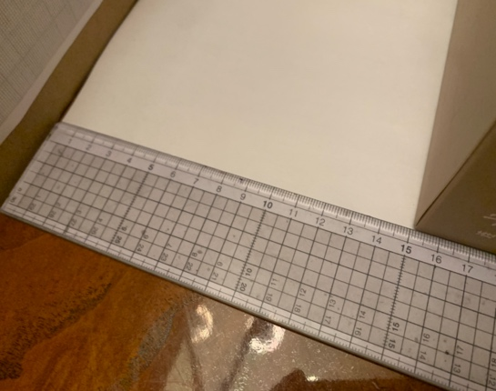

Figure 8 The distance ruler

### Coordinate Paper

In the initial experiment, we found that because the slits of the disc are not straight lines, but rings, it is difficult to ensure that the grating is perpendicular to the ground and the light spot is located on a straight line parallel to the ground. Therefore, here we use two position coordinate paper to replace the scale commonly used in traditional experiments as the recording medium of experimental results.

In the experiment, we use coordinate paper with an interval of 1mm to record the abscissa and ordinate position of the light spot in the experiment. Before the experimental measurement, we record the test parameters on the coordinate paper for statistics later. We recorded the results of the same experiment under different conditions.

### Distance Ruler

In the experiment, the distance between the grating and the screen is one of the control variables. Therefore, in this experiment, we use a 30cm scale pair to adjust the distance between the grating platform and the screen. The 0-scale line of the scale is close to the projection screen. And keep it perpendicular to the screen.

### Grating platform

In the experiment, we need to fix the grating (disc fragments) vertically on the desktop and control its height from the desktop and the distance from the screen. Therefore, in the experiment, we made a simple grating platform with cardboard. The platform can install two (30mmx30mm) square disc fragments at the same time. At the same time, the platform fixes the grating at the height of 10cm, about half of the screen height, to ensure that all the light spots can fall on the screen.

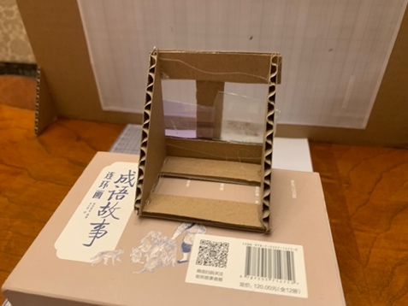

Figure 9 Grating Platform

### Grating / disc fragment

In the experiment, we cut the disc with an art knife and remove the reflective coating on it, leaving only the plastic information layer. The fragments are cut into a square size of 30mmx30mm, in which a pair of edges are parallel to the radius of the ring, which will help to ensure the horizontal distribution of the light spot as much as possible in the later design.

## Design of Spectrometer

In this section, we will discuss the design of the spectrometer.

According to experiment 1, we determined that DVD has stronger diffraction dispersion, that is, for light with different wavelengths, DVD can disperse them more widely, which will help to improve the accuracy of spectrometer. Therefore, in spectrometer, we use DVD as the grating.

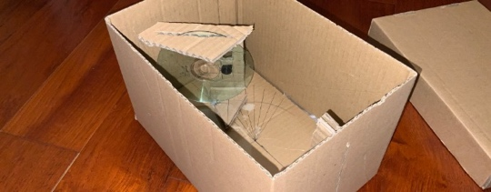In spectrometer, we use a 720p camera module as the data acquisition terminal. We remove the infrared filter on the camera to reduce the transmittance of long wavelength visible light and improve the accuracy of the experiment. At the same time, the camera uses manual focusing to avoid the blur caused by automatic focusing on the dark spectrometer. Since the use distance generally does not change, manual focusing has higher stability and accuracy.

Figure 10 Structure of prototype

Figure 11 Setup of Disc and Camera

Figure 12 Camera Module

The camera module and the DVD grating are placed close together to ensure that the camera can capture clear diffraction fringes. Both are placed vertically in the chamber with a cardboard platform that can be rotated to allow us to adjust the pointing of the camera so that clear and accurate diffraction fringes can be captured in the camera.

Firstly, according to Theremino’s DIY experimental guide,7 we made a prototype of spectrometer in a carton, as shown in the figure. Here we use cardboard to make a slit so that the light can keep the vertical incidence as much as possible.

The light will pass through the inclined grating through the slit, and the light of different colors will be diffracted to different angles and finally recorded by the sensor of the camera module. The following stripes are obtained.

Figure 13 Testing of prototype

Figure 14 The view of camera directly toward the slit

In the software, we use the python program created by Les Wright.[7] He obtains a luminous intensity spectrum by measuring the light brightness of each position on the central horizontal line of the camera, as shown in the figure. After calibration with red laser and green laser, each point corresponds to different wavelengths of incident light one by one. Finally, we will get a data set of light intensity spectrum of incident light.

It is worth noting that the obtained light intensity spectrum is a relative value calculated based on the brightest point as 100%, so we need to change the process of data analysis during the subsequent data analysis, which will be shown later in the presentation.

After testing the prototype, we found that it is feasible to experiment with this principle, and we can get some key data we need:

* Length and width of slit
* Angle between camera and filter group and incident light
* Relative position between camera and slit

Therefore, we can use these data to draw the 3D drawing of our formal spectrometer. The spectrometer will be divided into several different parts. Through assembly, we can flexibly adjust the instrument.

* Main body
* Spectrometer cover
* Camera dock
* Disc dock

### Main body

The main body is the main part of the spectrometer, which constitutes the cavity of the spectrometer and has the connection parts with various components on it. The head of spectrometer is a protruding circular ring, which is used to connect with the test module. The protruding part of the shear ensures that there will be no interference of ambient light at the connection. In the middle of the circular ring is a slit, which filters out the obliquely incident light.

There is a capsule shaped mounting slot at the back end of the main body, which will be fixed with the base of the camera dock. At the same time, it allows the camera to move and rotate left and right, and adjust the imaging position of the incident spectrum in the camera.

A set of magnetic ports for connecting with other parts are reserved at the upper end and front end of the main body. In this design, we use magnets to connect each part. It helps to adjust the connection strength and ensure the stability of the connection.

### A picture containing text, sky Description automatically generatedDiagram Description automatically generatedSpectrometer cover

Figure 15 Spectrometer Cover

Figure 16 Main Body

The spectrometer cover is connected with the main body to form a closed cavity of the spectrometer to prevent the influence of ambient light on the internal sensor. Like the main body, the cover has a mounting slot for fixing the camera dock and a magnetic port for fixing with the main body. The four sides of the cover extend outward, so that the ambient light cannot enter through the gap.

### Camera Dock

The camera dock consists of two circular bases and a middle fixing plate. The space and screw hole for inserting the camera module are reserved on the middle fixing plate, as well as the fixed square column for connecting with disc dock.

Figure 17 Disc Dock mounting on the Camera Dock

Figure 18 Camera Dock

### Disc Dock

The disc dock has three openings of different shapes, with square holes connected with camera dock on both sides and a slit for fixing the grating in the center. After the disc dock is installed on the camera dock, it still has the activity of moving back and forth. To adapt to the expansion and contraction of the lens during manual zoom.

### Others

All experimental parts are printed in 3D with white resin, which has certain light transmittance. In order to avoid the influence of ambient light. All the other parts are covered with light blocking tape, so that the light cannot pass through.

Figure 19 The shading tape is covered on the inside of the equipment

## Experiment 2: Measure the Planck constant by LED

The LED module is relatively simple. There are two guide rails on it. These two guide rails correspond to the screw holes on the back of the mini bread plate. The LED can be fixed in the same straight line of the slit, and the light released by the LED can enter the spectrometer vertically.

In the experiment, a series connection method is used to connect multiple LED lamp beads. This method not only improves the brightness of the experiment, but also widens the gap between the forward voltages of LED lamps with different colors, which is conducive to the error caused by Voltmeter measurement. There is a space on the side wall of the module to connect internal and external circuits. The voltmeter can measure the forward voltage of the internal LED by measuring the port left outside.

Figure 20 Circuit mounted on the LED module

Figure 21 LED Module

## Experiment 3: Investigate the absorption spectrum of copper sulfate solution

The cuvette module is composed of a front cover, a rear plate and a cuvette shelf in the middle. The front cover has a port connected with the spectrometer, and the rear cover is equipped with a lighting circuit and a white LED light board to provide light. The cuvette shelf in the middle can fix five cuvettes for measurement at the same time. The cuvettes measured by spectrometer can be adjusted by sliding and translating the rods on both sides to realize the measurement of multiple experimental sides without disassembly, which can greatly improve the efficiency.

Here, the white LED light board is used to provide light, and the white LED light board can evenly and stably blue and red light, which will help to explore the absorption rate in Experiment 3.

Figure 22 Cuvette Module mounting with spectrometer

Figure 23 Cuvette Module

# Diffraction grating of CD/DVD discs

## Hypothesis

* Other conditions remain unchanged, the shorter the wavelength of the laser, the closer the spot position.
* When other conditions remain unchanged, the closer the grating screen distance is, the smaller the spot spacing is.

## Methodology

1. Firstly, conduct preliminary experiment to confirm the test parameters that can conduct the test normally and accurately.

* In the experiment, the distance before the spot () is too far, so that the coordinate paper cannot completely record the positions of the three points, making the data incomplete.
* In the experiment, if the distance between the light spots is too close, the data is inaccurate due to the size of the light spot, and the error of the ruler.
* Therefore, after the preliminary test. We have confirmed several groups of test parameters that can be tested, as shown in the table below (Experimental group)



1. Then we use these data for grouping experiments.
2. Firstly, record the experimental control variables on the coordinate paper, including grating type (CD / DVD), grating screen distance (50 / 100 / 150mm) and laser type (650 / 550nm). It shall be pasted and fixed in parallel along the edge of the projection screen to ensure that the coordinate paper is pasted flat enough.
3. Fix the light screen with heavy objects. Press the scale vertically against the screen.
4. Fix the grating platform on the point marked by the scale. Make the grating a given distance from the screen.
5. Use the specified laser vertical incidence grating and keep it fixed.
6. Use a fluorescent marker to mark the position of the laser spot on the screen, which is generally 3 spots, and there is the possibility of 5 spots at the same time. Repeat the experiment with markers of different colors. During this period, the grating platform can be moved horizontally parallel to the screen plane, or the grating can be rotated to make the light spot fall at different positions of the coordinate paper and reduce the error in the experiment. 3-5 groups of experiments were carried out for each experimental parameter.

Figure 24 One coordinate paper with result

1. After the experiment with the same experimental parameters. Take off the coordinate paper with the experimental results, take photos and archive, and carry out the next group of experiments.
2. All experimental parameters. After the experiment, start the transcription and analysis of the test results. See the data analysis section.

## Data Analysis method

In this part, the recording and analysis of test results will be introduced. Matlab script will be used for automatic calculation in the process of data calculation.

1. The coordinate paper recording the experimental results will have several groups of marks of different colors. First, we confirm the center point of each group of marks, which corresponds to the center spot () in the diffraction spot. The next two marks correspond to the spot of respectively. Therefore, to calculate the distance between the two, we can first take the center point as the origin, record the relative positions, horizontal and vertical coordinates of the surrounding two points, and record these distance coordinates in the same column of the CSV document with the experimental parameters.

Each column represents one experiment, and the recorded results are as follows:

1. Then we can calculate the diffraction angle through the average value of the distance (d) between the light spots and the distance (L) between the grating and the screen,
2. Next, we can calculate the grating constant of the disk, where we use the diffraction formula in the literature review.
3. So, we can calculate the required results.

## Result

Here we list out one experiment and its result to prove the feasibility of experiment

, , ,

Therefore

And we can turn out the diffraction

The reciprocal is

The standard CD has 625 rows per 1mm. Therefore we can find that the result is very close to the exact value.

# Measure the Planck constant by LED

## Hypothesis

* The shorter the wavelength of light, the greater the voltage across the LEDs (forward voltage).

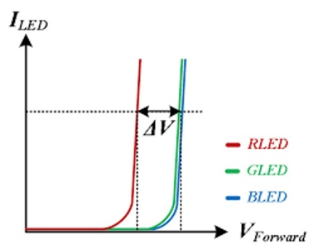

Figure 25 the forward voltage with different colors lights

## Methodology

* In this experiment, we use multiple LEDs of the same type in series and measure their total potential to reduce the error due to with the multimeter as the measurement tool. And to save cost, here we use 8 households 1.5V batteries as the power supply, which constitute a 12V DC voltage.
* The figure below demonstrates the circuit simulation of this experiment in Multisim. We can see that when different switches are closed, different voltages can be obtained, which is the result of multiple LEDs forward voltage.

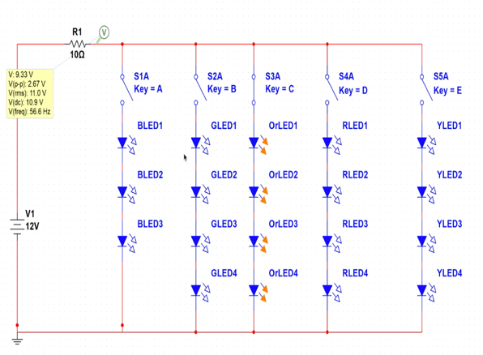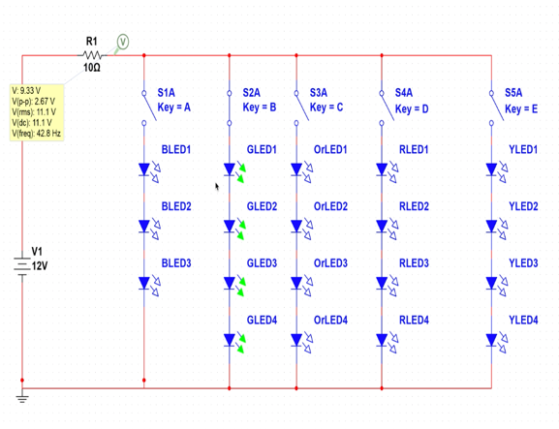

Figure 26

Figure 27 Circuit simulation of this experiment

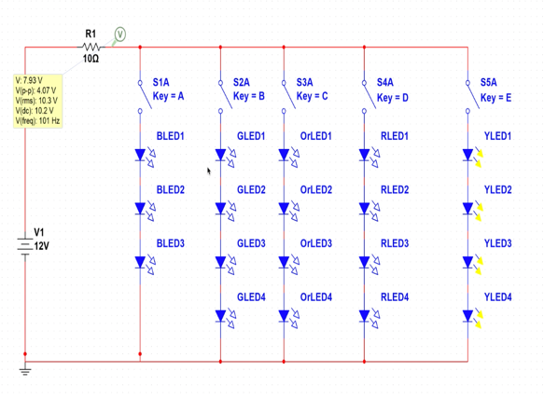

The results in this part of the experiment will be used to calibrate the Spectrometer accurately.

### Specific Experiment Steps:

1. Calibrate the voltmeter
2. Calibrate the spectrometer with a red laser and a green laser
3. Install the specified number of LED lights of the same color in series on the breadboard and fix the breadboard on the testing module. Connect the power supply through the wire, make sure the circuit is connected correctly and the LED lights up normally.
4. Connect the Module to the spectrometer, switch on the power. Then record the experimental spectrum after the software displays the stable light intensity spectrum.
5. Record the voltage at both ends of the LED lights and record the data.
6. Turn off the power, turn it on again, repeat the experiment, repeat the above operation, record more than 3 groups of data to reduce the error.
7. Replace the LED lights with different colors and repeat the above operation.

## Data Analysis method

After obtaining the measured voltage value, divide it by the number of LED lights , here is the voltmeter reading, is the number of LED lights, and the is the final voltage we need.

Then substitute the result into the formula:, here the value of the constant q is , then we get the energy.

Since that , and we already know the wavelength of the LED lights, with the formula we can get the value of frequency.

Finally using we can obtain the value of h, which is the Planck’s Constant.

## Expected Result

Here we first list out the result of experiment done by previous people9:

Table 1Experiment data of Planck Constant measurement for LED light source with zero-point method

From the table above, we can conclude that the shorter the wavelength of light, the lower the voltage across the LEDs. So, our hypothesis is wrong.



Table 2 Camparative data of planck constant measurement experiment for LED source with zero point method

This is the experiment that using a monochrome LED light source to measure the Planck’s Constant.

# Investigate the absorption spectrum of copper sulfate solution

## Hypothesis

* Under certain wavelength of light (500nm and 650nm), the absorbance of CuSO4 solution is positively related to the concentration of the solution, i.e., the higher the concentration of the solution is, the more significant the absorbance will be.
* Under certain concentration of CuSO4 solution. The absorbance of light at 650nm is higher than the absorbance of light at 500nm

## Methodology

### Material

Spectrometer, LED white light source, cuvette, deionized water, volumetric flask, 4 set of CuSO4 solution separately with concentration of 0.1 mol/L, 0.5 mol/L , 1 mol/L and 2mol/L

Figure 28 Cuvette(10mm)

Figure 29 LED panel

Figure 30 Copper sulfate crystal

### Solution Preparation

i. Calculate the amount of CuSO4, and deionized water needed.

ii. Weigh out the amount of material determined in step i.

iii. Prepare the volumetric flask, add in the solute (CuSO4 Crystal) first.

iv. Add in the deionized water about 2/3 full and mix the solution.

v. Add in the deionized water until the water level reaches the mark on the flask accurately.

vi. Mix the current solution again and obtain the solution with accurate molar concentration.

### Experiment Procedure

i. Turn on the spectrometer, and turn on the LED panel in the testing module.

ii. Insert the cuvette with deionized water into the spectrometer, assure there’s no dirt or fingerprint on the cuvette, if there is, wipe them off with light duty wipe.

iii. Record the spectrum of the deionized water.

iv. Repeat the experiment step ii and iii with another cuvette filled with each concentration of solution.

vi. Each solution or solvent must be measure at least 3 times to assure the accuracy.

## Data Analysis method

i. Mark certain wavelength (500nm and 650nm) on the spectrum recorded in the experiment.

ii. Read the absorbance in such wavelength, i.e., the intensity of certain wavelength of light.

iii. Fill the data into such analysis form below:

iv. Calculate the relative intensity loss caused by the increase of concentration, compare the data, and draw the solution.

|  |  |  |
| --- | --- | --- |
| Wavelength/ | 500nm | 650nm |
| Intensity |
| Concentration |
| Deionized water |  |  |
| 0.1mol/L Solution |  |  |
| 0.5 mol/L Solution |  |  |
| 1 mol/L Solution |  |  |
| 2 mol/L Solution |  |  |

Table 3 The experiment Sheet

## Expected Result

The results are expected to be:

* For hypothesis 1, the absorbance of different concentration of solution under different wavelength of light is following the same rule: the intensity absorbed (light intensity lost in the solution) is proportional to the molar concentration of the solution.
* For hypothesis 2, the solution’s absorbance of 600nm light is higher than 400nm light, i.e., at same concentration, the light intensity absorbed of 650nm light is higher than 500nm light, whatever the concentration is.

Here we haven’t started the preliminary result, thus here we list the previous experiment done by others to show the Feasibility of experiment.10 Here we can see that with the increase of solution concentration, the absorption rate shows a positive proportional upward trend, which also proves the feasibility of this experiment.

# Conclusion and Improvement

## Conclusion

### Measuring Diffraction Grating of CD/DVD

In the experiment, we can conclude that DVD has larger angular dispersion than CD, and calculate that DVD has more dense slits (CD 600-700/cm, DVD 120-1300/cm), which makes DVD more suitable for light splitting. For spectrometer.

6.1.2 Measuring the Planck Constant

In the experiment, we can conclude that the shorter the wavelength of light, the lower the voltage across the LEDs. With the average value of the experiment data ‘h’, we get 6.19005, and its relative error is 6.6%.

6.1.3 Absorption Spectrum of Copper Sulfate

In the first hypothesis, we can conclude that, under same wavelength of light, the higher the concentration, the more significant the absorption, and therefore calculate under different concentration, the rate of absorption varies.

In the second hypothesis, we can conclude that, under different wavelength, the copper sulfate solution tends to absorb more light with higher wavelength, and with 2 pairs of solution with different concentration, and with molar absorptivity at 635nm (2.81 M-1cm-1), we can calculate the molar absorptivity of the solution, where we may find that comparing with lower wavelength (500nm), the absorption at higher wavelength is larger, which corresponding to the blue colour of the solution.

## Further Improvement

There are some aspects still that can be improved in the experiment.

* First, because the DIY spectrometer is used in the experiment, it cannot accurately measure the spectral intensity, only the brightness of stripes photographed by the photographic module can be used to judge the results of normalization, which is difficult to be very precise and scientific.
* In the experiment, the fringe is too thick and overlaps with the surrounding fringe. This is because the incident light is too thick due to the large width of the slit, which forms a large fringe in the diffraction process. Therefore, the experimental results can be accurate by further reducing the width of the slit.

In Experiment 2,

* we can use more LED beads in series and parallel at the same time to improve the sum of voltage and brightness and install an astigmatism plate at the front end of the spectrometer to make the incident light more uniform, so as to reduce the possible problem of distortion of experimental results caused by the uneven incident light in the experiment.
* At the same time, we can choose more LED beads and a wider wavelength range to conduct experiments, which will help improve the accuracy and universality of the experiment, and also reduce the errors generated in the experiment by taking the average.

In Experiment 3,

* we can try to use a more uniform light source to irradiate to get more accurate spectral information. Meanwhile, we can adjust the brightness of the LED beads to make the result more accurate and avoid the problem that the camera cannot accurately measure the brightness relationship of each point due to the high brightness.
* We can increase the solute concentration again to verify the accuracy of Beer-Lambert Law at high concentrations.

# Experiment Management

## Budget



Table 4 Budget of Project (update at 24/4/2022)

## Distribution of Work

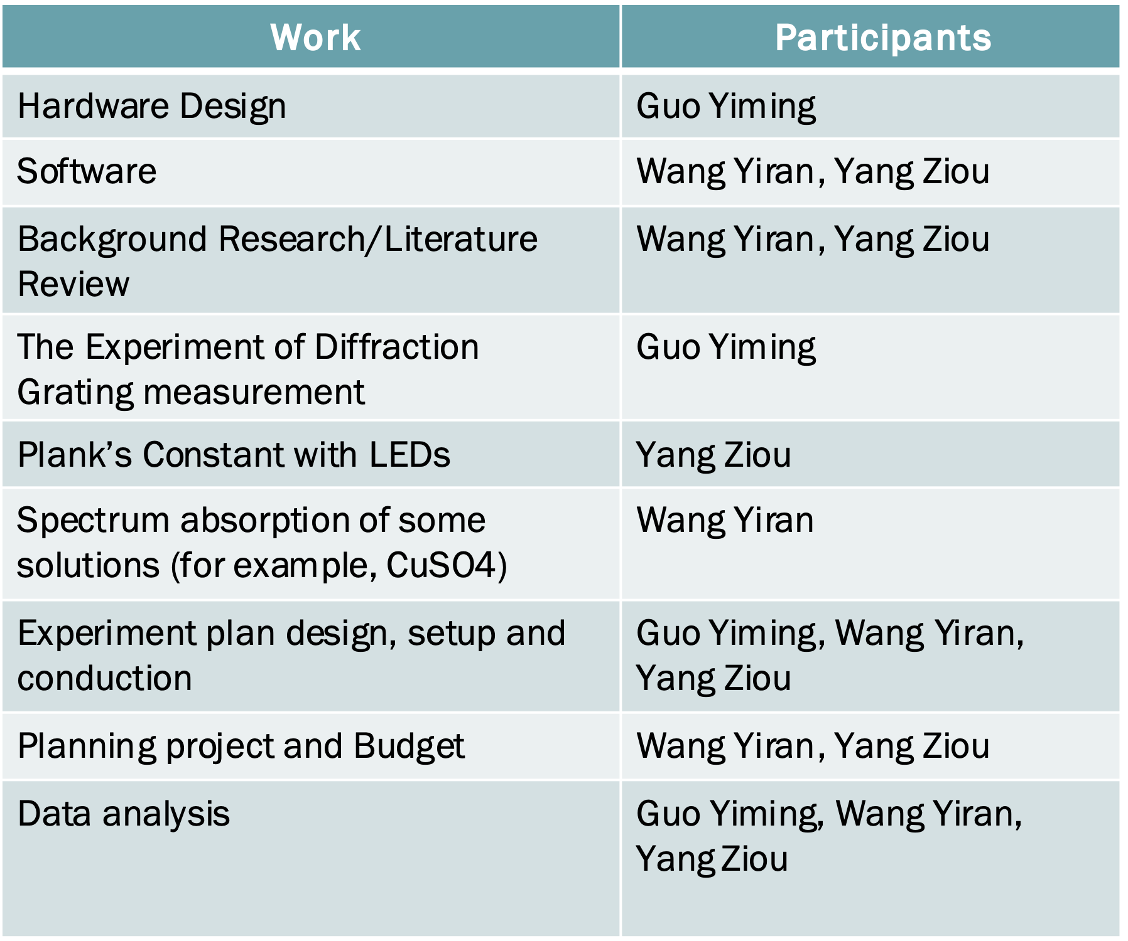

Table 5 Distribution of work

## Timeline & Milestone



Table 6 Timeline and Milestone

# Reference

1. Born, M. & Wolf, E. *Principles of optics*. (Cambridge University Press, 2019).

2. Pedrotti, F. L., Pedrotti, L. M. & Pedrotti, L. S. *Introduction to optics*. (Pearson/Prentice Hall, 2007).

3. Blundell, S. & Blundell, K. M. *Concepts in thermal physics*. (Oxford University Press, 2010).

4. Harris, R. *Modern physics: Randy Harris.* (Pearson, 2014).

5. Boylestad, R., Nashelsky, L. & Boylestad, R. L. *Electronic devices and circuit theory*. (Pearson, 2013).

6. Formation of complex ions.

7. Theremino. Theremino Spectrometer Construction.

8. Wright, L. *PySpectrometer 2021-03-05*. (2022).

9. 用单色LED光源测量普朗克常数 - 百度文库. https://wenku.baidu.com/view/994884787b3e0912a21614791711cc7931b7782c.html.

10. Doe, J. & Smith, S. Using Absorbance to Determine the Concentration of CuSO4. 4.

1. Image from http://electron9.phys.utk.edu/optics421/modules/m5/Diffraction.htm
2. Image from Introduction to optics, Pedrotti
3. Image from <https://www.nnin.org/>
4. Image from <https://www.nnin.org/>
5. Image from <https://www.xedlight.com/blog/post/what-are-the-disadvanges-of-led>