*Shows proof the markers work with clickable information*

API – WeatherAPI- GMAPS Project Write Up

In this project, we generated latitude and longitudinal coordinates; totally almost 600 coordinates. With these coordinates, we found the nearest city. Using the weather API from openweathermap.org, we retrieved information and placed it into a pandas data frame, see below.

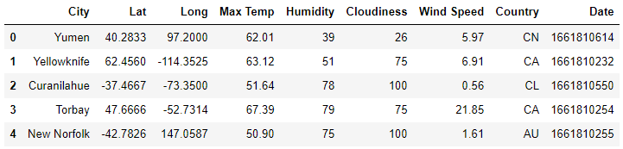

Trend 1: looking at the latitude and max temperature plot, the max temperature peaks at 0 – 40 latitude. The temperature rises from latitudes -60 degrees to about 35 degrees then steady decreases. This trend resembles a negative quadratic graph shifted over the x-axis. I concluded the temperature increases at a certain range of latitudes. Surprisingly, the hottest latitude isn’t at the 0 degree latitude which is called the equator. The hottest range from 0 – 40 degrees latitudes.

Trend 2: Humidity really isn’t dependent on latitude however the more extreme latitudes you reach; the less humidity you do see. Near 0 latitude, you only have humidity over 60%.

Trend 3: the northern and southern hemispheres have opposite correlations with temperature and latitude. Southern hemisphere has a positive correlation, while the north has a negative correlation. The north as the latitude goes away from 0, the temperature decreases. The southern hemisphere as they approach 0 the temperature increases.

Essentially, the two graphs above cuts the graph below in half and dissects the relationship of latitude and temperature based on different hemispheres.

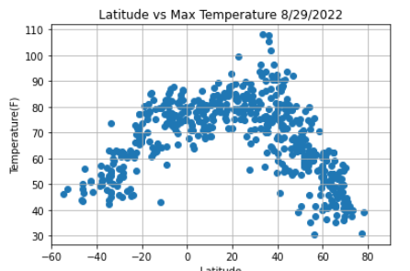

Trend 4: Cloudiness has no relationship with latitude. The scatter plot is erratic and unpredictable. The way to determine the cloudiness of a certain latitude will be up to factors not covered in this project.

