**The Chinese University of Hong Kong**

**CSCI4999 Final Year Project II**

Oculus Rift Project

YUNG Man Lee (1155032377)

Supervised by

Professor Jiaya Jia

April 20, 2016

Contents

1. Introduction 3

2. Milestones 4

2.1 Timeline 4

3. Game Design and Development 5

3.1 Story 5

3.2 Control Architecture 5

3.3 Level Architecture 7

3.4 Game Logic 8

3.5 Artificial Intelligence 12

3.6 Leap Motion Control 13

3.7 Head Movement Control 18

4. Implementation 19

4. 1 Challenges 19

5. User Experience 20

5.1 User Acceptance Test 20

Contribution 22

Reference 23

Appendix –Feedback of user testing 24

# 1. Introduction

Virtual reality (VR) has become a big trend in gaming industry. A game in virtual world can make player experience more interactive and fun. A horror VR game can provide an exciting and terrified game experience without causing danger in real life.

This project is a VR horror game develop for Oculus Rift, which is supported by multiple OS on PC. Having developing experience in the first semester, more advanced components has been adapted in our project, including an AI for enemy character, opening animation and additional control with Leap Motion. We focused on completing the whole story with more linkages, so that players could have better understandings and excitement with our game.

# 2. Milestones

### 2.1 Timeline

Below are the major changes of our project:

|  |  |
| --- | --- |
| Early January 2016 | Discussed the direction of development with supervisor |
| Mid January 2016 | Start working on animation and head movement detection via Oculus |
| Late January 2016 | Built and made events for the living room 2 (The new area for fighting the ghost AI) |
| Mid February 2016 | Switch Oculus DK1 to Oculus DK2  Upgrade the Unreal Engine from 4.7 to 4.10 version for better control |
| Late February 2016 | Made opening animation to describe the story  Study the API and start integrating Leap Motion to the project |
| March 2016 | Built fighting related elements with the ghost (Leap Motion, AI) |
| April 2016 | Included control tutorial and final review |

# 3. Game Design and Development

### 3.1 Story

The story has changed slightly comparing with the previous semester.

There was a homicide case took place in a haunted house some years ago. The family of three lived there were very normal at first. But the dad lost his job and started drinking all day long. The mom and dad argued a lot and their girl (Dora) was of course upset about it. One day, the dad could not take it anymore and with the affect brought by the ghost, he killed his wife in a stormy night and nobody knew what happened after that.

The player was watching TV in a stormy night. After a bolt of lightning, the power of the house was cut and the door of living room was connected to the haunted house which mentioned above. She explored the house in the dark and eventually eliminated the ghost and released the soul of Dora.

### 3.2 Control Architecture

Gaming controller and Leap Motion is added to facilitate the control. For the other parts, the control architecture remains the same to previous semester (Refer to Fig. 1).

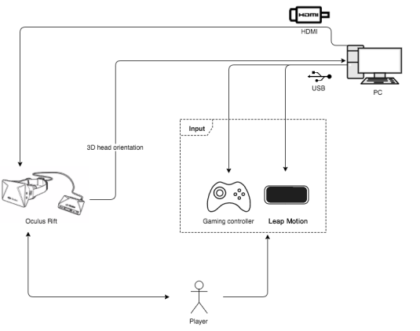

Fig. 1 Control Architecture of this game

The game is designed to execute on PC. In order to enjoy all functions of the game, the above setup is highly recommended. Oculus Rift serves as both 3D head orientation input and video output devices. Game controller is for movement input while Leap Motion is for gesture input (punching).

### 3.3 Level Architecture

The graph (Fig. 2) shows the level architecture of the game environment.

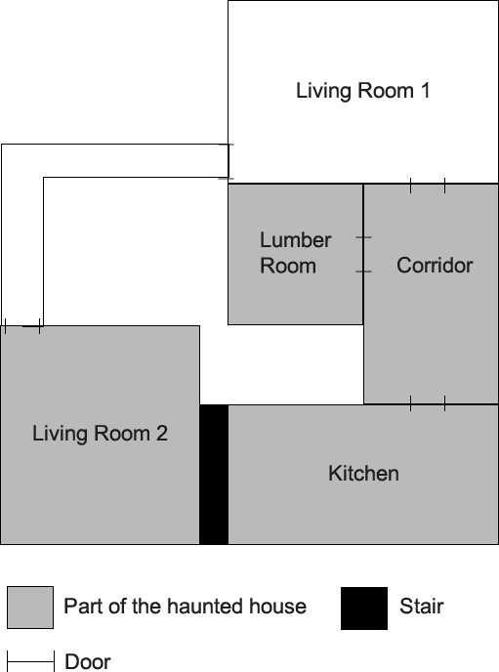

Fig. 2 Level architecture of the game

### 3.4 Game Logic

The game logic can be summarized by this graph (Fig. 3). The tutorial, opening animation, living room 2, game over and game ending scenes have been newly added in this semester. So the following chapters are going to mainly focus on the details of these scenes.

C:\Users\Ivy\Desktop\Untitled Diagram.png

Fig. 3 Overview of game logic

#### 3.4.1 Tutorial Scene

The use of tutorial scene is to ensure players understood different controls in the game before playing. After the tutorial ends, the game will count down from 3 and fall the player down to the game scene.

C:\Users\Ivy\Desktop\下載.png

Fig. 4 Scene transition of tutorial

After the tutorial, the player should have knowledge of how to control the character completely.

#### 3.4.2 Opening Animation

Some players have given us some feedback that they found it was difficult to understand the story in the first semester. Opening animation was added to help players understanding the whole story better, and also add more 3D experience for the player.

Unreal Engine does not support playing different videos of different eyes. To allow the animation look 3D in the Oculus, the opening animation is an online animation, which means it is rendered immediately instead of pre-recorded.

Other than that, an advantage of using online animation is players are still able to rotate and look around in the Oculus. This makes the animation special comparing to traditional opening animation.

The animation is played when the players look at the TV in living room, so they can have a brief understanding in the beginning of the game.

The scene transition is stated in the graph below (Fig. 5).

C:\Users\Ivy\Desktop\Untitled Diagram.png

Fig. 5 Scene transition of opening animation

#### 3.4.3 Living Room 2

After finishing all passing criteria from the previous rooms, the player will be able to pass a broken stair and not to be able to go back. Unlike the rooms made previously with a lot of scary events, living room 2 is an area for the players to fight with the ghost. The area is covered by a navigation mesh for the engine to compute the best route for the ghost to reach the player. Also, the room was built with a lot of empty space so the players can dodge attacks from the ghost more easily.

#### 3.4.4 Fighting Scene

Fighting scene is started when the player walks down from kitchen to living room 2. After the stair case broken, the ghost AI appears and starts the fight.

The details about the ghost AI logic and leap motion control will be described in section 3.5 and 3.6.

#### 3.4.5 Game Over Scene

This is simply the room the players will be sent to if they fail to defeat the ghost. A room was built specially due to keeping the 3D characteristic was preferred. If a UI widget was used instead, this characteristic would be unable to perform.

Player can nod their head or stare at the retry button to reset life points and fight with the ghost again.

#### 3.4.6 Game Ending Scene

For the game ending scene, the living room 1 was reused.

In order to bring out the idea that the players’ job of helping the girl has finished and everything is back to normal, the state of the room will be reset as same as the one before power cut.

### 3.5 Artificial Intelligence

In this semester, an enemy was brought into the game to act as a final boss.

#### 3.5.1 Behavior

The graph below (Fig. 6) shows its behavior.

C:\Users\Ivy\Desktop\Untitled Diagram.png

Fig. 6 Behavior tree of the enemy (the ghost)

It will first roar at the player then approach to him/her. When the player is within its attack range (the big sphere), it will try to perform an attack action. The attack animation takes about 1.5s to complete but the real attacking function fires only at the middle of the animation once. This helps players to have time reacting for the attack. If the player overlaps with the hand of the enemy (the small sphere on hand) at that instance, it will be considered as a successful attack and player’s HP will be decreased.

### 3.6 Leap Motion Control

Leap motion is one of the new attempts in this semester. Leap Motion can be mounted in Oculus as an additional input. Figure 7 shows how Oculus mounted with Leap Motion.

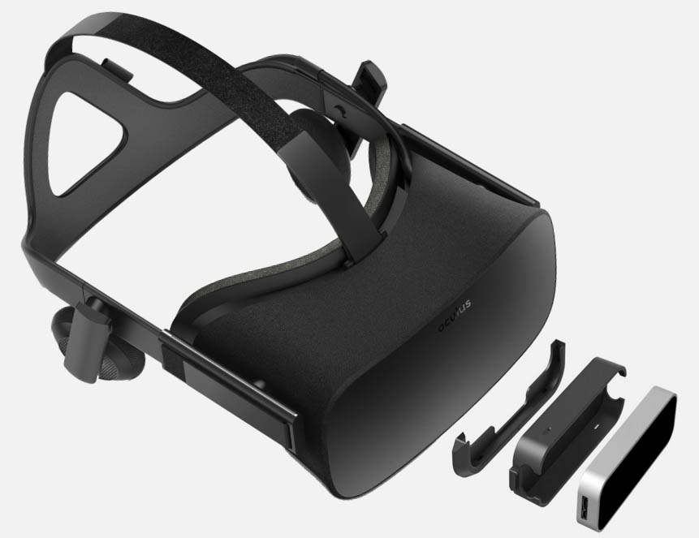

Fig. 7 Oculus with Leap Motion

Leap motion is an input device that traces player’s hands and fingers motions. It has a rather small observation area and high resolution when compared to other motion capture device like Kinect. Therefore, it is suitable to capture tiny movement like pinch, grab and hand movement.

Leap motion is officially integrated in Unreal Engine with an open-source plugin. It provides touchless detection without any gloves or detectors put on hands or arms. Hence, players can experience a better gaming involvement.

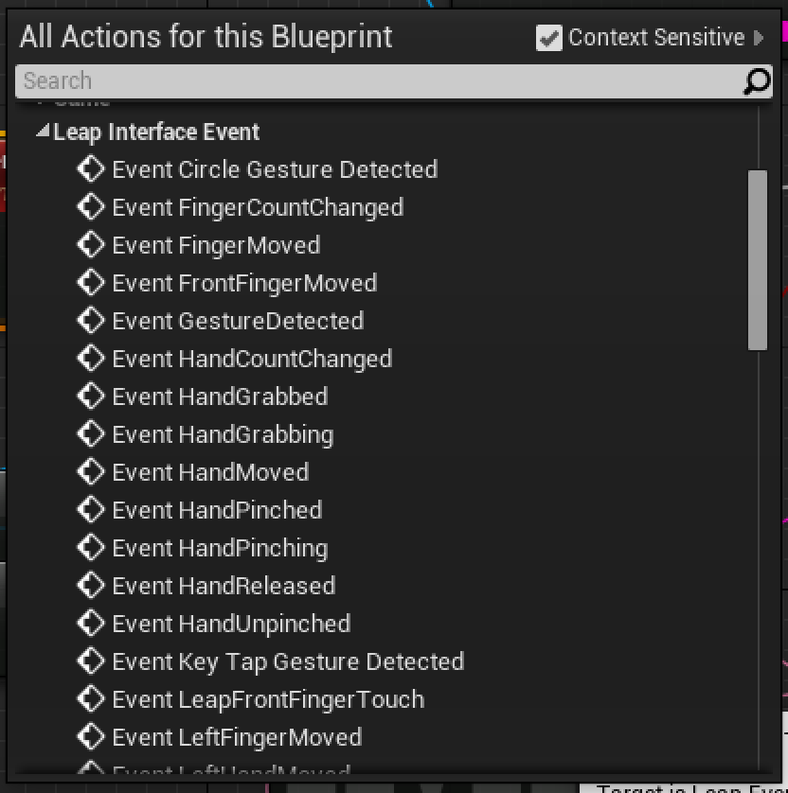

Fig. 8 List of events from Leap Motion plugin

Leap Motion plugin for Unreal Engine provides a list of pre-defined events. There is not an event customized for punching. For example, Event HandMoved can be triggered whenever the arms move, even when the arms move horizontally.

In the game, Event Leap Front Finger Touch was used to detect the punch action. This event will be triggered when player’s hands move forward. Since the detection is very sensitive, it may be triggered for 5 to 8 times for a quick punch action. The flowchart below (Fig. 9) shows the logic for sensing the punch action.

Untitled%20Diagram.png

Fig. 9 Punching logic

After several testing, the maximum fighting frequency is set as once per 0.5 second can provide the best player’s experience.

As the sensing of leap motion is not 100% accurate, sometimes there would be errors when controlling the characters and shown that the hand pose is weird. Figure 10a is the correct pose which the skeleton hand supposed to be shown. However, the directions can be flipped when the hand is moving rapidly (See 10b and 10c).

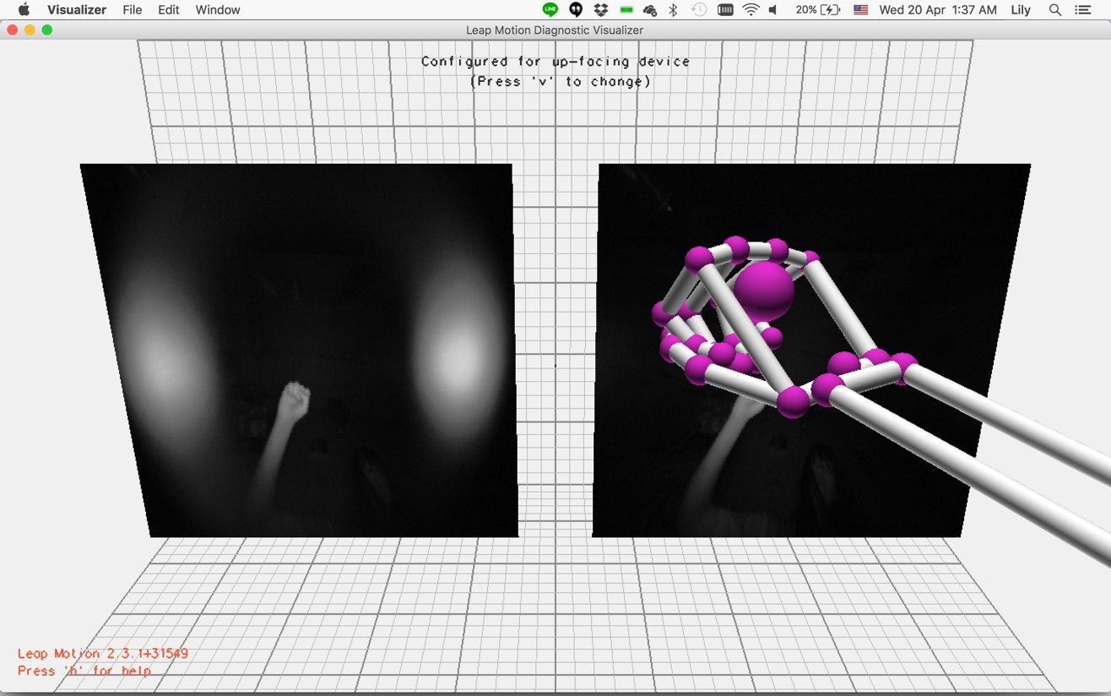

Fig. 10a Example of correct sensing of leap motion

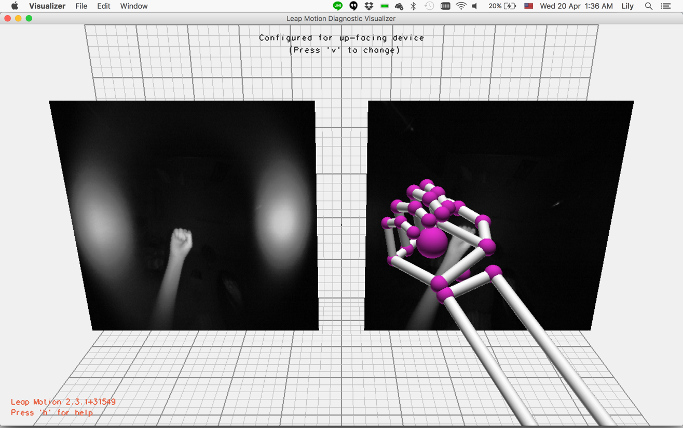

Fig. 10b Example of error sensing of leap motion

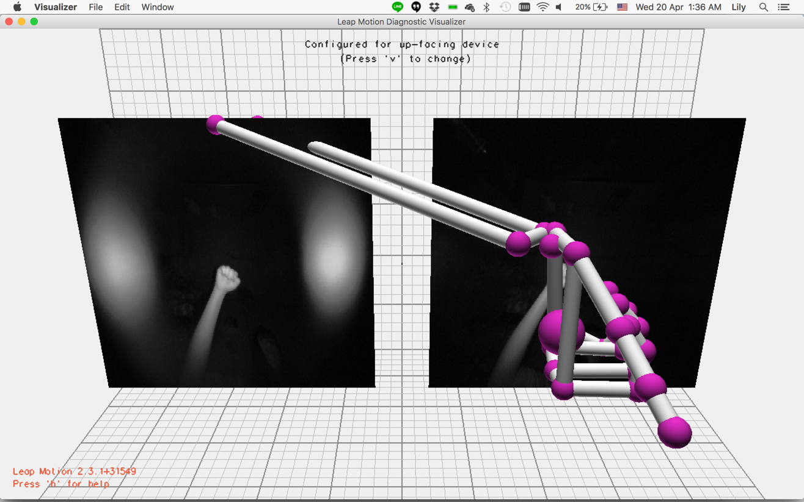

Fig. 10c Example of error sensing of leap motion

In our game, these kind of errors can result into the bad experience of the players. To avoid the weird pose, the leap motion input is not directly shown on screen in real time. When the player performs a certain action, the respective action is shown on screen only because of a successful detection.

### 3.7 Head Movement Control

When the player’s game over, we have a retry scene involving head movement selection control. The movement velocity of the sensor value can be obtained from Oculus. However, the head nodding gesture is different for different person, resulting a great error in sensor’s values. In order to detect the head movement accurately, two invisible bounds are used (Fig. 11).

Untitled%20Diagram.png

Fig. 11 Head Selection logic

These two bounds are attached with the first person character. When head selection event is triggered, the rotation of the two bounds is fixed and the nodding detection is started. Hence, it is not affected by the initial viewing angles and direction of the player. When the player looks at the upper bound and lower bound once relatively within 1.5 second, it is treated as a complete head nodding action. Afterwards, the two bounds return to their original position and follows the head movement and rotation again.

# 4. Implementation

### 4. 1 Challenges

* Finding breakthrough from first semester

As the gameplay was almost settled in the first semester already, it was hard to make breakthrough. Although we managed to add some new elements, they are not that eye-catching comparing to first semester when the game was built from none.

* Limited support

VR is still a very new technology and the software support is very limited. Although Leap Motion is a common controller for VR device, the API and plugins keeps changing from time to time. Unreal Engine sometimes have some internal bugs for VR mode and it keeps updating. In addition, unlike traditional gaming, online resources for VR game cannot covered all our needs.

* Provide better VR experience

3D experience is one of the important elements of VR. When we add some fast-moving events to strengthen the sense of shock, some players can get dizzy easily. We need to balance between the shocking events, the comfort of players and the story line carefully.

* Hardware limitation

Unreal Engine is very powerful in term of visual effects. However, this does not mean that we could put whatever effects we liked in the project. Oculus DK2 itself has high resolution and double screens (for both eyes) that brings heavy demand on hardware already. Therefore, only effects which really necessary were brought into the game.

# 5. User Experience

8 people has been invited to test our prototype. Overall, most of the players enjoyed our game and able to finish the game smoothly. For the details of testing, please refer to the appendix.

### 5.1 User Acceptance Test

With the help of testers, we have found out some unexpected input can lead to buggy output. Additionally, the testers have given us many useful comments to make improvement.

Problem spotted

* Dizziness

Many players, especially for those wearing glasses, found it is dizzy after playing the whole game in different level.

* Narration

Most of the players reported that the narrations were blurry as they were not recorded in a real recording studio. And some reported that the guidelines are not clear enough. For example, in the lumber room the guidelines said “What’s happened outside?”, some players thought that they should look outside the windows instead of the door.

* Fighting scenes

Many people found it hard to beat the ghost AI. Their fighting frequency is lower than our expectation, as they are not familiar with the control of leap motion.

* Bug

During the gameplays, some players encountered some bugs that we have never seen. As we have played the game for many times and a lot of debug portals were used, it was easy for us to miss some bugs from the normal gameplay.

Improvement made

* Dizziness

We slowed down the walking speed to reduce the dizziness caused.

* Narration

We re-recorded the narrations by a text-to-speech software. Also, we have redesigned the content of the guidelines to avoid confusion.

* Fighting scene

We increased the HP hurt applied to the ghost AI and shorten the latency between two punches, so it is more easy for them to beat the ghost.

* Bug

We debugged according to the list of bugs gathered from the players.

# Contribution

The following are my major contributions in the second semester.

1. Oculus Control
   1. Head selection detection
2. Opening animation
   1. Levels switching between game and animation
3. Leap motion control
   1. Hand detection events
   2. First person character control
   3. Detection logic of the fighting scene
4. Tutorial
   1. Control logics
   2. Scene switching from tutorial to game

# Reference

1. Honours Project. Navigation Mesh used to find a path between two points - Edward Gorman. http://eddgorman.com/?page_id=1571. [Online; accessed 14/4/2016]
2. getnamo. Leap Motion plugin for Unreal Engine 4. https://github.com/getnamo/leap-ue4. [Online; accessed 14/4/2016]
3. Wikipedia. Leap Motion. https://en.wikipedia.org/wiki/Leap_Motion. [Online; accessed 14/4/2016]

# Appendix –Feedback of user testing

|  |  |  |
| --- | --- | --- |
| Tester | Gaming Experience | Feedback & Suggested improvement |
| Jack Tsang | Frequent First Person Action Gamer | The game is enjoyable but the fighting scene is hard to control. It’s too easy to game over. |
| Janice Wong | Seldom play PC games | An extremely scary game made me screaming a lot. A very enjoyable game. I like it very much! |
| Judy Cheung | Play mobile games mostly | The game is quite interesting but it’s very dizzy. As I cannot wear glasses to play, I cannot see things clearly as well. |
| Justin Cheung | Gamer of real-time strategy game like AOC | I don’t know when should I fight or when should not fight. It’s better if I can control without using the keyboard, but overall the game is fun. |
| Lai Bai | Frequent Gamer of variety of games | The game is nice to play but it is not scary enough. Maybe use another scary horror music may help, like Silent Hill’s background music. The scream can be louder to make it more terrified. |
| Terry Tse | Frequent First Person Action Gamer | It is very good to play the game but I can randomly find some bugs, which makes the game not that horrible. If the ghost in the game is rush to camera, instead of just appeared suddenly, it’ll be better. |
| William Cheung | Frequent Gamer of real-time strategy game like AOC | The fighting scene is hard to control. There could be more guidelines. Sometimes I confused why the things are blocked. |
| Wing Kwok | Frequent RPG Gamer | A lot of details are provided in the game. The environment and story are well designed. It is very enjoyable to play, although it is a little bit dizzy. |