**CSCI3260 Project**

IP Wing Ha 1155033071

YUNG Man Lee 1155032377

List of functionality

*Basic*

1. Top down view
2. Train view

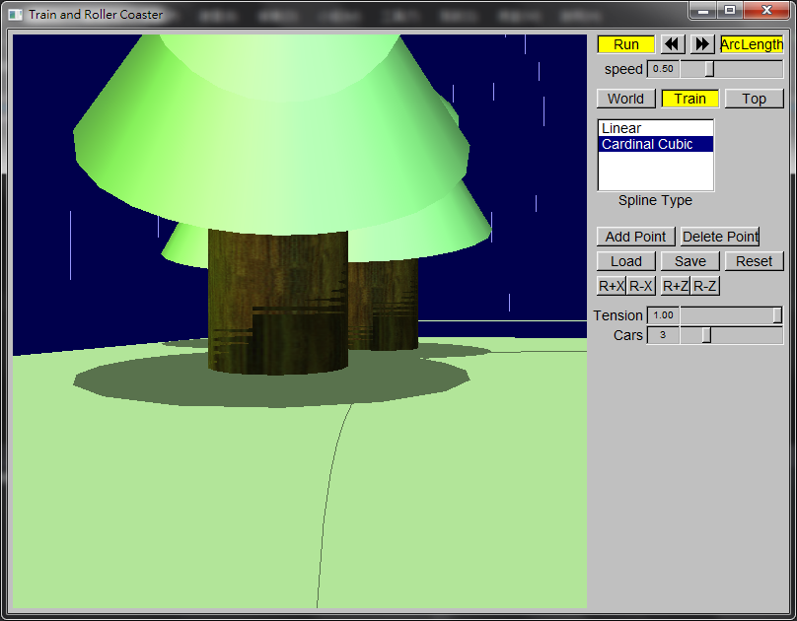

Figure 1 Train View

1. Buttons for adding, removing, or repositioning control points
2. Saved and loaded control points from text files in the format of given sample
3. Multiple kinds of curves
4. Play button to start/stop
5. Slider for speed control for the train
6. Have some scenery with texture in the world besides the ground plane

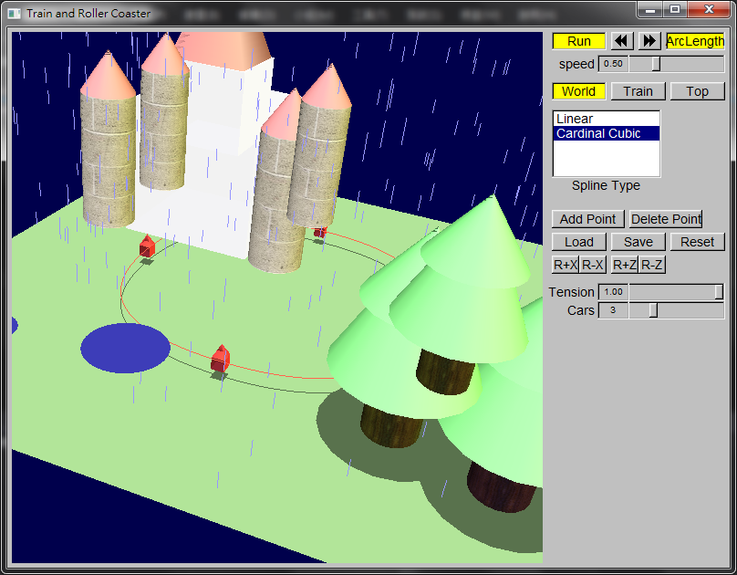

Figure 2 Castle and trees with texture

*Bonus*

1. On/Off for Arc-length parameterization
2. Additional carriages on your train (adjustable from user interface)

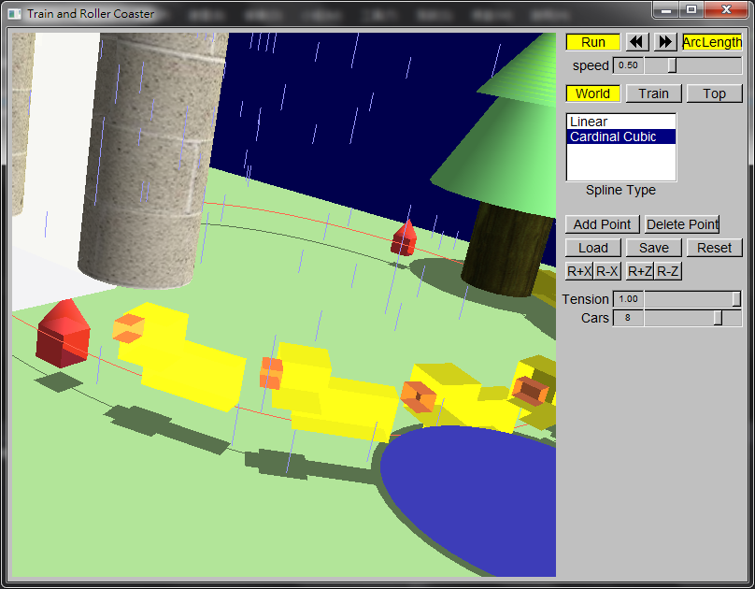

Figure 3 More carriages

1. Simple physics for train
2. Other Cool Effects: Animations with particle system, advance texture mapping etc.

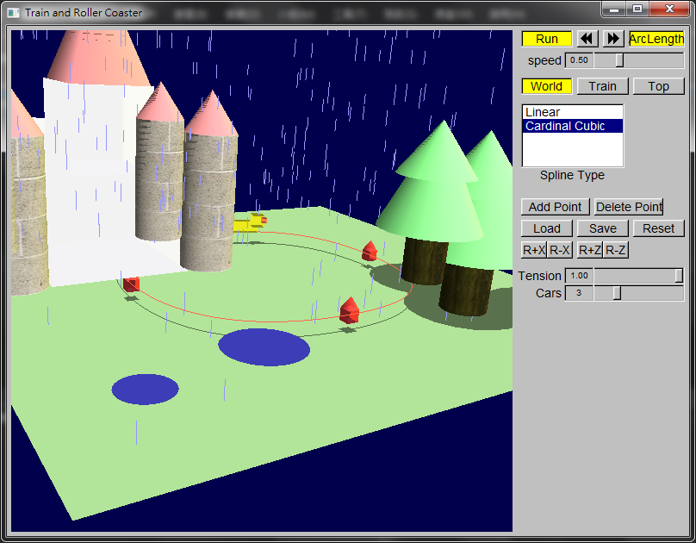

Figure 4 Rain Scene and the size of ponding will increase



Figure 5 Carriages become ducks now