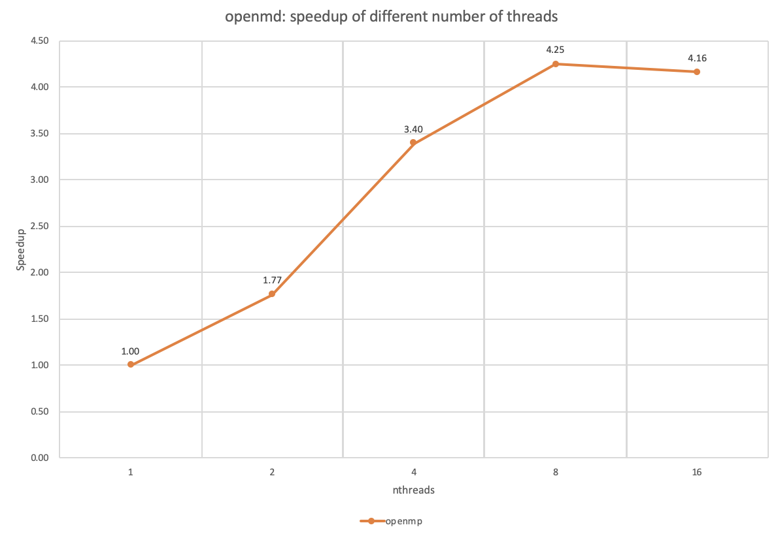

It turns out that the speedup did not grow up linearly. I think the reason is because the calculation of each element in the result array vector is not independent, it relies on the previous the calculation. In order to solve this problem, we have to use another space to store the last element of each subdomains and barrier to wait for all threads. Then each thread adds up every last element in the subdomains that before it to its own elements.

All in all, it takes time to barrier the threads and the additional space allocation and free.