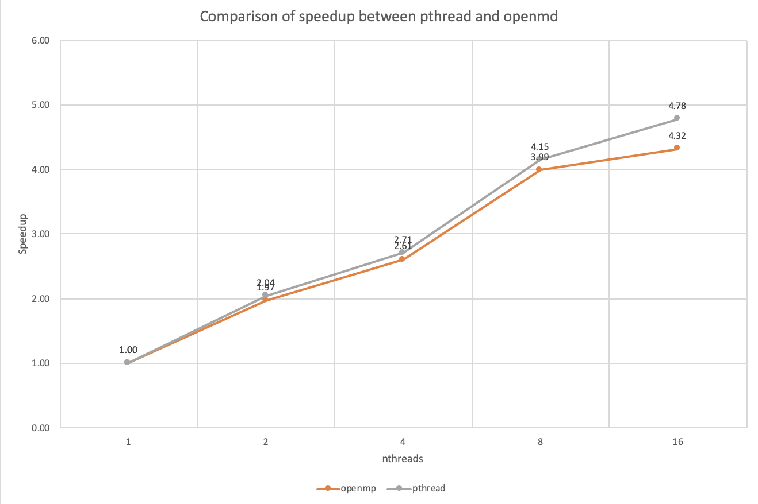

I think it is possible to implement a dynamic load balancing scheme in pthreads. Because the calculation of every pixel is independent.

To balance the load of each thread, I would like to adopt the consumer-producer model to have the threads to get the task from the tasks buffer(which contains all (x,y) pairs.) . Everytime when the thread(consumer) gets the task from the ‘buffer’, use a mutex to lock up the ‘buffer’ when the buffer is consuming.