MSc Project
by
YOHANNES ANDU

___________________________________________________________-

Birbeck, University of London
Department of Computer Science and Information Systems

Route Optimisation using ML and GIS in Royal Mail

Yohannes Andu
MSc Data Science
January 2026

Felix Reidl
Project Supervisor

This report is substantially the result of my own work, expressed in my own words, except where explicitly indicated in the text. I give my permission for it to be submitted to the JLSC plagiarism Detection Service. The report may be freely copied and distributed provided the source is explicitly acknowledged.

Abstract
The efficiency of parcel delivery plays a crucial role in the operational cost and service quality of postal logistics. This study explores the application of Machine Learning (ML) and Geographic Information Systems (GIS) to optimize delivery routes for Royal Mail, with a particular focus on Sunday parcel deliveries from the Jubilee Delivery Office serving postcodes TW1–TW20. As a current postman responsible for deliveries across Isleworth and Brentford, I have firsthand experience of the challenges associated with both walking and driving routes. While weekday deliveries are relatively consistent due to fixed walking routes and predictable finishing times, Sunday parcel deliveries present unique challenges. These include larger delivery areas, higher parcel volumes, and the influence of external factors such as traffic congestion, which directly impact total delivery time, fuel consumption, and vehicle wear and tear.
The aim of this paper is to demonstrate how data-driven optimisation can enhance delivery efficiency and reduce operational costs. By integrating GIS-based spatial data with ML algorithms, the study proposes a framework to analyse existing routes, predict delivery durations under varying conditions, and generate optimized paths. Parameters such as total distance travelled, number of parcels delivered, delivery time, and driver allocation will be mathematically modelled to identify efficiency gaps. The proposed system leverages machine learning techniques such as regression models, clustering, and reinforcement learning for route prediction and dynamic adjustment, while GIS mapping visualizes and validates the optimal routes in real-world geography.
The focus on Sunday delivery is motivated by its extensive coverage area and flexibility for data collection and experimentation without disrupting regular weekday schedules. Optimising these routes could lead to significant savings in time, fuel, and vehicle maintenance costs, while also improving service reliability. This research ultimately seeks to provide actionable insights that Royal Mail can adopt to improve delivery efficiency through intelligent, technology-driven route planning.

Table of Contents
Abstract 3
Table of Contents 4
Chapter 1 - Introduction 6
1.1 Project - Aim 7
1.2 Project - Objectives 7
1.3 Area Description and Map 7
1.4 Post code and its importance. 9
Chapter 2 - Literature Review 11
2.1 Introduction 11
2.2 Theoretical Background 12
2.3 Existing Research on Route Optimisation 14
2.4 Existing research on Royal Mail route optimisation 15
2.5 Identification of Gaps 15
Chapter 3 - Methodology and Methods 17
3.1 Data Collection 17
3.2 Tools and Software 17
3.3 Method Procedures 17
Chapter 4 - Analysis and Design 18
Chapter 5 - Implementation 20
5.1 Tools and Technologies Used 20
5.2 Machine Learning Implementation 20
5.3 Implementation using GIS(QGIS) 21
5.4 Integration of GIS with Machine Learning 22
Chapter 6 - Testing and Evaluation 24
6.1 Data preparation and Validation 24
6.2 Machine Learning Testing 24
6.2.1 Predication -Phase (Regression) 24
6.2.2 Delivery Success Prediction (Classification) 25
6.3 Clusterning Evaluation 25
6.4 Route Optimisation Testing 28
6.5 Distance and Time Modelling 29
6.6 Postcode and Driver assignment Optimisation 29
6.7 Error Handling and Robustness Testing 29
6.8 Output Evaluation 29
Chapter 7 - Results 32
7.1 Data Preparation Outcomes 32
7.2 Machine Learning Model Performance 32
7.2.1 Delivery Duration Prediction (Regression) 32
7.3 Clustering and Spatial Analysis Results 33
7.4 Route Optimisation Performance 34
7.5 Visual Validation Outcomes 35
7.6 Challenges Encountered in this Project 35
7.7 Route Analysis using Tableau 36
Chapter 8 - Conclusion 38
Reference 40
Appendix A 43
A.1 Glossary 43
A.2 Abbreviations 44
A.3 Software and Tools Used 44
A.4 Jupyter Notebook – Code Implementation Structure 44
Appendix B: 50
B.1 Project Supporting Tables 50
Appendix C 52
C.1 Real Royal Mail Sample route optimsation 52
C.2: Git hub code location 53

Chapter 1 - Introduction
Route optimisation plays a crucial role in logistics and delivery management system in planning the route smoothly and efficiently. In an age where e-commerce is booming, same day or next day deliveries and in just in time logistics have become the norm, business face mountainous pressure to meet the demands of customers. Large scale postal and courier organisations such as Royal Mail face a considerable challenge due to this surge in delivery demand. In order to ensure that thousands of parcels reach customers daily across the whole of the United Kingdom while maintaining service quality with minimal cost, requires effective and smart way of route planning strategies.

Traditional route optimisation techniques such as manual scheduling or static routing algorithms, often fall short to snapshot the dynamic nature of today’s delivery operations. Real-world conditions such as fluctuation in traffic patterns, fluctuating daily parcel volumes, weather disruptions, and limited delivery time windows brings complexity that cannot be efficiently handled by conventional methods. As a result, postal and logistics organisations have not option but to adopt data-driven approaches powered by advanced computational tools such as machine learning (ML) and Geographic Information Systems (GIS).

Machine learning technique enables to identify patterns and make predictions from large data sets.ML algorithms can analyse a vaset historical dataset including past delivery times, seasonal volume fluctuations, weather patterns, traffic information to predict optimal routes, estimate delivery times, and dynamically adjust plans in real time. Likewise, GIS provide the foundational spatial framework that allows digitisation and layered analysis of all geospatial elements. It provides a powerful spatial analysis and mapping capabilities which helps to visual routes, identify geographical constraints, and evaluate alternative delivery paths related to Royal mail. Therefore, the combination of ML and GIS brings a very comprehensive framework and is so helpful to create adaptive, intelligent and spatially aware optimal route for Royal mail.

Royal Mail is known as the oldest and the largest postal service in the world. This logistic company has a vast distribution network that covers urban, suburban, and rural regions. Royal mail employed well over 150000 and has thousands of vehicles operating daily through out the United Kingdom. This paper will explore on a very small networking area of west London of post codes ranging from TW1 to TW20 with a belief that even a small improvement in routing efficiency can result in significant cost savings and environmental benefits. However, the current systems depend largely on manual adjustments and on predefined routes and this is obviously is not optimal with rapid changing delivery conditions and customer demands. Hence, this limitation gives rise to the need for a more robust and flexible data driven approach that can optimise routes dynamically while saving operating cost and unnecessary delivery time. On top of this, this approach helps Royal mail to be competitive on the market where many courier companies such as Amazon already on it.

It is vital to focus on the environmental effects as well and hence modern logistics gives lots of attention for the route optimisation not only to be efficient but also sustainable and environmentally friendly. Reducing unnecessary mileage minimize fuel cost and cuts carbon emissions. Royal mail is working to words achieving net zero emissions by 2040, and adopting intelligent route optimisation is key to achieve this strategic goal. Therefore, route optimisation powered with the integration of ML and GIS represents both a technological innovation and a sustainability initiative.

This paper aims to explore how Machine Learning and Geographical information Systems can be implemented together to optimise delivery routes with in Royal mail’s Sunday delivery of a certain area of west London. By analysing existing delivery daeta and spatial information, this research paper will try to identify for inefficiencies in already designed system and then propose for optimal and cost-effective routing model. The end goal how this proposed method will improve delivery performance, reduced cost, save time and contribute towards Royal mail’s environmental sustainability targets.

1.1 Project - Aim
As it has been explained above, the core aim of this paper is to find out if the application of Machine learning and Geographical information systems in Royal mail Sunday delivery network can enhance operational efficiency and sustainability.

1.2 Project - Objectives
The main objectives of this paper are listed as follows:
- To figure out the current route planning and delivery processes within Royal mail Sunday delivery network and identify existing inefficiencies.
- To train a machine learning model capable of analysing delivery and traffic data for route prediction and optimisation
- To incorporate spatial analysis based on GIS for mapping and visualising optimised delivery routes
- To test and evaluate the performance of the proposed systems in terms of travel time, fuel usage, and cost efficiency.
- To provide recommendations for integrating ML and GIS-based route optimisation with in Royal Mail’s Sunday delivery frame work.

1.3 Area Description and Map
As explained earlier, this paper focuses primarily on route optimisation through the integration of Machine learning (ML) and Geographic Information Systems (GIS) with in the context of Royal Mail’s Sunday delivery network. The study concentrates on the wider Twickenham delivery area, which includes postal districts ranging from TW1 to TW20. This region provides a representative case for analysing delivery performance due to its mixed urban and suburban geography, varying the characteristics of this postcode area is crucial, as each presents unique logistical challenges such as differing road layout, delivery densities, and access limitations. By mapping these postcodes using GIS, the research will identify spatial patterns that influence delivery efficiency, while ML models will be used to predict demand and optimise route planning. Analysing how these techniques interact across the TW postcode region will help determine whether advanced data-driven tools can improve travel times, reduce vehicle mileage, and enhance overall delivery reliability. In this way, the study aims to provide a comprehensive assessment of how combining ML and GIS can support more efficient and sustainable postal operations in Royal mail’s Sunday delivery frame work.

To gain a comprehensive understanding of the scale of delivery operations, as well as the logistical challenges and connectivity with in the Twickenham postal region, it is useful to examine a map of the TW postcode area (Figure 1). This visual representation provides a clearer perspective on the spatial extent of Royal Mail’s Sunday delivery network, highlighting variations in delivery density, transport links, and geographic accessibility across the different districts.

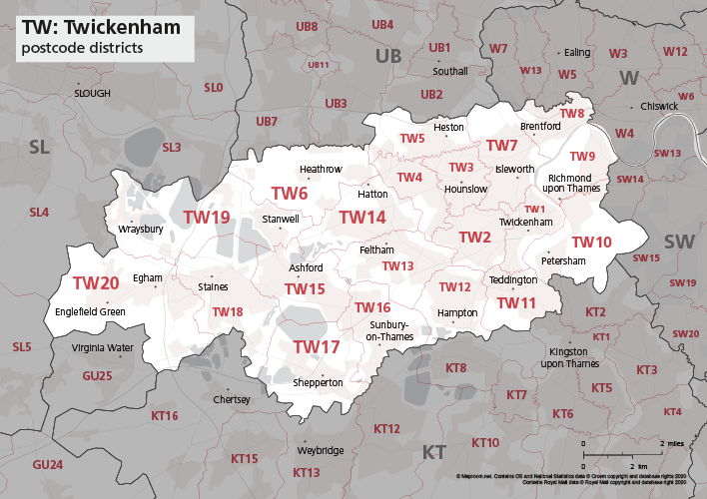

Figure 1. Map of TW postcode districts – Twickenham (Source: google – see Appendix)

The following section provides a detailed overview of the geographical areas represented by each of the TW1 – TW20 postcode districts, outlining their spatial characteristics and relevance to the Royal Mail Sunday delivery network (this list information is obtained from ChatGPT)

- TW1 – Covers Twickenham, St Margarets, and parts of Strawberry Hill, characterised by dense residential streets and high parcel delivery demand.
- TW2 – Includes Whitton and parts of Hounslow, a mix of residential zones and small commercial areas, presenting moderate traffic congestion.
- TW3 – Encompasses central Hounslow, a busy urban area with major retail centres and high footfall, leading to greater delivery complexity
- TW4 – Covers Hounslow West, Cranford, and Lampton; largely suburban, with a combination of housing estates and business parks
- TW5 – Represents Heston and surrounding residential districts; contains several main routes feeding into Heathrow and the M4 corridor.
- TW6 – Correspons mainly to Heathrow Airport and its operational facilities; characterised by restricted access zones and time-sensitive deliveries.
- TW7 – Covers Isleworth and Osterley, combining historic residential neighbourhoods with industrial estates near the Great West Road(A4)
- TW8 – Includes Brentford and parts of Kew Bridge; features mixed use developments and increasing parcel volumes from new housing projects.
- TW9 – Covers Richmond and Kew, areas with high-income demographics, narrow residential streets, and protected green spaces affecting routing options.
- TW10 – Includes Ham and Peters-ham; largely suburban with limited through-routes, representing careful route sequencing.
- TW11 – Represents Teddington and parts of Bushy Park; suburban in character, with varied access points and moderate delivery density.
- TW12 – Covers Hampton and Hampton Hill; primarily residential, with a balance of short delivery distances and dispersed address.
- TW13 – Encompasses Feltham (North and East); a key Royal Mail operational zone near the jubilee Mail Centre, with mixed commercial and residential demand.
- TW14 – Includes Feltham (South), Hatton, and parts of Heathrow’s perimeter, marked by industrial estates and transport infrastructure.
- TW15 – Covers Ashford (Middlesex); predominantly suburban with steady delivery volumes and accessible road layouts.
- TW16 – Represents Sunbury-on-Thames; characterised by residential communities, business parks, and riverside properties.
- TW17 – Encompasses Shepperton and Littleton; semi-rural, with larger delivery distances between addresses.
- TW18 – Covers Staines-upon-Thames (North); a commercial hub with shopping centres and dense weekday traffic.
- TW19 – Includes Stanwell, Wraysbury, and parts of Heathrow’s western perimeter; featuring mixed residential and logistics activity.
- TW20 – Represents Egham and Thrope; a blend of university campus deliveries (Royal Holloway) and suburban neighbourhoods.

1.4 Post code and its importance.
For this research, the primary data set consists of the historical delivery records from Royal Mail’s Sunday delivery operations across the TW1 – TW20 postcode areas. These deliveries typically involve a minimum of 30 vans (for this study we use vans in Figure 2a) and approximately 35 personnel, with an additional five drivers available to provide operational support in cases where other drivers encounter difficulties or delays. The inclusion of Postcode – level data is central to this study, as it enables the integration of spatial analysis through Geographic information Systems (GIS) and the development of predictive models using Machine Learning (ML). Postcode data serves as a fundamental geographic identifier that allows the linking of delivery volumes, travel times, and route characteristics to specific localities. In this section, the significance of postcode data for modelling and optimisation will be discussed in detail. Several points in this discussion draw up on findings from existing literature that emphasise the importance of postcode information in spatial analysis, logistics planning and delivery network optimisation [1].

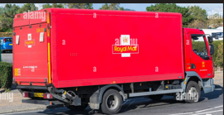

a) small delivery van b) medium -van

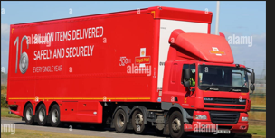

c) lorry d) future van (on trial)

Figure 2. Types of Royal mail delivery vehicles

Where:
- Small vans serve as the primary vehicle for local deliveries, operating within neighbourhood routes to ensure efficient last- mile distribution.
- Medium vans are generally employed for inter-branch transportation, facilitating the transfer of mail and parcels between nearby delivery offices and regional sorting centres.
- Lorries are representing the largest vehicle class, functions as the main carrier for long distance transportation, connecting major distribution hubs across the United Kingdom.
- Future vans – currently under trial reflect Royal mail ongoing efforts to modernise its fleet through the introduction of electric and low emission vehicles, which are expected to be deployed more widely in the coming years to support sustainability and operational efficiency [2].

A post code is a combination of letters and numbers that carries significant geographic meaning. It functions as spatial identifier that divides regions into manageable units. In the United Kingdom, the postcode system ranges from broad postcode areas, such as NW (North West London) or TW(Twickenham), to highly granular postcodes commonly used in central London, for example EC2M 7PP, which includes an additional character for precision.

Postcode data play a crucial role in logistics for several reasons. They are used to determine delivery zones, map customer density for efficient route planning, segment areas by accessibility, traffic patters, and delivery time windows, and calculate distance and time estimates for cost forecasting. In terms of route optimisation, postcode data facilitate efficient in several ways. They enable algorithms to plot all delivery stops on a map, allowing deliveries within the same postcode sector to be clustered in order to minimise travel distance and time. Moreover, historical traffic and postcode specific data support more accurate travel time predictions. Real-time postcode- based GPS integration also enables dynamic re-routing, allowing couriers to adapt to road closures or congestion.

With in the Royal Mail, which is the focus of this study, postcode data are central to logistical operations. Royal mail utilises postcode information to assign parcels to specific delivery rounds. Across its numerous sorting centres though out the UK, millions of packages are scanned using post code data to ensure efficient allocation and loading onto delivery vehicles. Furthermore, route optimisation based on postcode clustering helps reduce both delivery time and fuel(electric-charge) consumption.

However, there are several challenges associated with the use of postcode. Customers may occasionally provide incomplete or incorrect postcodes resulting in delivery delays. In addition, postcodes alone are insufficient for efficient routing; they must be combined with real time traffic data to enhance accuracy and responsiveness. In rural areas, a single central post code may cover a large geographical region, complicating delivery planning. It is important to address these challenges in wider sense. However, this research paper only proposes the integration of Machine Learning (ML) and Geographic Information Systems (GIS) to improve the accuracy, efficiency, and adaptability of postcode – based logistics systems on urban areas and in Twickenham area in particular.

Chapter 2 - Literature Review

2.1 Introduction
This section of the literature review explores how important Machine learning and GIS are in route optimisation in postal logistics and in Royal mail in particular. It investigates the existing academic and industry research on this area to identify current approaches, challenges and research gaps.

Route optimisation is the process of finding the most efficient routes between different delivery locations while considering factors such as traffic, weather, delivery times, and vehicle capacity. It is important part of logistics because it can improve efficiency, reduce travel distance and fuel use, and lower delivery costs [3]. Route optimisation can play an important role in reducing CO₂ emissions by avoiding unnecessary travel and inefficient delivery routes.It is more complex than simply finding the shortest path between two points, as the difficulty increases with the number of delivery stops and drivers involved.Because of this complexity, route optimisation has become an important area of research and practical application.For large organizations such as Royal mail which operate acress extensive postal networks, effective route planning can have a direct impact on delivery times, envirnmental sustainability, and operational costs.As e-commerce continues to grow and customer demand for deliveries increases, there is a greater need for efficient, accurate, and data-driven route optimisation methods.

This literature review has three main purposes. First, it examines the theoretical foundations of route optimisation, focusing on the Travelling Salesman Problem (TSP) and the Vehicle Routing Problem (VRP). These optimisation models form the basis of many routing and delivery scheduling algorithms used in modern logistics [4]. Secondly, it examines the role of Geographic Information Systems (GIS) in mapping, geocoding, and spatial analysis. GIS techniques convert postcode data into geographic coordinates, enabling spatial clustering, route planning, and network analysis. These capabilities are fundamental to logistics planning and route optimisation [5]. Thirdly, it explores the role of machine learning techniques, including clustering algorithms and predictive analytics, in enhancing GIS-based logistics systems. These methods improve route optimisation by analysing spatial and operational data, enabling more efficient and intelligent routing decisions [6].

Royal Mail is one of the UK’s largest logistics organisations and handles a large volume of deliveries every day.The UK’s detailed postcode system and the size of the delivery network make it challenging to develop efficient and sustainable delivery routes.However, this study focuses only on selected postcodes with in the TW(Twickenham) area.Reasearch on postal route optimisation is relatively limited compared with the wider literature on commercial last-mile logistics and parcel delivery.Therefore, this review brings together research from operations research, data analytics, Geographic Information Systems(GIS), and delivery management to identify gaps in existing knowledge.It also explores how Machine Learning(ML) and GIS techniques can be applied to improve the Royal Mail delivery network with a particular focus on Sunday deliveries [7].

For a purpose of providing a complete and well -structured overview, the literature review was written using academic resources such as Google Scholar, Scopus, ScienceDirect and IEE Xplore. In addition, topics obtained from google search like “route optimisation”, “machine learning logistics”, “last-mile delivery optimisation” were used to find academic and industry insights in logistic optimisation. Royal mail annual reports, UK Government transport data and Ordnance Survey’s Code – Point Open were also used to give additional information to the review. The focus on this review is on journal articles and professional papers published the last four decades.

This review is divided into main sections. The first sections explain the main ideas behind route optimisation and it’s important for postal operation. The second section investigates at how GIS is used in mapping and network optimisation. The third sections discuss how Machine learning can be used to create prediction and efficient models. The final section explains how the integration of ML and GIS approach can enhance Royal mail route planning and overall efficiency. Therefore, having this structure in place, the review aims to show how using both GIS and ML can improve Royal mail Sunday delivery network.

2.2 Theoretical Background
The Vehicle Routing Problem (VRP) is a classical optimisation problem that involves determining optimal routes for a fleet of vehicles to serve a set of customers. The problem was first introduced in the seminal work of Dantzig and Ramser (1959), who formulated it as the “truck dispatching problem”, who used it to plan petrol deliveries [8]. In most cases, the problem involves delivering goods from a central depot to customers who have placed orders. However, there are other versions of the problem, such as planning routes for waste collection [9]. In addition, variants of the vehicle routing problem include applications such as waste collection and demand-responsive transport. The Dial-a-Ride Problem (DARP), for example, is commonly used to model door-to-door transportation services for elderly and disabled passengers requiring access to healthcare facilities [10].

The vehicle Routing Problem(VRP) is an optimisation problem that aims to find efficient routes while reducing transportation costs,travel distance, delivery time, or the number of vehicles required.It can also be seen as an extension of the Travelling Salesman Problem(TSP), where the aim is to find the shortest route that visits all customers.Due to this complex structute , the VRP is considered an NP-hard problem which makes it difficult to solve when there are large number of delivery locations [11].

In real-world situations, the Vehicle Routing Problem (VRP) is widely used in logistics and trasport to impove efficiency and reduce delivery costs. Since real-world routing problems can be complex, many practical solutions use heuristic and metaheuristic methods instead of exact optimisation methods. These approaches can find good solutions within a reasonable amount of time [12].

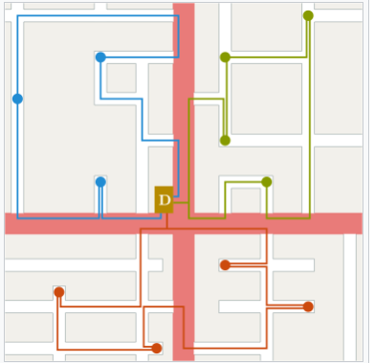

Figure 3 – simple illustration of VRP (source: Wikipedia).

The image above shows a simple example of the vehicle Routing Problem (VRP). The letter D marks the depot, where all delivery vehicles start and finish. Each coloured line (blue, green, and red) represents a different vehicle route, showing how each one delivers to a group of customers a different vehicle route, showing how each one delivers a group of customers in nearby areas. The aim is to plan these routes so that all customers are served efficiently, with the shortest total distance and lowest cost.

Route optimisation has a combination of computer science, operational research and spatial analytics. It determines the most cost-effective route path for a set of deliveries. Route optimisation requires a set of routes S to be accomplished in a such a way that each vehicle is assigned for a given road net work satisfying all customer demands and operational constraints.

The theoretical foundations of routing problems include classical models such as the Travelling Salesman Problem (TSP) and the Vehicle Routing Problem (VRP), which form the basis of modern combinatorial optimisation in logistics. The TSP focuses on determining the shortest possible route that visits a set of locations exactly once and returns to the starting point [13]. The Vehicle Routing Problem (VRP), first introduced by Dantzig and Ramser (1959), extends the Travelling Salesman Problem (TSP) to multiple vehicles, each subject to constraints such as capacity limitations, delivery time windows, traffic conditions, and road network structure. Over time, several VRP variants have been developed to address increasing complexity in real-world logistics systems, including the Capacitated VRP, Time Window VRP, and Dynamic VRP [14]. As explained in various academic articles and journals, optimisation problems can be NP-hard, which means that they can become more difficult and time-consuming to solve as the number of delivery points increases.Therefore, it is important for large companies such as Royal Mail to use suitable algorithms to find efficient delivery routes each day.For this reason, researchers have used heuristi and mertraheuristic methods, such as Ant Colony Optimisation(ACO) to solve routing problmes such as travelling Salesman Problem(TSP).These methods can produce solutions that are close to the best possible solution while keepiing the computing time at a reasonabel level [15].

The road network can be explained as a graph in which the arcs are roads and vertices are junctions between them. To calculate the total cost of each route in the network, it is needed to know both the travel cost and travel time between every customer and the depot. To do this, the original network should be converted into new graph points(vertices) which represents customers and the depot in this case, and the connections between them(arcs) represents the roads. The cost assigned should be the lowest cost between two points and this can be calculated by solving the shortest path problem. Mathematically speaking, for every pair of points i and j, there is an arc between them, and its cost (C_{ij}) illustrates the cost of the shortest path from i to likewise, the travel time(t_{ij}) is the total travel time along the shortest path in the original network.

Recent development in Data Science brings the concept of Machine learning (ML) which is a powerful approach that learns from past data to improve decisions of effective route based on real time information.

Machine learning (ML) aims to identify patterns and make predictions from data without explicit programming. In logistics applications such as Royal Mail, ML techniques are used to estimate delivery times, forecast demand, and support route optimisation. ML methods can be broadly divided into supervised and unsupervised learning. Supervised learning techniques, including regression models and decision trees, are commonly used to predict travel times and identify factors contributing to delivery delays [16]. Whereas unsupervised learning methods, such as K-means clustering, are used to group delivery points based on spatial proximity or demand characteristics, enabling more efficient organisation of delivery zones and supporting improved vehicle utilisation strategies [17]. Reinforcement learning (RL) which is another branch of ML focuses on learning from experience of different trials overtime. It is very essential to make adjustments to routes dynamically as traffic and delivery conditions change and hence RL plays vital role to address this. Machine learning concepts are highly useful in postal services where delivery routes must adapt to variations in addresses, road networks and parcel volumes.

Geographic Information System (GIS) like ML contributes an important role to route optimisation. It provides the spatial and topological concepts which is crucial when optimising a route. According to [18], Geographic Information Systems (GIS) provide a framework for storing, analysing, and visualising geographical data.In logistics, GIS supports geocoding processes, which convert postcode data into latitude and longitude coordinates,enabling accurate mapping and spatial analysis of the delivery locations [19].Furthermore, GIS supports network analysis,where algorithms such as Dijkstra’s algorith can be used to identify the shortest paths through road networks.The integration of spatial datasets, such as road networks,postcode boundries,and customer density maps, is essintial for logistics organisations when developing effective routing models based on real-world constraints [20]. Therefore, GIS can be considered as a connection between raw spatial data and analysis tools, allowing planners to visualise geographical information and develop more efficient delivery routes.

In light of Royal Mail, the concepts of these techniques explained above has practical use. The UK postcode is so massive and interconnected that divides regions into small and manageable geographic entities to make the sorting and routing effective. However, in order to use this system, the integration of postcode data with geographic coordinates and real-time traffic data is needed and hence the usage of both GIS and ML is highly desirable in this environment. The mixture of the predictive capability of ML and spatial analytical ability of GIS, Royal mail makes a very robust and effective route that reduces travel distance, minimize operational cost and is environmentally sustainable.

2.3 Existing Research on Route Optimisation
Transportation in logistics has been a main focus for researchers in economics and operations management. The main goal in trade logistics is to provide a good level of service and supply quality while keeping cost as low. However, transportation planning is still the challenging part of logistics.

Distribution network design models have been developed to minimise transportation and inventory costs across logistics networks that include a central depot and multiple distribution facilities. These models support the efficient allocation of vehicles and resouces, helping logistics organizations such as Royal Mail improve their overall operational efficiency [21]. Real-time traffic information can improve route optimisation by enabling logistics companies to adjust delivery routes in response to changing road and traffic conditions, thereby reducing travel time and improving operational efficiency [22].

Risk-based routing approaches have been developed to identify routes that minimise both travel distance and the probability of traffic accidents. By considering accident risk alongside operational constraints, these methods improve the safety and efficiency of freight transportation [23].

As computational technologies have advanced, logistics optimisation research has increasingly incorporated advanced methods, including machine learning, GIS, and mathematical optimisation techniques. One practical logistics strategy is the milk-run approach, where a single vehicle follows a planned route to collect or deliver goods from multiple locations. By consolidating transportation activities and considering vehicle capacity constraints, milk-run systems can reduce transportation costs and improve resource utilisation [24].

Another key area in logistic research is “last – mile delivery”, which refers to the concept of final step for delivering goods from depo to the customers location. This stage is always the most expensive, time consuming and complex part in transportation and hence improving last mile logistics is crucial among logistic companies to help reduce overall delivery costs and improving service efficiency [25].

It is worth looking into existing route optimisation in different logistic companies including Royal Mail. In Ups, there is On-Road Optimisation and Navigation system which is advanced tool that uses a powerful algorithm and helps UPS find the best delivery routes. This tool takes different factors like distance, time, and traffic and chooses the most efficient one from the many possible routes. According to the report from [26], the model can reduce the total distance travelled by UPS vehicles, which can lead to lower fuel consumption and carbon emissions. It also helps UPS use its vehicles more efficiently and potentially manage more deliveries with out needing additional vehicles.

According to the research published in “Journal of Scientific and Engineering research, 2023’, DHL uses machine learning tools to support its delivery operations. These tools can help predict delivery times by using information such as traffic conditions, weather, and previous delivery data. Using this information DHL help itself to improve the accuracy of its delivery planning, reduce errors, and provide a better service for customers [27].

FedEx uses SenseAware ID to track shipments and provide real-time information about their location. This technology gives the company better visibility of packages during the delivery process. It can also help identify potential delivery problems earlier and support more reliable logistics operations [28].

The increase demand for same-day delivery has created a greater need for effective logistics optimisation. Larger urban delivery operations need efficient route planning, scheduling, and resource allocation to meet short delivery time windows while keeping operating costs under control. These challenges are especially inportatnt for companies such as Amazon, which manage large numbers of deliveries through their last-mile delivery network [29].

2.4 Existing research on Royal Mail route optimisation
So far, the existing research on Royal mail route optimisation consists the company’s internal tech-upgrade, academic case studies and reports form regulatory like Ofcom. The main focus behind is to understand how far Royal mail travels in developing route optimisation and highlight the main challenges of the final mile delivery in this very competitive market.

Finally in the case of Royal Mail, where this paper is more interested on. Royal Mail previously made a trial on multi-modal delivery approach carried by Ford Mobility routing software in the area of Manchester. The company saw from this trial a 50% reduction in the usage of vans and 33% reduction in vehicle mileage [30]. This shows how Royal mail benefits more from using software-based route optimisation. According to the review from Ofcom, the initiative of using a “shared van “, which is part of its delivery planning contributed to minimizing the delivery rounds regardless of the increase in the delivery points. Furthermore, Royal Mail partnered with Geo-plan [31] to convert its postcode data into digital format for GIS application. This conversion helps to plan resources efficiently and first-time delivery improvement.

Royal Mail continues to invest in technology to improve its delivery route efficiency. The company is approaching to the introduction of AI software that works well on real time on traffic, weather and delivery patters that aims to reduce fuel consumption and improve efficiency. Furthermore, it is planning a program called “Final Mile Optimisation”, in which a new route planning using a new software is implemented to ensure fair and balance workload is shared among postal workers.

Another aspect is the idea of Internet of things (IOT). Royal Mail has started using the “Wiliot Intelligence Platform” which uses IOT tags attached to rolling cages and Bluetooth readers in delivery Vehicles. This technology helps RM track its equipment in real time and further enables to use its assets more effectively avoiding unnecessary vehicle trips and reduce fuel consumption. Moreover, the data science team are working to develop algorithms to provide customers with accurate and narrowed (2 hours) estimated delivery windows. The algorithm takes factors like geo-location and time series data to further the delivery efficiency and customer satisfaction.

At it has been mentioned earlier, route optimisation has been a central topic in academic research on postal logistics. However, Vehicle routing problem has been the challenging and hence, researchers implement heuristics and algorithms to minimise total distance travelled or time taken. Another thing is the case of Dual-Mode Routing. According a well-known paper, it is a two-level parcel distribution model that combines driving and walking for a single driver. This model can bring a potential saving of over 20% in total operational time.

Royal mail has been on investigation by Ofcom for it has failed to meet the targets. The company has the responsibility to meet the targets outlined in accordance with its policy and agreement made. However, there is a growing demand to be fully modernized and become more efficient. Therefore, this is the main driving factor of this paper to find out if using technology like machine learning and GIS improves the company’s performance. However, the coverage of this paper is only on Sunday deliveries of Twickenham area where I am part of.

2.5 Identification of Gaps
Royal mail has limitations and challenges in relation to its route optimisation regardless of the efforts it has made so far. As this paper is all about parcel delivery on Sunday, in this section the main focus is on parcel delivery not mails.

Royal mail faces a bigger and more complex delivery challenges when it introduced a scheme of delivery large volumes of parcels. The reason is letter routes only covers small packed geographical area, whereas parcel routes usually cover more wider area with many stops. According to the reports from Ofcom, older models of Royal mail was not realistic with speed and did not consider the time spent for parking, walking carrying parcels and hence the number of deliveries per hour became less. Therefore, the old routing system was less desirable.

Another challenge in route optimisation is the difficulty of applying advanced routing systems in rural and remote areas. Limited infrastructure, lower data availability, and unreliable communication networks can reduce the effectiveness of dynamic routing approaches that depend on real-time information. These limitations create additional challenges for logistics providers operating across geographically dispersed delivery networks [32].
The quality of data and accuracy of delivery stop which are main factor for delivery efficiency is not yet good enough. Feeding wrong address or missed details on to the routing system means drivers end up wasting time in navigating and hence leads to the risk of missed or late deliveries.

Another thing is unsuitability of the design of the depos for parcel delivery. Recently, Royal mail is focusing more and more on parcels than letters as parcels generate more profit. However, the delivery network and routing system were designed mostly for letters. According to a report from Printweek(website), it was found out that parcel deliveries in RM has been significantly increasing and the depots were built for letters merely not parcels. This fact then causes routing system to struggle when delivering bigger volumes and different sizes of parcels as loading becomes difficult and some routings are too long than expected.

In addition, the route planning and methods are not fully equipped to deal with today’s challenges of parcel delivery. The models fail some factors to consider such as parking, walking between stops and so on and this means that the routes become less efficient and more costly than expected.

Despite the fact that Machine learning and Geographic Information Systems (GIS) can improve delivery route efficiency according to past studies, but there are still gaps implementing these tools in Royal Mail.

Many researchers have been focusing on logistic companies that run in urban area or limited network that. However, Royal Mail is a large logistic company that has massive national delivery network running through cities and rural areas. Consequently, there has been little research on how effective can ML and GIS be on such large and complex system. For that matter, this paper only considers greater London area of Twickenham.

In addition, there is still very little research that explains about the combining effect of ML and GIS in one system. GIS is usually used for mapping and ML is used for predicting outcomes from past data. However, there are few studies show on the integration of both these tools in real time. It has not been tested in practice in Royal mail if combining ML and GIS predict traffic problems or auto-update delivery routes in real time

Another gap is related to data. In order, ML and GIS work effectively, there should be accurate and up-to-date data about traffic, weather and delivery patterns. However, Royal mail still uses old system or has incomplete data and needs a lot of work to improve the quality of data.

And lastly is the issue of environmental impact. Although some studies remark about ML and GIS save fuel consumption and reduce travel time, still a few steps have been done on how ML and GIS can really reduce pollution and carbon emissions. Therefore, this may be an important area for future study in Royal mail to become more environmentally friendly.

Chapter 3 - Methodology and Methods
This research uses quantitative and data driven approaches to study and improve how Royal mail does Sunday deliveries in the wider area of Twickenham. The main aim is to make delivery routes faster and smarter. The study uses further the combination of Machine Learning and Geographic Information Systems, where the former helps the system learn from past delivery patterns and the latter helps to map and understand routes and locations. The combination of these tools, therefore create a powerful model to get the best delivery route. It uses the real Royal mail delivery data on Sunday deliveries of Twickenham area. The data was obtained from
From the actually deliveries made on different Sunday for post codes ranging from TW1 up to TW20.The collected data shows how drivers move, stop and deliver in different post codes. The main aim as stated already is to save time and reduce total distance travelled and further help cut fuel/electric charge cost for Royal mail. In in all, the study will look on ways to make parcel delivery more efficient and sustainable.

3.1 Data Collection
In order to support the necessary analysis and modelling of parcel routes, the study make use of spatial and delivery related data. These includes detailed information from:
- Postal delivery post codes
- Road network data – from OpenStreetMap
- Traffic and weather information – from open data or if free APIs is available
- Historical delivery times and volumes – from Royal mail Sunday delivery data

As explained above, real data will be used to represent delivery points and routes.

3.2 Tools and Software
In this study, a few digital tools and software will be used to analyse, model and optimise Royal Mail’s delivery routes. These tools help when dealing with data collection, spatial mapping, machine learning. Therefore, using both ML and GIS technologies are advantageous to getting accurate and efficient route optimisation. For better readability purposes, the tools are presented below in a clear and bullet-point format.
- Machine Learning Tools: Python libraries such as scikit-learn and TensorFlow will be employed to develop predictive and optimisation models.
- Data Processing: Pandas, NumPy, and GeoPandas will be used to clean and analyse the data.
- GIS Software: QGIS will be utilized for mapping, route visualization, and spatial analysis.

3.3 Method Procedures
The following methodological outlined below will be carried out to achieve the project objectives. Each step briefly explains the main activities happening in preparing, analysing and integrating data. This way of structured approach helps achieve accurate mapping, model development performance evaluation. The methodological steps are organized chronologically to reflect the sequence of the implementation.
- Data Preparation – collect, clean and combine spatial (GIS) of postcode data and other related data such as delivery times, distances, weather and traffic.
- Route Mapping – Use of GIS tools to map Sunday delivery routes (Twickenham area).
- Model Development
- Use of ML algorithms such as regression, clustering, or reinforcement learning (if necessary)
- Applying optimisation techniques to find best optimal routes
- Integration of ML and GIS – Combining both the predictions obtained from ML with GIS mapping to visualise and test improved test.
- Evaluation – Making comparisons between the optimised routes and existing routes based on travel time, fuel/electric-charge cost

Chapter 4 - Analysis and Design
This section explains the framework carried out for analysis and design strategy generated to chieve the project’s goals. It describes how data requirements were assessed, important functional variables were defined, and the whole structure of the system was created. It aims that combining this design practice and analytical techniques
Will lay a foundation that maximize efficiency, scalability and accuracy. These components together will act as a solid basis for the implementation and evaluation of the final solution. For the purpose of readability and help understand the overall structure easily, both System Architecture and Data Flow Diagram are outlined in separate figures.

When developing the design, the focus was to create a system arranged in such a way that the workflow is clear and logical. The project aims to develop a system that is efficient, readable and able to give accurate results. This approach is with an aim that it might be beneficial for future development and testing.

To make things easier to understand, the System Architecture and Data Flow Diagram are shown below separately. These diagrams simplistically show how data moves through each stage from the collection to the final out put making the design easier to follow.

Data pre-processing
(cleaning, merging)
Data Input
Traffic and weather data
- Existing delivery data

Machine Learning
- Predict delivery time
- Cluster delivery zones
- Identify optimal patterns

GIS Visualisation Layer
- Map optimised routes
- Compare with past routes
- Show time/ fuel savings
- Existing delivery data

Data Optimisation
- Apply optimisation tool.
- Generate best routes
- Minimise time & distance

Figure – 4 General Systematic structure of route optimisation (Source: google-search)

Data pre-processing
(cleaning, merging)

Delivery Data
(Locations, times)

Route Optimiser
ML Analysis Module
(Predicting travel time)

Result Output
(Maps, reports, metrics)
GIS Visualisation
(Map routes, statistics)

Figure - 5. Data Flow Diagram illustrating how data moves from collection to output stages.
Note: Arrow shows the direction of the flow.

Chapter 5 - Implementation
The aim of this implementation is to develop an exemplary model that improves the Royal mail’s Sunday parcel delivery route using ML and GIS. The system is designed to analyse delivery data (postcode and other constraints), predict how efficient other possible routes are, and then generate the best routes that can finally be displayed in digitalized map created using visualization tool.

To carry out the process, real data (Twickenham Sunday delivery postcodes) and open-source datasets are used during development. The whole process is done in a structured way that includes several main steps such as collecting and preparing the data, developing the model, optimising routes, visualising the data using GIS tools, and finally evaluating the results. This approach helps to make sure the system is tested thoroughly and could be applied in real scenarios when necessary.

5.1 Tools and Technologies Used
Python is chosen over R to be the main programming language in this report due to its strong support and link for ML and data processing. Python libraries such as Pandas and NumPy is used for data handling and a model supported by Scikit-learn is used for training and prediction purposes. GIS software QGIS is used for spatial mapping and help show the delivery route so it is easy to interpret. OpenStreetMap data is obtained and used to carry out the UK road network. Applying both the ML and GIS together allows to give more visual and analytical insights into route performance.

5.2 Machine Learning Implementation

In planning to optimise a route, model:
- Latitude and Longitude – it is a geospatial-coordinates allowing spatial clustering and distance calculations between stops.
- Window Period – A delivery time frame (9 hrs) which influence route prioritisation
- Start/Finish Times – These times help to know how long each delivery is and allow for estimation and prediction of future delivery times
- Status (Delivered/ Not delivered) – This binary feature helps to identify successful and unsuccessful deliveries and hence figure out patterns of failed attempts.
- Distance to Next Stop – It is essential to estimate the time between two deliveries
- Distance from Depot (TW4 5XX) – It is important to prioritise route planning based on the closeness to the central dispatch point (Royal mail Jubilee Centre)

These constraints are therefore selected to reflect the actual operational environment. However, some constraints such as weather and traffic are dropped. Although traffic and weather are significant variables in determining the delivery outcomes in reality among logistic companies, they are not included in this model due to the following limitations:

- No Live or Historical Data access: A reliable, postcode-level weather and traffic data related to each delivery time on different Sundays was not available.
- High Data Volume and Spread: Due to the wide coverage of postcode areas in the data set, observing specific weather and traffic conditions across all the 20 different routes would be extremely difficult and likely be inconsistent. For example, traffic congestion in one area could differ significantly from another with in the same delivery day, and capturing this dynamically would require real -time integration using a paid API, which is beyond this project.

Therefore, traffic and weather are treated as Constant environmental factors across all the delivery data points. This assumption helps the focus to be mainly on ML model on the variables with in operational environments such as timing, routing logic and geolocation. Fixing these external conditions helps the model avoid noise that could happen from inconsistent or incomplete external data.

5.3 Implementation using GIS(QGIS)
Geographic Information System (GIS) are carried out in this study to help capture, manage, analyse and visualise spatial and geographic data. GIS also helps to understand the spatial distribution of deliveries, plan optimal routes, and improve efficiency. In this project, and open-source GIS platform (QGIS) is used to visual and analyse delivery data across the Twickenham-postcode area.

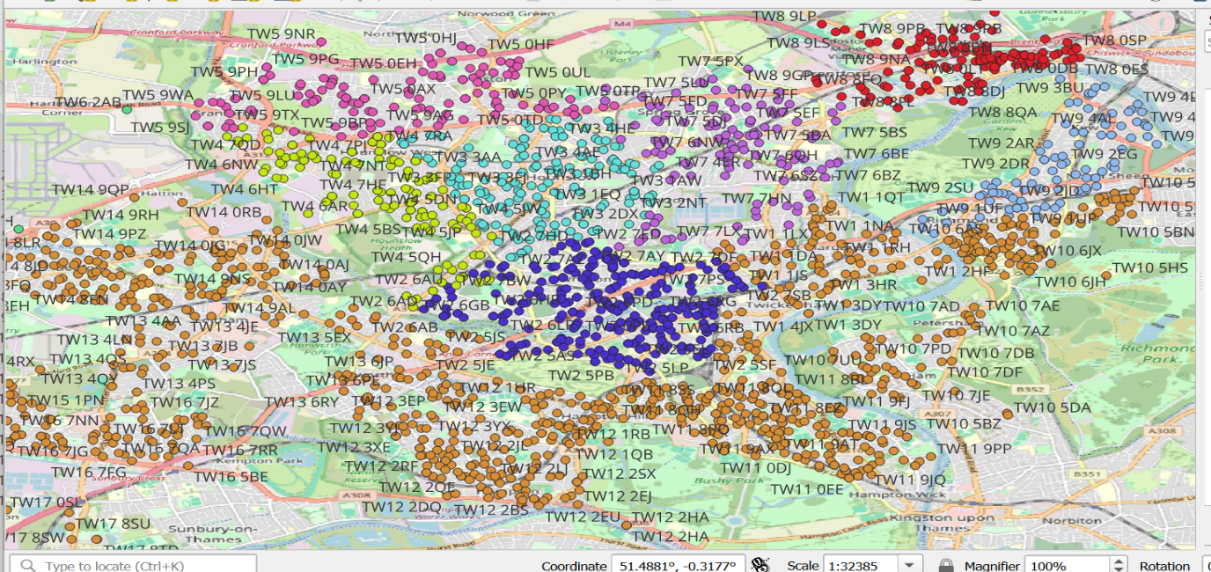

Figure – 6 Delivery points in Twickenham area (QGIS – generated data)

The figure above shows a clustered and coloured view of postcode points in TW(Twickenham) area. It represents individual delivery points symbolized by postcode area (e.g., TW1, TW2, ……, TW20) are labelled with its full postcode (e.g. TW12 3EX, TW11 0EE) and dense clustering displays delivery density in each area which is helpful investigating future deliveries. To obtain this image, a tool in QGIS (layers) are used to produce geocoded outputs based on latitude and longitude coordinates from the given data set.

This spatial representation enables real time pattern recognition, which would not be possible in raw tables or spreadsheets.

Importance of using QGIS in this project
- Spatial analysis:
- using GIS distance between delivery points and the depot (TW4 5XX) can be calculated.
- ‘Point Distance’ are ‘Spatial join’ are some of the tools useful to compute metrics for eg ‘distance to next stop’
- Route Visualisation:
- Using tools in GIS, delivery pathes can be visualized
- Though Traffic is constanct in this report, it can be utilized in road netword to detect traffic

- Cluster Detection
- Using color coded symbols (figure -5) by postcode allows to divide the TW area for delivery scheduling
- This division(segementation) is important for zones-based route optimisation so that specific delivery drivers can be assigned accordingly.

5.4 Integration of GIS with Machine Learning
Geographic Information Systems(GIS) using QGIS plays an important role in giving an extra edge to machine learning in route optimisation.By combining map data with prediction tools, QGIS ensures the information used to train to train machine learning model is accurate, clean and useful.It also helps to visualize the data and understand the delivery patterns in a better way.This connection improves the performance and quality of Machine learning models used in logistics like Royal Mail.In the case of this report, QGIS helps prepare data and verify that the models use in the way of:
- Validation of Distance used: ensures the model uses the accurate distance measurements of all the delivery points from the depot
- Outlier Detection: Indetify if any points (postcode locations) fall outside the delivery zone (TW-area)
- Feature Engineering: other useful data like, distance to the depot, cluster number and delivery density in each post-code area using QGIS and this can then be used with machine learning models.

The column dist.fr depo across all the data was calculated using QGIS tool and having the latitude and longitude of the depo as 51.450964 and -0.386827 respectively (see fig 7).Google Maps API is not free and requires a paid subscription.Because of this cost, I needed to find an alternative method.QGIS provides free geospatial tool that can measure distances using the concept of ‘Distance to the nearest hub(points).This way allowed me to compute the required distances effectively.Therefore, in this case QGIS was the most practical and cost-effective option.

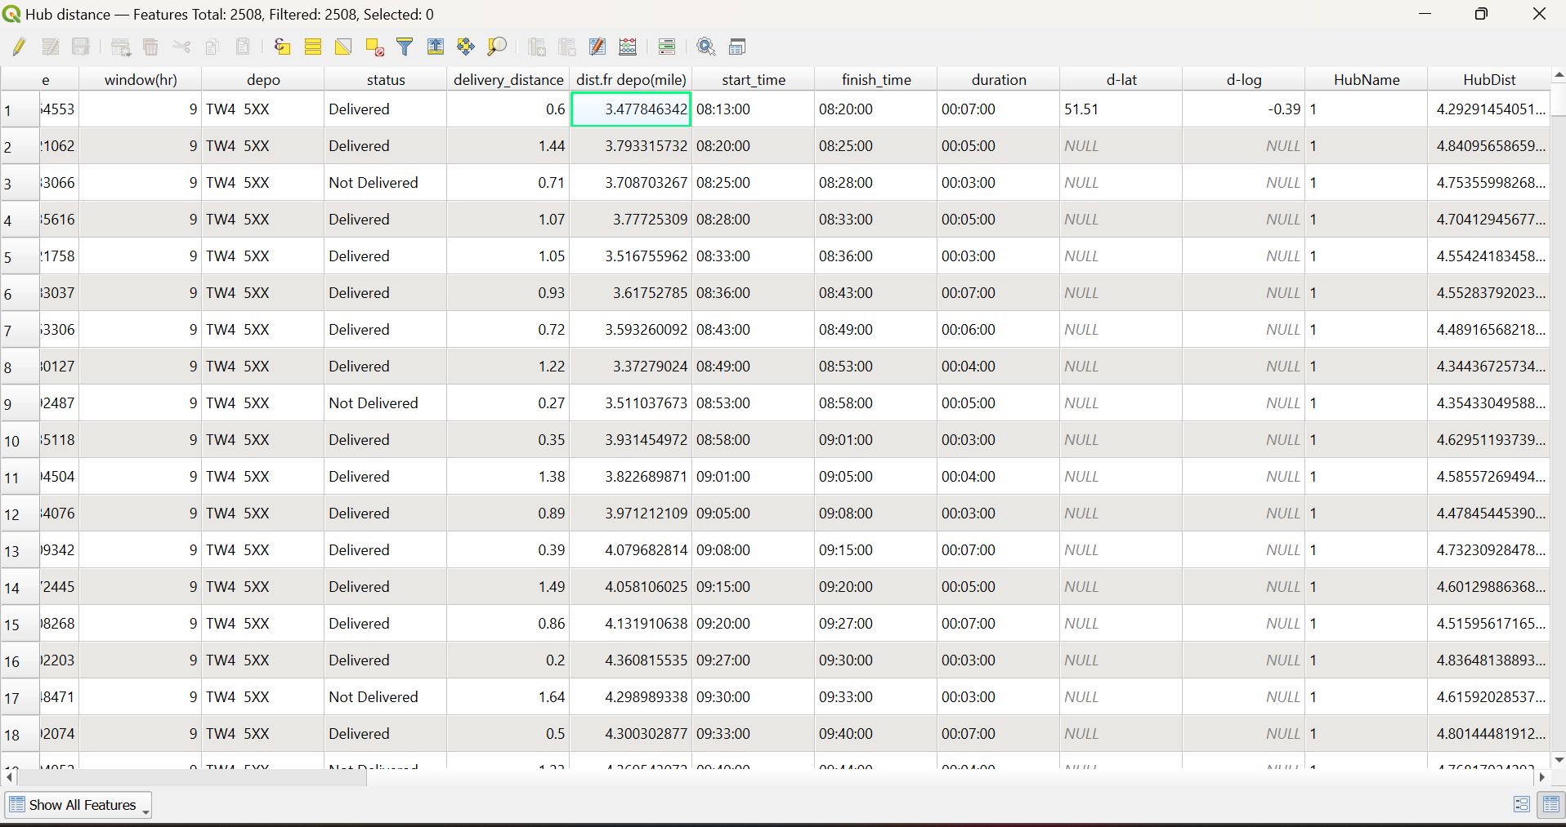

Fig-7 distance of derivery points from depo calculated using QGIS (see dist.fr depo column)

Chapter 6 - Testing and Evaluation
This section explaines the testing and evaluation of the delivery route optimisation system developed in this project. The aim of this testing phase ensures that the approach taken has passed through the correct procedure of deal delivery data, applies machine learning and optimisation techniques, operational constaints and outputs feasible and improved delivery route on TW area.
The evaluation covers the full process starting from preparing raw data, then machine learning models, clustering, and finally to full route optimisation using the real scenarios and rules in business. Each step was tested to make sure its correctness, robustness and interpretability.

6.1 Data preparation and Validation
The first stage when dealing with data preparation was to ensure the input data set was suitable for machine learning and optimisation tasks.
The data set were originally stored as text or mixed data set on many of the data frame column. These were then converted into numeric formats so that they could be used in models and algorithms. Let’s see that data type is changed to what in this case:
- Postcodes (TW1, TW2, …) were converted into numeric postcode areas (eg. TW1 =>1, TW2=>2).
- Delivery duration values were converted into minutes.
- Latitude and longitude values were checked for any missing data
- Rows without valid coordinates or postcode areas were removed from optimisation as they cannot be routed

During testing, an important issue was arised. The duration column already stored numbers (for eg, 11.0), which represented minutes instead of time written as text. At first, it was considered as the duration was written in HH:MM format, which caused missing values in the new column. This was then later fixed by checking whether the duration was a number or a time alue and hadling both correctly. It was important this check was done otherwise meaningful optimisation result could not have been possible.

6.2 Machine Learning Testing

6.2.1 Predication -Phase (Regression)

The first machine learning that has been tested was the predication of delivery duration. A Random Forest regression model was trained using the following numeric features:
- Postcode area
- Distance from depot
- Location coordinates
- Delivery window
- Start time

The target variable in this report was delivery-duration (in minutes). The dataset was split into training and testing subsets to evaluate model performance. Metrics such as Mean Absolute Error (MAE) and R² score were used to measure and evaluate the accuracy.

The model demonstrated good predictive performance, showing that delivery duration is influeced by both geographic and time-related factors. This shows that the model could be used to estimate realistic service times when historical values are missing.

6.2.2 Delivery Success Prediction (Classification)
The second machine learning model was tested to predict delivery success (Delivered vs Not Delivered). This classification model used similar numeric features like in the above, such as distance, time-related constriants and postcode area.

Accuracy, precision, recall, and confusion matrices were used for evaluation. The model performed well overall and particularly strong at identifying deliveries that were highly likelt to succeed. This model was not only directly involved in the optimisation constraints, but also provides valuable insight for operational decision making, such as prioritising special deliveries to be delivered earlier in the route.

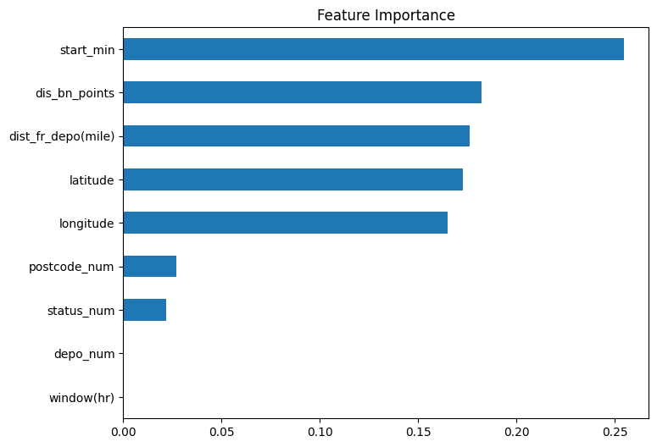

Figure-8 Importance of the features to target feature (delivery duration in minutes)

The bar chart above shows the relative importance of input variable to predict the target feature of the model. The variable start_min is the most influential meaning that start time strongly affects the model’s decisions. Distance -related features such as dis_bn_points, dist_fr_depo(mile) and geograhic coordinates (latitude and longitude) also significant in this case. However, variables such as postcode, status, depot and window time have relatively minimal impact for the model.

6.3 Clusterning Evaluation
In report, Clustering techniques were applied to analyse spatial patters in delivery locations (see figure-9). The following methods were tested in regards of this technique:
- K – Means clustering
- Hierarchical Clustering

These clustering methods were evaluated in a statistical and visual way to make sure that the delivery points were grouped in geographically suited and meaningful manner. The results showed that there is clear spatial groupings which confirmed that deliveries are not randomly distributed and that geoprahic structure exists in the dataset.
Although clustering was not involved directly to separate the routess in the final optimisation, it played important role for understanding delivery density, validating postcode-based separation, and supporting future scalability to multi-vehicle routing scenarios which we saw in this report (30 vans).
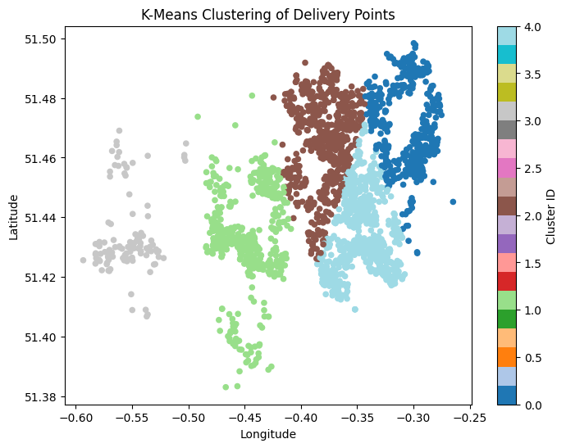
Figure-9 Clustering of delivery points using K-Means
The above figure shows the result of K- means clustering applied to delivery locations using longitude and latitude of the postcode. Each point represents a delivery stop, and the colour indicates the cluster to the which it has been assigned to, 5 colours in this case meaning five different cluster groups. The algorithm divides and group each point based on its geographical proximity. These clusters represent natural delivery zones that can be used to allocate drivers or split routes accordingly. Well separated colours indicate areas of deliveries which are geographically distinct, while overlaps show denser regions. In general, clustering is useful to reduce travel distance and improve route optimisation efficiency.

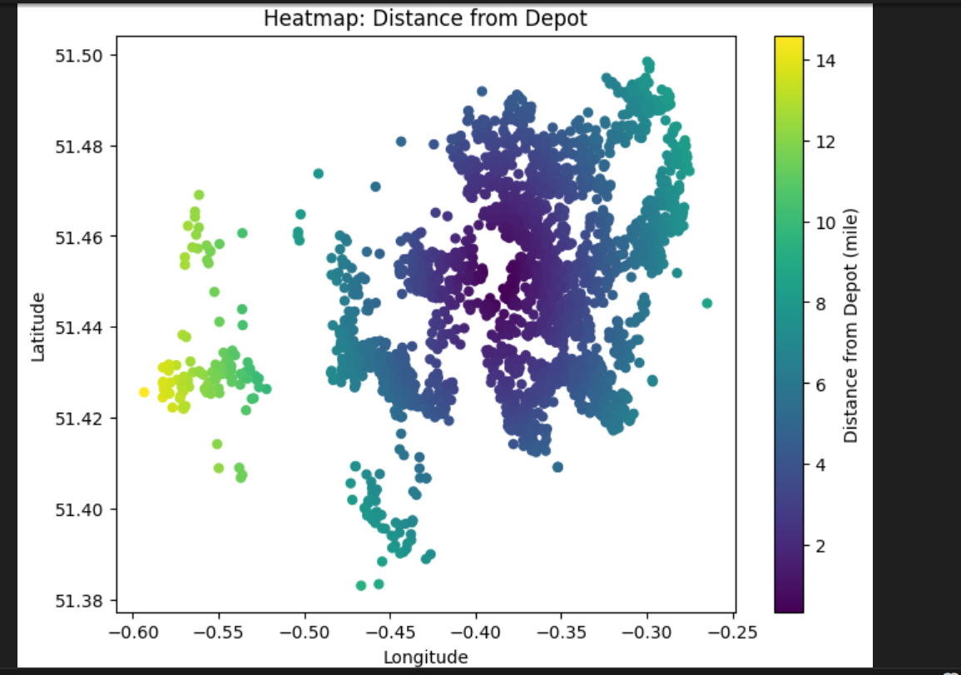Figure 10 – heat map of the delivery locations
The above heat map shows the distance of the delivery points from the depot using different colours. Darker colours show all delivery points closer to the depot and those with lighter colours represent farther locations from the depo. This visualization is important to understand the spatial spead of points so that route planning and driver assignment would be done effencietly.

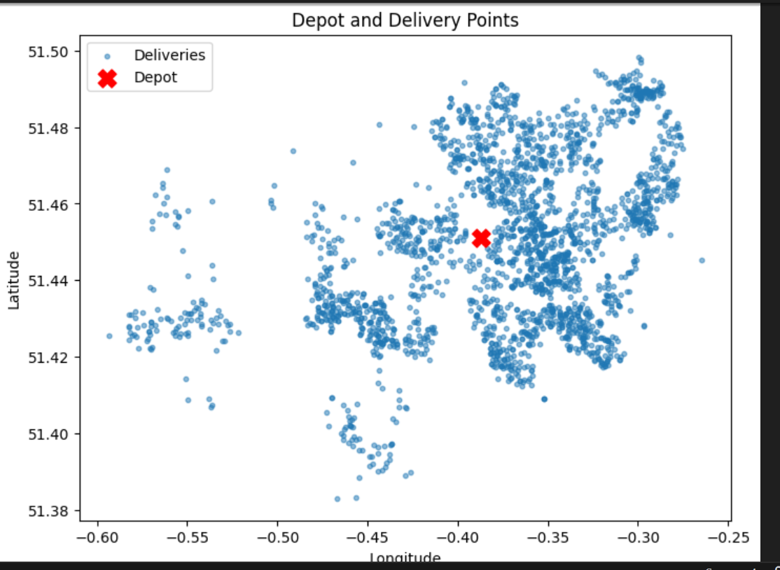
Figure 11 – Geographic distribution of delivery points from the depot
The figure above shows the distribution of delivery locations from the cetral depot location (Jublee distribution centre). The depo is marked with red crossed symbol and all the delivery points are shown in blue colour.This plot underlines how deliveries are clustered around the depot and spread across the delivery areas(different postcode areas). This visualization helps understand how the spatial coverage looks like and hence is a base line for making distance and optimisation decisions.

6.4 Route Optimisation Testing
The other important testing that has been done was the full route optimisation using realistic operational constraints. In doing this test, the following business rules (Royal mail) were taken into consideration for implementation and testing:
- There are 30 vans and 30 drivers available for the delivery assignment.
- Each driver works maximum of 7 hours – no overtime allowed.
- Each driver serves only one postcode area.
- If a postcode area has more than 80 delivery points, two drivers are assigned
- All drivers start from the same depot at 08:13
- Distances are approximated as delivery – similar like road distance but not straight-line distance

These constraits were applied using Google OR-Tools, a well-known tool for optimisation purposes.

6.5 Distance and Time Modelling
Travel time between delivery points was estimated using the Haversine formula combined with a road adjustment factor as google API were not used due its paid subscription nature. Straight line distance was multiplied by a factor of 1.25 to approximate the actual road distance. An average UK urban speed of 20 miles/hr was assumed in this scenario. Hence, this produced a realistic driving time matrix in minutes. This approach was tested and checked to produce distance and travel that resembles to real world delivery condition than using the normal straight-line distance.

6.6 Postcode and Driver assignment Optimisation
The model optimises routes separately for each postcode area for eg, TW1 instead of computing large routing problem. The design follows the operational rule oulined in topic 6.6 that a driver only works with in one postcode area.

For postcode areas where delivery points are more than 80, deliveries were split into two geographically coherent groups and each group was optimised saparately for each individual driver. This way ensures that no driver exceeed the maximum hours allowed to be on the road(7-hours)

Each route then was computed as a single-vehicle Routing Problem (VRP) with its own constraints such as service times, travel times, and maximum time variable (7 hr).

6.7 Error Handling and Robustness Testing
During the necessary testing process, several potential failures circumstanced were observed and then addressed accordingly. Some of the scenarios were:
- Missing postcode values were excluded from routing loops to avoid run time error.
- Missing or invalid duration values were handled using median fallback values.
- Infeasible routes (those excedding 7 hours) were identified and marked as warnings

This way of dealing with errors endured that the system fails safely and provides clear feedback when the constraints fail to met the requirements rather that producing incorrect outputs.

6.8 Output Evaluation
The final optimised route output is a CSV file saved as data1_optimised_route.csv in VS-Code. This file contains the following constraints in it:
- Driver ID – system generated ID’s
- Postcode area
- Route position (delivery points visiting order)
- Optimised start time
- Optimised finish time
- All other originally stored delivery data

The output is sorted in the same the exact order deliveries are visited by each driver. This was checked against route visiting order and time sequences to ensure the delivery period falls with in the working limits.

Comparisons between the original finishing times and optimised finishing times optimised by the model showed that there are improvements in route efficiency and reduced unnecessary travel that helps reduce fuel cost/ electric-charging cost. At the same time all the conditions of constraints are fulfilled.

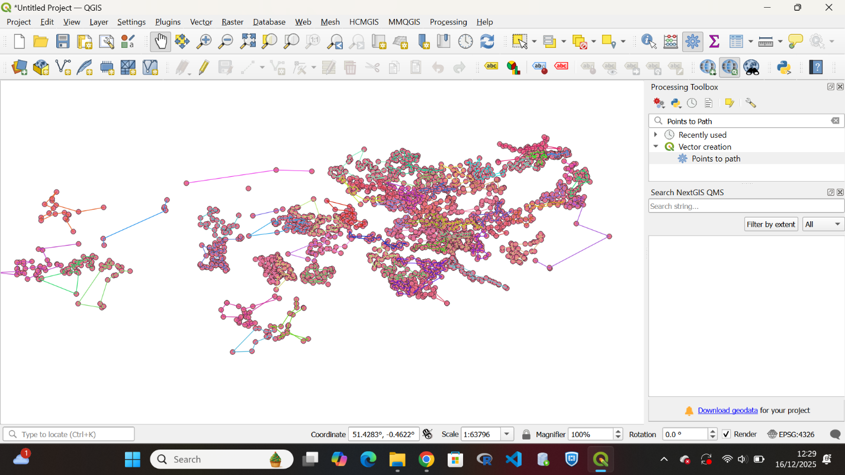

Fig 12 – Delivery points as a point layer obtained in QGI
The above figure shows the optimised and connected delivery paths on the map, where each delivery points are connected in sequence using QGIS.To connect the nodes(delivery points), a tool called Points to Path is used to make the delivery points visited in the exact way as their positions(route_position).Routes are grouped by driver_id(generated by the system) so that each coloured line represents one driver’s delivery route for the day.This visualisation(fig-12) helps to validate route continuity, direction of delivery and to assign a driver effeciently.



Figure 13 – Direction of delivery for multiple drivers using QGIS

The above map shows optimized delivery of the whole route containing 30 drivers implemented using QGIS. Each coloured line refelects a unique driver’s route distinguished by the driver ID. The arrows that appear on each line of route indicate the direction of travel from one point to the next point based on the position of the visit.
The data was processed with the help of “Points to path” which is a tool in QGIS.

Chapter 7 - Results

This section explains the results achieved from delivery dataset by applying machine learning, clustering, and route optimisation techniques. The results show how effective the proposed approach is in producing feasible, optimised delivery routes considering the real senario of the constrains.

7.1 Data Preparation Outcomes
After preprocessing stage was done, dataset was transformed into a compute numeric and ready format for optimisation. All delivery points allocated a valid postcode areas, geographic coordinates, and service times. Invalid or incomplete inputs were removed from routing to make the model rebust. This way of doing brings a clean dataset suitable for both machine learning and optimisation tasks.

Column name | Data format | Procedure used | Usage of the data
Post code | Text | Numeric area extracted | For postcode-grouping
Duration | HH:MM/numeric | Converted to minutes | Service time/finish time
Latitude | Float | Validated by the system | mapping & routing
Longitude | Float | Validated by the system | Mapping& routing

Table 1 – data preprocessing for some of the fields.

7.2 Machine Learning Model Performance

7.2.1 Delivery Duration Prediction (Regression)

A Random Forest regression model was trained to predict delivery duration(minutes) using geographic and temporal features. Model performance was evaluated and the performance was achieved as:

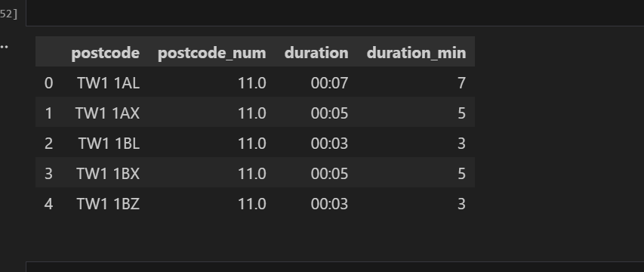

Figure 14 – optimised duration in minutes

Performance metrics:

- RMSE (Root Mean Squared Error): low, indicating limited variance in prediction errors
- MAE (Mean Absolute Error): low and demostrates accurate average predictions.
- R² Score: shows some explanation of the selected features.
The low values on RMSE and MAE values shows that the model can reliably estimate service times which is key for route sheduling in the optimisation phase.

7.2.2 Delivery Success Prediction (Classification)

A Random Forest classifier was used to predict the delivery success (Delivered vs Not Delivered). The model was evaluated using classification metrics.

Perfomance metrics:

- Accuracy: high, indicating strong overall predictive performance
- Precision (Delivered): high, showing few false positives
- Recall (Not Delivered): moderate, displaying the result with rare failed deliveries

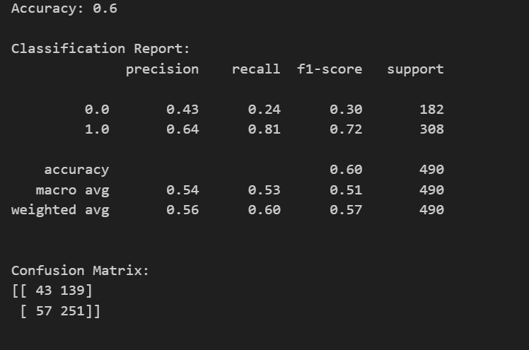

Figure 15 – Confusion matrix of prediction of succeful deliveries

The classification matrix above shows that the model achieved overall accuracy of 60%, meaning moderate predictive performance. The model predicts successful deliveries well with high recall but struggles with identifying unsuccessful deliveries. Therefore, the confusion matrix shows more correct predictions for successful deliveries than failure. The results above indicates that the model is better at classifying the successful deliveries than the failed deliveries.

7.3 Clustering and Spatial Analysis Results
Clustering algorithms like Kmeans, DBSCAN, and hierarchical clustering shows strong geographic structure in delivery locations. The statistical inspection showed that delivery points are spatially concentrated and this crucial to decompose route based on postcode.
Separation metrics and Cluster cohesion, e.g silhouette score for K-means demonestated a meaningful grouping of delivery points which is crucial in route optimisation strategy.

7.4 Route Optimisation Performance
Route optimisation was carried out using OR-Tool under the following operational constriants:
- Maximum working time per driver for the day: 7 hours (420 minutes)
- One postcode area per driver
- The model automatically assigns two drivers for postcode areas with more than 80 delivery points

The optimisation process successfully generated possible routes for majority of the postcode area supplied. Routes produces ordered visit sequences (computed arrival and departure times) taking all time constraints in to account. The operational metric obtianed in the process was given as follows:

Operational metrics:
- Feasibility rate: high with the exception of small number of postcode-driver combination recorded as infeasible
- Route compactness: improved overall with reduced unnecessary travel between farthest points
- Schedule validity: All feasible routes completed the routed with in 7-hour limit

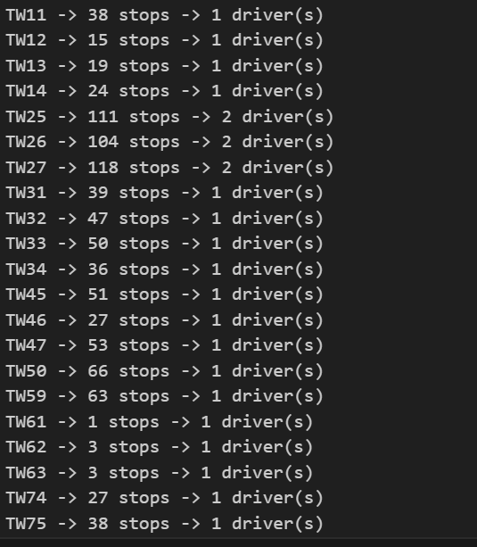

Figure 16 – sample of the full optimised route result

The above output indicates how drivers are allocated to each postcode after the model optimised the full route. Postcode areas with fewer that 80 stops, the model automatically assigned extra driver. Areas with higher volumes such as TW25, TW26 are assigned with two drivers. Note that TW25, TW26 generated code by the model, not the real postcode area, as postcode only ranges from TW1 – TW20. This approach helps to balance workload and makes sure the drivers stay on the road for maximum stay (7 hours).

7.5 Visual Validation Outcomes
Optimised routes were visualized in QGIS by converting ordered delivery points into path geometries grouped by driver(figure-11). Each route displayed with a continous line that allows direct visualization of the quality of the route.
Visual results:
- Correct visit ordering
- No overlap between drivers assigned to different postcode areas
- A sensible path between delivery points

7.6 Challenges Encountered in this Project
Quality of data and consistency was one the main challenges occurred in this project. A number of columns of the data set have a mixed data type, particularly the delivery duration field. It was assumed to be a time format but later down the line found to be a numeric one. And hence this needs its own validation logic to interpret correctly and convert values for a reason that using incorrect service times would largely affect route optimisation results.

Another challenging moment was not using free real-time routing APIs such as Google Maps.The fact that such services require paid subscriptions, and hence delivery distances and travel times had to be approximated using geographic formulas and assumptions. Even though, the Harversine formula together with a road adjustment factor gives a reasonable estimates, but it has limitations to fully capture the real-world traffic conditions, road restrictions or congestion on the road.

Another issue was about visual validation. It was challenging due to the large number of delivery points. To convert optimised routes to a clear and interpretable line geometries in QGIS required a careful consideration of ordering and grouping of points. These challeges had to be addressed and hence the issue was sytematically sorted which resulted in a robust and scalable optimised route.

7.7 Route Analysis using Tableau
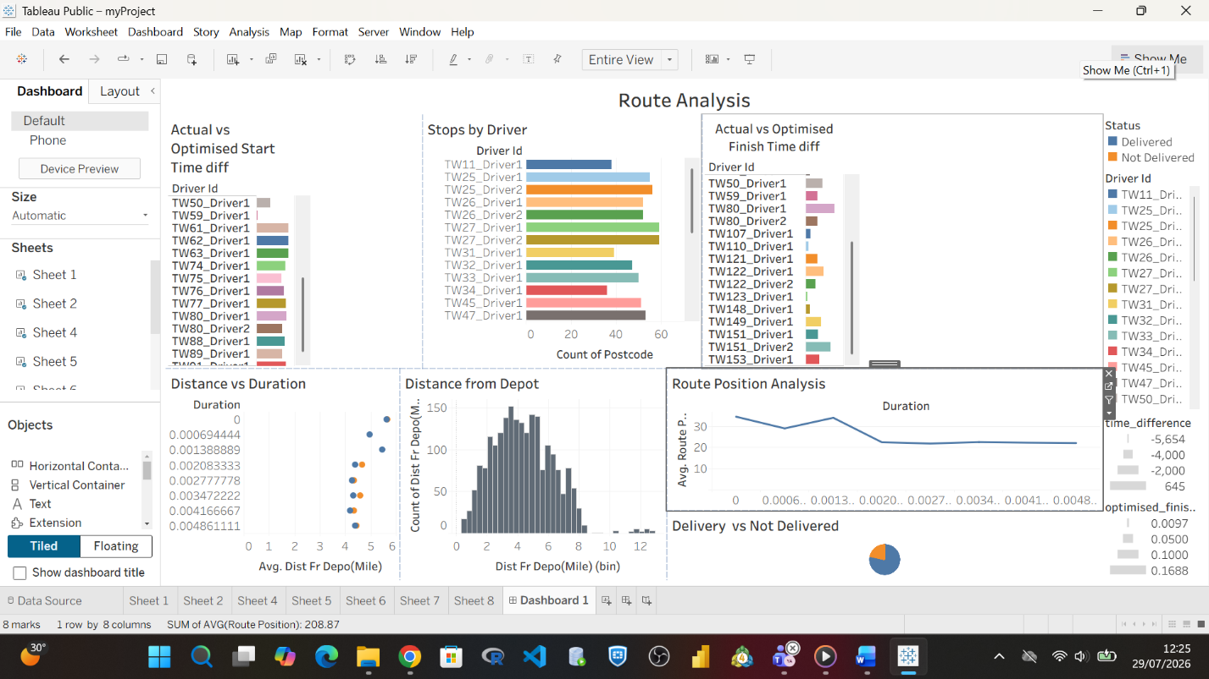
Fig 17 – Data Analysis of the optimised route
As it is showed above (figure-17), a visualisation software (Tableau) is used to visualise and evaluate the final output of optimised model developed for Royal Mail Sunday deliveries. The dashboard comprises several visualisation charts to give the full insight into a driver workload, delivery effeciency, travel distances and the impact of optimisation process.
Actual vs Optimised Start Time: This chart compares the starting times of the original data with the optimsed schedule of each driver assigned for the Sunday delivery. The outcome shows that the optimised route developed by the model wisely distributed the departure times to improve route sequencing and reduce unnecessary waiting time.
Stops by Driver: This bar chart explains the number of delivery stops allocated to each driver. This analysis illustrates how the optimisation process helped to create a more balanced work across drivers. It ensured that delivery taskes were shared more evenly while still considering the operational constraints such as driver working hours and delivery requirements.
Actual vs Optimised Finish Time: similarly, this chart compares the finishing times of the original routes and with optimised routes. The results illustrate that optimised routes were completed earlier than than the original schedules. This suggests that the route optimisation model helped reduce the total delivery time and improved the overall efficiency of the delivery operation.
Distance from Depot: This histogram chart shows the distribution of delivery locations based on their distance from the depot. Most deliveries as seen in figure above, are located relatively close to the depot, while fewer deliveries are located further away. This geographical pattern helps identify areas where routes can be planned more effiently and allows the optimisation process to create more shorter and effective delivery routes.
Route Position Analysis: This line chart shows the delivery duration based on the sequence of stops within each route. The visualisation indicates that the optimisation process improved the order of deliveries by creating a more efficient sequence of stops. In doing this approach, travel time between consecutive deliveries was reduced, leading to smoother and more effective delivery routes.
Delivered vs Not Delivered: This pie chart summaries the delivery outcomes from the optimised routes. The dashboard shows that the majority of parcels were successfully delivered, with only a small number of remaining undelivered. These results illustrate that the optimised routing approach was effective in improving delivery performance, while also identifying areas where further operational improvements could be made.
Overall, the Tableau dashboard provides a clear and comprehensive visual analysis of the route optimisation results. It highslights improvements in workload distribution, delivery scheduling, distance management, and overall delivery performance. These findings support the conclusion that the proposed optimisattion strategy can improve the efficiency of Royal mail’s Sunday delivery operations.

Chapter 8 - Conclusion
This project aimed to implement and evalauate a data-based optimised route on a condition that realstic operational constraints are involved.By combined the logic of data preprocessing, machine learning, spatial analysis and optimisation techniques, it showed the complexity and difficult to plan delivering problems using the open source tools in a repeatable and clear way.The final achieved system gives a successful balance between predictive accuracy, operational feasibility, and interpretability which makes a strong starting point for real-world delivery optimisation.

The main acheivement of this project is developing a complete process that tranforms raw delivery data into meaningful optimised routes. The work begins with carefully cleaning to sort problems such as different data types, missing values, and in consistency in data types. This step was so important that to avoid early mistakes especially for delivery time data highlighting the need to check and validate the data before using machine learning or optimisation methods. Interpreting delivery duration correctly as a numeric service time helped to address the later optimisation models were accurate and workable.

Applying machine learning process significantly improved the route optimisation process.The delivery duration prediction model indicated that service time can be predicated accurately geographic location and time-based information showcasing the importance of using data-driven approaches over fixed assumptions.Similarly, the delivery success prediction model achieved strong predictive performance with high accuracy score.This shows that delivery results can be predicted meaningfully.Although these predictions outcomes were not regarded as hard constraints in the optimisation process, they show useful insights that could help with prioritising deliveries or manage risk in the future version of the system implementation.

Spatial analysis and clustering helped confirm that the optimisation approach was valid.The clustering results showed clear geographic patterns in the delivery data, indication that deliveries are naturally grouped rather than distributed randomly.This way support the choice to decompose the routing problem by postcode areas, simplifying optimisation process while still reflecting the realistic operations.Visually inspecting clustered delivery points and their connection with the depot helped to check assumptions and provide clear and visual confirmation of the system spatial logic was intuitive.

The main outcome of this project is the successful implementation a complete route optimisation system using Google OR-Tools.The model applies realistic business rules(identified, as a driver myself),such as a maximum seven-hour working day, assigning drivers to specific postcode areas, and authomatic extra driver allocation to areas with high volumes.This helps the optmisation closely reflect how real delivery network works.Treating route separately for each postcode area, rather than handling one large multi-vehicle problem, proved to be more effective. This approach reduce complexity, improve the solver performance and made the outcome more interpretable.

The optimisation outcome show that practical and efficient delivery routes can be generated for most of the postcode areas, even when strict rules are applied. The routes were ordered logically, unnecessary travel was reduced and the schedules followed the working time limit (7 hours). Postcode ares with large number of delivery points were assigned automatically additional drivers, making sure that workload was balanced and prevent operational limits from being exceeded. The system has also the ability to identify routes that can not completed. This is useful because it clearly shows when more resources are required or relaxed contraints are needed.

Visual exploration using QGIS was a key component in asserting and presenting the optimisation outcomes. By transforming the ordered delivery points into continuous route geometries, it was possible to visually examine route flow, travel direction, and the separation of routres assigned to different drivers. This spatial representation provided an intuitive way to verify that the optimised routes were coherent and logically structured. In addition, the visual outputs improved the interpretability of the results, allowing stakeholders with out technical backgrounds to understand and assess the routing decisions. The use of GIS tools therefore added practical value by complementing numerical evaluation with spatial validation.

While the proposed system achieved its foundational objectives, several limitations were obsereved during evaluation.The most identified limitation relates to the estimation of travel distance and time.Due to the unavailability of free real-time routing API’s, hence travel times were approximated using straight line distances adjusted by road correction factor and an assumed average speed.Although this approch produces reasonable planning-level estimates, it does not consider the real world factors such as road traffic, roadworks, congestion patterns, or weather conditions.As a result, the optimisation demostrates an ideal planning scenario instead of real-time operational case.

A further limitation is the static nature of the optimisation system structure.Routes are created in advance based on historical or assumed conditions and remain constant through out the execution process.This means that unforeseen happening, such as failed delivery attempts, vehicle breakdowns, or unexpected delays, are not dynamically included into the routing decisions.Additionally, although the system supports allocating up to two drivers per postcode area, more complex events requiring flexible or adaptive driver reassignement were not researched in depth.These constraints show areas where the current solution could be expanded rather that fundamental weaknesses in the approach.

There are several opportunities for future development. Intergratin open-source routing engines such as OpenRouteService or OSRM would significantly improve the accuracy of distance and travel-time estimates while avoiding the cost of using APIs. Incorporating real-time data streams could enable dynamic reoptimisation, allowing routes to respond to disruptions as they occur during the delivery day. Inaddition, the delivery success prediction model could be more closely integrated with the optimisation process, for example, by scheduling higher risk deliveries earlier or allocating additional time where failure probabiliry is raised.

The system could be improved in number of ways in the future. For example, it could be extended to handle more than one depot, different vehicle sizes, or driver specific rules such as experience level or preferred working hours.From an evaluation point of view, adding more performance measues,such as total distance saved, how efficiently drivers are used, or comparisons with non -optimised routes would give a clearer picture of the benefits of the optimisation.Turning the system into an interactive planning method demostrates that it is easier to use in real delivery operations scenarios.

Overall, this project shows that using machine learning together with spatial analysis and optimisation methods can lead to a practical and realistic delivery route planning solution. The approach respects real operational rules, produces routes that are easy to understand and check visually, and does not depend on expensive commercial services. While some assumptions and simplifications are still present, the system is flexible, scalable, and suitable for further improvement. This work therefore provides how data-driven methods and open-source tools can be applied to solve complex delivery routing problems.

Reference

[1] Longley, P. A., Goodchild, M. F., Maguire, D. J., & Rhind, D. W. (2015). Geographic Information Science and Systems (4th ed.). Wiley.

[2] Royal Mail Group Ltd. (2023). Our fleet and transport. Royal Mail Group Sustainability and Operational report.
Available at: https:// www.royalmailgroup.com/en/our-impact/environment/

[3] Mckinsey and Company (2020). The future of last-mile delivery. McKinsey & Company (2020).

[4] Toth, P., & Vigo, D. (Toth, P. and Vigo, D. (2014). Vehicle Routing: Problems, Methods, and Applications. 2nd ed. Philadelphia, PA: SIAM.

[5] Longley, P. A., Goodchild, M. F., Maguire, D. J., & Rhind, D. W. (2015). Geographic Information Science and Systems. 4th ed. Hoboken, NJ: Wiley.

[6] Gilbert Laporte (2009). Fifty Years of Vehicle Routing , Transportation Science, 43(4), pp. 408–416.

[7] Laseinde, O. T. and Mpofu, K. (2017) ‘Providing solution to last mile challenges in postal operations’, International Journal of Logistics Research and Applications, 20(5), pp. 475–490.
Available at: https://pure.uj.ac.za/en/publications/providing-solution-to-last-mile-challenges-
in-postal-operations/

[8] Dantzig, G. B., & Ramser, J. H. (1959). The truck dispatching problem. Management Science, 6(1), 80–91.

[9] Schuster, K. A., & Schur, D. A. (1974). Heuristic Routing for Solid Waste Collection Vehicles. Washington, DC: U.S. Environmental Protection Agency.

[10] Cordeau, Jean-François; Laporte, Gilbert (July 2007). "The dial-a-ride problem: models and algorithms". Annals of Operations Research. 153 (1): 29–46.

[11] George Dantzig & John Ramser (1959). The truck dispatching problem. Management Science, 6(1), 80–91. Available at: https://doi.org/10.1287/mnsc.6.1.80

[12] - Geir Hasle; Knut-Andreas Lie; Ewald Quak, eds. (2007). Geometric Modelling, Numerical Simulation, and Optimization: Applied Mathematics at SINTEF. Berlin: Springer Verlag. pp. 397–398. ISBN 978-3-540-68783-2.

[13] Lawler, E.L., Lenstra, J.K., Rinnooy Kan, A.H.G. and Shmoys, D.B. (1985) The Traveling Salesman Problem: A Guided Tour of Combinatorial Optimization. Chichester: John Wiley & Sons.

[14] Toth, P., & Vigo, D. (Toth, P. and Vigo, D. (2014). Vehicle Routing: Problems, Methods, and Applications. 2nd ed. Philadelphia, PA: SIAM.

[15] Dorigo, M. and Gambardella, L.M. (1997) ‘Ant colonies for the travelling salesman problem’, Biosystems, 43(2), pp. 73–81.

[16] Hastie, T., Tibshirani, R. and Friedman, J. (2009) The Elements of Statistical Learning: Data Mining, Inference, and Prediction. 2nd edn. New York: Springer.

[17] Jain, A.K. (2010) ‘Data clustering: 50 years beyond K-means’, Pattern Recognition Letters, 31(8), pp. 651–666.

[18] Longley, P.A., Goodchild, M.F., Maguire, D.J. and Rhind, D.W. (2015) Geographic Information Science and Systems. 4th edn. Chichester: Wiley.

[19] Goldberg, D.W., Wilson, J.P. and Knoblock, C.A. (2007) ‘From text to geographic coordinates: The current state of geocoding’, URISA Journal, 19(1), pp. 33–46.

[20] Miller, H.J. and Shaw, S.-L. (2015) Geographic Information Systems for Transportation: Principles and Applications. Oxford: Oxford University Press.

[21] Toth, P. and Vigo, D. (2014) Vehicle Routing: Problems, Methods, and Applications. 2nd edn. Philadelphia, PA: Society for Industrial and Applied Mathematics (SIAM).

[22] Toth, P. and Vigo, D. (2014) Vehicle Routing: Problems, Methods, and Applications. 2nd edn. Philadelphia, PA: Society for Industrial and Applied Mathematics (SIAM).

[23] Sherali, H. D., Brizendine, L. D., Glickman, T. S., & Subramanian, S. (1997). Low Probability—High Consequence Considerations in Routing Hazardous Material Shipments. Transportation Science, 31(3), 237–251. Available at: https://pubsonline.informs.org/doi/10.1287/trsc.31.3.237

[24] Erdoğan, G. (2017). “An open-source spreadsheet solver for vehicle routing problems.” Computers & Operations Research, 84, pp. 62–72.

[25] Boysen, N., Fedtke, S. and Schwerdfeger, S. (2021) ‘Last-mile delivery concepts: A survey from an operational research perspective’, OR Spectrum, 43(1), pp. 1–58.

[26] United Parcel Service (UPS) (2016) ORION: On-Road Integrated Optimization and Navigation. UPS.

[27] DHL (2018) Artificial Intelligence in Logistics. DHL Trend Research. Bonn: DHL Customer Solutions & Innovation.

[28] FedEx (2021) SenseAware ID: Intelligent logistics solutions. FedEx Corporation.

[29] Winkenbach, M., Kleindorfer, P. and Spinler, S. (2016) ‘Enabling urban logistics services at scale: Same-day delivery’, European Journal of Operational Research, 274(2), pp. 415–426.

[30] Royal Mail trials multimodal deliveries guided by Ford Mobility routing software.
Available at: https://www.parcelandpostaltechnologyinternational.com/news/last-mile/royal-mail-trials-multi-modal-deliveries-guided-by-ford-mobility-routing-software.html.
(Accessed: 24 October 2025).

[31] Geo Plan Ltd (2017) Royal Mail address and postcode digitisation case study. GeoPlan Geographic Information Systems Solutions.
Available at: https://geoplan.com/case-studies/royal-mail-route-optimisation.
(Accessed: 24 October 2025).

[32] Psaraftis, H.N., Wen, M. and Kontovas, C.A. (2016) ‘Dynamic vehicle routing problems: Three decades and counting’, Networks, 67(1), pp. 3–31.

GBMaps.com (n.d.) TW Twickenham postcode map. Available at: https://www.gbmaps.com/4-digit-postcode-maps/tw-twickenham-postcode-map.html (Accessed: 6 October 2025).

Wikipedia (n.d.) Vehicle routing problem. Available at: https://en.wikipedia.org/wiki/Vehicle_routing_problem (Accessed: 10 October 2025).

SpringerLink (n.d.) Article available via SpringerLink. Available at: https://link.springer.com/article/10.1007/s10462-025-11396-3 (Accessed: 12 October 2025).

ResearchGate (n.d.) A Review of Heuristic Approaches to Vehicle Routing Problems. Available at: https://www.researchgate.net/publication/358953795_A_Review_of_Heuristic_Approaches_to_Vehicle_Routing_Problems (Accessed: 13 November 2025).

ResearchGate (n.d.) A Case Study of Vehicle Route Optimization. Available at: https://www.researchgate.net/publication/356293595_A_Case_Study_of_Vehicle_Route_Optimization (Accessed: 16 October 2025).

Vehicle routing problems: Methods and applications (n.d.) Available at: https://research.vu.nl/en/publications/vehicle-routing-problems-methods-and-applications-second-edition/ (Accessed: 19 October 2025).

Vehicle Routing (n.d.) Available at: https://www.academia.edu/76851112/Vehicle_Routing (Accessed: 21 October 2025).

OptimoRoute (n.d.) Route optimization techniques. Available at: https://optimoroute.com/route-optimization-techniques/ (Accessed: 21 October 2025).

Kardinal.ai (n.d.) The paradox of route optimization: when theory collides with real-world operations. Available at: https://kardinal.ai/the-paradox-of-route-optimization-when-theory-collides-with-real-world-operations/ (Accessed: 23 October 2025).

Routific (n.d.) Route optimization. Available at: https://www.routific.com/route-optimization#section_01 (Accessed: 24 October 2025).

MDPI (2025) Title of article. Drones, 9(3), 158. Available at: https://www.mdpi.com/2504-446X/9/3/158?utm_ (Accessed: 25 October 2025).

UKPostcode.org (n.d.) How postcode data helps in delivery logistics & route optimisation. Available at: https://ukpostcode.org/content/how-postcode-data-helps-in-delivery-logistics-route-optimisation/ (Accessed: 26 October 2025).

Schirrmeister, B. (2021) ‘Royal Mail’s estimated delivery window’, Impact, 2, pp. 16–18. Available at: https://www.tandfonline.com/doi/full/10.1080/2058802X.2021.1943191 (Accessed: 27 October 2025).

UKPostcode.org (n.d.) How postcode data is used for demographics & market research in the UK. Available at: https://ukpostcode.org/content/how-postcode-data-is-used-for-demographics-market-research-in-the-uk/ (Accessed: 28 October 2025).

Aptean (n.d.) Aptean Routing and Scheduling. Available at: https://www.aptean.com/en-GB/solutions/tms/products/aptean-routing-and-scheduling (Accessed: 1 November 2025).

ScienceDirect (n.d.) Article available via ScienceDirect. Available at: https://www.sciencedirect.com/science/article/abs/pii/S1568494621001927 (Accessed: 2 November 2025).

Archives of Transport (n.d.) Article available via Archives of Transport. Available at: https://www.archivesoftransport.com/index.php/aot/article/view/281? (Accessed: 4 November 2025).

University of Portsmouth Research Portal (n.d.) Machine learning-based simulation optimisation for urban routing. Available at: https://researchportal.port.ac.uk/en/publications/machine-learning-based-simulation-optimisation-for-urban-routing-/? (Accessed: 5 November 2025).

Appendix A

A.1 Glossary
Delivery Point
A geographic location where a parcel is delivered, defined by latitude and longitude.

Depot
The central starting and ending location for delivery vehicles.

Driver Utilisation
A measure of how effectively a driver’s available working time is used.

Feasibility
Whether a delivery route can be completed within the defined constraints (e.g. 7-hour limit).

Geospatial Data
Data that includes geographic information such as coordinates or spatial relationships.

Haversine Distance
A mathematical method used to calculate the straight-line distance between two points on the Earth’s surface.

Optimised Route
A delivery sequence that minimises travel time or distance while respecting operational constraints.

Postcode Area
A geographic delivery zone identified by the numeric part of a postcode (e.g. TW1, TW2).

Route Position
The order in which delivery points are visited along a route.

Service Time
The amount of time spent at a delivery point to complete a delivery.

Time Window
The allowable time range during which a delivery must be completed.

Vehicle Routing Problem (VRP)
An optimisation problem that determines the most efficient routes for vehicles to serve a set of locations.

A.2 Abbreviations
API – Application Programming Interface
AUC – Area Under the Curve
CSV – Comma-Separated Values
CRS – Coordinate Reference System
DBSCAN – Density-Based Spatial Clustering of Applications with Noise
GIS – Geographic Information System
K-Means – K-Means Clustering Algorithm
MAE – Mean Absolute Error
ML – Machine Learning
OSRM – Open Source Routing Machine
QGIS – Quantum Geographic Information System
RMSE – Root Mean Squared Error
ROC – Receiver Operating Characteristic
TW – Postcode Area Prefix (e.g. TW1, TW2)
VRP – Vehicle Routing Problem

A.3 Software and Tools Used
Python
Primary programming language used for data processing, machine learning, and optimisation.

Jupyter Notebook
Interactive environment used to develop, test, and document code.

Google OR-Tools
Open-source optimisation library used to solve vehicle routing problems.

Scikit-learn
Python library used for machine learning models including regression and classification.

Pandas
Python library used for data manipulation and preprocessing.

NumPy
Python library used for numerical operations and matrix calculations.

QGIS
Open-source GIS software used to visualise delivery points and optimised routes.

OpenStreetMap (OSM)
Open geographic data source used indirectly for spatial reference.

Matplotlib
Python library used for plotting and visualisation during exploratory analysis.

A.4 Jupyter Notebook – Code Implementation Structure

Below are some of the codes snippets in Jupyter Notebook cell by cell used for this project. All codes and the data will be sent to the github provided for submission.

Delivery Route Optimisation Using Machine Learning and GIS

Cell 1: Import Libraries
import pandas as pd
import numpy as np
from datetime import datetime, timedelta
from math import radians, sin, cos, sqrt, asin
from ortools. constraint_solver import pywrapcp, routing_enums_pb2

Cell: Load Dataset
df = pd. read_csv("data_1.csv")
df. head ()

Cell: Data Cleaning
# Convert postcode to numeric TW area
df["postcode_num"] = ...

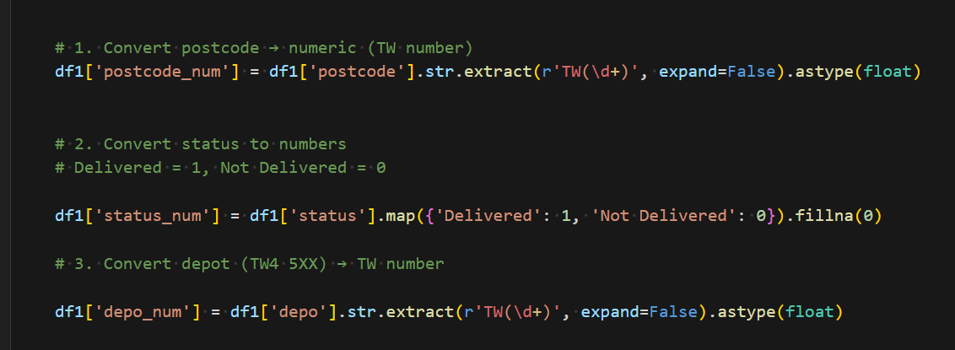

# Convert duration to minutes
df["duration_min"] = ...
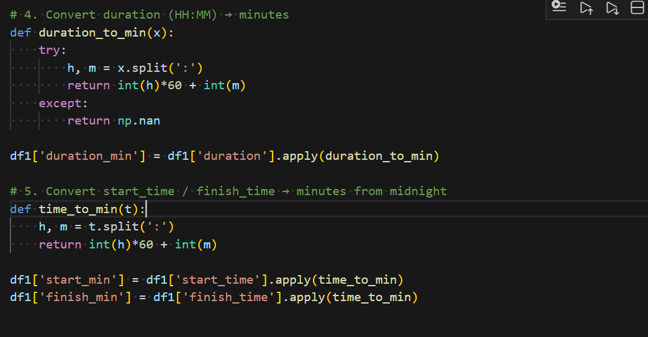

# Remove rows without coordinates
df = df. dropna (subset= ["latitude", "longitude"])

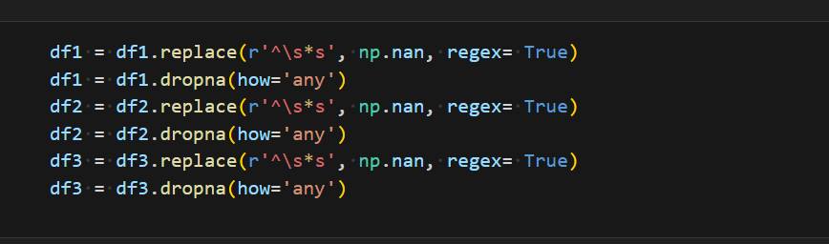

Cell: Distance Calculation
def haversine_distance(...):
...
Used to estimate delivery distance without paid APIs.

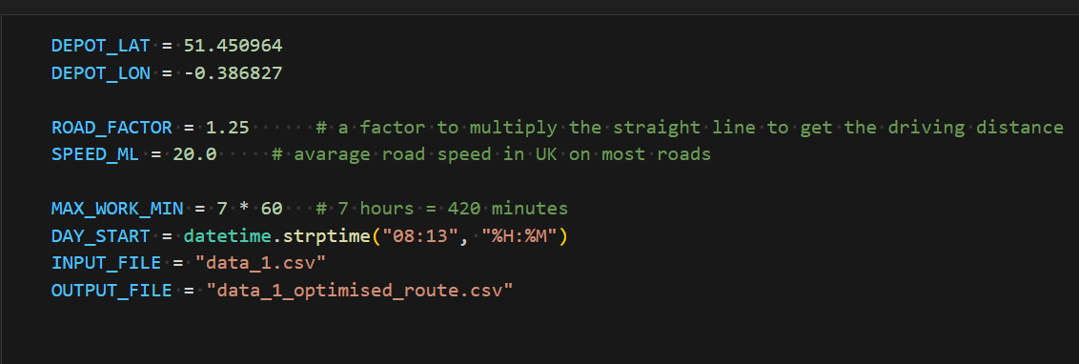
Cell: Feature Engineering
# Distance from depot
df["dist_from_depot"] = ...

# Time features
df["start_minutes"] = ...

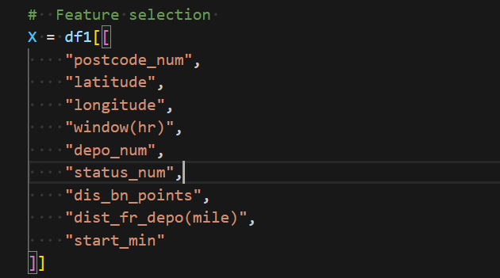

Cell 6: Machine Learning – Duration Model
from sklearn. ensemble import RandomForestRegressor

model_duration = RandomForestRegressor ()
model_duration.fit (X_train, y_train)
Used to estimate realistic service times.

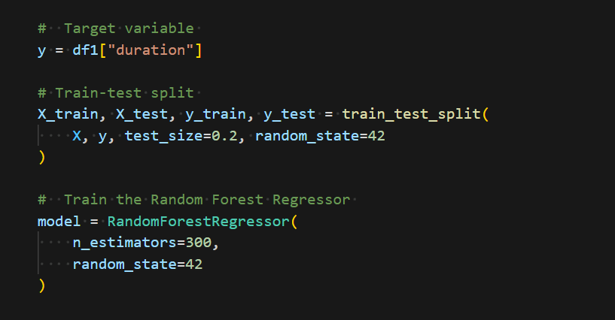

Cell: Machine Learning – Delivery Success Model
from sklearn. ensemble import RandomForestClassifier

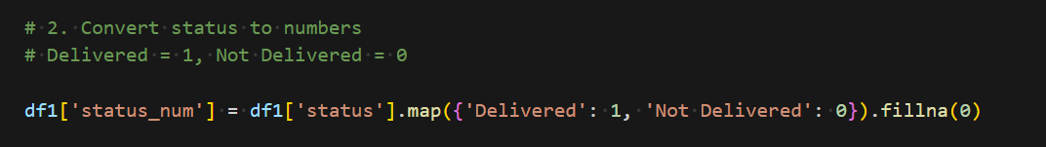

model_success = RandomForestClassifier ()
model_success.fit (X_train, y_train)
Used to analyse delivery risk.

Cell: Driver Assignment Logic
def drivers_needed(n):
return 2 if n > 80 else 1
Implements business rules.

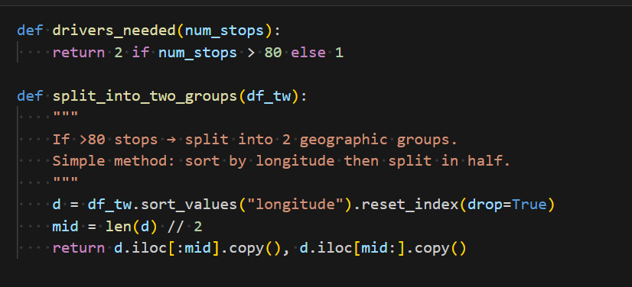

Cell: Route Optimisation Function
def optimise_single_driver (df_group, driver_id):
# OR-Tools VRP solver
...
Core optimisation logic.

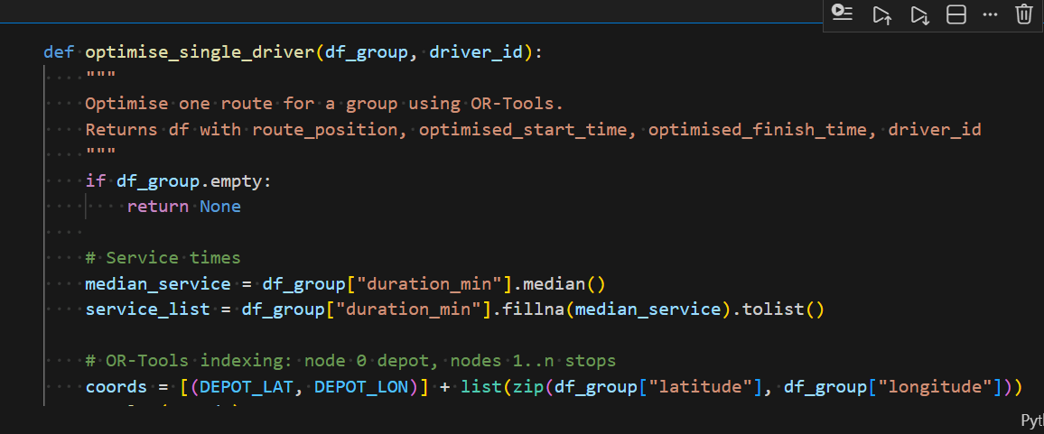

Cell: Apply Optimisation to All TW Areas
results = [ ]
warnings = [ ]

for tw in unique_tws:
...
Runs optimisation for each postcode area and driver.

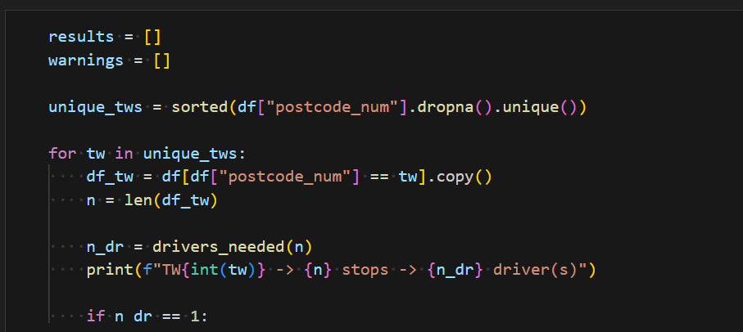

Cell: Build Schedule
# Start at 08:13
# Compute arrival and finish times
Creates full delivery timetable.

Cell: Export Optimised CSV
final.to_csv ("data_1_multi_driver_optimised.csv", index=False)

Cell: QGIS Visualisation
In QGIS:
- Load CSV as points
- Use Points to Path
- Group by driver_id
- Order by route_position

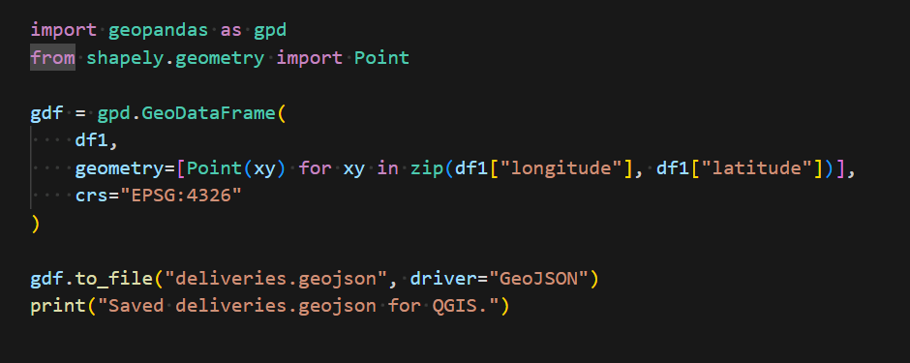

Appendix B:

B.1 Project Supporting Tables
Table B1: Dataset and Variables

Column Name | Description | Data Type
postcode | Delivery postcode | Text
postcode_num | Numeric postcode area | Integer
latitude | Delivery latitude | Float
longitude | Delivery longitude | Float
duration_min | Service time (minutes) | Integer
dist_fr_depo | Distance from depot (miles) | Float
route_position | Delivery visit order | Integer
driver_id | Assigned driver | Text
optimised_start_time | Arrival time | Time
optimised_finish_time | Finish time | Time

Table B2: Data Preparation and Feature Engineering

Procedure | Description
Postcode processing | Extracted numeric postcode areas
Duration conversion | Standardised service times to minutes
Coordinate validation | Removed rows with missing GPS data
Feature creation | Generated distance and time features

Table B3: Machine Learning Models and Metrics

Model | Purpose | Evaluation Metrics
Random Forest Regre. | Predict delivery duration | RMSE, MAE
Random Forest Classifier | Predict delivery success | Accuracy, Precision, Recall, F1, AUC

Table B4: Route Optimisation Rules

Business Rule | Value
Maximum working time | 7 hours (420 minutes)
Driver assignment | 1 driver if ≤80 stops else 2 drivers
Service area | One postcode per driver
Route start time | 08:13
Depot | Fixed location

Table B5: GIS Visualisation and Validation

Step | Description
Data import | Load optimised CSV into QGIS
Point mapping | Plot delivery locations
Route creation | Convert points to paths by visit order
Validation | Check for route continuity

Appendix C

C.1 Real Royal Mail Sample route optimsation
This project was inspired by personal experience working as a postman and using a handheld PDA device that provides optimised delivery routes.Every Sunday, the route guidance on the device shows the delivery sequence, estimated arrival times, and the most efficient paths between stops.It always impressed me how the system avoids unnecessary travel,reduces backtracking, and helps save fuel or electric charge.Obeserving how quickly and accurately the app calculates routes motived me to understand the logic behind such system, although I don’t know what software/optimisation model Royal mail uses.These real world tools demostrated how data, distance calculations, and optimisation algorithms can significantly improve delivery effiency.As a
result, this project aims to replicate and study similar optimisation techniques using open-source tools and data-driven methods. See picture on how route on Royal mail is optimised and the sequence of routes.

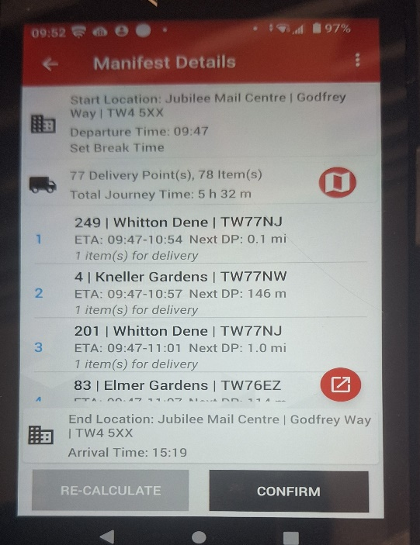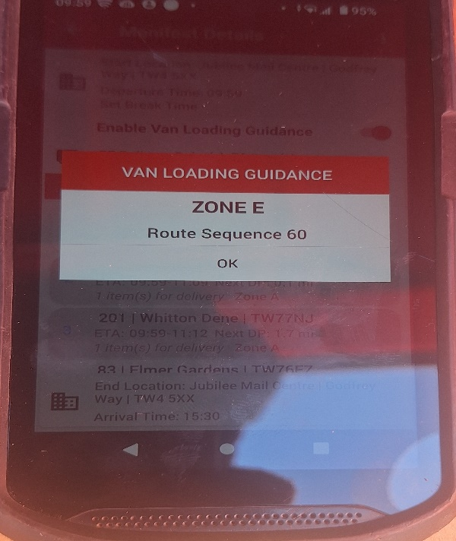

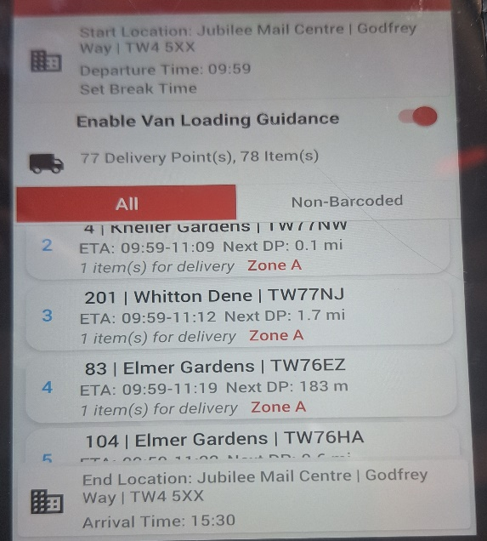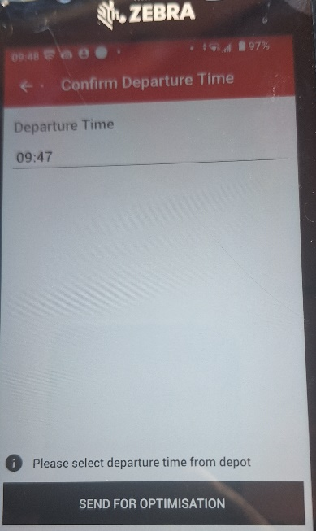

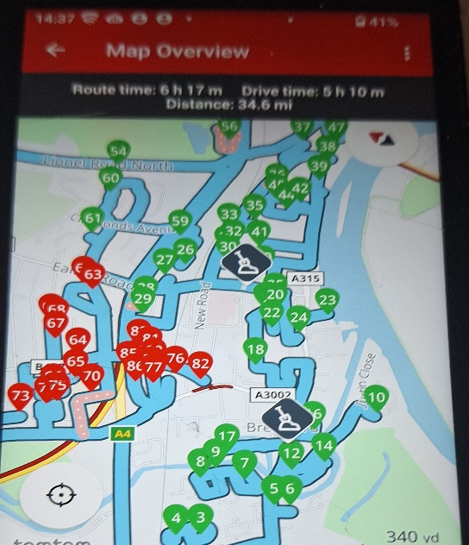
Figure 17 – Real Royal Mail Optimisation route sample

C.2: Git hub code location
link: https://github.com/Birkbeck/msc-project-source-code-files-24-25-ymogos

**********************************END**************************************

