Synaptic Architecture of the PreBötzinger Complex in the Rhythmic Slice Preparation
Yaroslav I. Molkov$​^{1,2}$, Hidehiko Koizumi$​^{3}$, and Jeffrey C. Smith$​^{3}$
$​^{1}$Department of Mathematics and Statistics, Georgia State University, Atlanta, GA, USA
$​^{2}$Neuroscience Institute, Georgia State University, Atlanta, GA, USA
$​^{3}$Cellular and Systems Neurobiology Section, National Institute of Neurological Disorders and Stroke,
National Institutes of Health, Bethesda, MD, USA
Abstract
The preBötzinger Complex (preBötC) generates the mammalian respiratory rhythm, but its core circuit architecture remains debated. While theories propose a “mutually inhibitory ring” logic, verifying this topology requires disentangling concurrent synaptic interactions in genetically defined neurons. We applied a novel conductance inference method to whole-cell recordings from VgluT2-expressing (excitatory) and VGAT-expressing (inhibitory) neurons in the rhythmic brainstem slice. We found that the core rhythmogenic kernel consists of a self-exciting inspiratory VgluT2 population coupled to a reciprocal inhibitory half-center formed by inspiratory and expiratory VGAT populations. Unlike in intact preparations, the expiratory VgluT2 population was passive, confirming its role as a conditional oscillator recruited only by metabolic demand. These results provide direct functional verification of the minimal synaptic architecture required to coordinate respiratory population activity.

Introduction
The preBötzinger Complex (preBötC) is the primary site of respiratory rhythm generation in mammals . While the intrinsic properties of preBötC neurons have been extensively characterized, understanding the network architecture—specifically how excitatory and inhibitory synaptic populations interact to generate robust rhythmicity—remains a fundamental challenge. A major hurdle has been the difficulty in disentangling concurrent excitatory and inhibitory synaptic drives during the respiratory cycle, particularly in genetically defined cell types . Crucially, this study focuses on the functional connectome and dynamic synaptic drives that coordinate population activity, rather than the intrinsic or network-level mechanisms (such as pacemaker currents) that generate the rhythm itself.
In a recent study, we developed a novel computational inference technique to decompose total synaptic conductance into its excitatory and inhibitory components using single-trace current-clamp recordings. By applying this method to the in situ arterially perfused preparation, we successfully mapped the dynamic “synaptic fingerprints” of respiratory neurons, revealing the functional connectivity between excitatory (VgluT2$​^{+}$) and inhibitory (VGAT$​^{+}$) populations that underpins the intact respiratory network.
However, the in situ preparation preserves a high degree of network complexity and external inputs. The acute brainstem slice preparation remains the gold standard for investigating the minimal, intrinsic circuitry necessary for rhythm generation. It is widely hypothesized that the slice contains a “reduced” circuit—a core kernel of the network capable of sustaining rhythmicity in the absence of wider pontine and feedback loops . Yet, identifying the precise topology of this reduced circuit and how it differs from the intact network requires rigorous quantitative analysis of synaptic interactions.
In this study, we apply our conductance inference methodology to the rhythmic slice preparation to define the core circuit architecture of the preBötC. We combined whole-cell recordings from genetically identified VgluT2-expressing glutamatergic and VGAT-expressing inhibitory neurons with computational analysis to reconstruct their dynamic synaptic inputs.
Our analysis reveals a distinct, reduced circuit topology in the slice. We identify four functional populations based on neurotransmitter identity and firing phase. Crucially, we demonstrate that while inspiratory rhythm is driven by recurrent excitation within the VgluT2 population, the phasic transitions are enforced by specific reciprocal inhibitory interactions between VGAT populations. Furthermore, we find that unlike in the intact preparation, the VgluT2-expressing expiratory population in the slice is largely passive, receiving inhibition but providing no significant synaptic drive. These findings allow us to propose a “minimal” circuit model—consisting of a self-exciting inspiratory source coupled with a half-center inhibitory oscillator—that constitutes the essential machinery for respiratory rhythm generation in vitro.

Methods

Experimental Procedures
All animal procedures were approved by the Animal Care and Use Committee of the National Institute of Neurological Disorders and Stroke (Animal Study Proposal number: 1154–21). We used the VgluT2-tdTomato mouse line (derived from Slc17a6-cre crossed with Rosa-CAG-LSL-tdTomato) to identify VgluT2-expressing glutamatergic neurons. In some experiments, VgluT2-tdTomato-ChR2-EFYP mice were used.
Rhythmically active medullary slice preparations (300–400 $μ$m thick) were obtained from neonatal (P3–P8) mice of either sex. Slices were superfused (4 ml/min) with artificial cerebrospinal fluid (ACSF) containing (in mM): 124 NaCl, 25 NaHCO$​_{3}$, 3 KCl, 1.5 CaCl$​_{2}$, 1.0 MgSO$​_{4}$, 0.5 NaH$​_{2}$PO$​_{4}$, and 30 D-glucose, equilibrated with 95% O$​_{2}$ and 5% CO$​_{2}$ (pH 7.35–7.40 at 27$​^{∘}$C). Rhythmic respiratory activity was maintained by elevating the K$​^{+}$ concentration to 8–9 mM.
Inspiratory motor output was recorded from hypoglossal (XII) nerve rootlets using fire-polished glass suction electrodes (50–100 $μ$m inner diameter). PreBötC inspiratory population activity was monitored using macro-patch recordings (150–300 $μ$m pipette tip). Signals were amplified (50,000–100,000$×$; CyberAmp 380), band-pass filtered (0.3–2 kHz), and digitized at 10 kHz (PowerLab or CED).
Whole-cell voltage- and current-clamp recordings were performed using a HEKA EPC-9 amplifier and PatchMaster software. Recording electrodes (borosilicate glass, 4–6 M$Ω$) contained (in mM): 130 K-gluconate, 5 Na-gluconate, 3 NaCl, 10 HEPES, 4 Mg-ATP, 0.3 Na-GTP, and 4 sodium phosphocreatine (pH 7.3 with KOH). Measured potentials were corrected for a liquid junction potential of –10 mV. Series resistance was compensated on-line by $∼$80%.

Data Preprocessing
Raw experimental data consisting of time series recordings of injected current ($I_{inj}(t)$), membrane potential ($V_{m}(t)$) and integrated hypoglossal nerve activity ($p(t)=∫\text{XII}(t)$) were processed to extract cycle-dependent characteristics. To reduce high-frequency noise while preserving edge information, a median filter was applied to all channels.

Cycle Detection and Phase definition
Cycles were defined based on the periodic activity observed in the control signal $p(t)$. The signal was first preprocessed and smoothed using a median filter. A robust threshold detection algorithm was employed to identify cycle onsets.
The detection threshold $θ$ was determined automatically to ensure robustness against outliers and varying background noise. We calculated the median $M=\text{median}(p)$ and the ${99}^{th}$ percentile $P_{99}$ of the signal distribution. The detection threshold was defined as the midpoint of the robust dynamic range:
$$θ=M+0.5⋅(P_{99}−M)$$
This approach effectively identifies the active phase of the cycle while ignoring high-amplitude artifacts or baseline fluctuations.
A cycle start event was defined as a rising edge crossing $θ$ (i.e., $p[i−1]<θ≤p[i]$), with the additional constraint that the signal must remain above the threshold for a minimum duration (default 10 samples) to reject transient spikes.
The phase $ϕ(t)$ was calculated linearly between consecutive cycle start times $T_{n}$ and $T_{n+1}$:
$$ϕ(t)=\frac{t−T_{n}}{T_{n+1}−T_{n}}, T_{n}≤t<T_{n+1}$$
where $t$ is the time, and $T_{n+1}−T_{n}$ represents the period of the $n$-th cycle.

Synaptic Conductance Reconstruction
To decompose the synaptic inputs into excitatory and inhibitory components, we utilized a "wedge diagram" method analogous to the technique described in previous studies . This approach relies on the current balance equation:
$$I_{inj}(t)=g_{L}(V_{m}(t)−E_{L})+g_{e}(t)(V_{m}(t)−E_{e})+g_{i}(t)(V_{m}(t)−E_{i})+C\frac{dV_{m}}{dt}$$
where $g_{L},g_{e}(t),g_{i}(t)$ are leak, excitatory, and inhibitory conductances, and $E_{L},E_{e},E_{i}$ are their respective reversal potentials. Assuming the membrane time constant $τ=C/g_{L}$ is fast relative to synaptic fluctuations ($dV_{m}/dt≈0$) and that the synaptic conductances depend on the phase of the cycle $ϕ(t)$ rather than explicitly on time (i.e., $g_{e}(t)≈g_{e}(ϕ(t))$ and $g_{i}(t)≈g_{i}(ϕ(t))$), the relationship between injected current $I_{inj}$ and membrane potential $V_{m}$ is linear at any given phase $ϕ$:
$$I_{inj}(t)≈G_{tot}(ϕ)V_{m}(t)+I_{0}(ϕ)$$
where $G_{tot}(ϕ)=g_{L}+g_{e}(ϕ)+g_{i}(ϕ)$ is the total conductance and $I_{0}(ϕ)$ represents the regression intercept (current y-intercept).
To estimate these parameters, we discretized the cycle phase $ϕ∈[0,1)$ into 1000 bins. For each phase bin, we collected all data points $(V_{m}(t_{k}),I_{inj}(t_{k}))$ where the phase $ϕ(t_{k})$ fell within that bin. A simple linear regression of $I_{inj}$ versus $V_{m}$ was performed on these points to determine the slope $G_{tot}(ϕ)$ and the intercept $I_{0}(ϕ)$ (Figure 1A).
The leak parameters ($g_{L}$ and $E_{L}$) were estimated by evaluating the total current at the reversal potentials of the synaptic currents. We calculated the theoretical currents at the inhibitory and excitatory reversal potentials for each phase:
$$\begin{aligned}Q_{i}(ϕ)&=G_{tot}(ϕ)E_{i}+I_{0}(ϕ) \\ Q_{e}(ϕ)&=G_{tot}(ϕ)E_{e}+I_{0}(ϕ)\end{aligned}$$
Since the driving force for inhibition is zero at $E_{i}$, $Q_{i}(ϕ)$ represents the sum of leak and excitatory currents. Assuming there exists a phase where excitation is minimal (zero), the maximum value of $Q_{i}(ϕ)$ corresponds to the pure leak current at $E_{i}$, denoted $I_{Li}$. Similarly, the minimum value of $Q_{e}(ϕ)$ corresponds to the leak current at $E_{e}$, denoted $I_{Le}$ (assuming zero inhibition):
$$I_{Li}=\max_{ϕ}Q_{i}(ϕ)=g_{L}(E_{i}−E_{L}), I_{Le}=\min_{ϕ}Q_{e}(ϕ)=g_{L}(E_{e}−E_{L})$$
The leak conductance $g_{L}$ and reversal potential $E_{L}$ are derived from these values:
$$g_{L}=\frac{I_{Le}−I_{Li}}{E_{e}−E_{i}}, E_{L}=E_{i}−\frac{I_{Li}}{g_{L}}$$
Finally, the excitatory and inhibitory conductances for each phase were calculated explicitly as:
$$\begin{aligned}g_{e}(ϕ)&=\frac{Q_{i}(ϕ)−I_{Li}}{E_{i}−E_{e}} \\ g_{i}(ϕ)&=\frac{Q_{e}(ϕ)−I_{Le}}{E_{e}−E_{i}}\end{aligned}$$
This method allows for the robust reconstruction of dynamic synaptic conductances from single-trace current-clamp recordings with varying injected current steps or from voltage-clamp recordings with varying voltage steps . The geometric relationship between total conductance ($G_{tot}$) and the current y-intercept ($I_{0}$) is visualized in the "wedge plot" (Figure 1B), where the trajectory is bounded by the limits of pure excitation and inhibition. The final reconstructed conductances $G_{exc}(ϕ)$ and $G_{inh}(ϕ)$ are shown in Figure 1C.
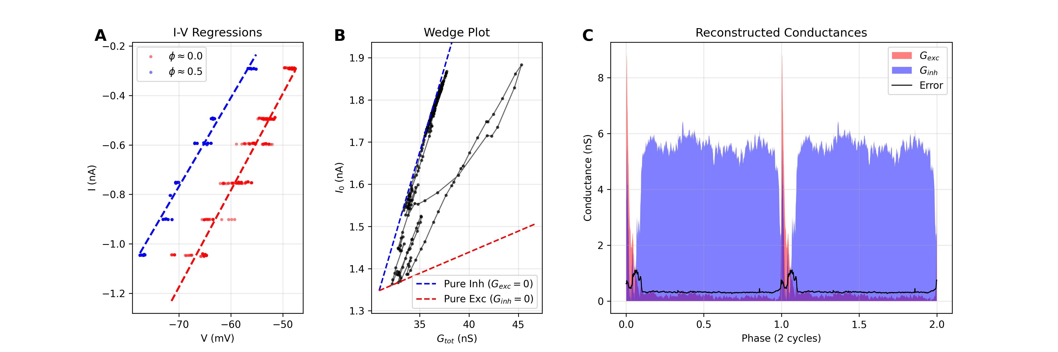
Illustration of the synaptic conductance reconstruction methodology. (A) Representative linear regressions of injected current ($I$) versus membrane potential ($V$) for two different phases of the respiratory cycle ($ϕ≈0$, red; $ϕ≈0.5$, blue). The slope corresponds to the total conductance $G_{tot}$, and the intercept represents the current y-intercept $I_{0}$. (B) "Wedge plot" showing the trajectory of the system in the $G_{tot}$ vs. $I_{0}$ plane across the respiratory cycle (black loop). Theoretical boundaries for pure excitation ($G_{inh}=0$, red dashed line) and pure inhibition ($G_{exc}=0$, blue dashed line) are determined by the leak parameters. The position of the trajectory relative to these boundaries dictates the decomposition into excitatory and inhibitory components. (C) Reconstructed time course of excitatory ($G_{exc}$, red) and inhibitory ($G_{inh}$, blue) conductances over two respiratory cycles. The black line indicates the standard error of the estimation.

Results

Synaptic Inputs Define Firing Phenotypes
We analyzed the synaptic inputs received by respiratory neurons to understand how these inputs shape their firing phenotypes. Figure 6 illustrates the inferred excitatory and inhibitory conductances for representative inspiratory and expiratory neurons, covering both excitatory (VgluT2$​^{+}$) and inhibitory (VGAT$​^{+}$) populations.
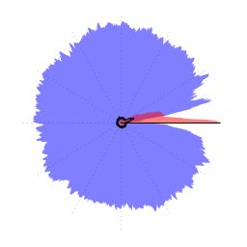  VgluT2-I | 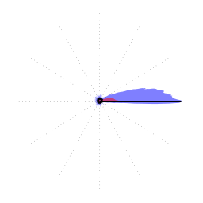  VgluT2-E | 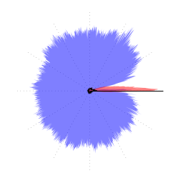  VGAT-I | 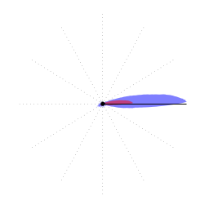  VGAT-E
Representative cells for each neurotransmitter and firing phenotype. Panels exhibit inferred synaptic conductances for different cell types: (a) VgluT2 Inspiratory, (b) VgluT2 Expiratory, (c) VGAT Inspiratory, and (d) VGAT Expiratory. VgluT2 (vesicular glutamate transporter 2) indicates excitatory (glutamatergic) neurons, while VGAT (vesicular GABA transporter) indicates inhibitory (GABAergic/glycinergic) neurons.
Inspiratory neurons (Figures 6a and 6c) consistently exhibited a specific pattern of synaptic input: they received phasic inspiratory excitation during the burst phase, concurrent with tonic expiratory inhibition during the inter-burst interval. This combination of drive and disinhibition supports their active phase during inspiration.
Conversely, expiratory neurons (Figures 6b and 6d) displayed a distinct connectivity profile. They received strong phasic inhibition during the inspiratory phase, which effectively shunted their activity during the cycle’s active phase. Notably, we encountered only a single VgluT2-expressing neuron with this expiratory firing phenotype. This rare VgluT2-E neuron, like the more numerous VGAT-E neurons, received no significant excitatory or inhibitory input during the expiratory phase, suggesting its firing is potentially intrinsic or driven by tonic baseline properties rather than specific phasic synaptic drive.
Critically, these synaptic input patterns appear to define the firing phenotype (inspiratory vs. expiratory) independent of the neuron’s own neurotransmitter identity. Both VgluT2$​^{+}$ (excitatory) and VGAT$​^{+}$ (inhibitory) neurons within the same firing class shared identical synaptic input profiles.

Inferred Circuit Connectivity
Based on these observations, we can infer the specific connectivity between these four populations (Figure 7).
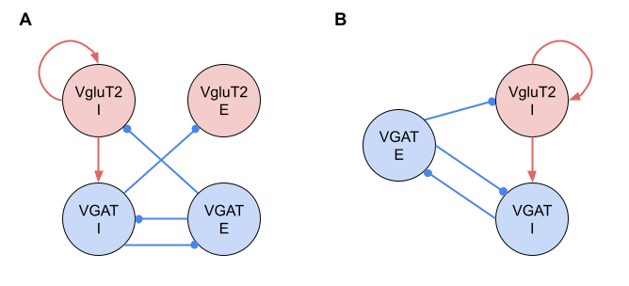
Proposed circuit diagram of preBötC connectivity inferred from synaptic conductance analysis. Red nodes/lines indicate (excitatory) components; Blue nodes/lines indicate (inhibitory) components. Arrows denote excitation; circles denote inhibition. (A) Complete connectivity graph comprising all four distinct populations defined by neurotransmitter type and firing phase. The VgluT2-I population provides recurrent and feed-forward excitatory drive (red arrows). Reciprocal inhibition (blue lines) enforces phase transitions: VGAT-I inhibits the Expiratory populations (VgluT2-E, VGAT-E) during inspiration, while VGAT-E inhibits the Inspiratory populations (VgluT2-I, VGAT-I) during expiration. Note that VgluT2-E receives phasic inhibition but does not provide significant synaptic output to other populations in this slice preparation. (B) The core rhythm-generating circuit. Excluding the non-driving VgluT2-E population highlights the essential “kernel” of the network: a self-exciting inspiratory source (VgluT2-I) coupled with a half-center oscillator formed by the mutually inhibitory VGAT-I and VGAT-E populations.
First, since all Inspiratory neurons (both VgluT2-I and VGAT-I) receive tonic inhibition during the expiratory phase, this inhibition must originate from the inhibitory population active during that phase: the VGAT-E neurons. Thus, we infer a connection from VGAT-E to both VgluT2-I and VGAT-I. Second, Expiratory neurons (VgluT2-E and VGAT-E) receive strong inhibition during the inspiratory phase. This inhibition must similarly arise from the inhibitory population active during inspiration: the VGAT-I neurons. This indicates a connection from VGAT-I to both VgluT2-E and VGAT-E. Third, the phasic excitation received by all Inspiratory neurons during their active phase must be driven by the excitatory population active at that time: the VgluT2-I neurons. This implies that VgluT2-I neurons provide recurrent excitation to themselves and feed-forward excitation to the VGAT-I population. Finally, the lack of significant synaptic drive received by Expiratory neurons during their active phase specifically excludes strong recurrent excitation within the VgluT2-E population or from VgluT2-E to VGAT-E in this slice preparation.

Discussion

The Core Rhythm-Generating Kernel in Reduced Preparations
The circuit topology we inferred for the rhythmic slice preparation (Figure 7B) represents a “reduced” version of the comprehensive respiratory network architecture previously described in computational reviews and modeling studies of the intact system . By isolating the essential components remaining in the slice, our conductance analysis bridges the gap between the complex, multi-compartmental models of the intact brainstem and the minimal logic required for rhythm generation.

Mapping the Slice Topology to the Intact Inhibitory Ring
Previous large-scale computational models have posited that the respiratory rhythm relies on a “mutually inhibitory ring” structure involving interactions between the Pre-BötC and BötC compartments. Specifically, these models suggest that the phase transitions are orchestrated by reciprocal inhibition between inspiratory (Early-I) and expiratory (Post-I/Aug-E) inhibitory populations.
Our results in the slice (Figure 7B) provide direct functional verification of this theoretical motif. The interaction we observed between VGAT-I (Inspiratory) and VGAT-E (Expiratory) neurons perfectly maps onto the core “half-center” oscillator proposed in the literature:
- VGAT-I corresponds to the Early-I population, which is driven by excitatory inspiratory neurons and provides inhibition during the inspiratory phase.
- VGAT-E corresponds to the lumped activity of Post-I and Aug-E populations, which enforce the expiratory pause through inhibition of inspiratory elements.
The persistence of this reciprocal inhibitory loop in the slice confirms that the “inhibitory ring” is not merely an emergent property of the intact system but is hard-wired into the local microcircuitry of the Pre-BötC and BötC, serving as the fundamental timing mechanism even in reduced preparations . As recently elaborated by , this local circuit likely represents a scalable logic: in the intact brainstem, the single “lumped” VGAT-E population identified here differentiates into distinct Post-I and Aug-E populations to allow for finer control of expiratory duration and phase transitions.

Synaptic Coordination and Global Architecture
Our results highlight the primacy of synaptic architecture in coordinating population activity. Rather than serving merely as a trigger for rhythm generation, the strong recurrent excitation within the VgluT2-I population acts as a synchronization mechanism, ensuring coherent network-wide output once the burst is initiated. Indeed, the high excitation-to-inhibition ratio we inferred for these neurons constitutes a “synaptic fingerprint” that allows for the identification of this critical Dbx1-derived “rich-club” across preparations .
Crucially, the interaction between VGAT-I and VGAT-E forms a “synaptic scaffold” that enforces phase-locking and defines the inter-burst interval. This local inhibitory circuit represents a modular building block for the global “inhibitory ring” described in intact systems, where the “lumped” VGAT-E population expands to coordinate diverse behaviors . Within this functional connectome, the VgluT2-E population exists as a “latent” node—functionally passive in the slice but structurally hard-wired to participate when recruited by metabolic demand, consistent with the Triple Oscillator Hypothesis . Finally, this robust inhibitory scaffold provides a stable temporal lattice that may serve as a global clock for synchronizing higher-order non-respiratory functions, from whisking to memory consolidation .

Conclusion
The inferred circuit (Figure 7B) effectively strips away the “conditional” layers of the respiratory network—such as the active expiratory oscillator and long-loop pontine feedback—to reveal the minimal rhythmogenic structure. This structure consists of a self-exciting inspiratory pacemaker (VgluT2-I, analogous to Pre-I/I) constrained by a robust, reciprocal inhibitory scaffold (VGAT-I $↔$ VGAT-E). This confirms that the theoretical “core microcircuit” proposed in previous modeling studies is physically instantiated in the local synaptic architecture of the ventrolateral medulla, providing the necessary timing mechanism for rhythmic coordination.

