Standalone Methods Draft:
Functional Synaptic Interactions and Inhibitory Circuitry of the PreBötzinger Complex in the Rhythmic Slice

Methods

Animals, slice preparation, and cell targeting
All animal procedures were approved by the Animal Care and Use Committee of the National Institute of Neurological Disorders and Stroke (Animal Study Proposal 1154–21). Experiments were performed on neonatal (postnatal day 3–8) mice of either sex in rhythmically active medullary slice preparations, as described previously for genetically identified preBötC neurons in reduced respiratory preparations (Koizumi et al. 2013; Ausborn et al. 2018). Excitatory neurons were targeted in Slc17a6-Cre;Rosa-tdTomato mice (referred to here as VgluT2-tdTomato mice), and inhibitory neurons were targeted in VGAT-Cre;Rosa-tdTomato mice (VGAT-tdTomato mice). TdTomato-positive neurons in the preBötC were identified by live fluorescence imaging and targeted for whole-cell recording.
Rhythmically active slices (300–400 $μ$m) were superfused at 4 ml/min with artificial cerebrospinal fluid containing (in mM): 124 NaCl, 25 NaHCO$​_{3}$, 3 KCl, 1.5 CaCl$​_{2}$, 1.0 MgSO$​_{4}$, 0.5 NaH$​_{2}$PO$​_{4}$, and 30 D-glucose, equilibrated with 95% O$​_{2}$/5% CO$​_{2}$ (pH 7.35–7.40, 27$​^{∘}$C). Rhythmic respiratory activity was maintained by elevating extracellular K$​^{+}$ to 8–9 mM. Inspiratory motor output was monitored from hypoglossal (XII) rootlets with suction electrodes, amplified 50,000–100,000$×$, band-pass filtered at 0.3–2 kHz, and digitized at 10 kHz.
Optical targeting was performed with a Leica TCS SP5 II MP upright microscope equipped with a 20$×$ water-immersion objective (NA 1.0) and a Ti:Sapphire laser (800–880 nm) for two-photon fluorescence imaging. Whole-cell current-clamp and voltage-clamp recordings were obtained with a HEKA EPC-9 amplifier using borosilicate electrodes (4–6 M$Ω$) filled with (in mM): 130 K-gluconate, 5 Na-gluconate, 3 NaCl, 10 HEPES, 4 Mg-ATP, 0.3 Na-GTP, and 4 sodium phosphocreatine, adjusted to pH 7.3 with KOH. Measured voltages were corrected for a $−10$ mV liquid-junction potential. Series resistance was compensated online by approximately 80% and adjusted during the recording. Voltage-clamp recordings with obvious space-clamp failure were excluded before quantitative analysis.

Recording inventory, acquisition modes, and acceptance screening
The repository contains 59 analyzed slice recordings spanning four phenotype groups: VgluT2 inspiratory (VgluT2-I), VgluT2 expiratory (VgluT2-E), VGAT inspiratory (VGAT-I), and VGAT expiratory (VGAT-E). Recordings were acquired in both current clamp (C) and voltage clamp (V), although not every cell was represented in both modes. Raw electrophysiological and XII signals were originally digitized at 10 kHz and then downsampled to 1 kHz for the exported analysis files used in this repository. This downsampling preserved the slower respiratory-cycle modulation, the stepwise command epochs, and the phase-binned current–voltage relationships used for conductance inference; reconstruction of the detailed spike waveform was not required for the analysis. Each exported trace contained four aligned columns: time, current channel, voltage channel, and integrated XII activity. In current clamp, the current and voltage channels corresponded to injected current and membrane potential, respectively; in voltage clamp, they corresponded to measured holding current and command voltage.
Because the slice recordings were more heterogeneous than the higher-quality data analyzed in the companion in situ study of Molkov et al. (2025), we did not impose strict requirements on the number of current or voltage steps per file or on the total command span covered by a given recording. Instead, we used an inclusive recording-level screen and then applied robust outlier filtering only after conductance reconstruction. The only hard acceptance criterion for inclusion in the population summaries was that the analyzed segment contain more than 25 detected XII cycles. This yielded 50 accepted recordings (27 current clamp, 23 voltage clamp): 20 VgluT2-I, 12 VGAT-I, 17 VGAT-E, and 1 VgluT2-E recording (Table 1).
Table 1. Recording inventory in the repository and after automated cycle-count screening.
Population | Candidate files | Accepted files | Accepted C | Accepted V
VgluT2-I | 23 | 20 | 12 | 8
VgluT2-E | 2 | 1 | 1 | 0
VGAT-I | 17 | 12 | 6 | 6
VGAT-E | 17 | 17 | 8 | 9
Total | 59 | 50 | 27 | 23
The command protocols used for conductance inference consisted of piecewise-constant current steps in current clamp and piecewise-constant holding-voltage steps in voltage clamp (Figure 1). A representative current-clamp/voltage-clamp pair from the same VgluT2-I neuron is shown to make the stepped acquisition strategy explicit, because this feature is not obvious from the conductance-reconstruction figure alone.
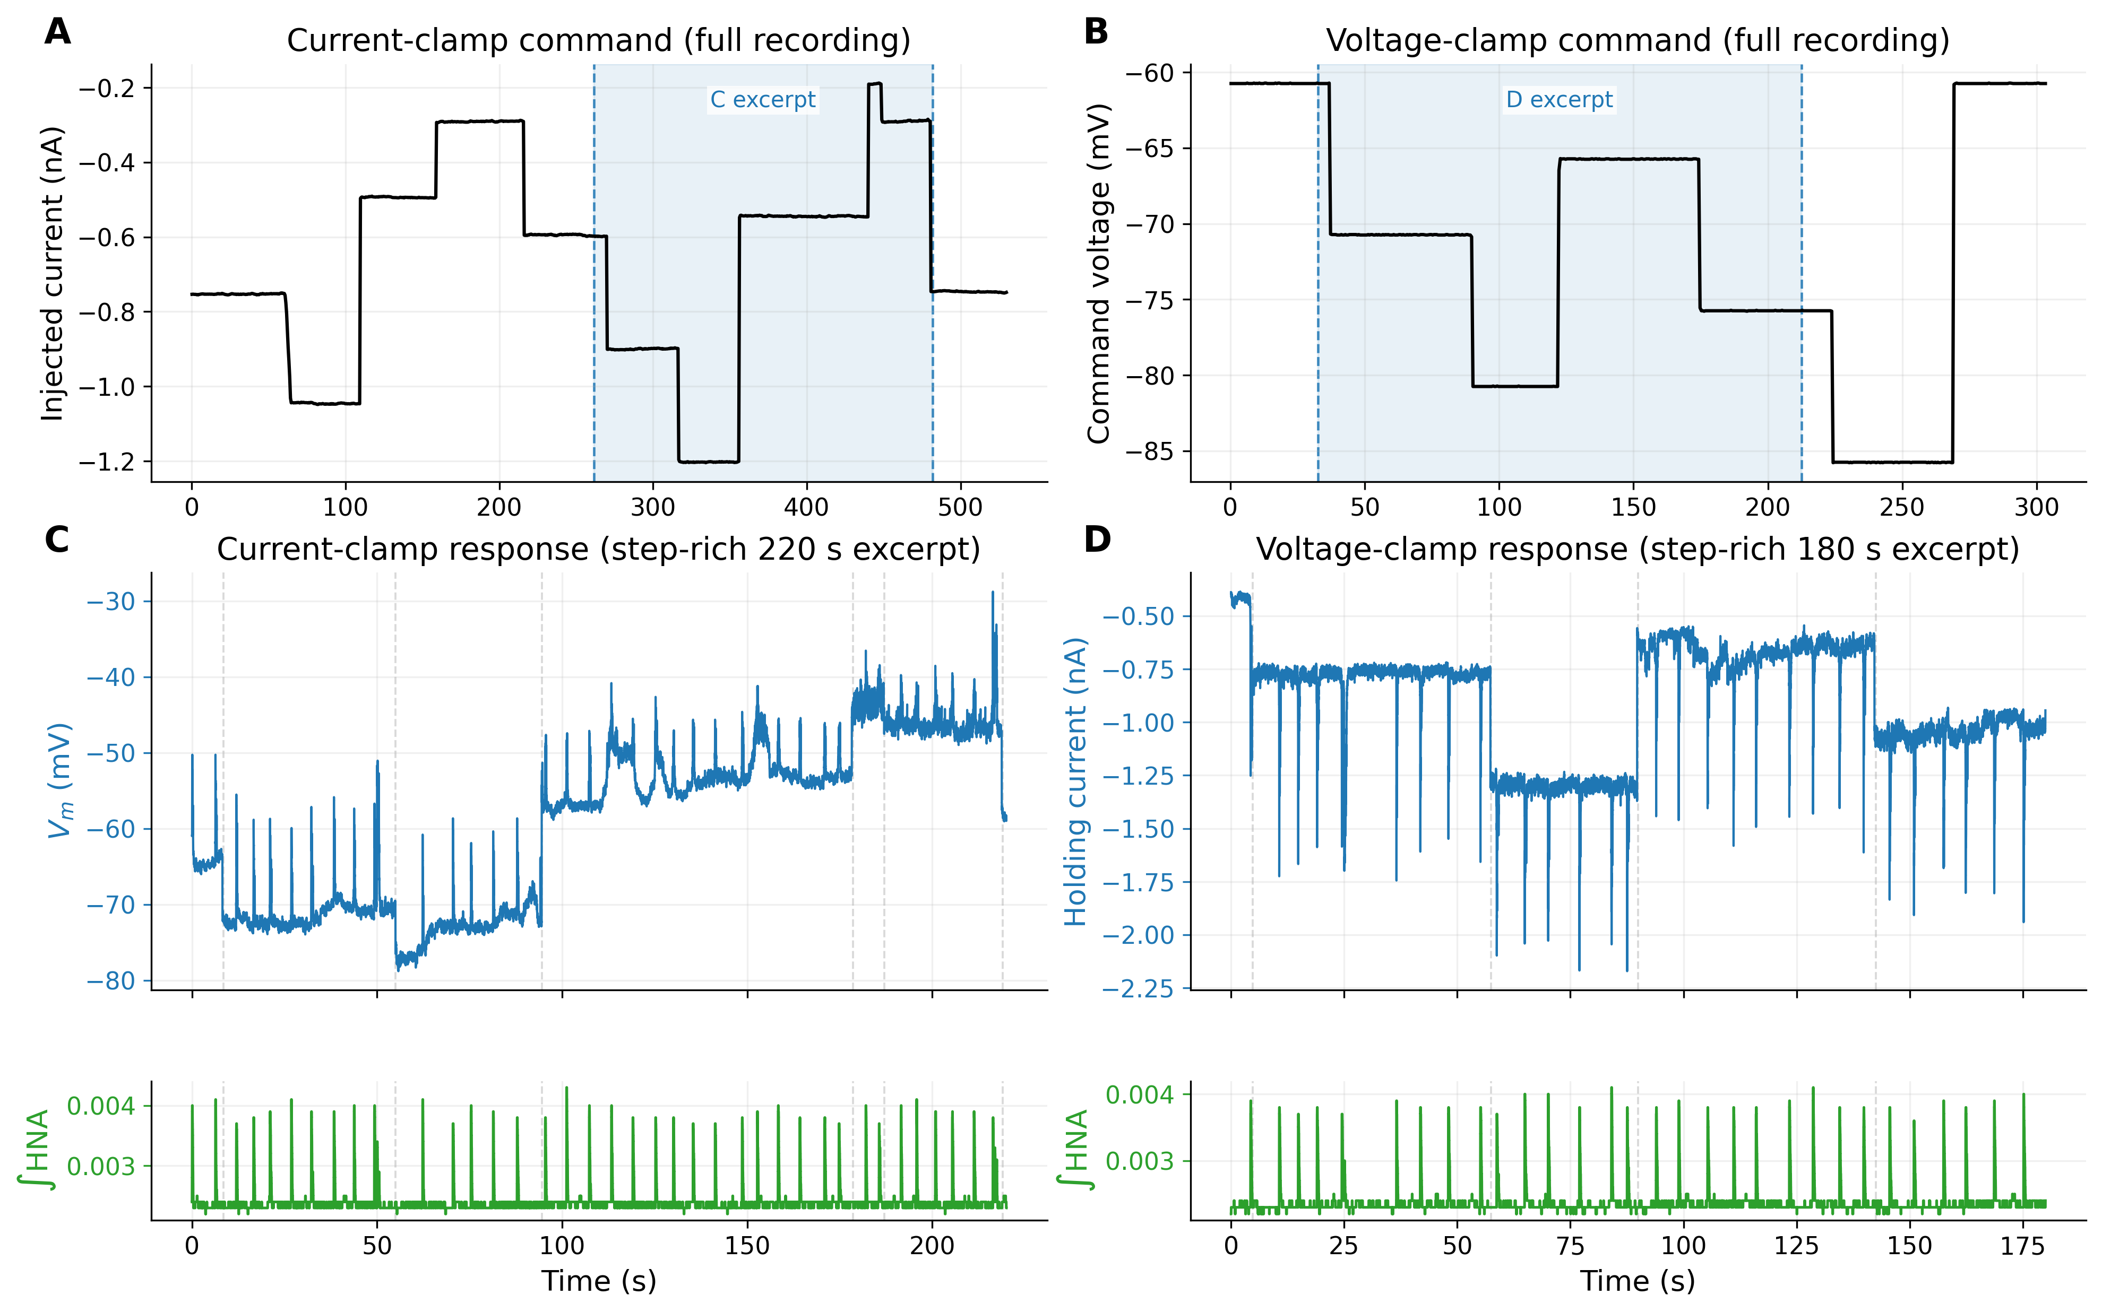
Figure 1. Representative stepped acquisition protocols used for conductance inference. A, full current-clamp command trace for VgluT2-I-Cell2-C, shown after coarse median smoothing to highlight the piecewise-constant current injections; the blue shaded interval marks the segment expanded in panel C. B, full voltage-clamp command trace for the matched recording VgluT2-I-Cell2-V; the blue shaded interval marks the segment expanded in panel D. C–D, longer step-rich excerpts selected automatically from later portions of the same two recordings; the response channel is plotted in the upper lane (membrane potential in current clamp, holding current in voltage clamp) and the integrated XII reference is plotted separately in the lower lane. Gray dashed lines mark command transitions that fall inside the excerpt. The full command traces were used to sample a range of current–voltage operating points across many respiratory cycles.

Manual curation and preprocessing of analyzed segments
Several recordings required limited manual curation before automated inference. Specifically, some files were trimmed at the beginning or end to isolate the longest reasonably stationary interval and to exclude obvious initial transients or late drifts. In the current repository version, 6 accepted recordings used a non-zero starting offset and 6 used an explicit end truncation. These edits were intentionally conservative and were applied before any conductance estimates were calculated.
All signal processing was then automated. The current and voltage channels were median-filtered with a per-file half-width defined in the analysis configuration (default 25 samples, corresponding to a 51-sample window). The XII reference signal was optionally combined with the electrophysiological channel when the rootlet signal alone was too weak or unstable to give reliable cycle onsets. In those cases, the reference channel was converted to a local z-score and linearly combined with a local z-score of the membrane-potential channel (current clamp) or the current channel (voltage clamp):
$$p_{mix}(t)=z​\left[p(t)\right]+s z​\left[y(t)\right],$$
where $p(t)$ is the integrated XII signal, $y(t)$ is the auxiliary electrophysiological channel, and $s=±1$ was chosen empirically to align the sign of the auxiliary signal with inspiratory onset. Local means and standard deviations were computed in a sliding window (typically 2000 samples). Among the 50 accepted recordings, 6 used this mixed trigger signal and 12 used a broader median post-filter on the final reference trace than the default setting.

Cycle detection and phase normalization
Respiratory phase was derived from the processed XII reference trace. Let $p(t)$ denote the final reference signal after optional mixing and median filtering. The detection threshold was chosen automatically from the median and robust peak amplitude of the full trace:
$$θ=M+0.5\left(P_{99}−M\right),$$
where $M=median(p)$ and $P_{99}$ is the 99th percentile of $p$. A cycle onset $T_{n}$ was defined as a rising threshold crossing, $p[i−1]<θ≤p[i]$, that remained above threshold for at least 10 consecutive samples. Crossing time was linearly interpolated between the two bracketing samples. Successive onsets were required to be at least 2 s apart to avoid double-counting within the same inspiratory burst.
Phase was then normalized linearly between successive accepted onsets:
$$ϕ(t)=\frac{t−T_{n}}{T_{n+1}−T_{n}}, T_{n}≤t<T_{n+1}.$$
Thus, $ϕ=0$ corresponds to XII burst onset, and $ϕ∈[0,1)$ indexes the respiratory cycle independently of its absolute duration.

Phase-binned current–voltage regression
Conductance inference followed the phase-domain method introduced in the companion in situ study of Molkov et al. (2025). We write the membrane-current balance as
$$I(t)=g_{L}​\left(V(t)−E_{L}\right)+g_{e}(t)​\left(V(t)−E_{e}\right)+g_{i}(t)​\left(V(t)−E_{i}\right)+C\frac{dV}{dt},$$
where $I(t)$ is the current channel, $V(t)$ is the voltage channel, $g_{L}$ and $E_{L}$ are the effective leak conductance and reversal potential, $g_{e}$ and $g_{i}$ are the phase-dependent excitatory and inhibitory conductances, and $E_{e}$ and $E_{i}$ are their reversal potentials. In this formulation, $g_{L}$ and $E_{L}$ absorb both intrinsic leak and any approximately tonic background synaptic drive, allowing the dynamic respiratory modulation to be isolated in $g_{e}(ϕ)$ and $g_{i}(ϕ)$.
Assuming that synaptic conductances vary primarily with respiratory phase and that the capacitive term is small relative to the synaptic terms on this time scale, Equation 4 reduces within each phase bin to a linear current–voltage relation,
$$I(t)≈G_{tot}(ϕ) V(t)+I_{0}(ϕ),$$
where $G_{tot}(ϕ)=g_{L}+g_{e}(ϕ)+g_{i}(ϕ)$ and $I_{0}(ϕ)$ is the phase-specific intercept.
The normalized cycle was discretized into 1000 phase bins. For each bin, all samples whose phases fell inside that bin were pooled across the analyzed segment. If more than two points were available, an initial linear regression was fitted and residuals were computed. Points with residual magnitude greater than 2.5 standard deviations were excluded, and the regression was recomputed on the retained points. Bins with fewer than three retained points were discarded.
The implementation differed slightly between acquisition modes to improve numerical stability while preserving the same $I$–$V$ output. In voltage clamp, the final regression was fitted directly as $I=aV+b$, so the slope and intercept were simply $G_{tot}=a$ and $I_{0}=b$. In current clamp, the second-pass fit was performed as $V=αI+β$, then algebraically transformed back to
$$G_{tot}=\frac{1}{α}, I_{0}=−\frac{β}{α}.$$
This avoids fitting a nearly vertical $I$–$V$ relation in recordings where the injected current is the more naturally discretized variable.

Leak estimation and decomposition into excitation and inhibition
For each valid phase bin, the fitted current–voltage relation defines the total conductance and intercept trajectory shown in Figure 2. The current expected at the inhibitory and excitatory reversal potentials is
$$\begin{aligned}Q_{i}(ϕ)&=G_{tot}(ϕ)E_{i}+I_{0}(ϕ), \\ Q_{e}(ϕ)&=G_{tot}(ϕ)E_{e}+I_{0}(ϕ).\end{aligned}$$
Assuming that each recording contains at least one phase at which excitation is minimal and one phase at which inhibition is minimal, the leak-only currents at the inhibitory and excitatory reversal potentials are estimated as
$$I_{Li}=\max_{ϕ}Q_{i}(ϕ), I_{Le}=\min_{ϕ}Q_{e}(ϕ).$$
These values give the effective leak parameters
$$g_{L}=\frac{I_{Le}−I_{Li}}{E_{e}−E_{i}}, E_{L}=E_{i}−\frac{I_{Li}}{g_{L}}.$$
Excitatory and inhibitory conductances are then recovered as
$$\begin{aligned}g_{e}(ϕ)&=\frac{Q_{i}(ϕ)−I_{Li}}{E_{i}−E_{e}}, \\ g_{i}(ϕ)&=\frac{Q_{e}(ϕ)−I_{Le}}{E_{e}−E_{i}}.\end{aligned}$$
For reporting and plotting, conductances were normalized by the effective leak conductance $g_{L}$, so all population summaries are expressed as $G_{exc}/g_{leak}$ and $G_{inh}/g_{leak}$.
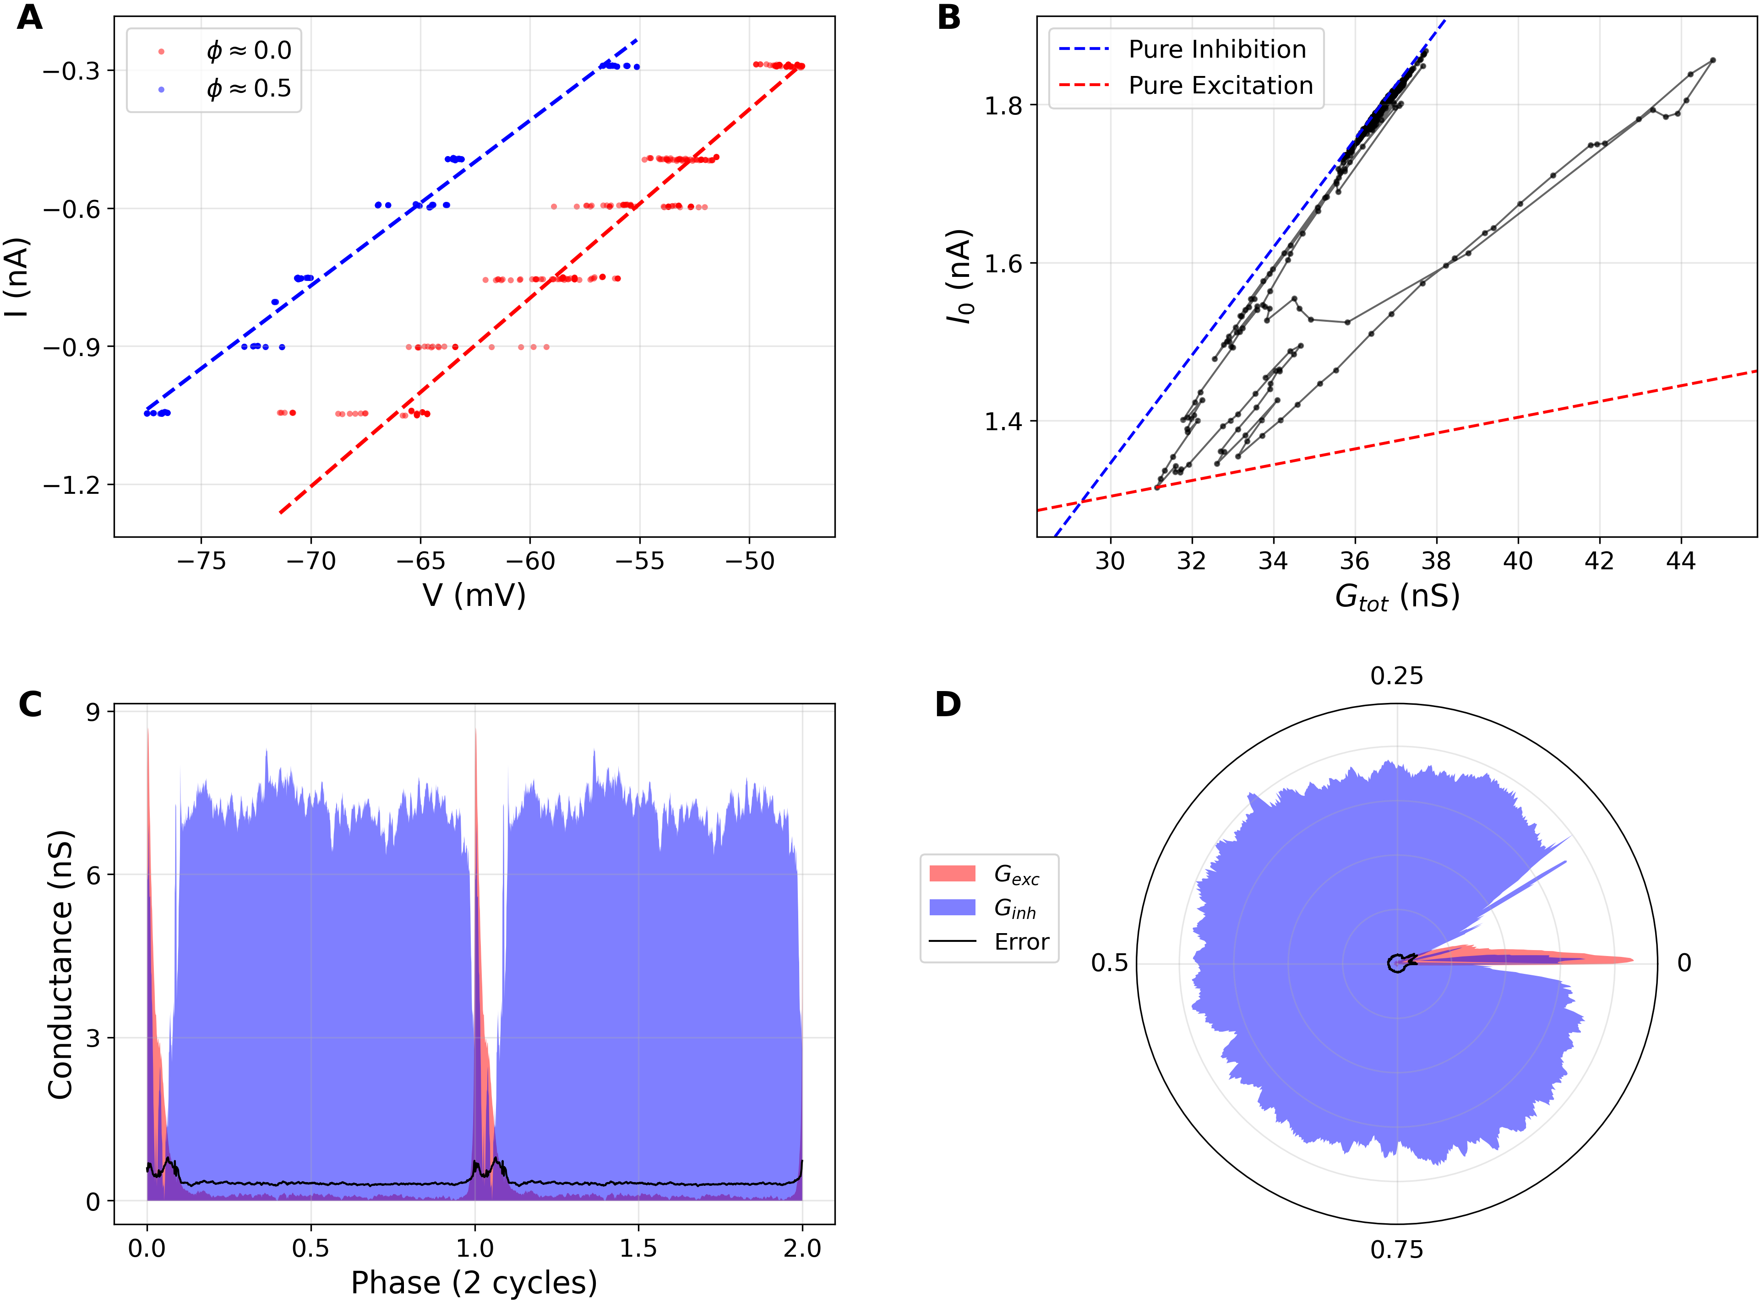
Figure 2. Geometric conductance inference workflow. A, representative phase-binned $I$–$V$ regressions for two phases of the respiratory cycle. B, wedge plot formed by the trajectory of $(G_{tot},I_{0})$ across the cycle, bounded by the theoretical pure-excitation and pure-inhibition lines. C, reconstructed excitatory and inhibitory conductances across two normalized cycles. D, the same conductances shown in polar coordinates over one normalized cycle.

Data-driven estimation of inhibitory reversal potential
The conductance decomposition depends critically on the inhibitory reversal potential, so treating $E_{i}$ as a single fixed constant would force every recording to obey the same inhibitory geometry. Instead, we estimated $E_{i}$ separately for each recording from the wedge plot formed by the phase-binned regression outputs $(G_{tot}(ϕ),I_{0}(ϕ))$.
Figure 2B illustrates the logic of this estimate. Each point on the black trajectory corresponds to one respiratory phase bin in the $(G_{tot},I_{0})$ plane. The blue dashed line is the pure-inhibition boundary, and the red dashed line is the pure-excitation boundary. If a phase contains inhibition with negligible excitation, its point lies on the blue boundary. Adding excitation moves the point into the interior of the wedge, away from that boundary, but cannot move it above the blue line because excitatory conductance is constrained to remain nonnegative. The upper envelope of the trajectory in Figure 2B therefore reflects inhibition alone. Because the slope of that upper boundary is set by $−E_{i}$, the wedge geometry provides a direct recording-specific estimate of inhibitory reversal potential before excitatory and inhibitory conductances are separated.
In practice, after the robust phase-binned $I$–$V$ regressions were computed, the analyzer searched for the tightest line that remained a global upper bound of all valid wedge points and took its slope as the recording-specific value of $−E_{i}$. The resulting $E_{i}$ was then used in the subsequent conductance decomposition for that recording. The analyzer was initialized with $E_{e}=−10$ mV and an initial inhibitory guess of $E_{i}=−80$ mV; if too few valid regression points were available to define a reliable boundary, the supplied inhibitory value was retained rather than forcing a geometric estimate. In the accepted data set, however, the automatic estimate was applied to all 50 included recordings. This recording-specific procedure prevented the decomposition from depending on a single assumed inhibitory reversal potential and ensured that each inferred wedge remained internally consistent with the geometry of its own regression cloud.

Definition of inspiratory and expiratory summary metrics
The per-bin conductance traces were next reduced to scalar metrics for population analysis. First, the medians of $G_{inh}(ϕ)$ and $G_{exc}(ϕ)$ across all valid bins were computed, together with median absolute deviations scaled to a 3$σ$-equivalent threshold. Any phase bin whose inhibitory or excitatory conductance lay outside this robust threshold was marked as belonging to a transient interval. The longest consecutive transient chain on the circular phase axis was then identified as the phasic respiratory event, and the complementary bins were treated as the stationary interval.
For each recording, the analyzer exported (i) the mean inhibitory and excitatory conductances over the stationary interval and (ii) the conductances in phase bin 0. Because the phase axis was reset at XII burst onset, the phase-0 conductances were used as the inspiratory summary metric, whereas the stationary-interval means were used as the expiratory/interburst metric for the bar plots and summary tables generated in this repository.

Population statistics and outlier handling
Population summaries were produced separately for VgluT2-I, VgluT2-E, VGAT-I, and VGAT-E recordings. After the cycle-count screen, one row per accepted recording was written to a group-specific CSV file containing the stationary means and phase-0 conductances. Outlier handling was deliberately postponed to this stage rather than applied as a strict recording-level exclusion rule.
For each group and each scalar metric, quartiles were computed across recordings, the interquartile range was defined as $IQR=Q_{3}−Q_{1}$, and recordings outside the standard Tukey interval
$$\left[Q_{1}−1.5 IQR, Q_{3}+1.5 IQR\right]$$
were labeled as outliers. Mean and SEM were then recomputed from the retained inliers only. Outliers were still displayed in the summary figure as separate markers but were not included in the reported group means or SEM values. This two-stage strategy was adopted because the slice data set contains recordings with limited command span or weaker reference signals that would be lost under rigid step-count criteria even though their reconstructed conductances fall well within the physiological distribution of the corresponding population.

Software implementation
All analyses in this repository are reproducible from the project Makefile. Conductance inference is implemented in src/trace_analyzer.cpp; phase aggregation, outlier filtering, table generation, and figure production are handled by the Python scripts in scripts/. The standalone methods draft presented here is therefore synchronized with the actual analysis code rather than being a prose-only summary of a previous manuscript version.

References
Ausborn, Jessica, Hidehiko Koizumi, William H Barnett, et al. 2018. “Organization of the Core Respiratory Network: Insights from Optogenetic and Modeling Studies.” PLoS Computational Biology 14 (4): e1006148. https://doi.org/10.1371/journal.pcbi.1006148.
Koizumi, Hidehiko, Naohiro Koshiya, Justine X Chia, et al. 2013. “Structural-Functional Properties of Identified Excitatory and Inhibitory Interneurons Within Pre-bötzinger Complex Respiratory Microcircuits.” Journal of Neuroscience 33 (7): 2994–3009. https://doi.org/10.1523/JNEUROSCI.4427-12.2013.
Molkov, Yaroslav I, Anke Borgmann, Hidehiko Koizumi, Noriyuki Hama, Ruli Zhang, and Jeffrey C Smith. 2025. “Inference Technique for the Synaptic Conductances in Rhythmically Active Networks and Application to Respiratory Central Pattern Generation Circuits.” eLife 13: RP101959. https://doi.org/10.7554/eLife.101959.1.

