Validation Report
Name: Ong Yung Meng
Validated IP: FIR Filter

TC# | Name
1 | Global enable/disable
2 | POR register values
3 | Input buffer overflow and clearing
4 | Filter bypassing
5 | Signal processing

Instance 1 (impl0)

TC# | Description | Pass/Fail
1 | CSR access blocked when disabled and restored when enabled. | PASS
2 |  | FAIL
  POR register values after reset do not match por.csv; mismatched fields: csr.sts, csr.rnd, coef.c1, coef.c2, outcap.hcap, outcap.lcap
3 | Input buffer counts 10 samples, overflows at 255, and clears correctly. | PASS
4 | Bypass mode successfully relays input to output | PASS
5 | Sample 0 mismatch: golden=0x18, impl0=0x38; likely wrong calculation or encoding. | FAIL

Instance 2 (impl1)

TC# | Description | Pass/Fail
1 | CSR access still allowed when disabled (global enable not enforced). | FAIL
2 |  | PASS
  POR register values after reset match por.csv
3 | Input buffer counts 10 samples, overflows at 255, and clears correctly. | PASS
4 | Bypass mode successfully relays input to output | PASS
5 | Sample 0 mismatch: golden=0x18, impl1=0x0; output completely incorrect, possible initialization or input handling issue. | FAIL

Instance 3 (impl2)

TC# | Description | Pass/Fail
1 | CSR access blocked when disabled and restored when enabled. | PASS
2 | POR register values after reset do not match por.csv; mismatched fields: csr.sts, csr.ibcnt, csr.ibovf, coef.c1, coef.c2 | FAIL
3 | Input buffer count mismatch (expected 10, got 255) and clear failed. | FAIL
4 | Bypass mode successfully relays input to output | PASS
5 | All samples match golden model or fall within acceptable tolerance. | PASS

Instance 4 (impl3)

TC# | Description | Pass/Fail
1 | CSR access blocked when disabled and restored when enabled. | PASS
2 | POR register values after reset do not match por.csv; mismatched fields: csr.sts, coef.c1, coef.c2 | FAIL
3 | Overflow flag not set when buffer reaches 255. | FAIL
4 | Bypass mode successfully relays input to output | PASS
5 | All samples match golden model or fall within acceptable tolerance. | PASS

Instance 5 (impl4)

TC# | Description | Pass/Fail
1 | CSR access blocked when disabled and restored when enabled. | PASS
2 | POR register values after reset do not match por.csv; mismatched fields: csr.sts, coef.c1, coef.c2 | FAIL
3 | Input buffer counts 10 samples, overflows at 255, and clears correctly. | PASS
4 | Bypass mode successfully relays input to output | PASS
5 | All samples match golden model or fall within acceptable tolerance. | PASS

Instance 6 (impl5)

TC# | Description | Pass/Fail
1 | CSR access blocked when disabled and restored when enabled. | PASS
2 | POR register values after reset do not match por.csv; mismatched fields: csr.sts, csr.rnd, coef.c1, coef.c2, outcap.hcap, outcap.lcap | FAIL
3 | Overflow behavior incorrect (ibcnt=255, ibovf=0) | FAIL
4 | Bypass mode successfully relays input to output | PASS
5 | Sample 0 mismatch: golden=0x18, impl5=0x38; first output encoded incorrectly, verbose logging shows all outputs. | FAIL

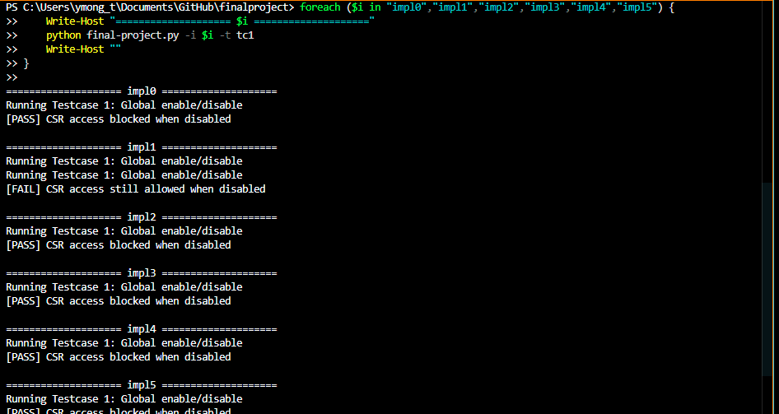
TC1 Test Result

foreach ($i in "impl0","impl1","impl2","impl3","impl4","impl5") {
Write-Host "==================== $i ===================="
python final-project py -i $i -t tc1
Write-Host ""
}

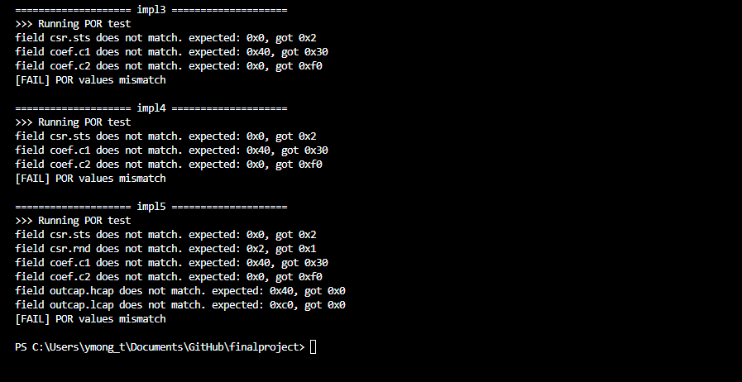
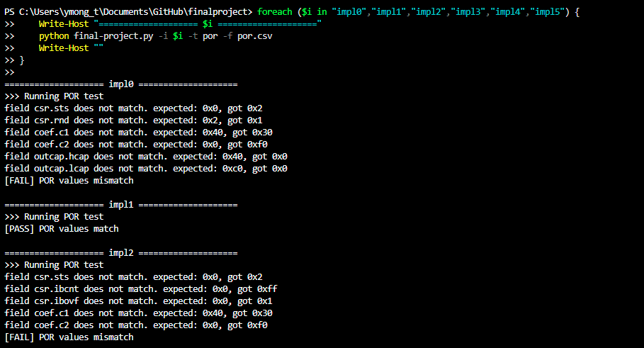
TC2 Test Result
foreach ($i in "impl0","impl1","impl2","impl3","impl4","impl5") {
>> Write-Host "==================== $i ===================="
>> python final-project.py -i $i -t por -f por.csv
>> Write-Host ""
>> }

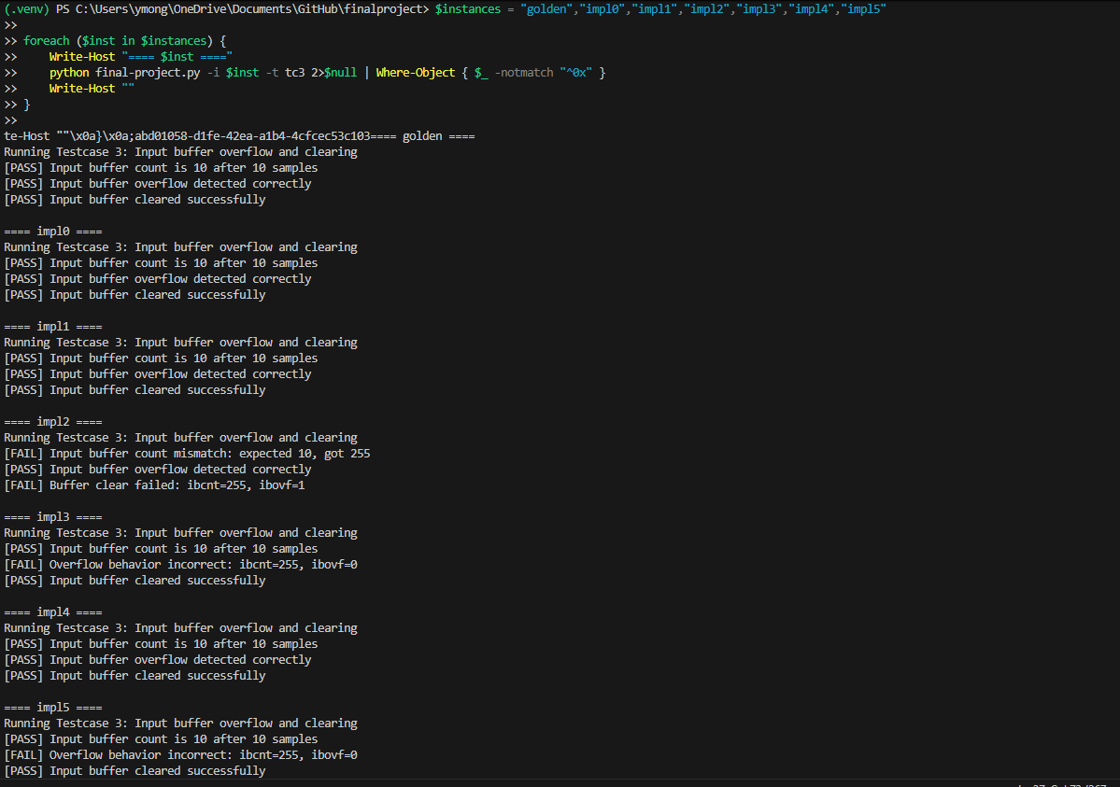
TC3 Test Result

foreach ($i in "impl0","impl1","impl2","impl3","impl4","impl5") {
Write-Host "==================== $i ===================="
python final-project.py -i $i -t tc3
Write-Host ""
}

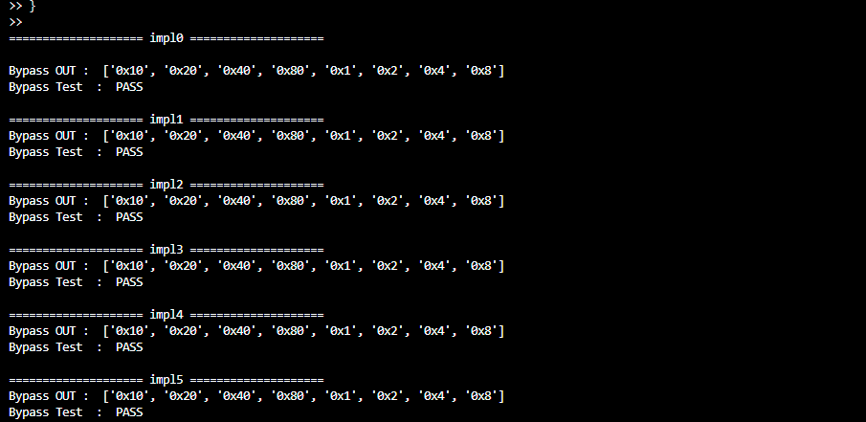
TC4 Test Result
foreach ($i in "impl0","impl1","impl2","impl3","impl4","impl5") {
>> Write-Host "==================== $i ===================="
>>
>> # Run TC4 but only print the essential bypass info
>> python .\final-project.py -i $i -t tc4 | Select-String "Bypass OUT|Bypass Test"
>>
>> Write-Host ""
>> }

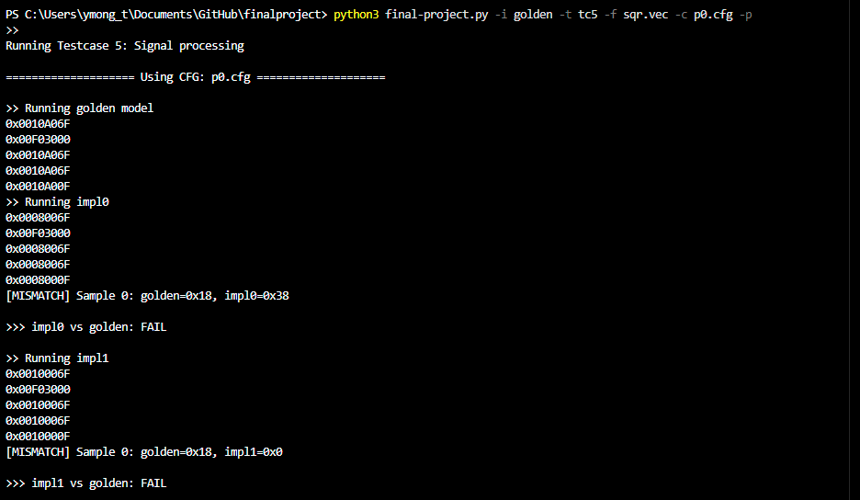
TC5 Test Result
(For p0.cfg only)
python3 final-project.py -i golden -t tc5 -f sqr.vec -c p0.cfg -p
