**

**Software Requirements Specification Report**

Project Name :GMYI

Team Number :18

Team Members :Cihat ÇOBAN

Bayram SALMAN

Yusuf Metin ÖZER

Github Link :https://github.com/ymozer/GMYI.

Date :23.10.2022

| **Revisions** |
| --- |

| **Version** | **Primary Author(s)** | **Description of Version** | **Date Completed** |
| --- | --- | --- | --- |
| Initial Draft | Cihat ÇOBAN  Bayram SALMAN  Yusuf Metin ÖZER | Github repository set up with documentation, to-do’s and main structure. Data collection functions of software has written. | 22.10.2022 |

| **Review & Approval** |
| --- |

**Requirements Document Approval History**

| **Approving Party** | **Version Approved** | **Signature** | **Date** |
| --- | --- | --- | --- |
|  |  |  |  |
|  |  |  |  |

**Requirements Document Review History**

| **Reviewer** | **Version Reviewed** | **Signature** | **Date** |
| --- | --- | --- | --- |
|  |  |  |  |
|  |  |  |  |
|  |  |  |  |

| **Contents** |
| --- |

1. Introduction 3

2. General Description 3

3. Functional Requirements 4

4. Interface Requirements 5

4.1 User Interfaces 5

4.2 Hardware Interfaces 5

4.3 Communications Interfaces 5

4.4 Software Interfaces 5

5. Performance Requirements 5

6. Other non-functional attributes 6

6.1 Security 6

6.2 Binary Compatibility 6

6.3 Reliability 6

6.4 Maintainability 6

6.5 Portability 6

6.6 Extensibility 6

6.7 Reusability 6

6.8 Application Affinity/Compatibility 7

6.9 Resource Utilization 7

6.10 Serviceability 7

7. Operational Scenarios 7

8. Preliminary Use Case Models and Sequence Diagrams 8

8.1 Use Case Model 8

8.2 Sequence Diagrams 9

9. Updated Schedule 10

10. Updated Budget 10

11. Appendices 10

11.1 Definitions, Acronyms, Abbreviations 10

**1. Introduction**

* 1. **Introduction**

The purpose of this document is to define and describe the requirements of the project and to spell out the system’s functionality and its constraints.

* 1. **Scope of this Document**

We are making data acquisition software for a Software Engineering course that collects data from computers. And this document explains and specifies the development and requirements of the software.

* 1. **Overview**

The product is a computer data collector software that works without a graphical interface on Windows machines. After collection is complete, software transfers data to the database. Afterwise analysis can be done about user type. Obtaining “User Type” can provide important information for businesses like Computer Support Services, Computer assembly business, law enforcement, private investigators…

* 1. **Business Context**

This product is being developed with an open source mentality in its core. Only for the “analysis” part needs a tiny amount of payment to be done. We charge per-computer.

## 2. General Description

**2.1 Product Functions**

The product should collect infected user's system data and analyze user type for displaying personalized pop-up ads on the desktop.

**2.2** **Similar System Information**

Of course there is a lot of hardware analysis and reporting softwares exists in the wild. But our system stands out from others by scraping installed 3rd party software and doing analysis of these datas with using machine learning. We couldn’t find any other similar system/product that does these processes.

**2.3 User Characteristics**

Users using this software will be able to obtain the necessary information quickly, so they will be able to learn about a computer with a windows operating system without using various programs manually with our software. This will make life easier for any IT workers or PIs without any training necessary.

**2.4 User Problem Statement**

The customer does not have enough time to examine the computer. And he/she doesn’t want to be bothered with manual labor.

**2.5 User Objectives**

The user wants a program that will run with one-click and output system information. The program must facilitate the speed and ease of use. Also it may need to analyze necessary data in order to understand the computer and its user. After the analysis, certain actions can be done based on the analyzed data. For example: replacing/upgrading computers, certain components; creating personalized advertisements etc.

**2.6 General Constraints**

This software is designed to work on only Windows computers. Specifically Windows 10 and Windows 11 operating systems. And for analyzing user types, computers need to have sufficient data. For example 3rd party software that stands out from others needs to be on the system.

## 3. Functional Requirements

1. **In order to store collected data for future steps, computers need to be connected to the Internet.**
   1. …
2. **Analysis part of the process should be done on server-side.**
   1. …
3. **Output file should be read-only.**
   1. ..
4. **Computers should not be factory new for analysis. (Installed programs required.)**
   1. …
5. **Items provided to the IDANRV shall be stored in the Access Database.**
   1. Items shall be stored on the laptop machine and have complete fields.
   2. Very high criticality
   3. Limited network / wi-fi availability could present a technical challenge
   4. The above stated factor is a risk we have encountered. Eliminate it by reducing the dependency of our program on these things.
   5. This requirement is the basis of the project; all other aspects depend on it.
6. **The items shall be accessible via queries and reports.**
   1. Users of the database should be able to run reports on the data that has been put into the database. They should also be able to run queries.
   2. Very high criticality
   3. We do not foresee any technical issues preventing the implementation of this.
   4. Given the capabilities of Access, this requirement is able to be satisfied.
   5. This requirement depends on requirement number one.

## 4. Interface Requirements

**4.1 User Interfaces**

* **4.1.1 GUI**  
  There is no GUI.
* **4.1.2 CLI**  
  Software can be used with command line flags. Without using it, the program should output default parameters (running all data collection functions).
* **4.1.3 API**  
  There is no API for the product
* **4.1.4 Diagnostics or ROM**  
  There is a troubleshooting and help section in our Github repository. If a user/customer discovers bugs or issues can “Create an issue” on Github.

**4.2 Hardware Interfaces**

The software mainly uses metadatas and registries on harddisk . Access to the hardware and software is managed by the operating system and software itself.

**4.3 Communications Interfaces**

Communication with the server is done by simple HTTP POST requests. Program POST’s output encrypted data/file to server if computer on the internet.

**4.4 Software Interfaces**

No interfaces with other softwares.

## 5. Performance Requirements

GMYI does not really need that much computing power. That’s because only the data collection parts are done on the client-side. Only concern is if the use case needs stealth, there is a much higher chance to be detected in older machines.

* 500 MHz processor or higher
* 1 GB RAM or higher
* Minimum 100 MB Available Hard Drive Space
* Minimum Recommended Graphic Cards: Intel UHD Graphics 630 / NVIDIA GeForce GT 1030 (DDR4)
* Windows 10 or Windows 11 operating system (Not tested on previous versions).

## 6. Other non-functional attributes

.

### 6.1 Security

The system shall be designed with a level of security appropriate for the sensitivity of information enclosed in the database. More interaction is needed with client about the volatility of the information. Since there is no obvious information that is of a high security level such as credit card information, the only requirements that could be implemented are encrypting the database and/or making the database password-protected, by user’s request.

### 6.2 Binary Compatibility

This system will be compatible with any computer that has Microsoft Office Professional 2007 or later installed (whether PC or Mac), and will be designed with more than one computer in mind.

### 6.3 Reliability

Reliability is one of the key attributes of the system. Back-ups will be made regularly so that restoration with minimal data loss is possible in the event of unforeseen events. The system will also be thoroughly tested by all team members to ensure reliability.

### 6.4 Maintainability

The system shall be maintained by Sheila Roop, of the IDA, or delegated to another employee.

### 6.5 Portability

The system shall be designed in a way that shall allow it to be run on multiple computers with Microsoft Office Professional 2007 or later installed.

### 6.6 Extensibility

### The system shall be designed and documented in such a way that anybody with an understanding of Microsoft Access shall be able to extend the system to fit their needs with the team’s basic instructions.

### 6.7 Reusability

The system should be designed in a way that allows the database to be re-used regularly for the various silent auctions that the organization shall hold.

### 6.8 Application Affinity/Compatibility

This system requires the Microsoft Office Professional 2007 suite or later, as it operates primarily through Microsoft Access, in conjunction with Microsoft Excel.

### 6.9 Resource Utilization

The resources used in the creation of this system include: Dr. Lewis, the client (Sheila Roop), the computers in Davis Hall, and the internet.

### 6.10 Serviceability

The maintenance of the system should be able to be sufficiently performed by any person with a basic understanding of Microsoft Access.

## 7. Operational Scenarios

**Scenario A: Initial Item Definitions**

The user shall enter the information about the items into the database for its initial construction and evolution. The fields will be completed via a form that will manipulate the data.

**Scenario B: Customer Check-out**

The user shall be able to enter information about the customer purchasing a particular item, and record their bid and other information. They will also enter the winning bid

**Scenario C: Database Maintenance**

The user may want to alter/delete information after the auction is over, In this case they will need to be able to remove the data that has been entered.

## 8. Preliminary Use Case Models and Sequence Diagrams

This section presents a list of the fundamental sequence diagrams and use cases that satisfy the system’s requirements. The purpose is to provide an alternative, "structural" view of the requirements stated above and how they might be satisfied in the system.

**8.1 Use Case Model**

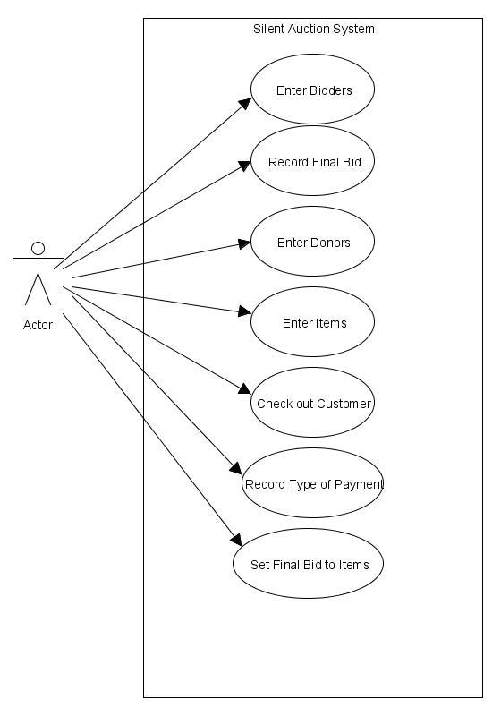

**8.2 Sequence Diagrams**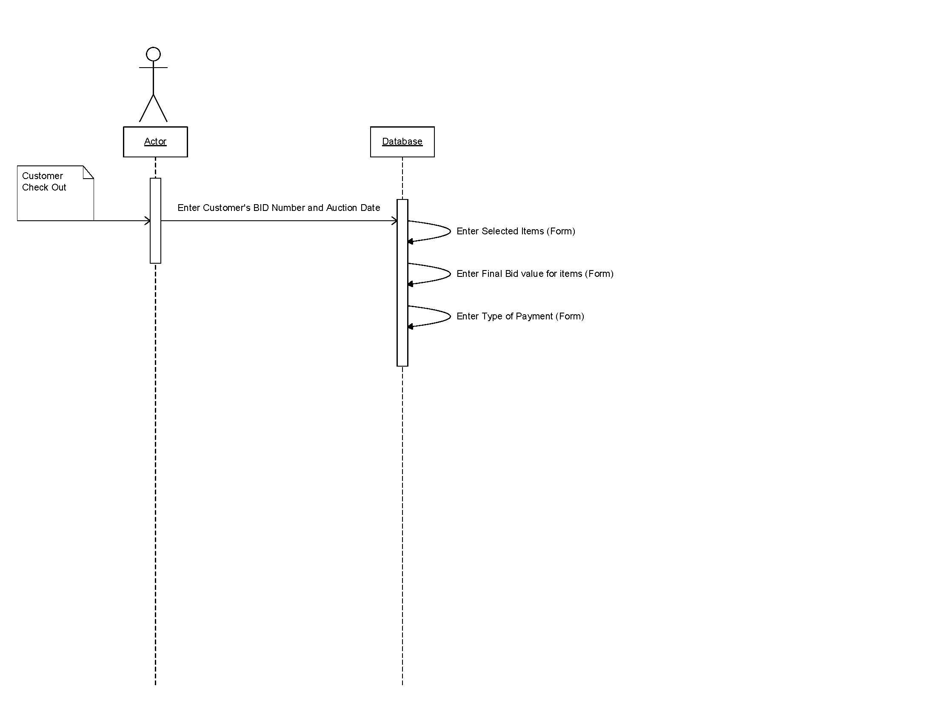

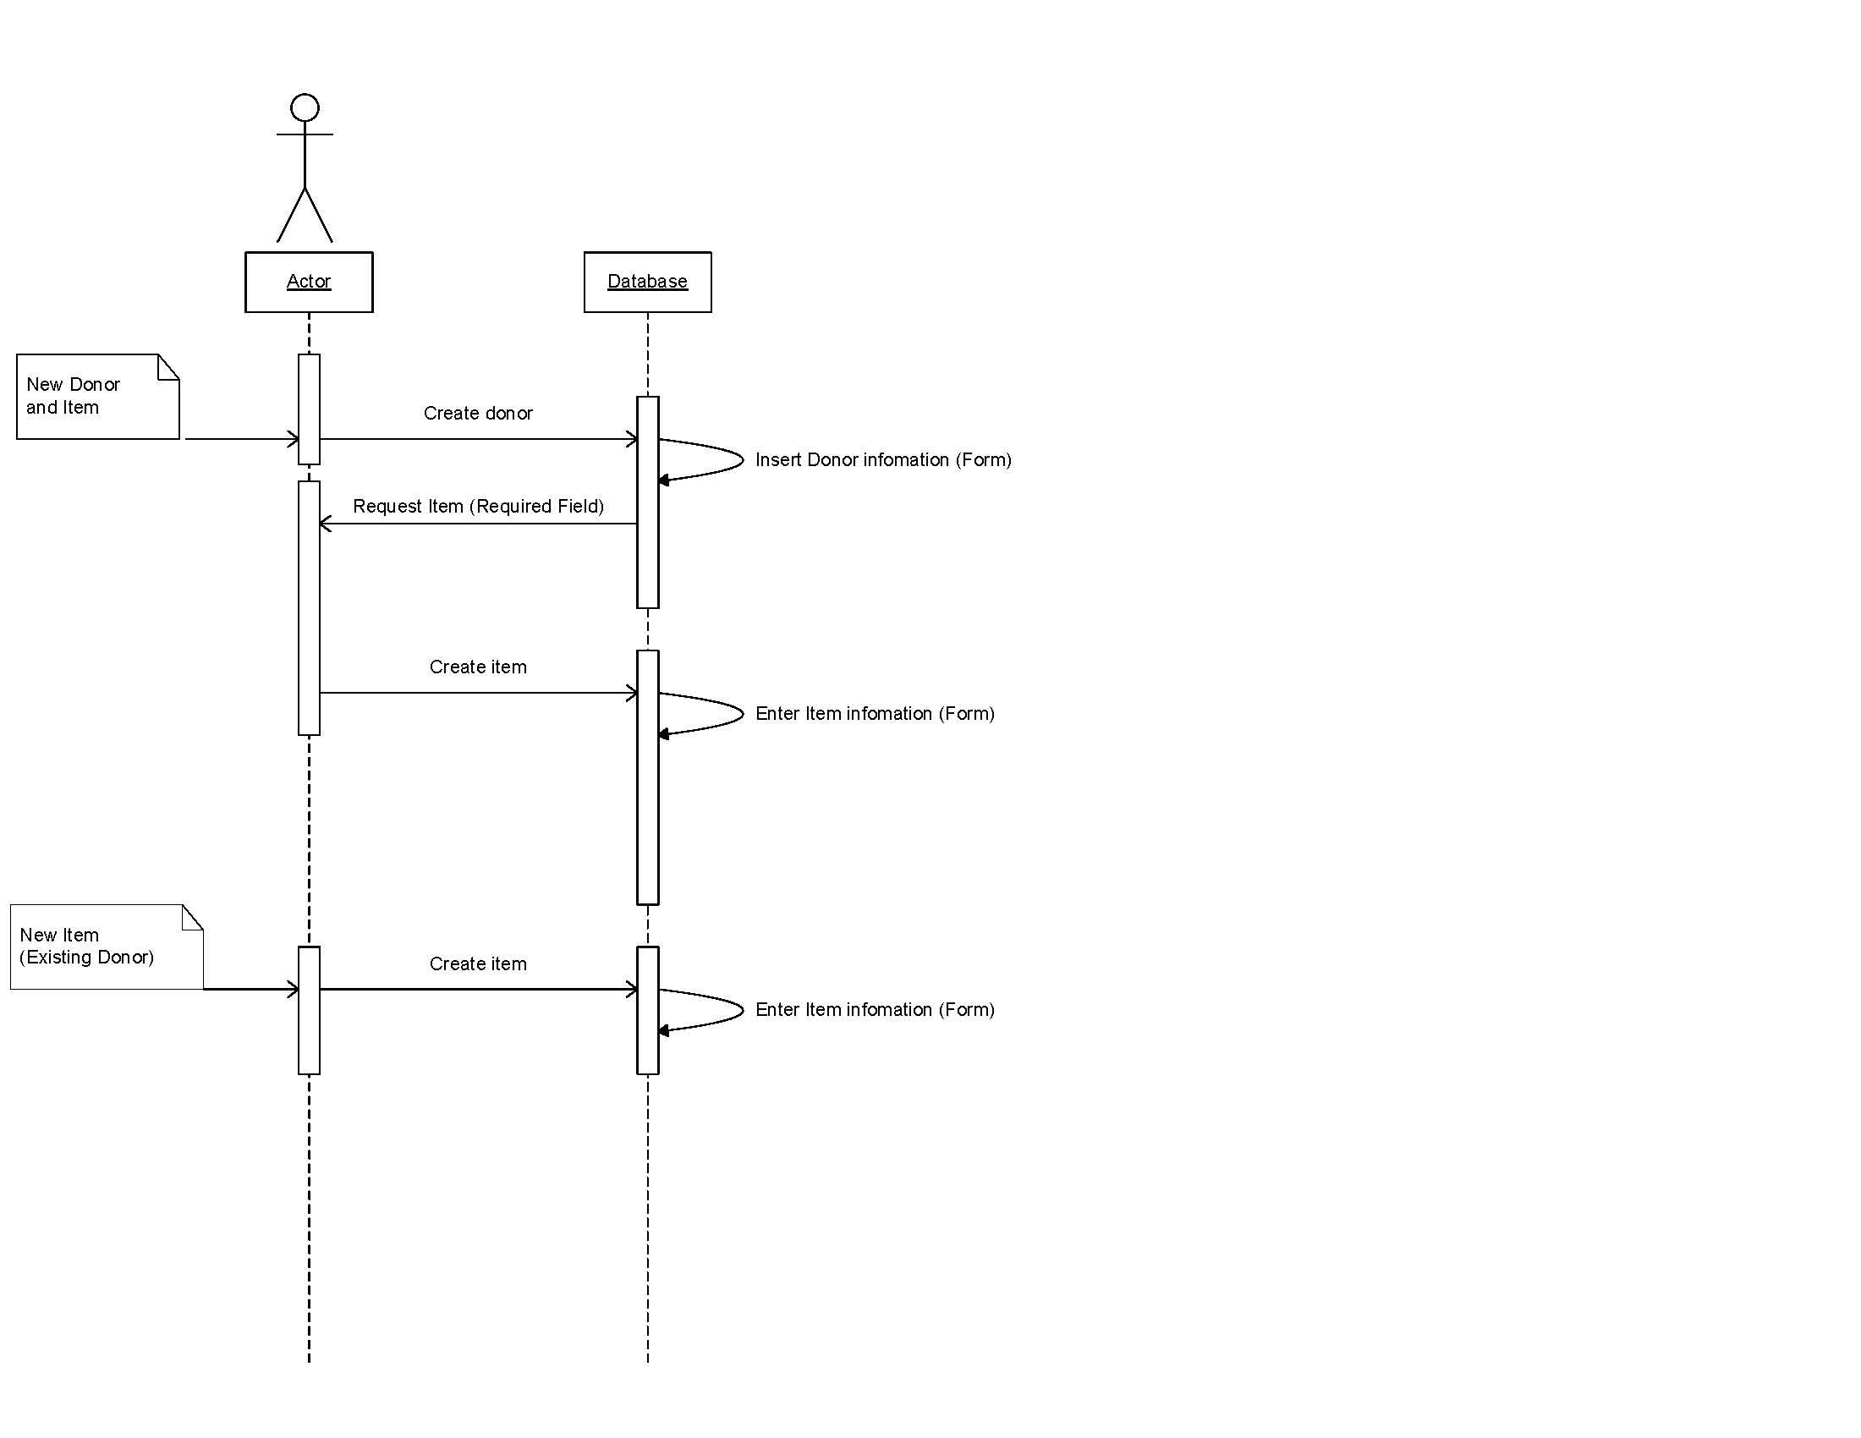

## 9. Updated Schedule

The updated PERT/GANTT chart is attached at the end of the document

## 10. Updated Budget

An updated budget is attached at the end of this document

## 11. Appendices

**11.1 Definitions, Acronyms, Abbreviations**  
GMYI - Give Me Your Information