WA-1:

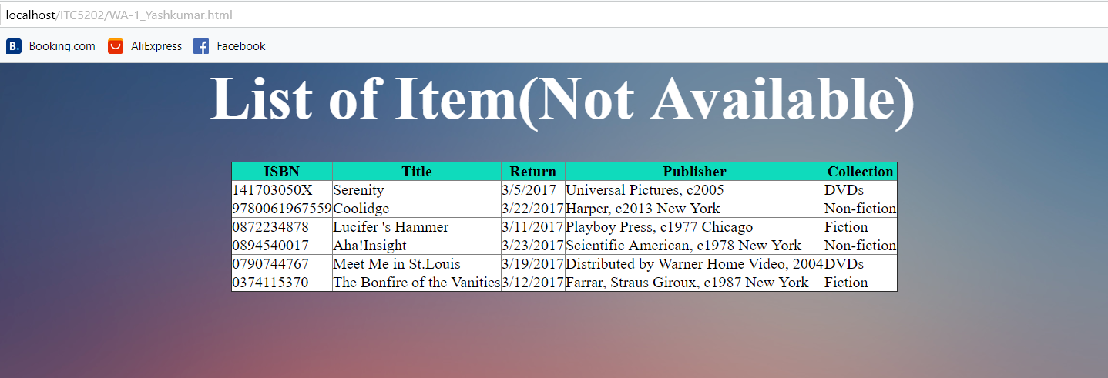

A1:

Q1:

Main purpose of the webserver is to provide information through the webpages on the request of client

Another usage of webserver is to process the data for the webpages like get data from the database or other files like JavaScript and arrange them in webpage and provide that processed webpage to the Client.

Q2:

1:

Apache: <https://httpd.apache.org/>

2:

Nginx: <https://www.nginx.com/>

3:

Microsoft IIS: <https://www.iis.net/>

4:

Light pad -fly light : <https://www.lighttpd.net/>

A2:



readyState is has five values:

State: 0) Unset: client Is created but not called by open().

State: 1) Opened: Client is created and called by open().

State: 2) header Received: header received by the Send() function.

State: 3) Loading : responseText have partial Data.

State: 4) done: the operation is complete.

Status has several values.

10(0,1,2,3): so far connection is ok or Sever is processing the data.

20(0,1,2,3,4,5,6) : Request is Succeed and resource has been fetched

30(0,1,2,3,4,5,6,7,8): Page is moved or redirect to other page.

400(s): Page not found or payment is needed of bad request.

500(s): Server Errors.

A3:

