PANDIT DEENDAYAL ENERGY UNIVERSITY
SCHOOL OF TECHNOLOGY


Course: Artificial Intelligence
Lab
Course Code: 23CP307P
LAB MANUAL
B.Tech. (Computer Engineering)
Semester 6

Submitted To: | Submitted By:
Dr. Pooja Shah | Yash Prajapati
 | 22BCP144
 | G4 batch

Practical 8 - Project part 1 - overfitting/dropout/optimizer

Instructions
Design the Neural Network model for the project title submitted by you.
Demonstrate "Over-fitting" and solve the same using "Dropout technique".

1.Diagram:

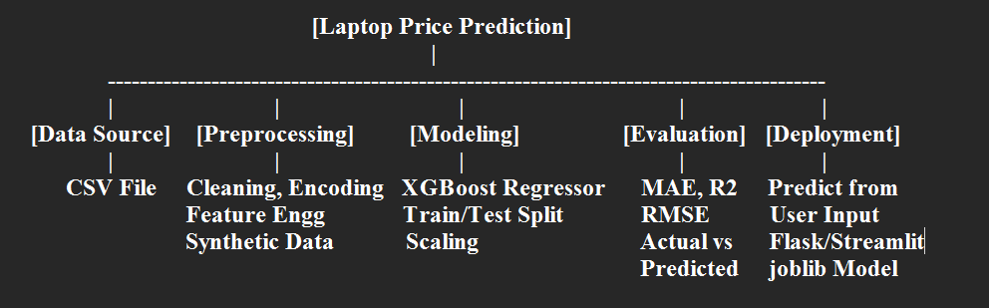

2.Model Justification with Project Domain:
Why XGBoost is suitable:
- Laptop prices depend on many numerical and categorical features (RAM, brand, GPU, etc.).
- XGBoost handles mixed-type data well without needing deep feature scaling or normalization.
- It uses boosting to correct errors from previous trees and improves performance.
- It performs well even on tabular data, which is our domain (laptops dataset).
- Offers interpretability and feature importance, helpful in explaining price drivers.

3.Demonstration of over fitting and dropout technique
Although XGBoost does not use "dropout" like neural networks, we can demonstrate overfitting and use regularization techniques:
Overfitting:
- Overfitting occurs when the model performs very well on training data but poorly on test data.
- You can demonstrate it by training with:
xgb_model = XGBRegressor(n_estimators=500, max_depth=10)
- This might give low training error but high-test error → overfitting.
Solution (Regularization):
- Use XGBoost's built-in regularization like dropout:
xgb_model = XGBRegressor (
n_estimators=150,
max_depth=6,
subsample=0.8,
colsample_bytree=0.8,
reg_lambda=1,
reg_alpha=0.5
)
These techniques prevent the model from relying too much on specific features → better generalization.

4.Need of optimizer
An optimizer is essential for:
- Reducing the prediction error (loss) between actual and predicted prices.
- Updating model parameters (like tree splits or weights) effectively.
- Making the learning process efficient and stable.
Without optimization, the model cannot improve during training.

5.Significance of your choice of optimizer
XGBoost uses an advanced optimizer internally:
- Based on gradient descent + second-order approximation (Newton's method).
- It is faster and more accurate than basic optimizers.
- Supports early stopping and regularization, helping avoid overfitting.
- Unlike traditional optimizers, it works on trees, not weights.
Hence, XGBoost's built-in optimizer is highly suited for structured data and regression tasks like this.

