Mybatis

1、基本架构
a）simple start
mybatis-config.xml
<?xml version="1.0" encoding="UTF-8" ?>
<!DOCTYPE configuration PUBLIC "-//mybatis.org//DTD Config 3.0//EN" "http://mybatis.org/dtd/mybatis-3-config.dtd">
<configuration>
<properties resource="db.properties">
<property name="a" value="avalue"/>
<property name="b" value="bvalue"/>
</properties>
<environments default="development">
<environment id="development">
<transactionManager type="JDBC"></transactionManager>
<dataSource type="POOLED">
<property name="driver" value="${driver}"/>
<property name="url" value="${url}"/>
<property name="username" value="${username}"/>
<property name="password" value="${password}"/>
</dataSource>
</environment>
</environments>
<mappers>
<mapper resource="UserMapper.xml"/>
</mappers>
</configuration>

XXXMapper.xml
<?xml version="1.0" encoding="UTF-8"?>
<!DOCTYPE mapper PUBLIC "-//mybatis.org//DTD Mapper 3.0//EN" "http://mybatis.org/dtd/mybatis-3-mapper.dtd">
<mapper namespace="myTest.base.userMapper">
<resultMap type="myTest.base.User" id="detailUserResultMap">
<result property="id" column="user_id" />
<result property="password" column="user_pwd" />
<result property="svcnum" column="svc_num" />
</resultMap>
<sql id="base">
<if test="1==1">
id, `name`, ${a}
</if>
</sql>
<select id="selectUserDetail" resultMap="detailUserResultMap" flushCache="false">
select user_id,user_name,user_type,cust_id
from tf_f_user a
where a.user_id=#{userId}
and a.user_id=${userId}
</select>
</mapper>

Test:
String resouce = "mybatis-config.xml";
InputStream is = Resources.getResourceAsStream(resouce);
SqlSessionFactoryBuilder builder = new SqlSessionFactoryBuilder();
SqlSessionFactory factory = builder.build(is);
SqlSession sqlSession = factory.openSession();
try {
Map<String, Object> param = new HashMap<>();
param.put("userId", 1L);
List<User> userss = sqlSession.selectList("myTest.base.userMapper.selectUserDetail", param);
System.out.println(userss);
sqlSession.commit();
} catch (Exception e) {
sqlSession.rollback();
e.printStackTrace();
} finally {
sqlSession.close();
}

b）两个重点
mybatis-config.xml --> Configuration
XXXMapper.xml --> MappedStatement

- 加载阶段
概况：
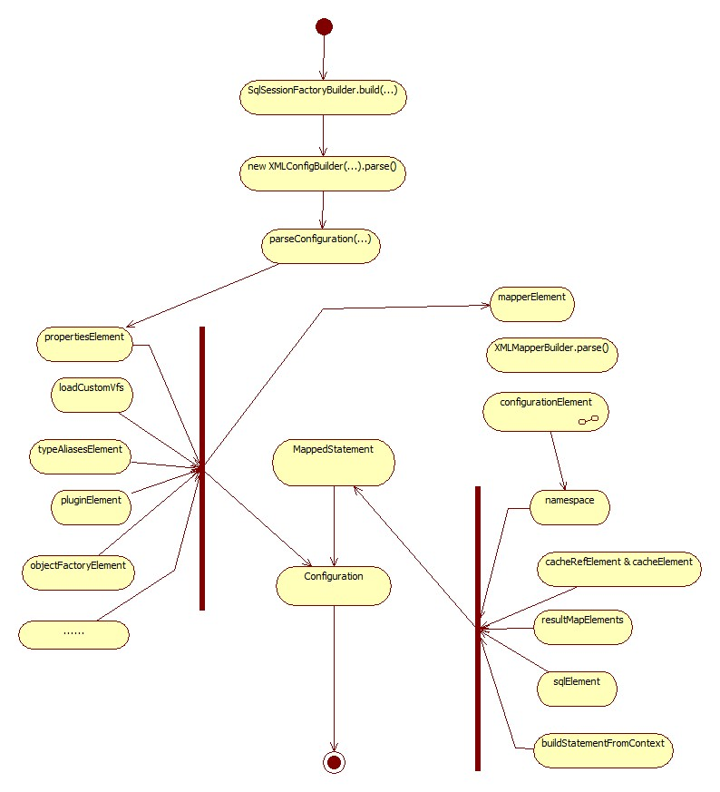
  - Load Configuration
    - Properties 优先级
      - Resource | url （二选一）
      - Configuration.getvariables
    - Aliases 别名
      - new TypeAliasRegistry() 基本类型
      - new Configuration() Mybatis 一些助手 LruCach，JdbcTransactionFactory
      - parseConfiguration typeAliasRegistry.registerAlias(
  - Load MappedStatement
    - Cache

    - sql element
    - sql statement

c) $: xpath 变量处理
sql外变量 表名称等
sql 变量
统一为字符串替换

#: sql 内参数变量
mybatis 处理JDBC协议类型

d) sql 结构
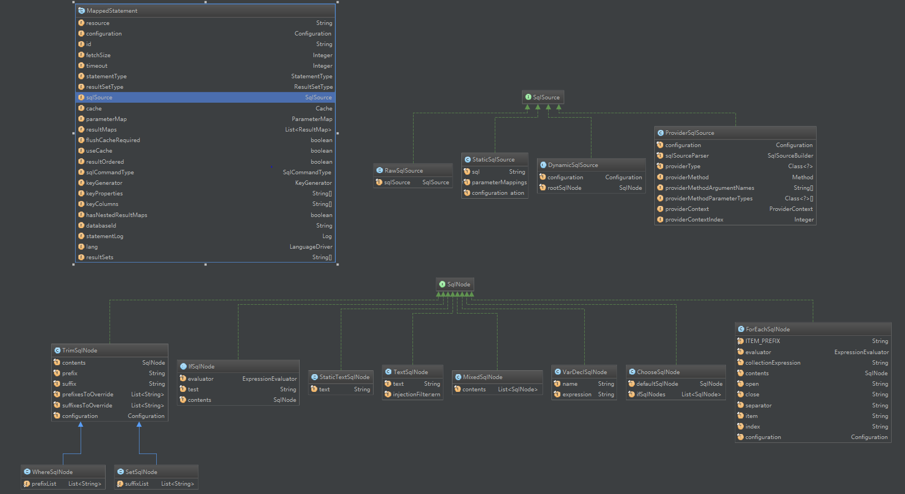
e) D.P
装饰者
cache
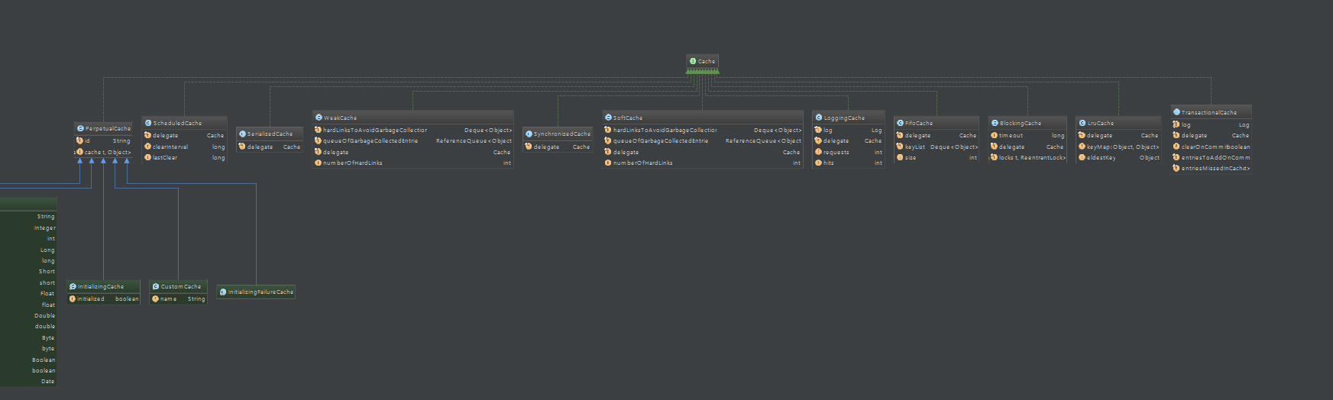
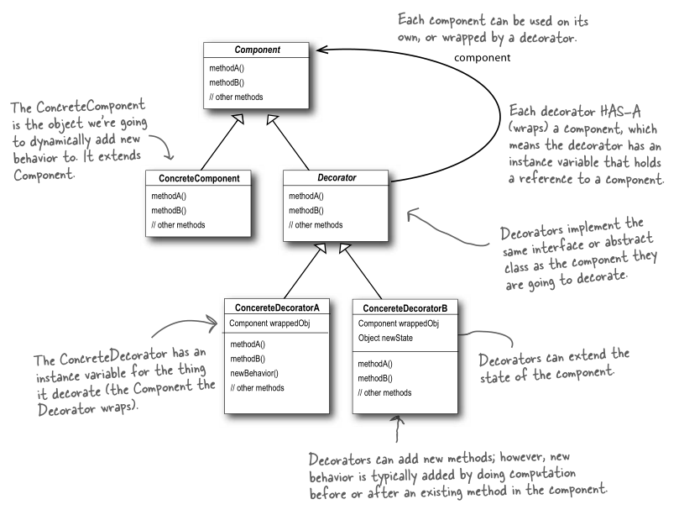

public class LruCache implements Cache {
private final Cache delegate;
private Map<Object, Object> keyMap;
private Object eldestKey;
public LruCache(Cache delegate) {
this.delegate = delegate;
setSize(1024);
}

策略模式
XMLScriptBuilder NodeHandler
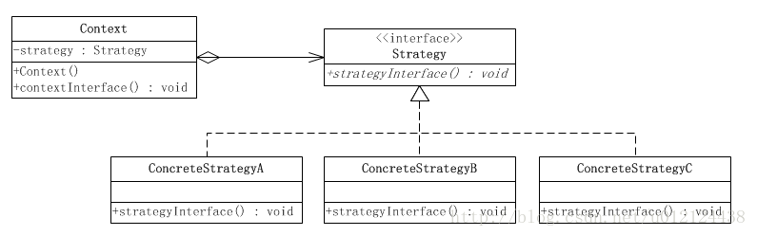
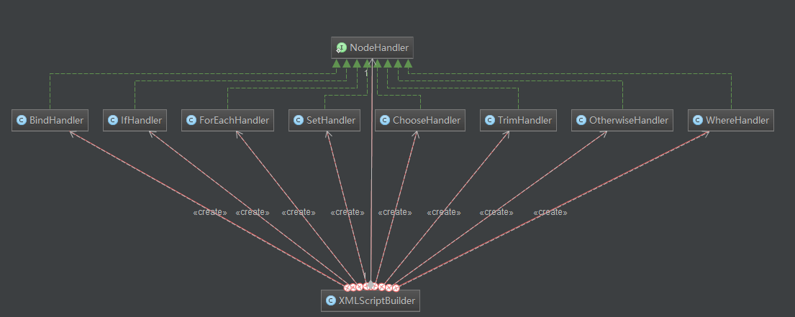
模板模式
abstract class BaseBuilder
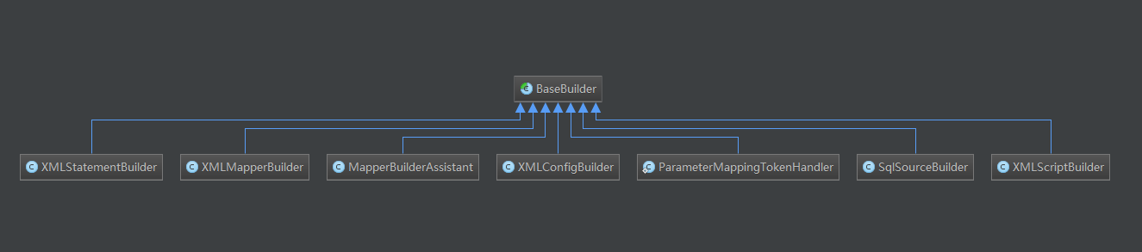
Builder模式
MappedStatement.Builder
...

- 运行阶段
流程
Executor
Cache
ResultTypeHandler

- with spring

- With spring-boot

