**ACE: Align, Compare, Exhibit**

**… of SPADES: Software Package for Amino-Acid and DNA Examination of Sequence**

By: Jamie Mortensen, Yara Rose, Madelyn Schreiner, Kevin Schutt

1. User: download ClustalW
   1. Go to Clustal.org (<http://www.clustal.org/download/current/>) to download the appropriate version of ClustalW
2. User: download HomoloGene files (dna and protein) for 2 homologous genes/proteins
   1. Go to the HomoloGene database (<https://www.ncbi.nlm.nih.gov/homologene>) and search for a gene of interest

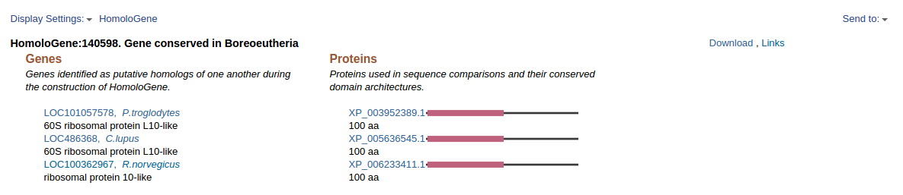

* 1. The “Download” link offers options to download both the nucleic acid (DNA) and the amino acid (protein) sequence.

1. User: run ACE
   1. Ensure the HomoloGene files reside in the same folder as the ACE.py script.
   2. Run ACE.py using python.
2. ACE: Asks user for filename
   1. When the ACE program is run, the interface will prompt the user to enter a filename downloaded from the HomoloGene database. The sequences from the HomoloGene database can be DNA, mRNA, or Amino Acids. Sample of Prompt is shown below.



1. User: inputs file names
   1. Input name of file that is downloaded from Homologene, include extension (example.txt)
   2. File needs to be in the same location as the ACE.py file
2. ACE: runs clustal on files to produce aligned output files

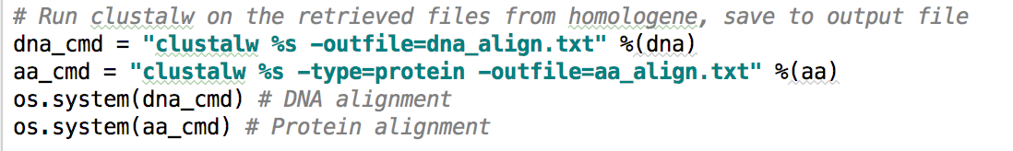

1. ACE: accesses Clustal output files and parses sequences

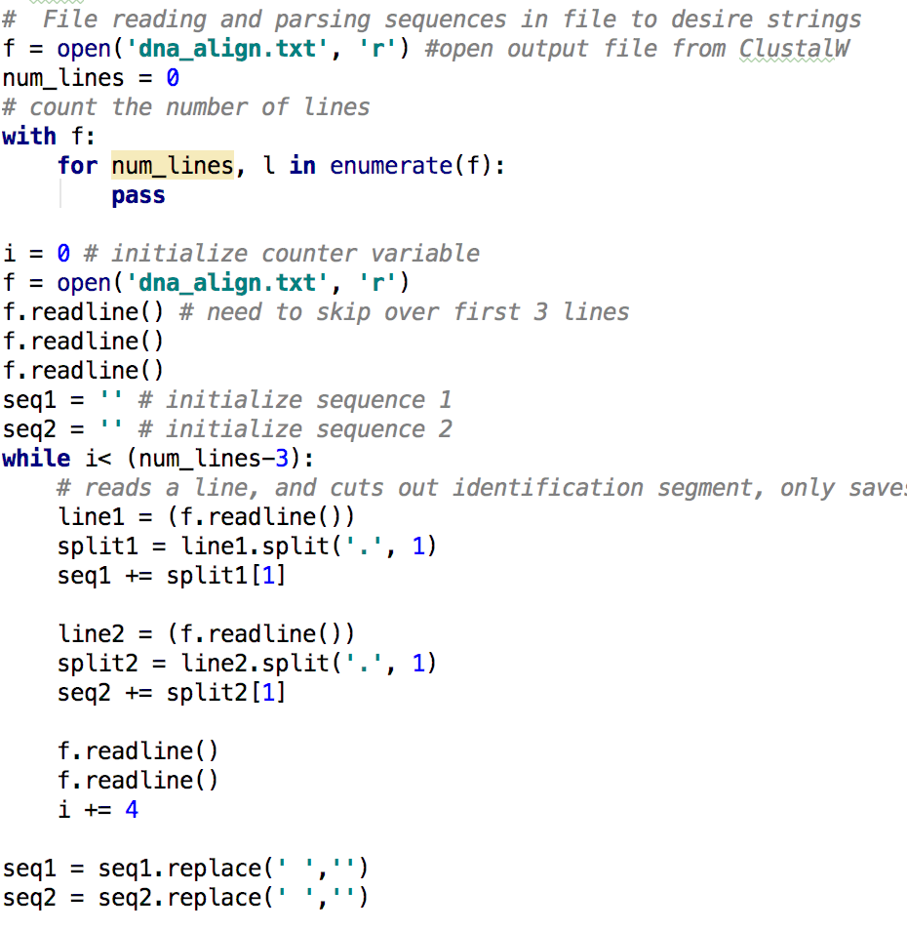

1. Check to make sure all nucleotides and amino acids are valid
   1. Uses an if statement to compare known amino acid and nucleotide symbols to the sequences that were outputted by homologene
   2. Checks sequences string before determining percent similarity
   3. If there are invalid symbols in its corresponding sequences , the code will not run
2. ACE: counts similarities in sequences
   1. Goes through each character of the first sequence and compares it to the character of the second sequence.
   2. Does not count as same character if a ‘-’ .

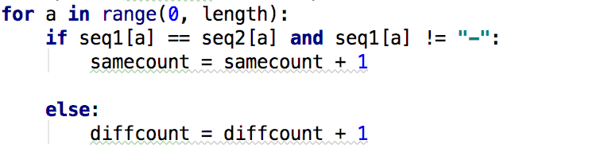

1. ACE: calculates and displays percentage of similarities

