*Yong Son*

*Dec 05, 2020*

*IT FDN 110 A Au20: Foundations of Programming: Python*

*Assignment 09*

gitHub link: <https://github.com/yms7/ITFnd100-Mod09>

**Assignment 09: Main Module**

Introduction

In week 09, we’ve learned how to split programming code into different files and use modules to run it on the Main.py file. Modules can help programmer to organize functions and classes into different sectors of programming code. These modules can be re-used by different programming code per its design intentions.

Summary

On this assignment, we have split the script code into multiple files: DataClasses, ProcessingClasses, IOClasses, TestHarness and Main. All other scripts sources were provided in this assignment except Main.py file. For the purpose of this assignment, I’ve only focused to write a script code for Main.py. Below picture shows all scripts that I programmed for Main.py. I used “import” command to bring all other modules created for this assignment. (Figure 9-1)

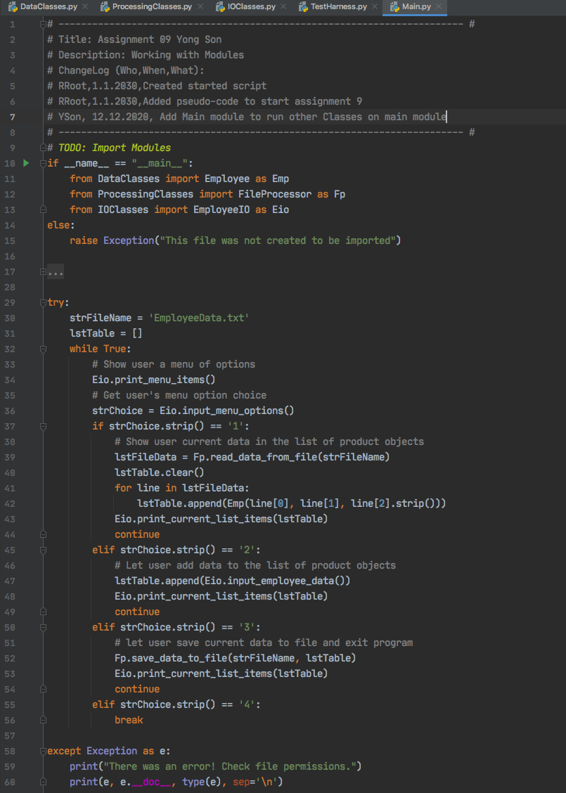

***Figure 9-1: Main***

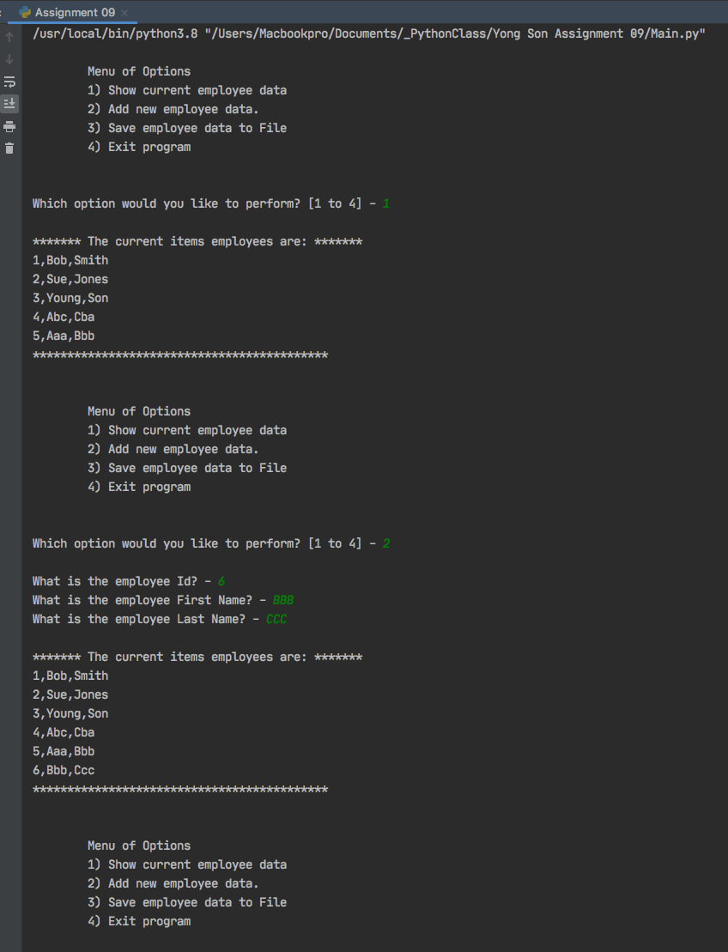

***Figure 9-2: Result1***

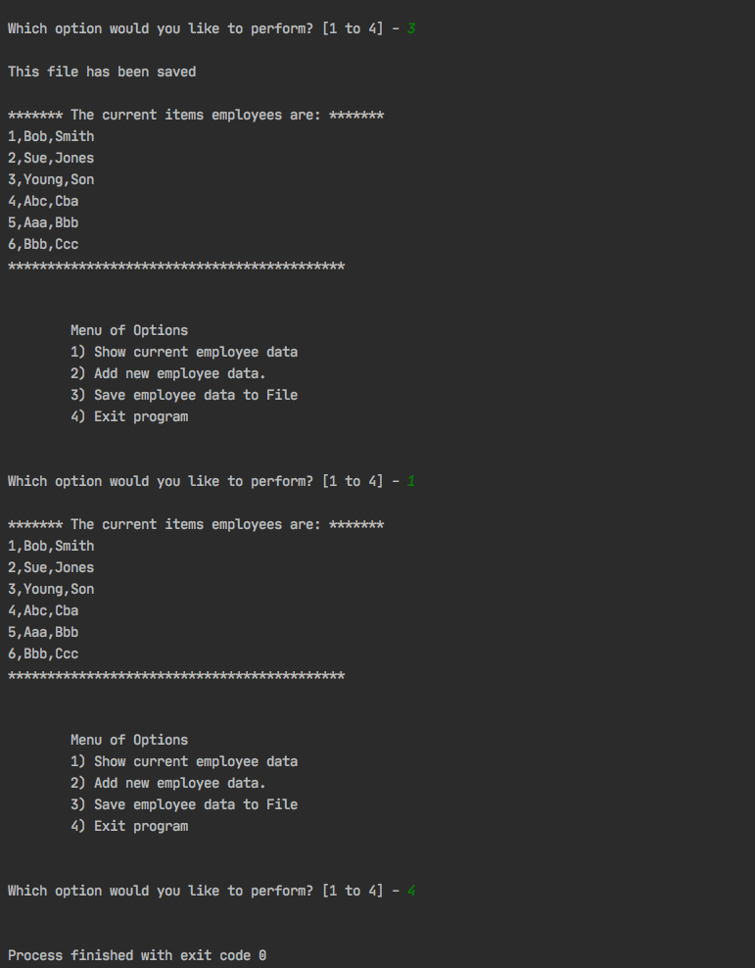

***Figure 9-3: Result3***

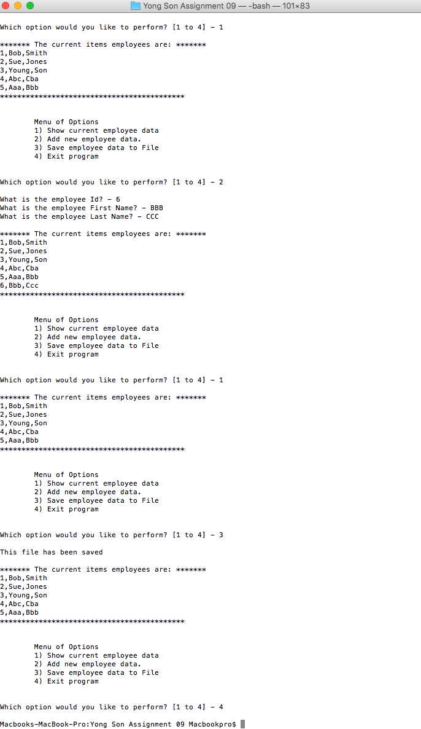

***Figure 9-4: Result in Terminal***

Conclusion

On Main file, as long as other modules are properly imported, all other scripting process is similar to using Classes. I used EMP, Fp, and Eio for module callouts and all other classes and functions were used based on each module setting. Codes in each module file seems much simpler and easy to read.