Program description: This program will create tickets for users in a GUI for IT workers like myself to keep track of what we need to do. Admin users are able to close, update, and remove tickets if they need to.

**Admin:**

Username: ymtmb

Password: Tran123

Regular User:

Username: Joe User

Password: 123

1. Insert at least 10 tickets into the DB table. *Include a record with your name* into the table

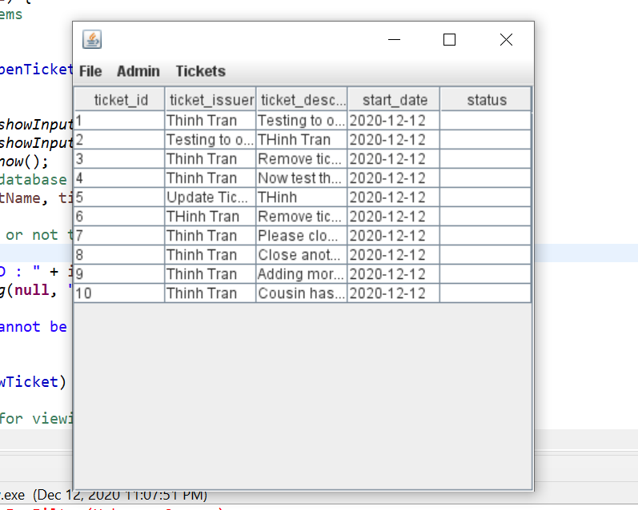

1. Update your record by changing your ticket description

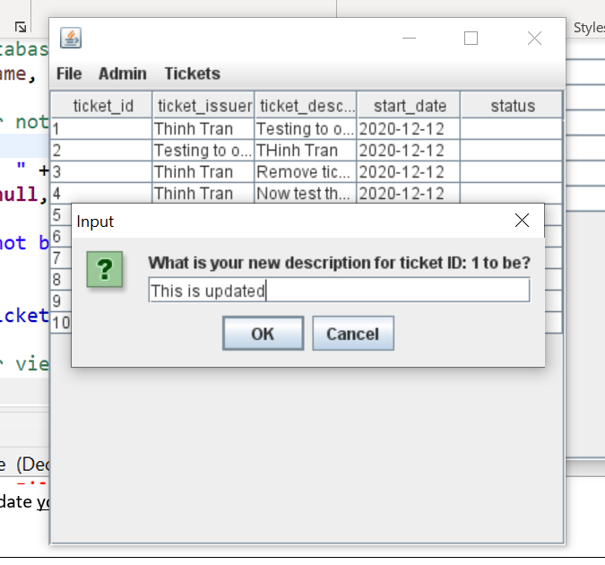

1. Show a view of your updated ticket.
2. 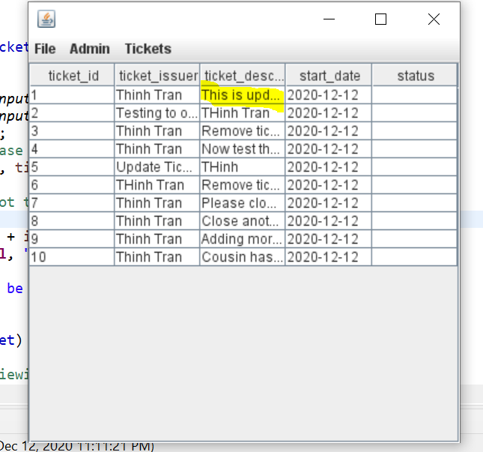
3. Delete your ticket from the DB.

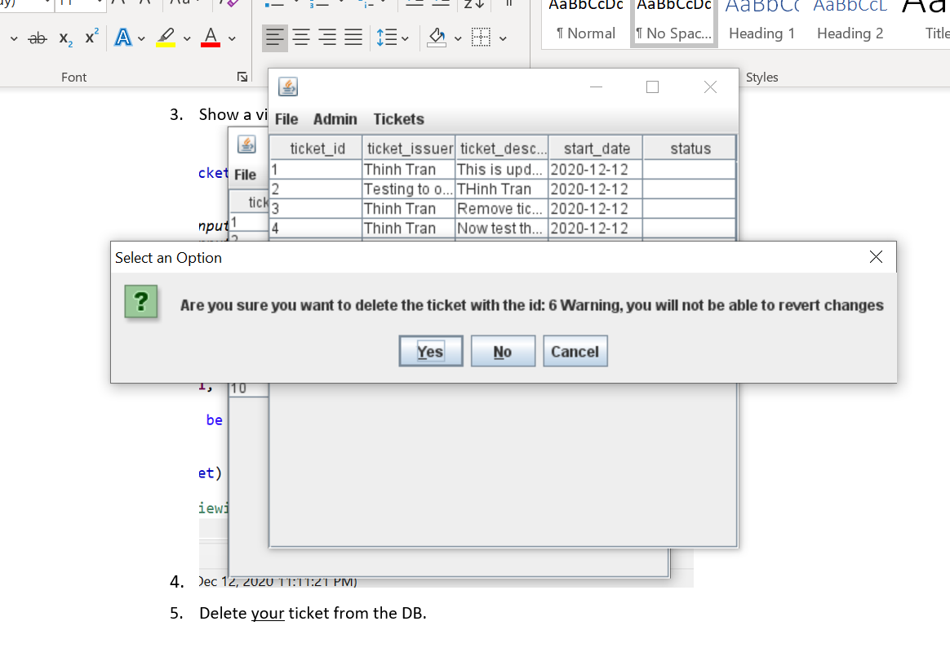 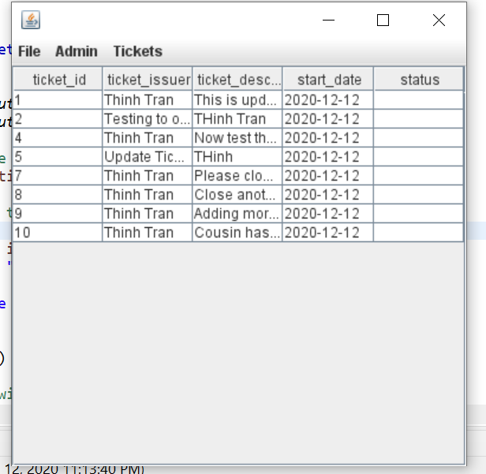

1. Close any two existing tickets.

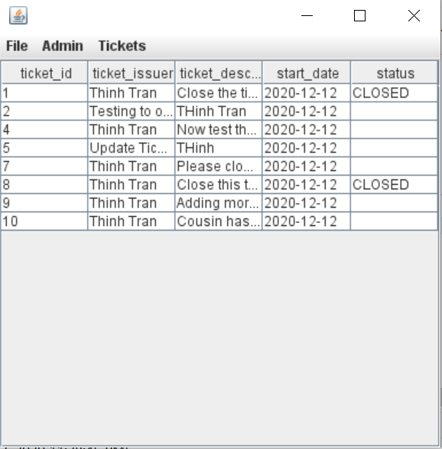

1. Lastly, show a table view of all of your tickets. (I have alalso removed ticket 6 but I removed it after provided the last screenshot