AZURE LAB TASK:

=======================

1. Research and list any five benefits of cloud computing over traditional on-premises infrastructure.

Online cab booking system

**High availability** – It ensures that the cab booking system should have the maximum uptime but the downtime should be minimum as much as possible

e.g., 99.99% uptime i.e., 4 min per month downtime

**Elasticity** - As the cab booking/ Businesses increases the demand(like during peak hours, festivals, new year eve and holidays.),cloud computing can easily adjust their storage capacity, server resources, and other infrastructure elements(GPS and OTP and Transaction details) to meet their specific needs and when demand decreases in off seasons ,it shrinks the resources .

**agility**- If we add any new features in our cab booking system, updates will be added easily to the application using cloud computing ‘s services and resources without any disturbance on users end.

**fault tolerance** – Even in internet lost, networking, server down and hardware failures(short circuits) situation occurs in the developer's side  ,application will work properly.

**disaster recovery**  - there is data backup hence data is not lost even in disasters, business will continue.

2. Describe the Capex and Opex models of financing IT infrastructure, providing examples of when each model might be preferred.

Capex or Capital Expenditure refers to the money invested in assets in the beginning something upfront money. In case of Cab Booking Application, at the initial stage, the cost of application making such as cost of vehicles, equipment's and machinery comes under Capital Expenditure.

OpEx or Operational Expenditure refers to the money spent on regular intervals on operating expenses. In case of Cab Booking Application, the cost of salary for employees, cloud services, maintenance for vehicles, rent, tax and utility comes under OpEx these are paid a certain time of interval.

3. create  a brief report differentiating between public, private and hybrid clouds. include a diagram that represents each cloud model

Private cloud

Providing services to selected users and organizations.

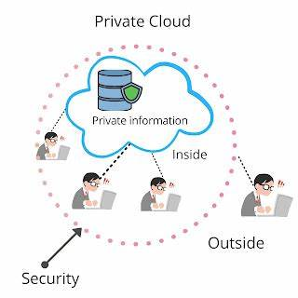

Ex: organization

Public cloud

Services offered to public internet; anyone can signup

Ex: train ticket booking

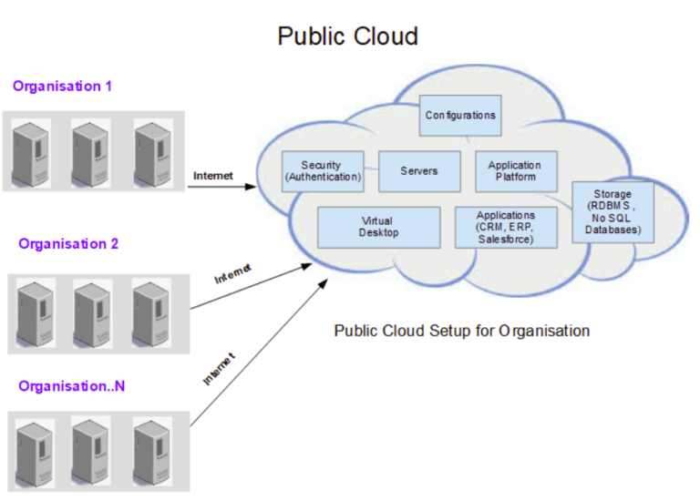

Hybrid cloud

Combination of public and private

Ex: bank

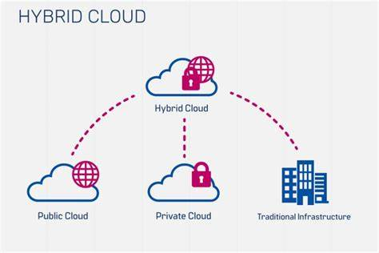

4. For each cloud model, list one real-world application or scenario where that model would be the most appropriate choice.

1.Public Cloud:

Real-World Application: A startup company developing a new mobile app chooses to host their app on a public cloud platform. The company has limited resources and wants to minimize upfront costs. They also anticipate a variable and potentially high volume of users, making the scalability of public cloud resources ideal for their needs.

2.Private Cloud:

Real-World Application: A financial services firm with strict regulatory requirements decides to build a private cloud to host its financial data and applications. The firm needs to ensure data privacy, security, and compliance with regulations such as GDPR and HIPAA. A private cloud allows the firm to have full control over its infrastructure and data, meeting its security and compliance needs.

3.Hybrid Cloud:

Real-World Application: A retail company uses a hybrid cloud model to manage its e-commerce platform. The company uses the public cloud for hosting its website and handling peak shopping seasons when traffic is high. It uses a private cloud for sensitive data such as customer financial information, ensuring security and compliance with industry regulations. The hybrid cloud model allows the company to scale resources up or down based on demand while maintaining control over sensitive data.