LessonPace

#### The average time for differen plans by Grade

## plan_name Grade mean n  
## 1 Custom Plan PK 1.0 1  
## 2 Custom Plan PS 2.0 2  
## 3 T1 Addition Strategies PK 3.0 54  
## 4 T1 Addition Strategies PS 2.5 22  
## 5 T1 Classification/Sorting PK 2.0 4  
## 6 T1 Comparative Value PK 2.0 20  
## 7 T1 Comparative Value PS 1.8 19  
## 8 T1 Compound Words PK 2.3 34  
## 9 T1 Compound Words PS 2.6 77  
## 10 T1 Conversations PK 2.1 39  
## 11 T1 Conversations PS 2.0 33  
## 12 T1 ELL Units 2-4 DIP PK 3.1 5  
## 13 T1 ELL Units 2-4 DIP PS 2.7 9  
## 14 T1 ELL Units 9-10 DIP PK 1.2 2  
## 15 T1 ELL Units 9-10 DIP PS 1.4 6  
## 16 T1 Expression: Ask & Answer PK 2.0 12  
## 17 T1 Expression: Ask & Answer PS 2.0 28  
## 18 T1 Expression: Descriptive Language PK 2.3 76  
## 19 T1 Expression: Descriptive Language PS 2.2 90  
## 20 T1 Final Sounds PK 1.8 13  
## 21 T1 Initial Sounds PK 2.4 18  
## 22 T1 Initial Sounds PS 1.9 11  
## 23 T1 Letter Sounds and ID PK 1.0 9  
## 24 T1 Letter Sounds and ID PS 1.0 1  
## 25 T1 Narrative Comprehension PK 1.0 4  
## 26 T1 Number Symbols PK 3.0 76  
## 27 T1 Number Symbols PS 2.5 67  
## 28 T1 One-to-One PK 2.7 39  
## 29 T1 One-to-One PS 3.0 70  
## 30 T1 Oral Comprehension PK 2.5 33  
## 31 T1 Oral Comprehension PS 2.6 73  
## 32 T1 Ordering PK 3.0 1  
## 33 T1 Patterns PK 2.5 2  
## 34 T1 Phonemes PK 3.0 89  
## 35 T1 Phonemes PS 2.6 69  
## 36 T1 Quantification PK 2.4 79  
## 37 T1 Quantification PS 2.4 70  
## 38 T1 Rational Counting PK 3.0 132  
## 39 T1 Rational Counting PS 3.4 128  
## 40 T1 Rhyme PK 3.4 115  
## 41 T1 Rhyme PS 3.3 184  
## 42 T1 Rote Counting PK 2.7 51  
## 43 T1 Rote Counting PS 2.2 66  
## 44 T1 SED PK Units 1-5 PK 3.1 41  
## 45 T1 SED PS Units 1-5 PK 5.2 2  
## 46 T1 SED PS Units 1-5 PS 3.3 58  
## 47 T1 SED PS Units 6-10 PK 4.0 2  
## 48 T1 SED PS Units 6-10 PS 3.5 21  
## 49 T1 Shape Identification PK 2.5 6  
## 50 T1 Shape Identification PS 2.5 1  
## 51 T1 Spatial Awareness PK 1.5 1  
## 52 T1 Subtraction Strategies PK 2.9 22  
## 53 T1 Subtraction Strategies PS 2.6 9  
## 54 T1 Syllables PK 2.7 47  
## 55 T1 Syllables PS 2.7 60  
## 56 T1 Vocabulary PK 1.8 4  
## 57 T1 Vocabulary PS 1.1 5  
## 58 T1 Word Awareness PK 3.4 66  
## 59 T1 Word Awareness PS 3.3 76

*note: I first define diff as the value of Round_Last_lesson_Taught minus its corresponding average time. if the absolute value of diff is less than 0.3, then I define rate as equal, otherwise, if diff>0, I define rate as more and if diff<0, I define rate as less.*

#### Build linear regressions to study the relation between the lesson pace and PassRate

model1= lm(PassRate~rate+Grade, data=pace1)  
summary(model1)

##   
## Call:  
## lm(formula = PassRate ~ rate + Grade, data = pace1)  
##   
## Residuals:  
## Min 1Q Median 3Q Max   
## -0.8339 -0.1515 0.1661 0.2363 0.2822   
##   
## Coefficients:  
## Estimate Std. Error t value Pr(>|t|)   
## (Intercept) 0.83389 0.01937 43.044 < 2e-16 ***  
## rateless -0.04596 0.02360 -1.947 0.0517 .   
## ratemore -0.01571 0.02088 -0.753 0.4518   
## GradePS -0.07015 0.01759 -3.988 7.07e-05 ***  
## ---  
## Signif. codes: 0 '***' 0.001 '**' 0.01 '*' 0.05 '.' 0.1 ' ' 1  
##   
## Residual standard error: 0.297 on 1161 degrees of freedom  
## Multiple R-squared: 0.01525, Adjusted R-squared: 0.01271   
## F-statistic: 5.994 on 3 and 1161 DF, p-value: 0.0004717

plot(model1,which=3)

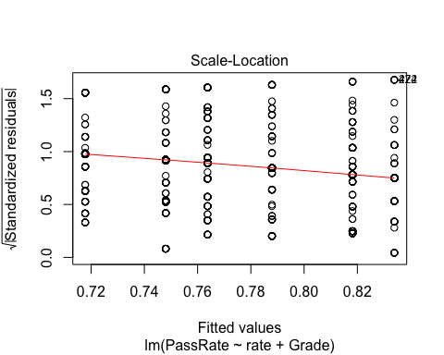

*The above result shows that both rate and Grade have signficant impact on the PassRate, then I check the linear model assumpution by ploting the fitted value towards residul. In the plot,it doesn't satisfy the linear model assumption of constant residual variance because the red line in the plot is not constant*

#### some viuslization

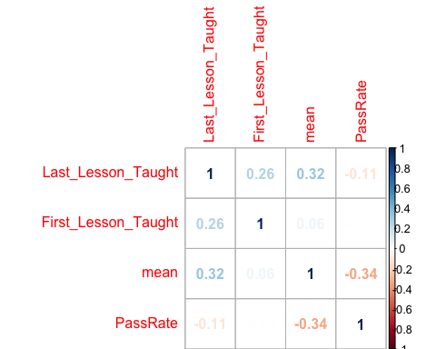

*According to the above correlation matrix, none of the numerical variables are highly linear correlated with PassRate*

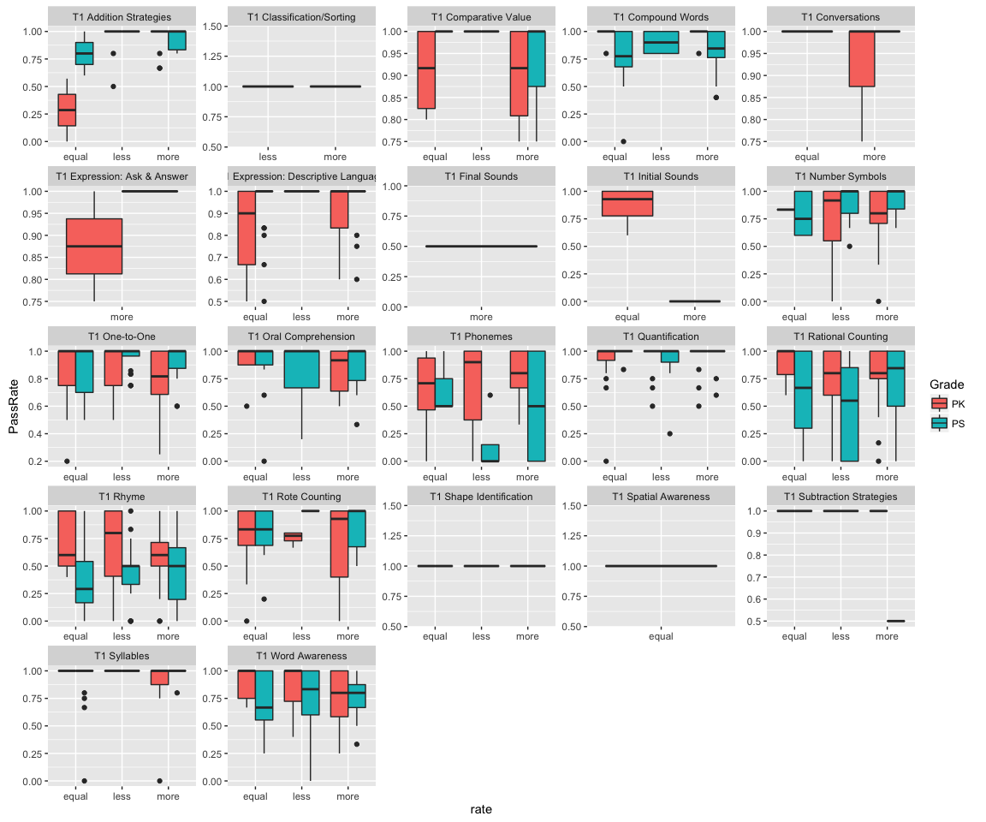

#### Build spline model (non-linear)

##   
## Family: gaussian   
## Link function: identity   
##   
## Formula:  
## PassRate ~ s(Last_Lesson_Taught)  
##   
## Parametric coefficients:  
## Estimate Std. Error t value Pr(>|t|)   
## (Intercept) 0.777867 0.008673 89.69 <2e-16 ***  
## ---  
## Signif. codes: 0 '***' 0.001 '**' 0.01 '*' 0.05 '.' 0.1 ' ' 1  
##   
## Approximate significance of smooth terms:  
## edf Ref.df F p-value   
## s(Last_Lesson_Taught) 2.582 3.239 6.952 7.92e-05 ***  
## ---  
## Signif. codes: 0 '***' 0.001 '**' 0.01 '*' 0.05 '.' 0.1 ' ' 1  
##   
## R-sq.(adj) = 0.0188 Deviance explained = 2.1%  
## GCV = 0.087908 Scale est. = 0.087637 n = 1165

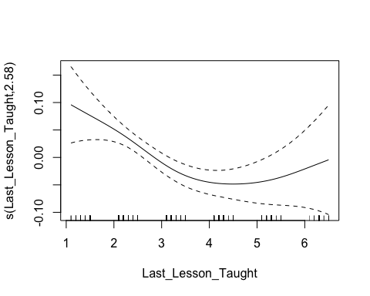

According to the result, the spline item of Last_Lesson_Taught significant affects on PassRate. The plot shows what kind of transformation applies on Last_Lesson_Taught.